Don’t Settle God’s Chosen
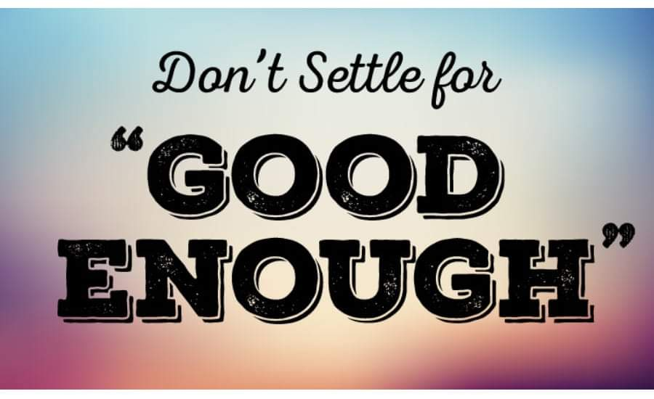
Have you ever found yourself saying...."I can work with it, if I just change xyz," "Its not what I want but.....," He/she is not what I want, but I can fix them up to make them into what I want😏, "....God's chosen....If you are trying to convince yourself that something is right for you when every fiber of your being is screaming at you not to go that way.....YOU ARE SETTLING. Don't settle for bread crumbs God's chosen. Wait on God for his best. I know it seems like it will never come but if you keep settling and getting sidetracked by the enemies counterfeit blessings, you can't blame God for how long its taking for your blessings to come through. Glad Tidings✨✨

