Join Neighbourhood Watch NSW and make a difference.

What will a Neighbourhood Watch program do for me?

A Neighbourhood Watch program gives you information and programs about keeping you, your neighbour’s and your community safe.

A Neighbourhood Watch program teaches you how to:

• Increase community communication and knowledge

• Reduce preventable crime

• Encourage reporting of criminal or suspicious activity

• Improve the quality of information passed on to police

• Improve the level of home security

• Improve personal safety
Neighbourhood Watch New South Wales is a joint Police and community program. It puts YOU back into community and its success depends upon you.

• Encourage property marking
Important Contacts
In an emergency call: 000
For police assistance call: 131 444
Crime Stoppers: 1800 333 000

Neighbourhood Watch NSW: 02 4048 1068
Email: nhwnsw.org.au

• Help reduce the fear of crime particularly for the
elderly in your local community

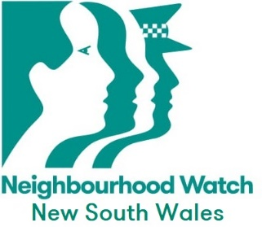
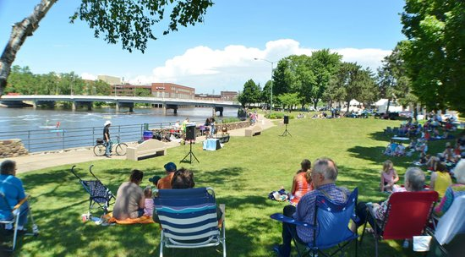

© Neighbourhood Watch NSW 2020

What is Neighbourhood Watch?

Neighbourhood Watch is a community led safety and awareness program that aims to prevent crime, stop social isolation and increase the safety, security and quality of life for everyone in your community.
A Neighbourhood Watch program helps people feel more connected to each other in their community. Community participation and a shared responsibility for what is happening in your local neighbourhood can be vital to your safety.

By communicating with your neighbour’s you can share important information that will help make your community a safer place. You and your neighbour’s are in the best position to notice when something unusual is happening in your area and to report any suspicious activity to police.

Should I become involved with Neighbourhood Watch?

YES! We encourage you to take just a small amount of your valuable time to talk to your neighbour’s.

If you are looking for a meaningful way to contribute to your community then joining or starting a Neighbourhood Watch program is an ideal way to achieve this.Join the vibrant body of active Neighbourhood Watch volunteers.

Crime prevention is everybody’s responsibility

As part of a Neighbourhood Watch program, what do I have to do?

You will represent Neighbourhood Watch by encouraging effective community relations and promoting crime prevention initiatives in your local area.

You can do this by being able to:

• Communicate with your neighbour’s regularly

• Evaluate the safety and security of your home

• Take steps to improve areas of your home security
where required

• Keep informed on local and contemporary crime prevention
information and share this information with your neighbour’s

• Mark all items of value for police identification

It takes many different people, working together as a team, to successfully build a Neighbourhood Watch program and promote its objectives.

How to start a Neighbourhood Watch NSW Group

Identify YOUR Community Area. It may be a cluster of homes around you, your street, a larger block area, a suburb or town.

Find some other neighbour’s who would support wanting to live in a safer community and become part of a Neighbourhood Watch NSW program with you. Often people are willing; it just needs a neighbor to take the first initiative by asking them if they would like to be involved.

Register your community interest with Neighbourhood Watch NSW State office. They can assist you in establishing your community program and provide you with all the information you need to get started and about keeping yourself and your community safe.

Invite all your neighbour’s to a gathering. You can meet in a hall, garden or local park. Introduce yourselves and talk about your community and the safety issues that concern you in your neighbourhood. Encourage discussion about how these issues may be solved.

Agree on a Community spokesperson. To have a voice, someone needs to speak and take the lead. Establish how your neighbour’s would like to receive information and news about your Neighbourhood Watch group or receive alerts about crime and other related issues.

Decide if your group wants to be a Facebook only group or hold regular meetings.

Register your community group by contacting Neighbourhood Watch New South Wales
Email: admin@nhwnsw.org.au
Phone: 0401 384 003

