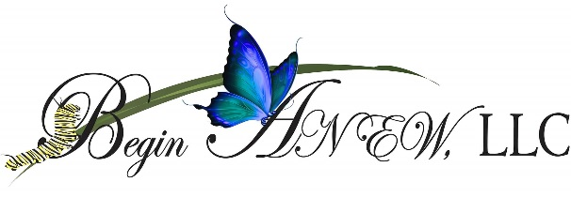
1607 Lake Harbin Rd. Suite-B
Morrow, Ga 30260
404-457-7219

PREPARE/ENRICH
Information and Consent

I am pleased that you have selected me as your PREPARE/ENRICH pre-marriage and or marriage counselor/coach. This document is designed to ensure that you understand our counseling relationship.
Although our sessions (4-8) may be very intimate and challenging, it is important for you to complete all sessions, however you or I may terminate session(s) any time we feel your needs are not met. This is a professional setting and respect is essential to accomplishing your goals.
I will keep confidential anything you say to me, with the following exceptions, (1) you direct me to tell someone else, (2) I determine you are a danger to yourself or others, (3) I am ordered by a court to disclose information.
If at any time for any reason you are dissatisfied with my services, please let me know. It is my desire to work with you, to accomplish your goals for your relationship not bring destruction to it.
Your fee per session is $____(Determined at Intake) due prior to each session which does not include your online questionnaire fee $35 per couple. Bring all paperwork with you at first session. Sessions are 45-60 minutes in duration.
If you have any questions, feel free to ask.
Client Signature_________________
Counselor’ Signature____________________________ Client Signature_________________
Date_____________ Date______________

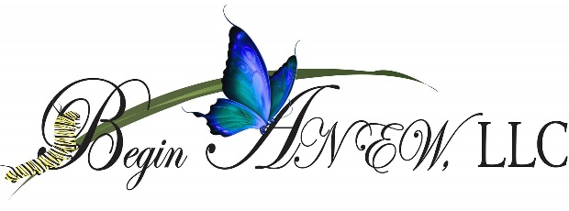
PREPARE/ENRICH
Intake Forms
The Prepare/Enrich Program is designed to help engaged and married couples develop a strong and growing relationship. Through the program, you will learn as a couple to share your feelings, ideas and work together to achieve your goals. The couple program will assist you in identifying relationship areas for you to enrich and build on your strength and teach you to communicate more effectively with your partner about a variety of important topics.

Date:_____________________

Marital status: We are (circle one) Dating Engaged Married
For Dating or Engaged couples, please check all that apply:
_____We live separately
_____We live together
_____We have children together
_____My partner have children from a previous relationship
_____We would like a certificate of completion 6hr. –Premarital Counseling Education which
allows a discount on Ga. State marriage license

Partner 1

First Name______________________________Last Name______________________________
Address_______________________________________________________________________
Hm Phone_____________________________Work/Cell Phone__________________________
Email Address_______________________________________
Religious Affiliation__________________________________

- List 2 goals you would like to see met.
________________________________
________________________________
- How do you feel about your relationship (describe with one word)
- Are you in love with your partner? Yes No
- Do you believe this relationship can improve? Yes No Maybe Uncertain
- Are you willing to work at this relationship?

Partner 2

First Name______________________________Last Name______________________________
Address_______________________________________________________________________
Hm Phone_____________________________Work/Cell Phone__________________________
Email Address_______________________________________
Religious Affiliation__________________________________

- List 2 goals you would like to see meet.
________________________________
________________________________
- How do you feel about your relationship (describe with one word)
- Are you in love with your partner? Yes No
- Do you believe this relationship can improve? Yes No Maybe Uncertain
- Are you willing to work at this relationship?

