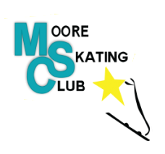
The Nominating Committee invites you to submit nominations for the Board of Directors. We will be accepting nominations for 6 vacant positions on the Board of Directors. Please be advised that there is a By-Law amendment proposed that would decrease the number of vacant positions to 1. Nominations will be accepted from now until midnight (12:00 am) on October 6, 2020. Voting will take place at the Annual General Meeting on October 21, 2020 which will be held virtually. Voting will be completed by Simply Voting, an online voting platform approved by Skate Ontario.
Who is eligible?
All active members of the Moore Skating Club who are in good standing are eligible to serve.

How to recommend nominees.
You may nominate yourself or another member using the following form or by providing a letter of intent. Please send completed form/letter of intent to Cherie Gaulton at cheriegaulton@gmail.com by midnight (12:00 am) on October 6, 2020.

The Nominations Process
The Nominations Committee will submit a single slate of candidates at the AGM. Nominations from the floor are not permitted.

Moore Skating Club Board of Directors Nomination Form
Date: ______________________________________
Name of Nominee: _____________________________________
Address: ______________________________________________________________________
Phone:______________________________ Email: _________________________________
Nominator Name: _____________________________________________

Thank you for your interest! We look forward to working with you to govern the Moore Skating Club.

Please send completed form to:
Cherie Gaulton, Club President and Chair of the Nominating Committee.
cheriegaulton@gmail.com

