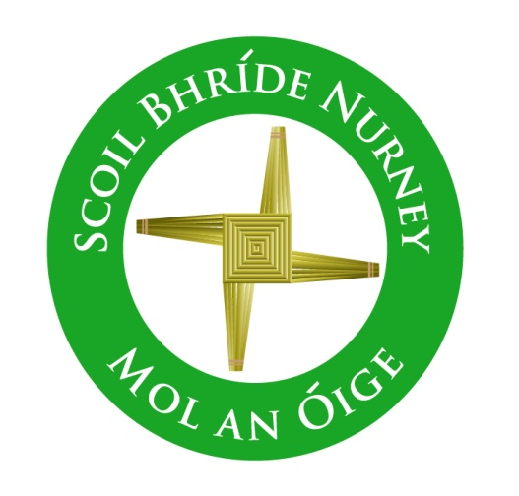
Protected Disclosure (Whistleblower) Policy
2016+

Board of Management Scoil Bhríde Nurney
2016+
Scoil Bhríde

Protected Disclosure (Whistleblower) Policy

The Protected Disclosures Act 2014
The above act came into effect on the 16th of July 2014.It heralds a new era in Ireland for whistle blowing. Schools are required to put in place whistle blowing policies which meet the requirements of the act. The Board of Management of Scoil Bhríde Nurney takes the issue of malpractice seriously and as a result has drafted this policy.

What is a Protected Disclosure?
“A protected disclosure means disclosure of relevant information which in the reasonable belief of the worker tends to show one or more relevant wrongdoings and which came to the attention of the worker in connection with his/her employment”

What are “Relevant Wrongdoings?”
Relevant Wrongdoings are defined exhaustively in the act and include the following:
- The commission of an offence
- Non-compliance with a legal obligation
- Threats to Health & Safety
- Misuse of Public Monies
- Concealment or destruction of information relating to any of the foregoing
Whom do you make the Disclosure to?
The vast majority of disclosures should be made to the school principal, Chairperson of the Board of Management (BOM), or the Board itself in the first place. Where this is inappropriate or impossible the Minister for Public Expenditure and Reform has published a list of “Prescribed Persons”. These are bodies that in his opinion are the appropriate ones to investigate. In relation to schools the prescribed person is the Secretary General of the Department of Education and Skills (DES). In making a disclosure a worker must reasonably believe the information disclosed to be substantially true.

What protections are available to whistle blowers?
Among the protections are;
- Protection from dismissal,
- Up to 5 years remuneration for unfair dismissal
- Protection of identity (subject to certain exceptions)
- Protection from penalisation by the school Board of Management

What is best practice?
If you as a member of staff have a genuine or reasonable concern that there is malpractice in the school you should report it to the principal. If this is not appropriate or possible you should then report it to the chairperson of the BOM, or failing that to the BOM itself. Workplace grievances should be reported in the normal manner and are not covered by this policy. It should be noted that while internal reporting is encouraged you have the option to raise concerns outside of line management and report to the prescribed person namely the Secretary General of the DES.

NOTE:
To date the Minister for Public Expenditure and Reform has not issued guidance or a timeline to the DES or indeed management bodies.

Ratification of Protected Disclosure (Whistleblower) Policy

This policy was adopted by the Board of Management on _________________

Signed: _________________________ Signed: __________________________
Chairperson of Board of Management Principal

Date: __________________________ Date: __________________________

Date of next review: __________________

