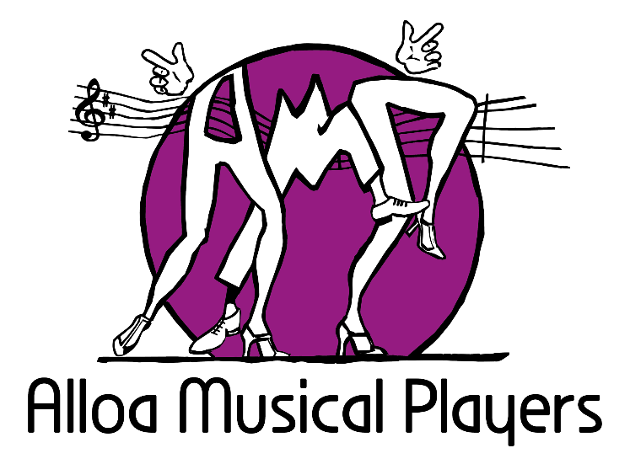
Annual Report
2020-21
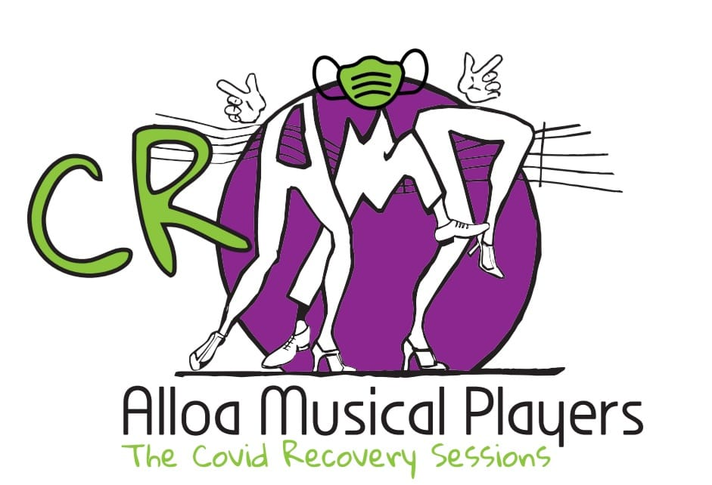

Trustees Annual Report

The Trustees have pleasure in presenting their Report together with the Financial Statements for the year ended 31st May 2021

Activities, achievements, and performance

2020
May

This is a year like no other. We were eternally grateful to have completed our production of “Chicago” in the final week of February 2020. Not only did we have a magnificently sold-out-every-night week, we had such amazing fun and ended our year with enough money in the bank to survive and just wait …. For this is the year of Covid19 – the pandemic that stopped almost every type of human interaction other than survival. People reading this Report years from now will find it hard to believe that we were locked down, confined to our homes, banned from travelling more than a few miles and forbidden to touch each other. Schools were closed. Theatre, song, dance, audiences – all banned. People died – thousands – especially the elderly or vulnerable.

The phenomenon called Zoom entered our lives with a vengeance and it (or other online platforms) proved to be the only way of “meeting” friends or doing our jobs.

On 31st May, AMP held its first Zoom event. Bingo!

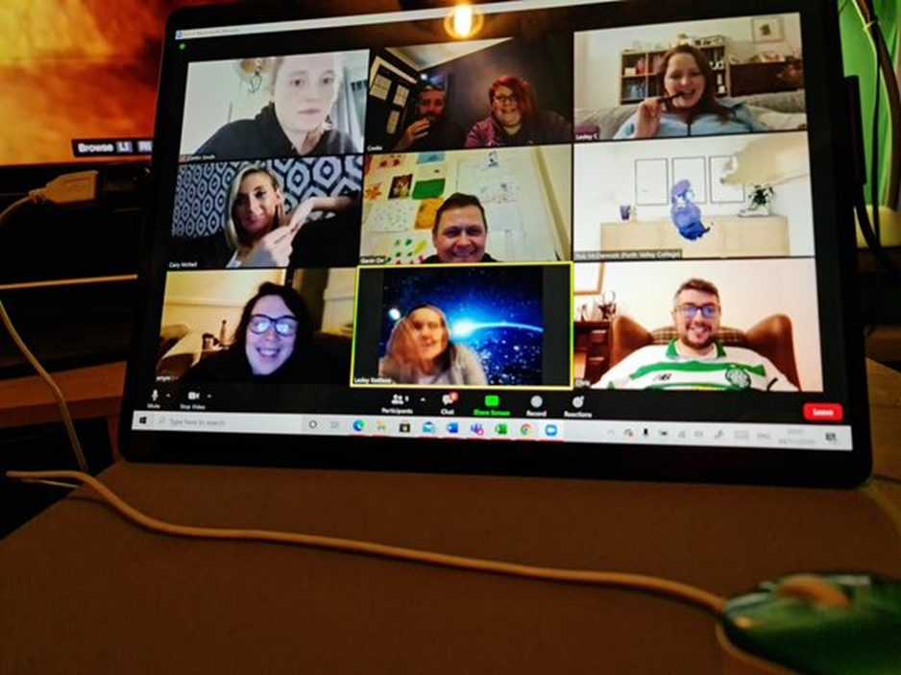

June

Our plans for holding our usual “Summer Energiser” sessions and for launching “Junior AMP” all had to be abandoned due to the restrictions in place during the pandemic.

Work continued on the company website, doggedly archiving programmes, photographs and other material. The pandemic certainly provided an opportunity to spend long hours on the computer.

July

Much the same as June – with Trustees meeting to plan an online AGM.

August

Our third AGM as a charity took place on Monday 3rd August by Zoom. There was no change to Trustees or office bearers. It was good to reflect on the massive success of “Chicago” but because it was unlikely that rehearsals could resume any time soon, we decided to delay our planned production of “Little Shop of Horrors” until 2022. This means that for the first time since 1952, a whole year would go by with no public performance from AMP. There had been postponements and other changes in the past, but never a year of complete inactivity. So we invented some fun to keep our spirits up …

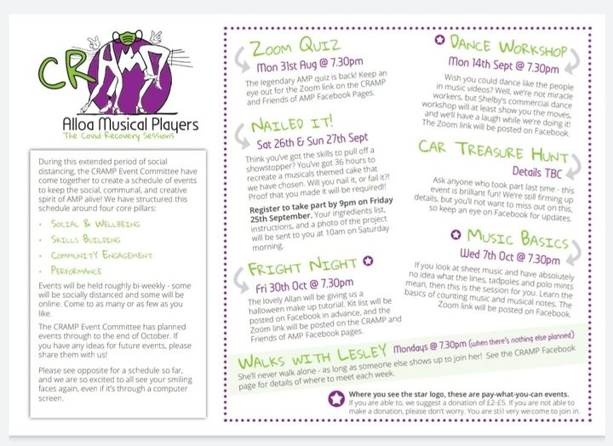

September

Realising the pandemic was here to stay, we began to organise some online activities. A Zoom dance workshop was held on 14th September – thank you Shelby Struthers! It was fun but nothing like a real-life event! Then on 26/27 September a cake decorating contest was dreamed up entitled “Nailed It” themed on “Little Shop”. There were some amazing entries and we all had fun in our own kitchens making a great mess with varying degrees of success.

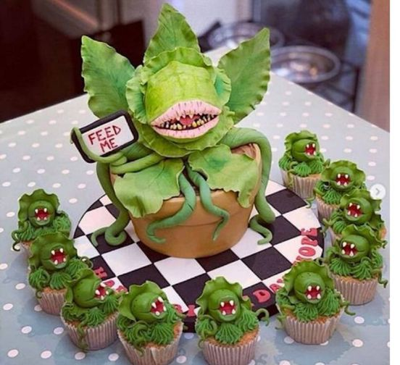

October

October 11th – restriction arrangements made it possible to hold a car treasure hunt – yes, an actual live one!
Looked like great fun for all who took part. Then on 20th October came the online “Fright Night” – Halloween fun!

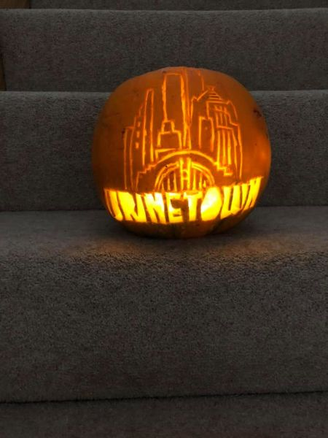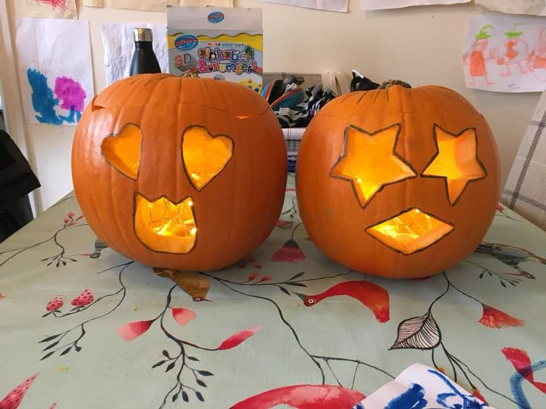

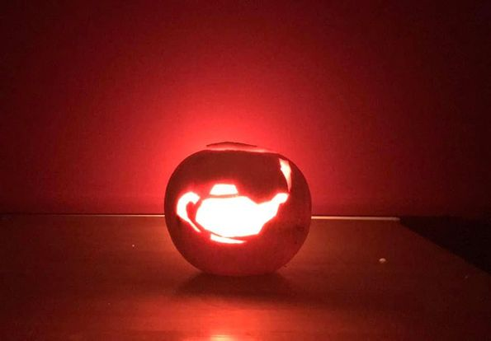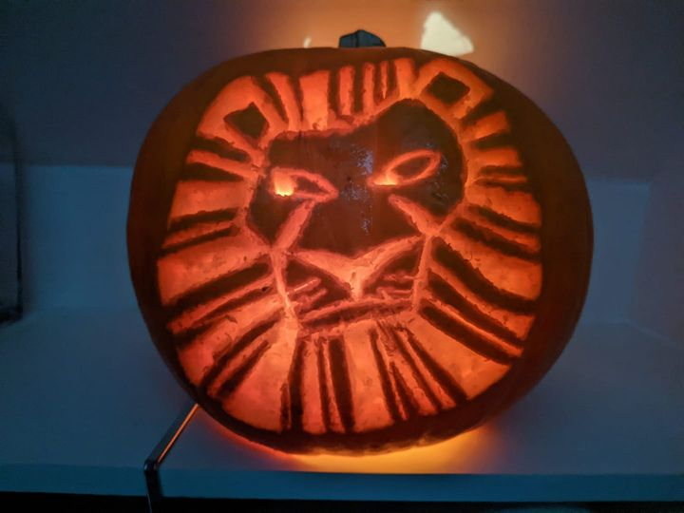

November

Walking with Lesley became a regular thing as we were all confined to an hour a day of exercise …..

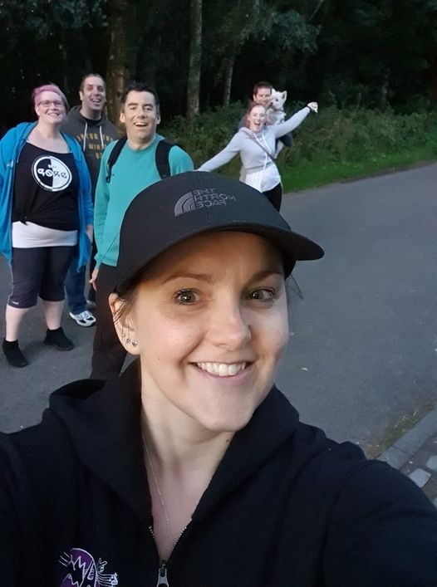

December

Monday 14th we held a brilliant online Christmas party with lots of folks attending and a whole elabourate Secret Santa set up – items being secretly delivered to our doorsteps by stealthy elves.

Gifts were plentiful and imaginative …

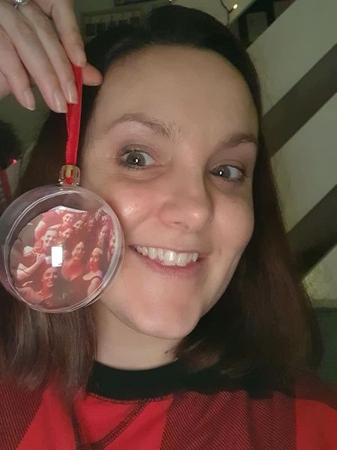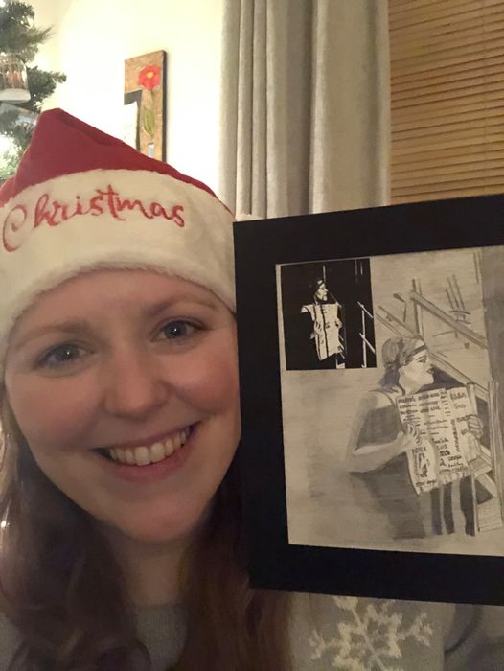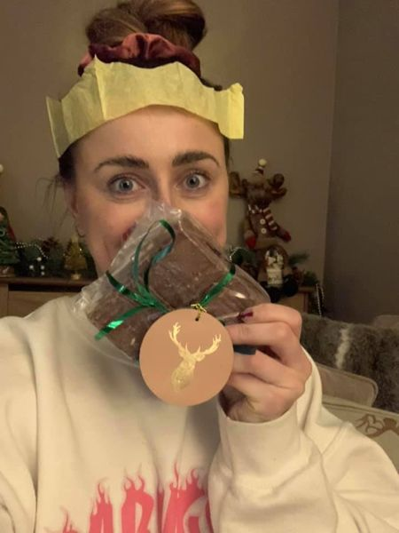

Memorable photos resulted and we all loved our new CR/AMP (go away Covid) mugs.

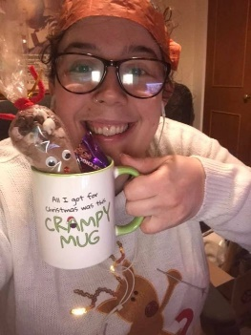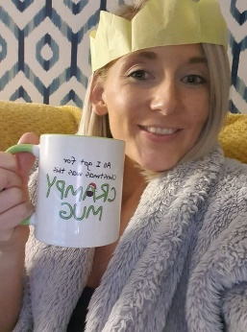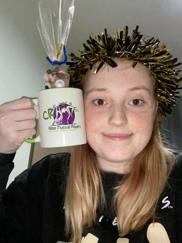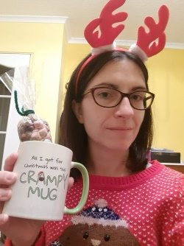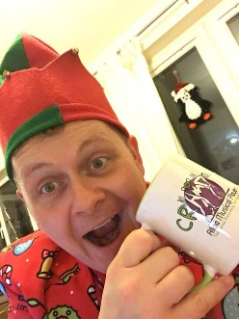

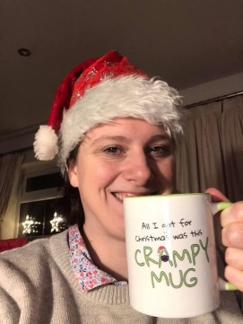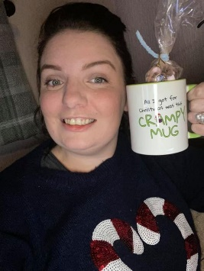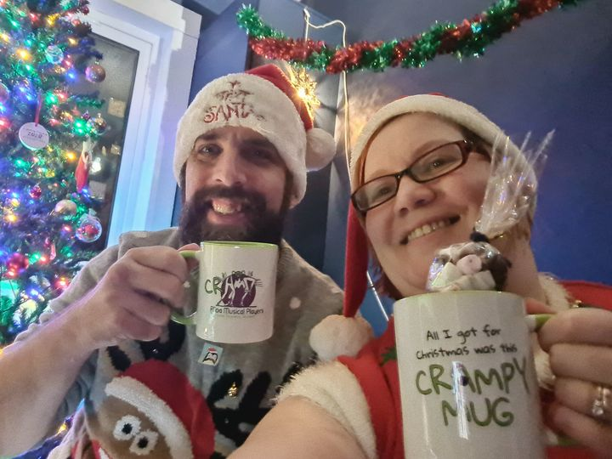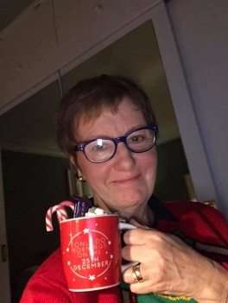

2020
January

Picture us all, in our back yards etc, huddled in our winter woollies around fire pits trying to see a couple of friends and family for Christmas and New Year.

February

Nothing

March

Nothing

April

Trustees continue to keep in touch, but the pandemic continues, wave after wave … maybe next year?

Grant Funders

Alloa Musical Players are grateful to the following funders from 2019/20 but no applications were undertaken this year:

- The Gordon Fraser Charitable Trust donated £500 for Summer Energiser workshops 2019

- The National Lottery (Awards for All) awarded £5,000 to help stage our 2020 production

- The Foyle Foundation for £2,000 of revenue assistance

Friends of Alloa Musical Players

The following members of our community have generously supported AMP as donors and we hope they will continue to do so when we return to the stage:

Gold Friends
Dick Clark
Alistair Spowage

Silver Friends
Nancy Irvine
Margaret Cowell
Mrs S Mason
Jack Storrie
John Cunningham

Bronze Friends
Marion Fitzpatrick
Avril Hughes
Bill Kettles
Lesley Kettle
Taylor Williams
John Adamson

Table Sponsors

A number of local businesses sponsored tables at Chicago, helping us to keep ticket prices down
and make our shows as affordable for our audience as possible. We are grateful to:

SMS Tyre & Exhaust Centre
Norland Joiners
Ladybird Tearoom
CTSI
MacFarlane Jewellers
Alloa Rugby Club
Dunmar House
The Royal Oak Hotel

Obituaries

We say goodbye and remember a much-loved Dance Director from the 1970s/80s who died this year:

Jessie Murray

Reference and Administrative Information

Charity Name
Alloa Musical Players (SCIO)

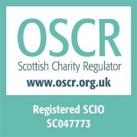
Registered Address

Glenochil Bungalow
Menstrie
Clackmannanshire
FK11 7EG

Trustees

Rob McDermott, President
Lindsey Spowage, Vice-president, Admin
Antony Carter
Leanne Cook, Treasurer
Lesley Kettles
Kirsty Gillies, Membership
Caitlin Smith
Alan Musgrave

Structure, Governance and Management
Constitution

The charity is a Scottish Charitable Incorporated Organisation (a SCIO). It was registered in its current legal form on 25th September 2017. The charity was previously an unincorporated association (since 1952) but changed its legal form to a SCIO. The assets of the unincorporated association were transferred to the SCIO on 1st October 2012. It has a two-tiered structure consisting of:
- the MEMBERS who have the right to attend members' meetings (including any annual general meeting) and have important powers under the constitution; in particular, the members appoint people to serve on the board and take decisions on changes to the constitution itself;
- the BOARD - who hold regular meetings, and generally control the activities of the organisation; for example, the board is responsible for monitoring and controlling the financial position of the organisation.
The people serving on the board are referred to in this constitution as CHARITY TRUSTEES.

Appointment of Trustees

The Management Committee, which meets as and when necessary, but at least four times per year, are the charity’s Trustees. All Members are eligible to be Trustees. Trustees, of which there must be at least 5 but no more than 8, step down at each AGM, but are eligible for re-election. The AGM is generally held in August. Trustees control the activities of the organisation; for example, the Board of Trustees is responsible for monitoring and controlling the financial position of the organisation, protecting it, ensuring legal and charitable compliance, and providing leadership and direction.

Members are those who sign up to agree to abide with the rules and values of the organisation.
Membership is no longer associated mostly with performance on stage but is for all who wish to join in any voluntary capacity to support AMP’s aim, vision, mission and charitable purpose. There is no charge, but Members are encouraged to become donors. There are as many volunteers supporting our activities off-stage as take part in performances on-stage.

Key Volunteer Roles

Stage Management/crew
Props and Set
Costumes
Prompt
Front of House
Tickets online
Tickets over the counter
Box Office
Hospitality
Programmes
Marketing Materials
Sponsorship
Grants
Community Fundraising
Social Media and Website
Theatre Bar
Scores and Librettos
Patrons and Friends

Alloa Musical Players has the following Honorary officials:

Honorary Presidents: Joyce Stalker, Margaret Cowell, Avril Hughes, Lynda Young and Kate Paterson

Objectives and Activities

AMP provides opportunities for local people to fulfil their potential, growing and learning through musical theatre, both as participants and as audience, and we share skills by working in partnership across our community. Our vision is of a friendly, inclusive community, both of place and of interest, where the performing arts and supporting crafts and technology support the wellbeing of our citizens.

Purposes
The organisation’s charitable purposes are the advancement of the arts, heritage, culture or science through the provision of recreational facilities, or the organisation of recreational activities with the object of improving the conditions of life for the persons for whom the facilities or activities are primarily intended.

And in furtherance of the above purposes, we carry out the following activities:

  - provide a range of opportunities for local people to enjoy participation in musical
  - theatre and to develop their knowledge and skills at all levels
  - develop audience awareness and appreciation of community-based musical theatre
  - play a useful role as a community partner to other local organisations

In normal times, from September to February, we rehearse twice a week on Mondays and Wednesdays – with additional Sunday afternoon rehearsals in January and February. We then present our musical in Alloa Town Hall in late February or early March. In summer we sometimes rehearse a less ambitious performance for autumn performance, or, as this year, we run theatre workshops. Also, in summer we review our situation and if necessary, recruit new sessional professionals as Artistic, Dance or Musical Directors. Fundraising of all kinds continues across the year as well as social activities, and involvement in other organisations’ initiatives.

Throughout the year we also work to research and select future material for performance, taking suggestions from our members, and seeking Performing Rights for short-listed shows. We try to think two years ahead and ring the changes in style and vintage of musicals.

Financial Review

Our main source of income as planned is our sale of tickets for performances we give. We also work to secure grant income where and when appropriate. We secure sponsorship of tables at our Town Hall show and we recruit supporters and donors as Friends of AMP. Members continue to be encouraged to donate to their organisation as far as they are able. Performing members are required to contribute to the cost of hired music and costumes, and this can be done in instalments across the year.

Our Accounts for 2019 – 20 are posted on the OSCR website at https://www.oscr.org.uk/about-charities/search-the-register/charity-details?number=47773

Reserves Policy

At the close of our Financial Year, we held £10,317 cash in the bank representing around 7 times more than this years annual turnover. The Trustees’ policy is to work to retain a minimum of one quarter of annual turnover to meet commitments and cover any unexpected expenditure. The organisation has no staff and no long-term rental agreements. AMP is insured against the costs of unforeseen cancellation of performances, and sessional staff contracts have tapering arrangements should they need to be ended early.

Plans for the Future

In the coming financial year, 2021/22 we are still uncertain about how much of our usual activity we will be able to continue due to the risks (human and financial) presented by the COVID-19 virus.

Declaration

The trustees declare that they have approved the trustees’ report above.

Signed on behalf of the charity’s trustees

Signature(s) | Lindsey Spowage
Full name(s) | Lindsey Spowage
Position (e.g. Chair) | Vice President
Date | 22nd August 2021

Receipts and Payments Account For Alloa Musical Players for the Year ending 31/5/2021

 | 2021  £ | 2021  £ | 2020  £ | 2020  £
Opening Bank Balance - 1/6/20 |  | 8,670.44 |  | 1,633.74
Opening cash balance |  | 2,331.41 |  | 1,588.78
Add Receipts
Performance Subscriptions/Donations | 1,382.00 |  | 3,887.03
Box Office Ticket Sales | - |  | 12,857.14
Friends/Patrons | - |  | 375.00
Sponsorships | - |  | 600.00
Front of House Income | - |  | 2,351.00
Bar receipts | - |  | 3,154.86
Aftershow Party Tickets | - |  | -
Sweets | - |  | 194.00
Grants | - |  | 7,000.00
Advertising Income | - |  | 140.00
Sale of Teas in Rehearsals | - |  | 315.01
Lucky Number | - |  | 86.50
Libs | - |  | 110.00
Clothing Merchandise | - |  | 905.76
Photos | 10.00 |  | 100.00
Community Fundraising | 35.89 |  | 1,727.75
Miscellaneous | - |  | -
 |  | 1,427.89 |  | 33,804.05
 |  | 12,429.74 |  | 37,026.57
Less Payments
Rehearsal Hall Hire | - |  | 1,204.00
Town Hall Hire | 100.00 |  | 1,683.00
Storage | 1,200.00 |  | 1,200.00
Renumeration (Production Team) | - |  | 3,450.00
Royalties | - |  | 2,280.00
Insurance | 375.68 |  | 375.68
Noda Membership | 163.00 |  | 117.00
Marketing | - |  | 1,028.99
Printing Programme | - |  | 505.00
Postage and Stationery | - |  | 41.80
Noda Fees for Service Awards | - |  | -
Bar Supplies | - |  | 887.42
Sweets | - |  | 149.50
Grants | - |  | 165.00
Music | - |  | 891.99
Ticket paper/printer ink | - |  | 27.99
Photography fee | - |  | 100.00
Costumes | - |  | 183.09
Staging | - |  | 298.93
Transport | - |  | -
Sound (& Lighting) | - |  | 5,573.80
Clothing Merchindise | - |  | 955.20
Miscellaneous | 273.79 |  | 16.00
Orchestra Fees | - |  | 3,360.00
Fundraising Costs | - |  | 1,530.33
Thank You Gifts | - | 2,112.47 | - | 26,024.72
Closing Balance |  | 10,317.27 |  | 11,001.85

Cash Balance | 2,331.41
Bank Balance - 31/5/21 | 7,985.86
 | 10,317.27

Notes to Accounts – for the year ended 31 May 2021

- Basis of accounting
These accounts have been prepared on the Receipts and Payments basis in accordance with the Charities & Trustee Investment (Scotland) Act 2005 and the Charities Accounts (Scotland) Regulations 2006 (as amended)

- Nature and purpose of funds
Unrestricted funds are those that may be used at the discretion of the trustees in furtherance of the object of the charity. The trustees maintain a single unrestricted fund for the day-to-day running of the club.

Restricted funds may only be used for specific purposes. Restrictions arise when specified by the donor or when funds are raised for specific purposes. The charity had a grant for energizer workshops to be held during the summer from The Gordon Fraser Trust and received grants from The National Lottery, Awards for All for support to run our 2020 production as well as a grant from the Foyle Foundation for support of revenue costs.

- Related party transactions
The Groups insurance policy includes Trustee Indemnity Insurance for all its trustees. No other renumerations was paid to the trustees.

Unrestricted Restricted Total
Funds Funds 2021

Director renumerations 0 0 0
Musical Director renumerations 0 0 0
Stage Manager renumerations 0 0 0
Rehearsal Accompanist renumerations 0 0 0

0 0 0

- Grants received

Unrestricted Restricted Total
Funds Funds 2021

None

- Miscellaneous accounts
The miscellaneous payments include raffle books purchased.

- Reserves
As can been seen our end of year figure we have reserves available after a year with very little expenses and is within our agreed reserves policy.

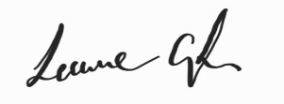
Leanne Cook
AMP Treasurer
Contact information

Website: www.alloamusicalplayers.org Email info@alloamusicalplayers.org

Our website holds a great deal of information about our Company including current news, a gallery of photographs, our historical timeline since 1952 and a secure Trustee area holding key documents.

Find us on Facebook Telephone: 07765 638687 (please leave a message)

Bank Details
Alloa Musical Players
Bank of Scotland
Account No. 00335686
Sort Code 80-05-28

