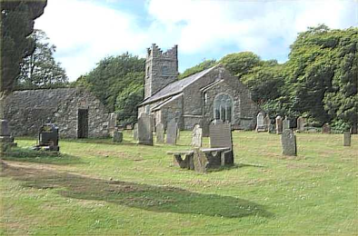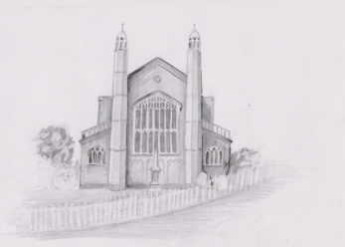

Church of Ireland

Diocese of Armagh

Rural Deanery of Creggan and Louth

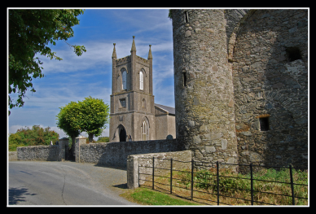

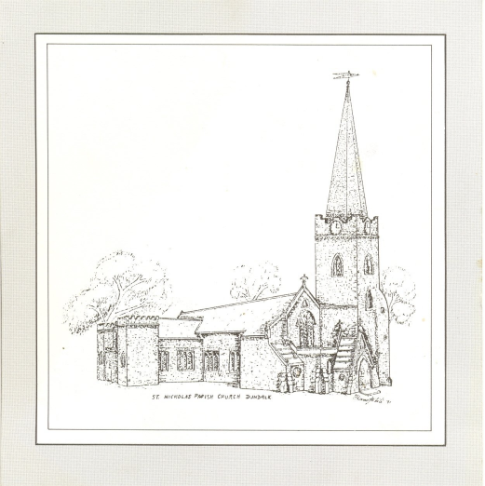

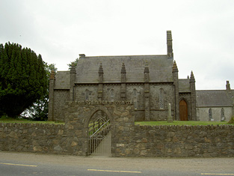



**20210117 HC**

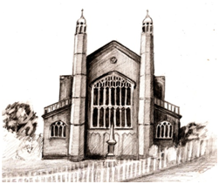

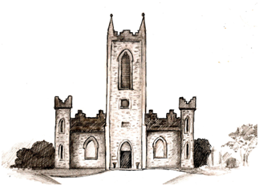

For where two or three are gathered together in my name, there am I in the midst of them.

clip_image001Dunleer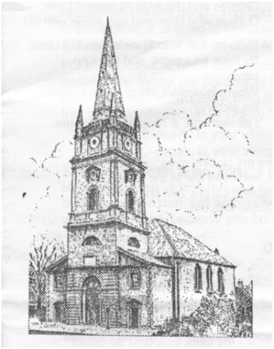

*Opening Hymn 624* Speak Lord, in the stillness

**THE GREETING** *page 201*

Grace, mercy and peace from God our Father and the Lord Jesus Christ be with you all.

**and also with you.**

**SENTENCE OF SCRIPTURE**

*Rita Arthur* From the rising of the sun to its setting my name is great among the nations, and in every place incense is offered to my name, and a pure offering; for my name is great among the nations, says the Lord.

**WELCOME**

HYMN 584 Jesus calls us

**THE COLLECT FOR PURITY**

[Let us pray]

**Almighty God, to whom all hearts are open, all desires known, and from whom no secrets are hidden; Cleanse the thoughts of our hearts by the inspiration of your Holy Spirit, that we may perfectly love you, and worthily magnify your holy name; through Christ our Lord. Amen.**

**PRAYERS OF PENITENCE**

*David Murphy* Hear what our Lord Jesus Christ says:  
You shall love the Lord your God with all your heart and with all your soul and with all your mind. This is the first and great commandment. And the second is like it. You shall love your neighbour as yourself. On these two commandments depend all the law and the prophets. *Matthew 22: 37-39*

*J and R* **Lord, have mercy on us, and write these your laws in our hearts.**

**CONFESSION**

*Victor Whyte* God so loved the world that he gave his only Son Jesus Christ, to save us from our sins, to intercede for us in heaven, and to bring us to eternal life. Let us then confess our sins in penitence and faith, firmly resolved to keep God’s commandments and to live in love and peace:

*J and R***Almighty God, our heavenly Father, we have sinned in thought and word and deed, and in what we have left undone. We are truly sorry and we humbly repent. For the sake of your Son, Jesus Christ, have mercy on us and forgive us, that we may walk in newness of life to the glory of your name. Amen.**

Almighty God, who forgives all who truly repent, have mercy on you, pardon and deliver you from all your sins, confirm and strengthen you in all goodness, and keep you in eternal life;  
through Jesus Christ our Lord. **Amen.**

**GLORIA IN EXCELSIS**

Glory to God in the highest, and peace to God’s people on earth. Lord God, heavenly king, almighty God and Father, we worship you, we give you thanks, we praise you for your glory.

Lord Jesus Christ, only Son of the Father, Lord God, Lamb of God, you take away the sin of the world: have mercy on us; you are seated at the right hand of the Father: receive our prayer.

For you alone are the Holy One: you alone are the Lord: you alone are the Most High, Jesus Christ, with the Holy Spirit, in the Glory of God the Father. Amen.

**THE COLLECT OF THE WORD**

*Rita Arthur* Eternal God, whose Son, Jesus Christ, is now exalted as Lord of all, and pours out his gifts upon the Church: grant it that unity which only your Spirit can give, keep us in the bond of peace, and bring all creation to worship before your throne; through Jesus Christ our redeemer, who lives and reigns with you in the unity of the Holy Spirit, one God, for ever and ever.

**THE COLLECT of the SECOND SUNDAY AFTER THE EPIPHANY**

*David Murphy* Almighty God, in Christ you make all things new: Transform the poverty of our nature by the riches of your grace, and in the renewal of our lives make known your heavenly glory; through Jesus Christ our Lord.

## THE FIRST READING 1 Samuel 3: 1-10, 11-20

*The reader says*

The first reading is from the First Book of Samuel, in the third chapter beginning at the first verse.

Now the boy Samuel was ministering to the Lord under Eli. The word of the Lord was rare in those days; visions were not widespread.

2 At that time Eli, whose eyesight had begun to grow dim so that he could not see, was lying down in his room; 3the lamp of God had not yet gone out, and Samuel was lying down in the temple of the Lord, where the ark of God was. 4Then the Lord called, ‘Samuel! Samuel!’[\*](javascript:void(0);) and he said, ‘Here I am!’ 5and ran to Eli, and said, ‘Here I am, for you called me.’ But he said, ‘I did not call; lie down again.’ So he went and lay down. 6The Lord called again, ‘Samuel!’ Samuel got up and went to Eli, and said, ‘Here I am, for you called me.’ But he said, ‘I did not call, my son; lie down again.’ 7Now Samuel did not yet know the Lord, and the word of the Lord had not yet been revealed to him. 8The Lord called Samuel again, a third time. And he got up and went to Eli, and said, ‘Here I am, for you called me.’ Then Eli perceived that the Lord was calling the boy. 9Therefore Eli said to Samuel, ‘Go, lie down; and if he calls you, you shall say, “Speak, Lord, for your servant is listening.” ’ So Samuel went and lay down in his place.

*Mike Buchanan (Dunleer)*10 Now the Lord came and stood there, calling as before, ‘Samuel! Samuel!’ And Samuel said, ‘Speak, for your servant is listening.’ 11Then the Lord said to Samuel, ‘See, I am about to do something in Israel that will make both ears of anyone who hears of it tingle. 12On that day I will fulfil against Eli all that I have spoken concerning his house, from beginning to end. 13For I have told him that I am about to punish his house for ever, for the iniquity that he knew, because his sons were blaspheming God,[\*](javascript:void(0);) and he did not restrain them. 14Therefore I swear to the house of Eli that the iniquity of Eli’s house shall not be expiated by sacrifice or offering for ever.’

15 Samuel lay there until morning; then he opened the doors of the house of the Lord. Samuel was afraid to tell the vision to Eli. 16But Eli called Samuel and said, ‘Samuel, my son.’ He said, ‘Here I am.’ 17Eli said, ‘What was it that he told you? Do not hide it from me. May God do so to you and more also, if you hide anything from me of all that he told you.’ 18So Samuel told him everything and hid nothing from him. Then he said, ‘It is the Lord; let him do what seems good to him.’

19 As Samuel grew up, the Lord was with him and let none of his words fall to the ground. 20And all Israel from Dan to Beer-sheba knew that Samuel was a trustworthy prophet of the Lord.

This is the Word of the Lord.

**Thanks be to God.**

*Reflection on listening to voice of God:* HYMN 608 Be still and know

## PSALM 139 *page 754 Lord Bellew*

1  O Lord, you have searched me out and known me; ♦︎  
   you know my sitting down and my rising up;  
      you discern my thoughts from afar.  
2  You mark out my journeys and my resting place ♦︎  
   and are acquainted with all my ways.  
3  For there is not a word on my tongue, ♦︎  
   but you, O Lord, know it altogether.  
4  You encompass me behind and before ♦︎  
   and lay your hand upon me.  
5  Such knowledge is too wonderful for me, ♦︎  
   so high that I cannot attain it.  
12  For you yourself created my inmost parts; ♦︎  
   you knit me together in my mother’s womb.  
13  I thank you, for I am fearfully and wonderfully made; ♦︎  
   marvellous are your works, my soul knows well.  
14  My frame was not hidden from you, ♦︎  
   when I was made in secret  
      and woven in the depths of the earth.  
15  Your eyes beheld my form, as yet unfinished; ♦︎  
   already in your book were all my members written,  
16  As day by day they were fashioned ♦︎  
   when as yet there was none of them.  
17  How deep are your counsels to me, O God! ♦︎  
   How great is the sum of them!  
18  If I count them, they are more in number than the sand, ♦︎  
   and at the end, I am still in your presence.

## THE EPISTLE READING Revelation 5: 1-10

*The reader says:*

The Epistle is from the Book Revelation, in the fifth chapter, beginning at the first verse.

5Then I saw in the right hand of the one seated on the throne a scroll written on the inside and on the back, sealed[\*](javascript:void(0);) with seven seals; 2and I saw a mighty angel proclaiming with a loud voice, ‘Who is worthy to open the scroll and break its seals?’ 3And no one in heaven or on earth or under the earth was able to open the scroll or to look into it.

4And I began to weep bitterly because no one was found worthy to open the scroll or to look into it. 5Then one of the elders said to me, ‘Do not weep. See, the Lion of the tribe of Judah, the Root of David, has conquered, so that he can open the scroll and its seven seals.’

6 Then I saw between the throne and the four living creatures and among the elders a Lamb standing as if it had been slaughtered, having seven horns and seven eyes, which are the seven spirits of God sent out into all the earth. 7He went and took the scroll from the right hand of the one who was seated on the throne. 8When he had taken the scroll, the four living creatures and the twenty-four elders fell before the Lamb, each holding a harp and golden bowls full of incense, which are the prayers of the saints.

*Alex Aransiola*

9They sing a new song: ‘You are worthy to take the scroll and to open its seals, for you were slaughtered and by your blood you ransomed for God    saints from[\*](javascript:void(0);) every tribe and language and people and nation; 10 you have made them to be a kingdom and priests serving[\*](javascript:void(0);) our God,    and they will reign on earth.’

This is the Word of the Lord.

**Thanks be to God**

**GRADUAL HYMN** 250 All hail the power of Jesu’s name

## THE GOSPEL READING John 1: 43-51

Hear the Gospel of our Saviour Christ, according to St John, in the first chapter, beginning at verse 43

*Sung***Glory to you, Lord Jesus Christ.**

43 The next day Jesus decided to go to Galilee. He found Philip and said to him, ‘Follow me.’ 44Now Philip was from Bethsaida, the city of Andrew and Peter. 45Philip found Nathanael and said to him, ‘We have found him about whom Moses in the law and also the prophets wrote, Jesus son of Joseph from Nazareth.’ 46Nathanael said to him, ‘Can anything good come out of Nazareth?’ Philip said to him, ‘Come and see.’ 47When Jesus saw Nathanael coming towards him, he said of him, ‘Here is truly an Israelite in whom there is no deceit!’ 48Nathanael asked him, ‘Where did you come to know me?’ Jesus answered, ‘I saw you under the fig tree before Philip called you.’ 49Nathanael replied, ‘Rabbi, you are the Son of God! You are the King of Israel!’ 50Jesus answered, ‘Do you believe because I told you that I saw you under the fig tree? You will see greater things than these.’ 51And he said to him, ‘Very truly, I tell you,[\*](javascript:void(0);) you will see heaven opened and the angels of God ascending and descending upon the Son of Man.’

This is the Gospel of the Lord.

*Sung* **Praise to you, Lord Jesus Christ.**

**SERMON** *The Rev’d Iain Jamieson*

**THE NICENE CREED** *Stand*

**We believe in one God, the Father, the Almighty, maker of heaven and earth, of all that is, seen and unseen.**

**We believe in one Lord, Jesus Christ, the only Son of God, eternally begotten of the Father, God from God, Light from Light, true God from true God, begotten, not made, of one Being with the Father. Through him all things were made. For us and for our salvation he came down from heaven, was incarnate by the Holy Spirit of the Virgin Mary, and was made man. For our sake he was crucified under Pontius Pilate; he suffered death and was buried. On the third day he rose again in accordance with the Scriptures; he ascended into heaven and is seated at the right hand of the Father. He will come again in glory to judge the living and the dead, and his kingdom will have no end.**

**We believe in the Holy Spirit, the Lord, the giver of life, who proceeds from the Father and the Son, who with the Father and the Son is worshipped and glorified, who has spoken through the prophets. We believe in one holy catholic and apostolic Church. We acknowledge one baptism for the forgiveness of sins. We look for the resurrection of the dead, and the life of the world to come. Amen.**

**PRAYERS OF INTERCESSION**

Let us pray for obedience to the call of God in all things.

As the first disciples came to faith in Christ, so may the Church be faithful in following him. May she be made worthy to know and to reveal the mystery of salvation.

Lord, in your mercy

**Hear our prayer**

*David Adair (Heynestown)* Where there is hostility between nations and races, where a name can arouse suspicion or hatred, bring the peace of Christ. Teach all people to trust one another and to find friendship for each in seeking the good of all. Today, three days before the inauguration of President Biden, we pray that his presidency will bring peace to a divided nation.

Lord, in your mercy

**Hear our prayer**

*Jane Angel (Ardee)* Help each of us to live so that our lives may guide in the right way all who know us. May our homes be blessed with the knowledge of the presence of the Lord.

Lord, in your mercy

**Hear our prayer**

Have mercy on all who suffer in mind or body or spirit, remembering all afflicted by Covid-19. We give thanks for all who work selflessly to bring healing to those in need. Let the light of your presence shine into the dark places of each life so that we may live as those who believe in your mighty power to bring good out of evil.

Lord, in your mercy

**Hear our prayer**

*Margaret Dagg (Drogheda)* We give thanks for the memory and example of those who have died in faith and we pray that we may share with them the joys of your eternal kingdom.

**Merciful Father, accept these our prayers for the sake of your Son, our Saviour Jesus Christ. Amen.**

**PRAYER OF HUMBLE ACCESS**

**We do not presume to come to this your table, merciful Lord, trusting in our own righteousness but in your manifold and great mercies. We are not worthy so much as to gather up the crumbs under your table. But you are the same Lord, whose nature is always to have mercy. Grant us, therefore, gracious Lord, so to eat the flesh of your dear Son Jesus Christ, and to drink his blood, that our sinful bodies may be made clean by his body, and our souls washed through his most precious blood, and that we may evermore dwell in him and he in us. Amen.**

**THE PEACE**

Our Saviour Christ is the Prince of Peace.  
Of the increase of his government and of peace there shall be no end. Isaiah 9: 6,7

The peace of the Lord be always with you

**and also with you.**

**AT THE PREPARATION OF THE TABLE**

Be present, be present, Lord Jesus Christ our risen high priest; make yourself known in the breaking of bread. **Amen.**

**THE TAKING OF THE BREAD AND WINE**

*Stand. The Presiding Minister takes the bread and wine and may say*

Christ our passover has been sacrificed for us

**therefore let us celebrate the feast.**

**THE GREAT THANKSGIVING**

**EUCHARISTIC PRAYER 1**

The Lord is here.

**His Spirit is with us.**

Lift up your hearts.

**We lift them to the Lord.**

Let us give thanks to the Lord our God.

**It is right to give our thanks and praise.**

Father, almighty and everliving God, at all times and in all places it is right to give you thanks and praise:

*Proper Preface*

For Jesus Christ our Lord who in human likeness revealed your glory, to bring us out of darkness into the splendour of his light:

And so with all your people, with angels and archangels, and with all the company of heaven, we proclaim your great and glorious name, for ever praising you and singing:

**Holy, holy, holy Lord, God of power and might, heaven and earth are full of your glory. Hosanna in the highest. Blessed is he who comes in the name of the Lord. Hosanna in the highest.**

Blessed are you, Father, the creator and sustainer of all things; you made us in your own image, male and female you created us; even when we turned away from you, you never ceased to care for us, but in your love and mercy you freed us from the slavery of sin, giving your only begotten Son to become man and suffer death on the cross to redeem us: he made there the one complete and all-sufficient sacrifice for the sins of the whole world: he instituted, and in his holy Gospel commanded us to continue, a perpetual memory of his precious death until he comes again.

On the night that he was betrayed \* he took bread; and when he had given thanks to you, he broke it, and gave it to his disciples, saying, \* Take, eat, this is my body which is given for you. Do this in remembrance of me.

In the same way, after supper \* he took the cup; and when he had given thanks to you, he gave it to them, saying, Drink this, all of you, \* for this is my blood of the new covenant which is shed for you and for many for the forgiveness of sins. Do this, as often as you drink it, in remembrance of me. Therefore, Father, with this bread and this cup we do as Christ your Son commanded:

**we remember his passion and death, we celebrate his resurrection and ascension, and we look for the coming of his kingdom.**

Accept through him, our great high priest, this our sacrifice of praise and thanksgiving; and as we eat and drink these holy gifts, grant by the power of the life-giving Spirit that we may be made one in your holy Church and partakers of the body and blood of your Son, that he may dwell in us and we in him: Through the same Jesus Christ our Lord, by whom, and with whom, and in whom, in the unity of the Holy Spirit,

**all honour and glory are yours, Almighty Father, for ever and ever. Amen.**

**THE LORD'S PRAYER**

As our Saviour Christ has taught us, so we pray

Our Father, who art in heaven, hallowed be thy name; thy kingdom come; thy will be done; on earth as it is in heaven. Give us this day our daily bread. And forgive us our trespasses, as we forgive those who trespass against us. And lead us not into temptation; but deliver us from evil. For thine is the kingdom, the power and the glory, for ever and ever. Amen.

**THE BREAKING OF THE BREAD**

 The bread which we break is a sharing in the body of Christ.

**We being many are one body, for we all share in the one bread.**

**AGNUS DEI**

**Jesus, Lamb of God, have mercy on us.**

**Jesus, bearer of our sins, have mercy on us.**

**Jesus, Redeemer of the world, grant us peace.**

**THE COMMUNION**

Draw near with faith. Receive the body of our Lord Jesus Christ which he gave for you, and his blood which he shed for you. Remember that he died for you, and feed on him in your hearts by faith with thanksgiving.

HYMN *during communion* 666 Be still my soul

The body of Christ keep you in eternal life. **Amen**

The blood of Christ keep you in eternal life. **Amen**

**THE GREAT SILENCE**

**PRAYERS AFTER COMMUNION**

*Victor Whyte* God of glory, you nourish us with bread from heaven. Fill us with your Holy Spirit that through us the light of your glory may shine in all the world. We ask this in the name of Jesus Christ our Lord. **Amen.**

**Almighty God, we thank you for feeding us with the spiritual food of the body and blood of your Son Jesus Christ. Through him we offer you our souls and bodies to be a living sacrifice. Send us out in the power of your Spirit to live and work to your praise and glory. Amen.**

**THE BLESSING**

Christ the Son be manifest to you, that your lives may be a light to the world: and the blessing of God almighty, the Father, the Son and the Holy Spirit, be upon you and remain with you always. **Amen**.

**HYMN** 576 I heard the voice of Jesus say

**DISMISSAL**

Go in peace to love and serve the Lord

**in the name of Christ. Amen.**

CONCLUDING VOLUNTARY Round the Lord *Flugelhorn*