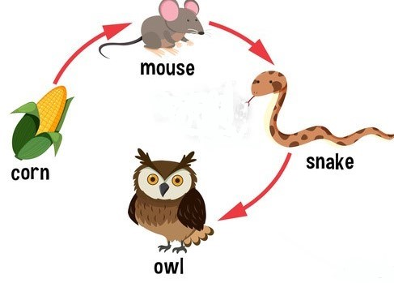

4A/4B Homework week #1
Ecology

- What is a producer? Give 3 examples: _______________________________________________
______________________________________________________________________________

- What is a consumer? Give 3 examples: _______________________,__________________________, ____________________________
- What is an herbivore? Carnivore? Omnivore? Give one example of each. ______________________________________________________________________________
______________________________________________________________________________

- What is a decomposer? Give 3 examples: ________________________, __________________________________________, ___________________________________

- Decomposers put ____________________________ in the soil, which makes the Producers healthier, which in turn makes the _____________________________who eat the producers healthier, which creates healthier decomposers, so more ____________________can be put into the soil.

- One pathway of energy flow through an ecosystem is a ______________________________ _____________________________________________

- Where do producers get their energy? __________________________
- Is a bunny a primary, secondary, or tertiary consumer? ____________________________

- Is a lion a primary, secondary, or tertiary consumer? ____________________________
- A secondary consumer eats producers and/or consumers. Is it (A)an herbivore & a carnivore or
- (B)a carnivore and omnivore? ____________________________________________________
- A diagram that shows the complex feeding interactions of all animals in an ecosystem is called what? ________________________________________________________________
- If a producer in an ecosystem decreases in number, what happens to the consumers? _______
_____________________________________________________________________________
- If a producer in an ecosystem increases in number, what happens to the consumers? _____________________________________________________________________________
- What happens to a producer in an ecosystem if the primary and secondary consumers decrease? ________________________________________________________________

