Skin Cancer
▪ Skin Cancer is the fastest growing cancer in North America
▪ Due to the decrease in the protective ozone layer over North American, the UVB radiation is
increasing 5% per decade. Sun damaged cells can initiate precancerous changes in the cells.

There are several types of skin cancer, but three are most common
- Basal cell carcinoma – highly curable if treated early
- Squamous cell carcinoma – highly curable if treated early
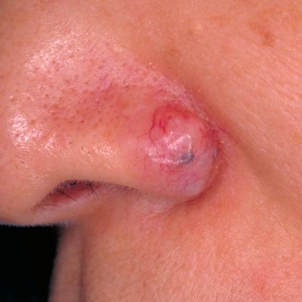
- Malignant melanoma – which is far more serious because it often travels in the blood and lymph system

Statistics show that …
- 1 in 7 people have skin cancer in their lifetime
- 1 in 100 get melanoma

Suggested Tips:
▪ always use Shaklee Sunscreen when exposed to the sun
▪ Eat a diet rich in fruits and vegetables
▪ Always have any suspicious spot or mole checked, and if cancer, have it removed (if ignored, a
basal cell carcinoma or squamous cell carcinoma can become a malignant melanoma!)
▪ Wipe suspicious spot with Enfuselle toner, then apply C+ E (2 or 3 times per day)

Suggested Supplements:
▪ NutriFeron
▪ CoQHeart
▪ Vita Lea
▪ Antioxidants: Vivix, Vitamin C, CarotoMax, Vitamin E (+ Selenium + Grapeseed Extract), FlavoMax in U.S.
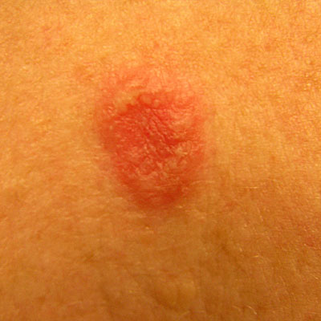
▪ Optiflora
▪ Soy Protein
▪ Garlic
▪ B Complex
▪ Alfalfa
▪ Essential Fatty Acids (OmegaGuard, Flaxseed Oil in Canada, GLA)

Suggested Detoxification
- Liver DTX & Herb Lax
- Optimize water & fibre intake
