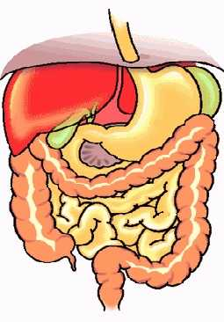

Natural Help for Colitis & Crohn’s
Shaklee Optiflora System
(2-part system)

- Optiflora Pearl (500 million microflora) …
  - 250 million acidophilus
  - 250 million bifidus

- Optiflora Powder (food to feed the microflora … causes it to multiple every 10 minutes … in one hour can create 8 billion

Essential Fatty Acids:

- Shaklee GLA (Omega 6 Fatty Acids)
  - Very anti-inflammatory
  - Essential for healing

Shaklee Vivix

- Very anti-inflammatory
- Reduces stress in the bowel
- Initiates repair
Aloe Vera (Juice or Gel)

- Short-term use only
  - Initially use 10 days
  - Then as needed, use no more than one week per month.

Shaklee NutriFeron

- Immune system modulator … helps down-regulate the over-reaction of the intestinal tract

- Reduces allergic reactions … especially environmental enhalents

Shaklee Bifidus
(only available in Canada)
- Extra microflora support for the large intestine

Shaklee B Complex

- To nourish the central nervous system (when an individual is experiencing stress, we use up large amounts of the B vitamins)

- Calms the hypersensitive reaction in the bowel

- STRESS RELIEF COMPLEX from Shaklee is also very calming to the hypersensitive bowel
Always get your food allergies checked … remove ALL offending foods.
For more information: contact Martha Willmore 905-871-4281

