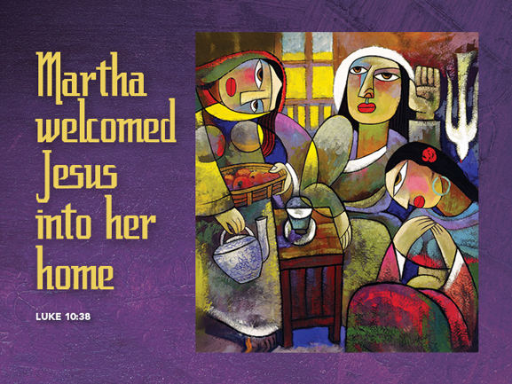

**Is God’s Word Useful?**

**July 17, 2016**

**Luke 10:38-42**

Grace and peace to you from God our Father and from the one at whose feet we sit to hear the Word of God, Jesus Christ our Lord, amen.

It’s widely known that for decades now most all Churches are in decline. The first question we ask is why? Where have all our people gone? That’s a hard question to answer and there’s more than one single cause, but I think I have one idea that may help us to understand where all our people have gone and why they are staying away from our Churches.

I’m a pretty pragmatic person. I try to rid my life of things that no longer have a purpose or have lost their usefulness. For example, before Tablets and iPads they came out with these things called Netbooks. These were very small laptops and I had to have one at about $400. They were very slow and for me, at least useless. My netbook ended up in the garage for a couple of years and then into a box and to the drop off for the Goodwill store. Netbooks were at best a temporary bridge between laptop computers and tablets and once tablets came onto the scene they rendered the netbooks obsolete.

Most people in our fast paced society today simply don’t have time for things in their lives that they don’t find useful and, unfortunately, for way too many folks, faith, Church, religion, and even God have become useless.

One of the great reasons the church is declining during our day is that many people have a hard time connecting what we do at church with what we do the rest of the week. Our faith practices on Sunday are nice, even comfortable, and they give us a sense of constancy in a world of change, but do our Sunday morning rituals inform our daily decisions at work, home, or school. If the answer to that question is no, then our faith isn’t particularly useful. In a 24/7 world of multiple opportunities and obligations we tend to cling to those things that help us navigate, make sense of, and get more from our lives. We tend to keep the things that are -- you guessed it -- useful to us.

Well, if there’s ever a story that was begging to be put to good use, it’s this one from today’s Gospel. Jesus was traveling and came to a certain town and was invited into the home of a woman named Martha. Martha’s sister Mary sat at Jesus’ feet and listened to him teach while Martha performed all the duties proper hospitality called for. The more Martha worked the more indignant she became until she couldn’t hold it in any longer and she spit out, “Jesus, can’t you do something! I’ve been slaving away over here while Mary just sits at your feet listening to your words. Make her give me a hand!” Jesus replies to her. “Martha, Martha, you are too busy and distracted by many things. Mary has decided what was most important and that will not be taken away from her.”

When I hear this story I’m reminded that even though we’re all over-burdened, we can still take one moment to discover what is the one most important thing and do that one thing. It’s okay to let the rest go for another time. Those things might work their way up to being most important later on, but for now, just concentrate on the one good and important thing.

What I appreciate about this story of Mary and Martha is that even non-religious people, or those who say they’re “spiritual, but not religious,” can find something of great value, something helps them understand and perhaps even improve their lives. This is a story of two sisters, but also a story we can all take away and put to use in our lives from Monday through Saturday. That’s what scripture is all about. It’s meant to give value and meaning to our lives. If the only time we think about biblical stories is on Sunday morning and they don’t help us lead more fruitful lives the rest of the week, then sooner or later we’re going to wonder why we’re spending time with these stories at all. Which is exactly what a lot of folks, I suspect, have already done.

My job is to prepare you for ministry in your daily lives. To do that I have to preach a more useful Bible. So here’s my take on what’s important and useful from this all too familiar story. Martha is busy. She is doing exactly what is expected of her by preparing the meal making sure the guests are comfortable, washing feet, cooking and serving food, pouring wine, and whatever else was needed. Martha’s doing exactly what was expected – working hard to extend hospitality to her guests.

Why, then, does Jesus address Martha with such harsh words? It’s because in her dutiful labors to be responsible and hospitable, Martha has lost something essential. She’s lost herself. She’s forgotten that ultimately her value and worth don’t come because of what she does, but because of who she is. Amid her concern to care for Jesus she forgot to listen to him, the One who might remind her who she is--a beloved child of God.

Jesus’ words may still seem needlessly harsh. So let’s be clear. Jesus is not rebuking Martha for doing good works and showing hospitality. There is nothing wrong with doing good works when they flow from a healed and thankful heart. When they are done out of a sense of duty or out of duty or obligation they inevitably lead to hardness of heart and feeling empty. Amid all of our doing we, also, can get distracted, lured into thinking that we ultimately will only find our true value and purpose in and through what we do, rather than in who we are, God’s beloved children.

Aren’t our lives pretty much like Martha’s? I mean, I began by describing our lives as “a 24/7 world of multiple obligations and opportunities.” Our culture, has lost any real sense of Sabbath -- the need for regular rest and renewal. Moreover, we are regularly told that our worth stems not from our status as God’s children or even as human beings, but from what we have, from what we own, from what we do. What’s the first question you ask when meeting someone new? “Hi, what do you do for a living?” In this kind of world, we need more than ever the opportunity to hear the most needed thing, to hear from Jesus that you are loved, even treasured, for who you are, regardless of what you do.

This is exactly what church is supposed to be. A time to stop amid all of our important doing and hear the one needful thing: that we are God’s children, beloved for all time, and that there is nothing we can do that would earn that love and nothing we can do to lose that love.

But be careful: in our hyper-busy world even coming to church can become an obligation, and the purpose of this Gospel lesson is not be to scold people for not choosing the “better part.” Rather, I propose Jesus’ words are not as rebuke, but as invitation -- to Martha and to us -- to come and be refreshed and renewed by God’s word of mercy, grace, and love.

So, this afternoon when you get home from eating brunch at your favorite restaurant I invite you to discover a more useful Bible and faith by making a short list of 4 or 5 things you most want or need to get done this week. Then rank on a scale of 1 to 10 just how important getting each thing done really is. Ask yourselves what are the consequences of not completing each item on your list: whose life will be affected, what will change or happen? No doubt there will be a lot of sevens, eights, and even nines among these things. We are, after all, responsible for a number of important things. After you’ve assigned the number of relative importance next to each item, then assign a value to hearing God’s Word that you are loved, that you have meaning, purpose, and value in and of yourself. I’d like you to take it one step further by ranking how much you would want those closest to you -- your children, siblings, best friends -- to hear this message. My guess is that most of us, when we think about what we most want for those we love, realize just how important it is to hear and believe that we are loved not for what we do but for who we are.

One more thing, sometimes the one needful thing is to miss a Sunday at Church once in a while. Sunday is for Sabbath, not meeting obligations. Church wasn’t intended to be an obligation—Church is always an invitation to the kind of richer, deeper life that only comes from believing that you have dignity, worth, and value for no other reason than because Jesus chose you.

May you find in the stories of Holy Scripture meaning and usefulness for your lives. May you be a light shining in others’ lives pointing the way to God’s Word, the truly one good and needful thing that does make our lives more balanced and purposeful. Amen.