HHIBAC
Physical and Mental Health Report
May 2019

Committee: Physical and Mental Health

Chairperson (s) Naikeema Fields

Committee Members: Diane Neal, Facilitator, “Lifestyle Changes for Greater Physical and Mental Health” Initiative – April 27, 2019 Palmetto Heart Walk Coordinator
Tamika Bishop, Joleesa Johnson, Roselle Wilson, Marasol Jenkins, Pamela Redmon, Marion Payne

Goals: 1.To raise awareness about the need to be PROACTIVE about our health and wellness. (Exercise > Choose Wisely> Eat Healthy> Relax> Manage Stress> and Pray with Great Expectations)
2. To engage in physical activities in an effort to live a healthy life.
The American Heart Walk on April 27, 2019 was COG’s third walk since October 2019. (Beach Walk – Oct. 27, 2018; Martin Luther King Walk/March – January 21, 2019.
3. To encourage participants to seek the advice of medical professionals on a regular basis.

Major Accomplishments::

Central Oak Grove Baptist Church and HHIBAC collaborated
with the Gullah Heritage Trail Tour Team to generate team spirit and solicit funds for the American Heart Association. Carol Campbell, Gullah Heritage Trail Tour Team
Leader, provided water, fruit, and backpacks with the Gullah Heritage Tour Team label.
“In Case of Emergency” Red envelops were distributed. Thus, there was a real sense of
CommUNITY.

We were encouraged to nominate a person who changed their lifestyle to live a healthier life. Herman Neal was one of two nominees who were awarded the LiveWise Lifestyle Change Award.

The “Lifestyle Changes for Greater Physical, Mental, and Spiritual Health” initiative may be recognized as a program/initiative that fits the 2020 Healthy Churches Best Practices.
Nomination form is due May 30, 2019.

Funds raised for the American Heart Association: $542.00 (see attached report)

Average number of participants: 17 HHIBAC Sorors donated funds to the AHA
6 HHIBAC Sorors were present and/or participated in
the 5K Walk at Shelter Cove Community
Park on Saturday, April 27, 2019
20 COG Church members and friends.

April 27, 2019 Palmetto Heart Walk at Shelter Cove Community Park, HHI, SC 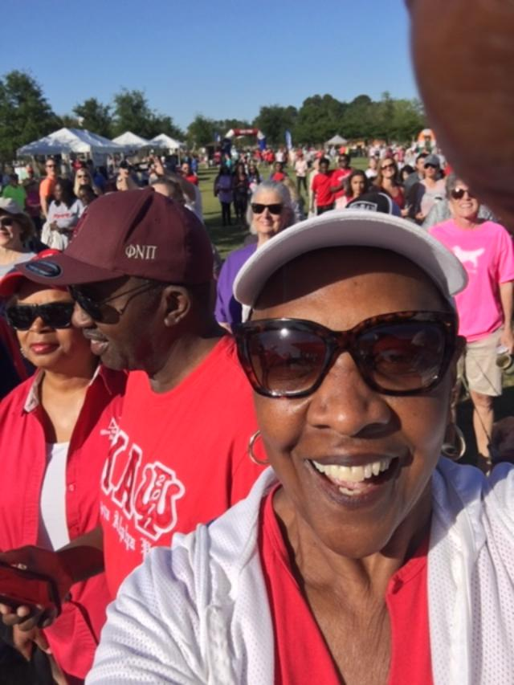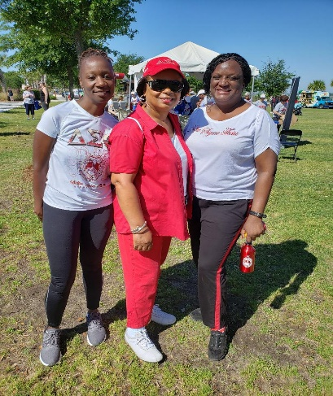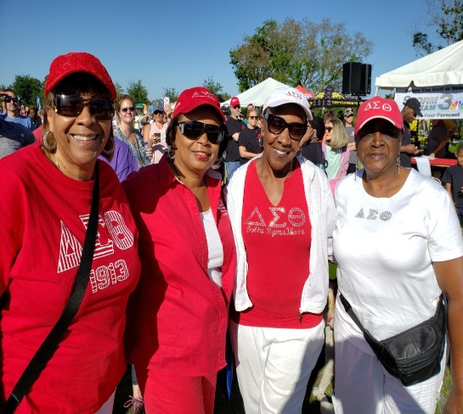
Soror Marion Payne Sorors DeAnna Campbell-Holmes Sorors Patricia Montgomery, Diane Neal,
Diane and Herman Neal Diane Neal, and Lucille Kannick Marion Payne, and Beverly Oheming

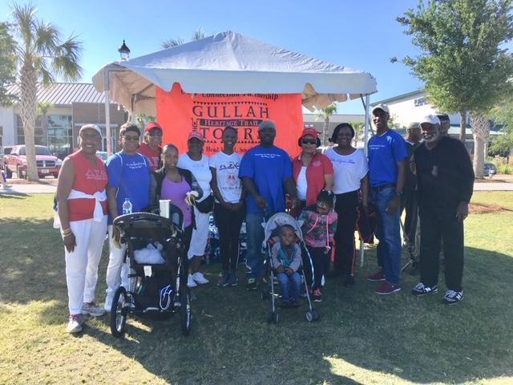
Gullah Heritage Tour Team
Carol Campbell, Team Leader

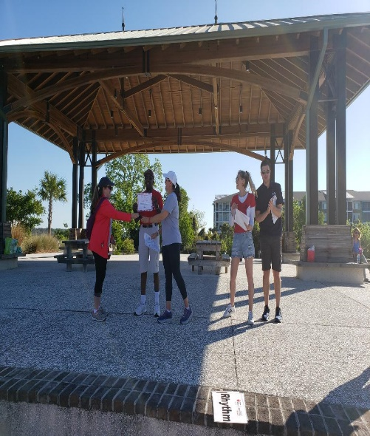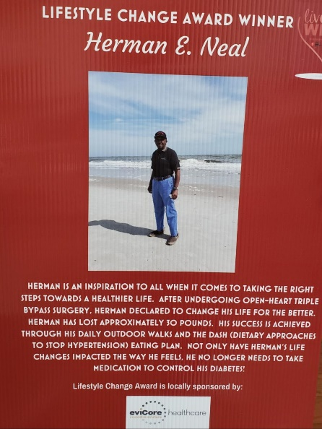

Herman Neal receives the LiveWise Lifesyle Herman Neal’s story about his
Change Award at the 2019 American Heart Walk Lifestyle Change.
Photo taken on Driessen Beach
March 15, 2019

