Grace Episcopal Church
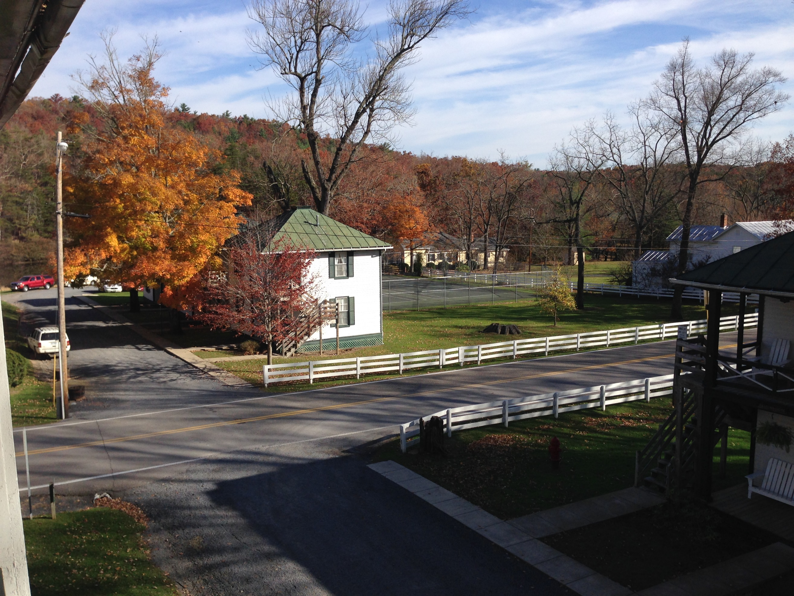
Shrine Mont

Grace Church Lane
Casanova, Virginia 20139
e-mail: gracechurchcasanova@gmail.com website: www.gracechurchcasanova.org

Episcopal Relief and Development needs you!

Bad news has a way of becoming cumulatively overwhelming. One night the news is all about an earthquake in impoverished Haiti; the next night fires in California, soon to be followed by thousands of Afghan refugees newly arrived and Afghans trapped in that strife-torn country. Hurricane season arrives and in our own part of the world, folks drown in basement apartments in Maryland and New York! A danger of this onslaught of bad news is something called compassion fatigue. I have personally suffered from this soul-killing and mission-killing malady! Perhaps it has infected you as well.
My main resource to fight compassion fatigue is to be inspired by and informed by our very own Episcopal Relief and Development (ERD.) Barbara and I have given a significant portion of our tithe to this amazing organization for many years and as of last week’s vestry meeting, Grace Church will use the month of October to raise a parish financial gift for ERD to be presented after All Saints Sunday.
Each week I hope to tell an ERD story and each week in October we will give an opportunity to make a donation. On the first Sunday in November our treasurer will announce our October total and the check (a big fat check, I hope) from our Church will be sent.
Don’t just take my word for it. Go to their amazing website, see compassion in action and let our small church with its generous heart help ERD as it becomes the hands and heart of the Lord Jesus caring for our desperately hurting world.
Happy giving!
 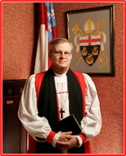 Bishop Ted

SENIOR WARDEN’S REPORT – SEPTEMBER 2021
Dear Grace Family,

Happy Fall Y’all! What a beautiful reflection of God’s glory is seen in the changing color of the leaves! I invite you to flip to the end of this newsletter to read about “Fall Camp!” It is a three-day retreat to either enjoy the worship and entertainment there, or simply bask in the beauty of your surroundings. It is a camp specifically designed for those of us who are aging (say 55 and up) but all are welcome. It is a prime location for a walk or hike and there is a golf course very nearby!

With Fall’s arrival we have resumed our monthly Vestry meetings. All are welcome to attend. We hold them outdoors, usually at one of our homes, on the 3rd Wednesday of the month at 3:00PM. If you are interested in attending, simply contact a Vestry member to find out where the meeting will be held that month.

The Vestry has applied for a Mission Grant from the Diocese for the purpose of assisting the Feed My Sheep ministry, of which we are a part. Apparently, no churches in the Diocese had been taking advantage of this opportunity, so we decided to do just that. A big thanks goes to Bryan Jacobs and Carol Grove for spearheading the grant endeavor.

Please notice that we are finally correcting our advertisements and displays to remove our former rector’s name. We are a little behind on that but are getting it done. Thanks for your patience!

Currently, Grace is not offering Sunday School, but we hope to return to it when the COVID-19 situation declines. Hang in there and please remember that there are many books and programs that can be accessed for spiritual growth in the meanwhile.

Our Discernment Committee (aka Search Committee) is still at work and we finally feel that we are making headway. Keep your ears and eyes open as we are hoping to have good news for you soon!
Shrine Mont
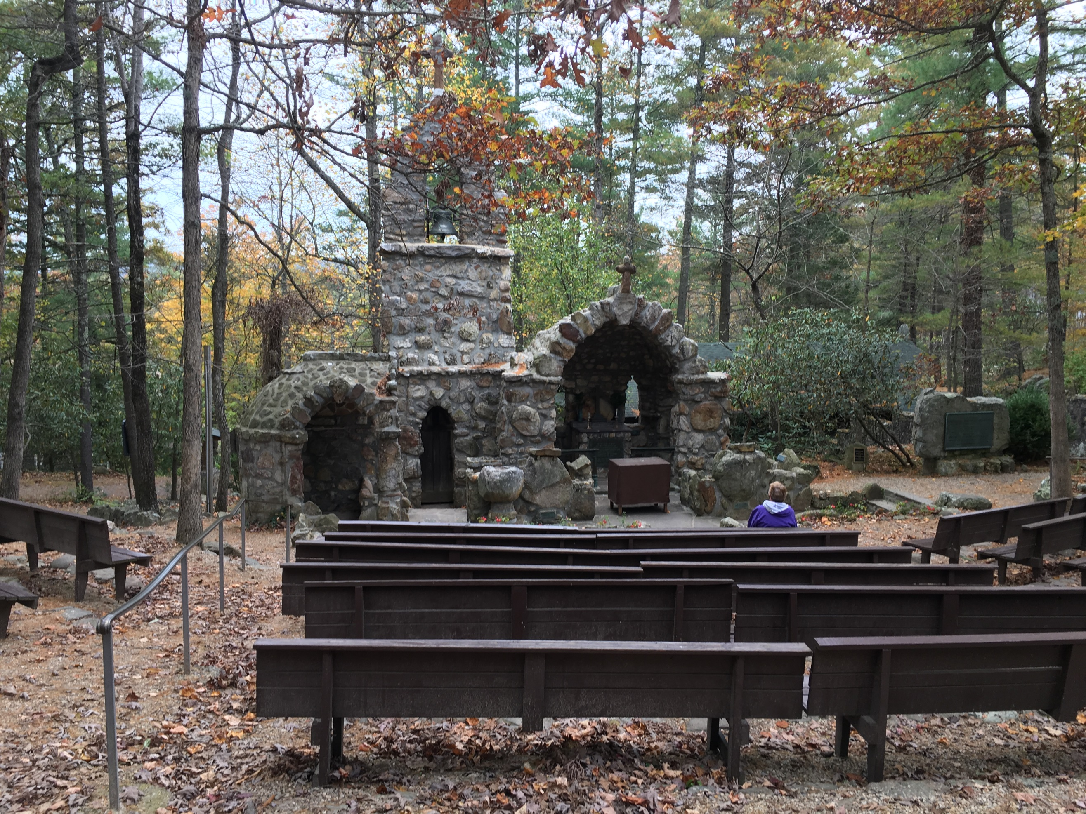
Blessings and love on behalf of the Vestry,
Mary


TREASURER’S REPORT – AUGUST 2021
Income for the month of August was $7,019.00 (budget $6,267.00); expenditures totaled $3,349.95 (budget $4,543.00), resulting in income for the month of $3,669.05.

The book value of our endowment fund is $60,073.49; market value as of July 31,2021 - $70,706.94.

Please continue to pray for Grace Church that it will grow spiritually, financially and numerically. If you have any questions about this report or any financial matter, please contact me.

Shrine Mont
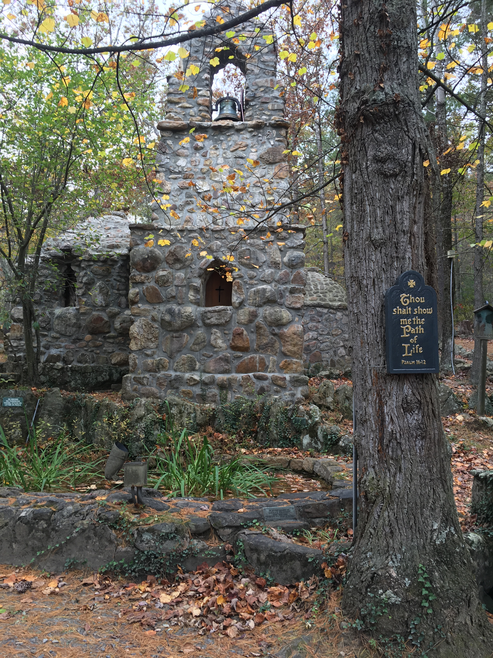
Judy Ball, Treasurer

FEED MY SHEEP (FMS)
Life is not a problem to be solved, but a gift from God to be enjoyed. It is not what you gather in life but what you scatter, by which you will be remembered. Good news! Feed My Sheep is now a non-profit ministry . Officially we are FMS ministries of No.Va. LLC. Two volunteers have debit cards, so we can provide exactly what we need. Grace church is setting an example of giving by contributing to FMS. 70 families known that they will have food on the table. We serve young and old, families and senior citizens. Groceries are matched to family needs as much as possible. We are one of the few that deliver directly to our clients as transportation is a very real issue in rural areas. All the work is volunteer and local. Please continue with your valued support.
Carol Grove 
Ashley O'Meara | 5-Oct
TJ Johnson | 12-Oct
Pamela Ruffner | 12-Oct
Jackie Shipe | 17-Oct
Logan Shipe | 17-Oct
Julie Brewer | 27-Oct
Corey Butler | 29-Oct
Barbara McLeod | 29-Oct
OCTOBER BIRTHDAYS and ANNIVERSARIES



OCTOBER SERVING SCHEDULE
Day | Readings | Altar/Flowers | Reader/Acolyte | Ushers | Coffee Hosts
3  Nineteenth Sunday after Pentecost | Job 1:1; 2:1-10  Psalm 26  Hebrews 1:1-4; 2:5-12  Mark 10:2-16 | Betsy Anderson/ Sharon Sweeney | Bryan Jacobs | Barbara Eanes/ Betsy Anderson | Marilyn Ottevaere/ Sharon Sweeney
10  Twentieth Sunday after Pentecost | Job 23:1-9, 16-17  Psalm 22:1-15  Hebrews 4:12-16  Mark 10:17-31 | Carol Cordell/ Mignonne Spellmeyer | Judy Ball | Carol Cordell/ Marilyn Ottevaere | Mignonne Spellmeyer/ Dee Garrett
17  Twenty-first Sunday after Pentecost | Job 38:1-7, (34-41)  Psalm 104:1-9, 25, 37b  Hebrews 5:1-10  Mark 10:35-45 | Mary Neal | Barbara Gulick | Judy Ball/ Mignonne Spellmeyer | Penny DePompa Davis/ Mary Neal
24  Twenty-second Sunday after Pentecost | Job 42:1-6, 10-17  Psalm 34:1-8, (19-22)  Hebrews 7:23-28  Mark 10:46-52 | Pam Ruffner | Mary Neal | Sharon Sweeney/ Sue Ballentine | Sue Ballentine
31  Twenty-third Sunday after Pentecost | Ruth 1:1-18  Psalm 146  Hebrews 9:11-14  Mark 12:28-34 | Sharon Sweeney | Betsy Anderson | The Jacobs | Judy Ball/ Barbara Eanes


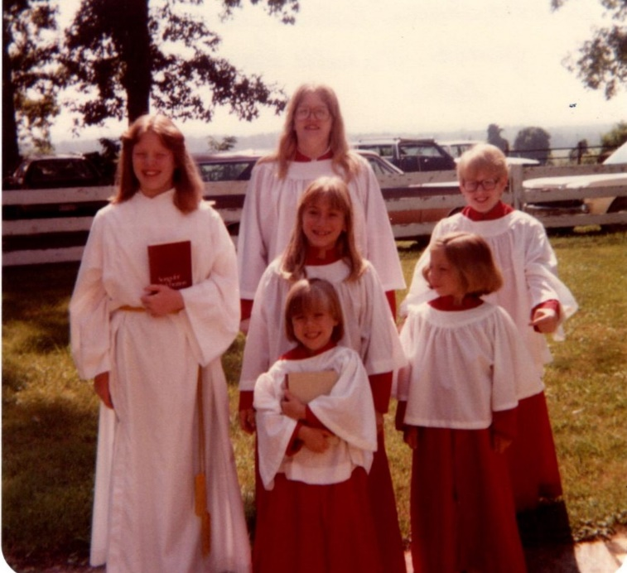
?
If you like this segment (From the Grace Archives,) please let us know and/or feel free to send us a submission!
e-mail: gracechurchcasanova@gmail.com

From the Grace Archives

Last month’s photo: How accurate was your guess? The three oldest and tallest children are Barbara, Teresa, and William Hartsell. The three younger children are Jessica Warren (Rhoads), Nellie Warren (Escorcia), and Michelle Perry. The year was 1985 and they were “the Children’s Choir.” Yep! Grace had a choir!

AMAZON SMILE
FOR GRACE CHURCH
Don’t forget to sign up with Amazon Smile to have 0.5% of the purchase price of eligible items given to Grace Church at no cost to you! You can also go to the Grace Church website home page and click on the link there.

*******AmazonSmile Shopping App for Android Users Now Available******
You can now support Grace in the Amazon shopping app on your Android device! Simply follow these instructions to turn on AmazonSmile and start generating donations to Grace from your Android device.
- If you have the latest version of the Amazon Shopping App, open the App on your Android device.
- View Settings and select AmazonSmile.
- Follow the in-App instructions to complete the process.
AmazonSmile is not currently available for IOS users – we’ll let you know when it becomes available.
Fall Camp
