Personally Driver Fitted
Left Foot Gas Pedal
Model 3545
Installation and Owners Manual

SOURCE ONE MOBILITY
WWW.SOURCEONE-MOBILITY.COM

DANGER
Use of this product
with adjustable accelerator and
brake pedals may
result in serious
bodily injury, death and/or
property damage.

Information

Many states either require or recommend that
anyone using our products have a driver
evaluation prior to installation.
We recommend all customers have a driver
evaluation performed by a qualified evaluator.
If you should need assistance contact
www.driver-ed.org
or
Source One Mobility
(248) 687-9870
Table of Contents

Warnings and Cautions . . . . . . . . . . . . . . . . . . . . . . . . . . . . . . . . 2

Determining Base Plate Location . . . . . . . . . . . . . . . . . . . . . . . . 3

Marking Base Plate Location . . . . . . . . . . . . . . . . . . . . . . . . . . . 4

Mounting Left Foot Gas Pedal Base and Base Plate . . . . . . . . . . 4

Attaching Left Foot Gas Pedal to Base . . . . . . . . . . . . . . . . . . . . 5

Adjusting Left Foot Gas Pedal Position. . . . . . . . . . . . . . . . . . . . 6

Removing Left Foot Gas Pedal From Base . . . . . . . . . . . . . . . . . 7

Post Installation Dealer Inspection . . . . . . . . . . . . . . . . . . . . . . 7-8

Left Foot Gas Pedal Operating Instructions . . . . . . . . . . . . . . . . . 9

Maintenance. . . . . . . . . . . . . . . . . . . . . . . . . . . . . . . . . . . . . 10-11

Warranty . . . . . . . . . . . . . . . . . . . . . . . . . . . . . . . . . . . . . . . 12-13

Parts Listing. . . . . . . . . . . . . . . . . . . . . . . . . . . . . . . . . . . . . 14-15

WARNING: NOT RECOMMENDED FOR TRANSFER
FROM ONE VEHICLE TO THE NEXT

FOR ASSISTANCE OR PARTS
CALL
SOURCE ONE MOBILITY
(248) 687-9870

90524-000 Revision G
1

Warnings and Cautions
CAUTION WARNING

INDICATES A POTENTIALLY
HAZARDOUS SITUATION THAT,
IF NOT AVOIDED COULD
CAUSE DAMAGE TO THE PRODUCT,
VEHICLE, OR MODERATE INJURY
TO THE INSTALLER OR OTHER
PEOPLE.
INDICATES A POTENTIALLY
HAZARDOUS SITUATIONTHAT,
IF NOT AVOIDED COULD
CAUSE SERIOUS BODILY INJURY
AND / OR PROPERTY DAMAGE.

General Installation and Operation Warnings

THIS PRODUCT MUST BE INSTALLED ONLY BY AN
AUTHORIZED SOURCE ONE MOBILITY DEALER.

ONLY TRAINED OPERATORS MUST OPERATE THIS DEVICE.

KEEP THE DEVICE MAINTAINED REGULARLY. (ACCORDING
TO THE MAINTENANCE RECOMMENDATIONS)

INSPECT THE DEVICE PRIOR TO EVERY OPERATION.

DO NOT USE THE ACCELERATOR GUARD AS A FOOT REST. REFER TO FIGURE 5.

IF SOMEONE OTHER THAN THE TRAINED OPERATOR IS USING
THE VEHICLE, THE LEFT FOOT GAS PEDAL MUST BE REMOVED. REFER TO FIGURE 7.

PLACE THE WARNING DECAL ON THE INSIDE OF THE
VEHICLE WINDSHIELD. DECAL MUST BE VISIBLE BY THE
DRIVER WHEN SEATED AND MUST NOT IMPAIR VISIBILITY.

THE LEFT FOOT GAS PEDAL IS TO BE USED ON VEHICLES EQUIPPED WITH AUTOMATIC TRANSMISSION ONLY.

READ AND UNDERSTAND THIS MANUAL PRIOR TO INSTALLING AND OPERATING.

DO NOT INSTALL THE BASE PLATE ON TOP OF FLOOR MATS
OR ANY OTHER LOOSE FLOOR COVERING NOT ATTACHED BY VEHICLE'S ORIGINAL MANUFACTURER.

2

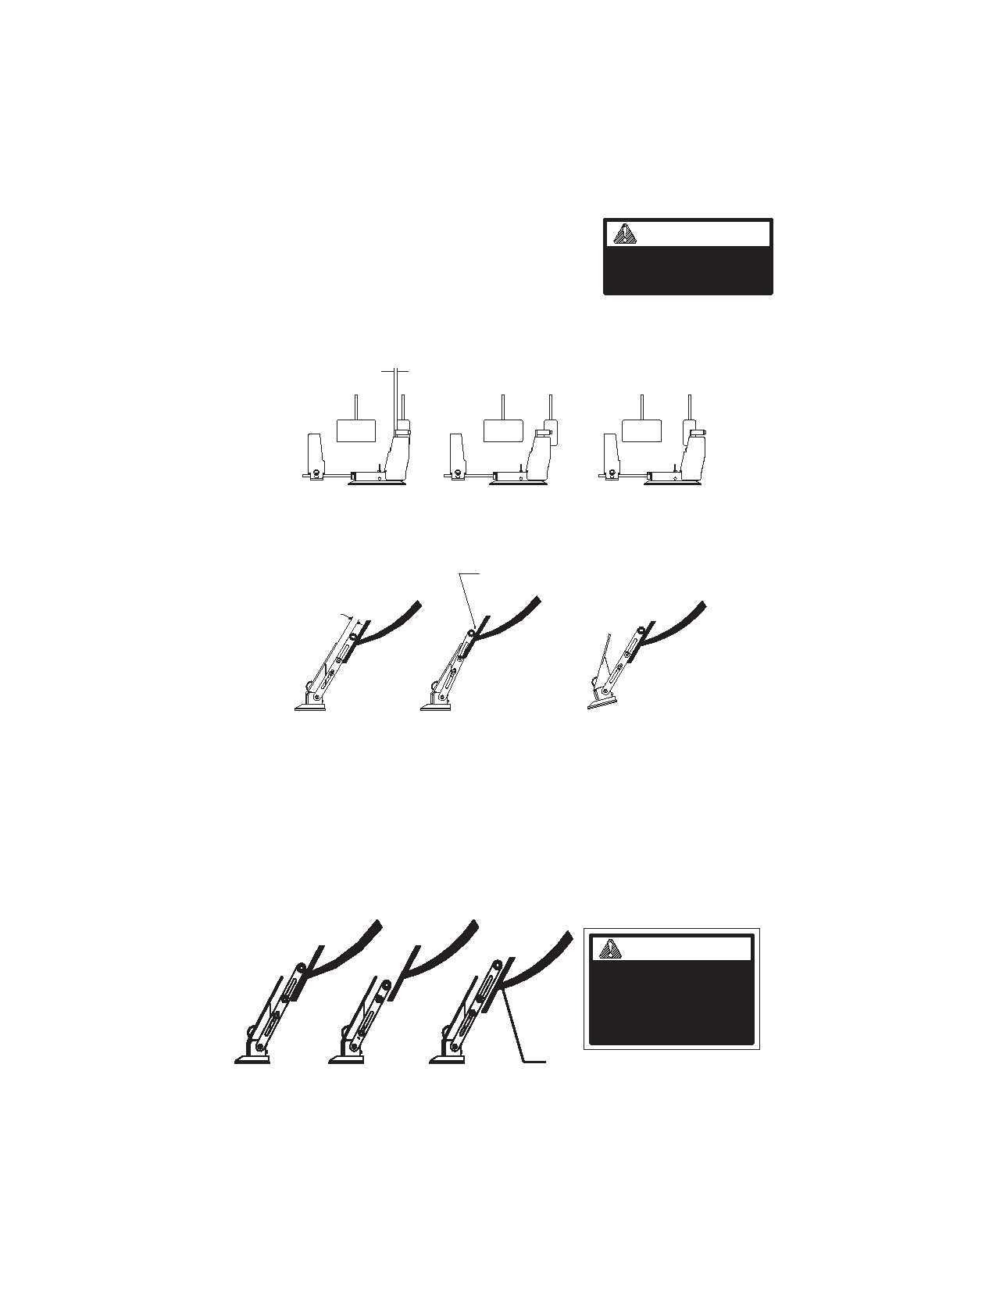
Step 1) Determining Base Plate Location
With the Base attached to the LFGP (Left

Foot Gas Pedal) assembly, follow these three steps to determine the Base Plate location.
WARNING
This product must be
installed only by an
authorized MPD dealer

1A) Left to Right: A 3/16" (approx.) gap should be visible
between the flat part of the Actuator Arm Assembly and the OEM gas pedal.

Figure 1
3/16"

Correct Wrong Wrong
1B) Front to Back: The adjustable slide of the Actuator Arm
should be parallel with the OEM gas pedal.
Figure 2 Incorrect spacing
1/2"
Minimum

Correct Wrong Acceptable on
inclined floor
1C) Actuator Arm Adjustment: For OEM (Original Equipment
Manufacturer) gas pedals with a pivot: The Roller should be locat-
ed above and close to the pivot (roller must not be
located even with, or below the OEM gas pedal pivot point). For
solid OEM gas pedals (no pivot): The Roller should be located
between the top 12 and 34 of the OEM gas pedal.

Figure 3
⁄
⁄
WARNING

IMPROPER ADJUSTMENT OR
INSTALLATION OF THE LEFT FOOT
GAS PEDAL, MAY RESULT IN THE
OEM PEDAL BEING LOCKED IN
THE PARTIAL OR FULL ACTIVATION
POSITION

Correct

Wrong

Wrong

3
Accelerator
Pivot

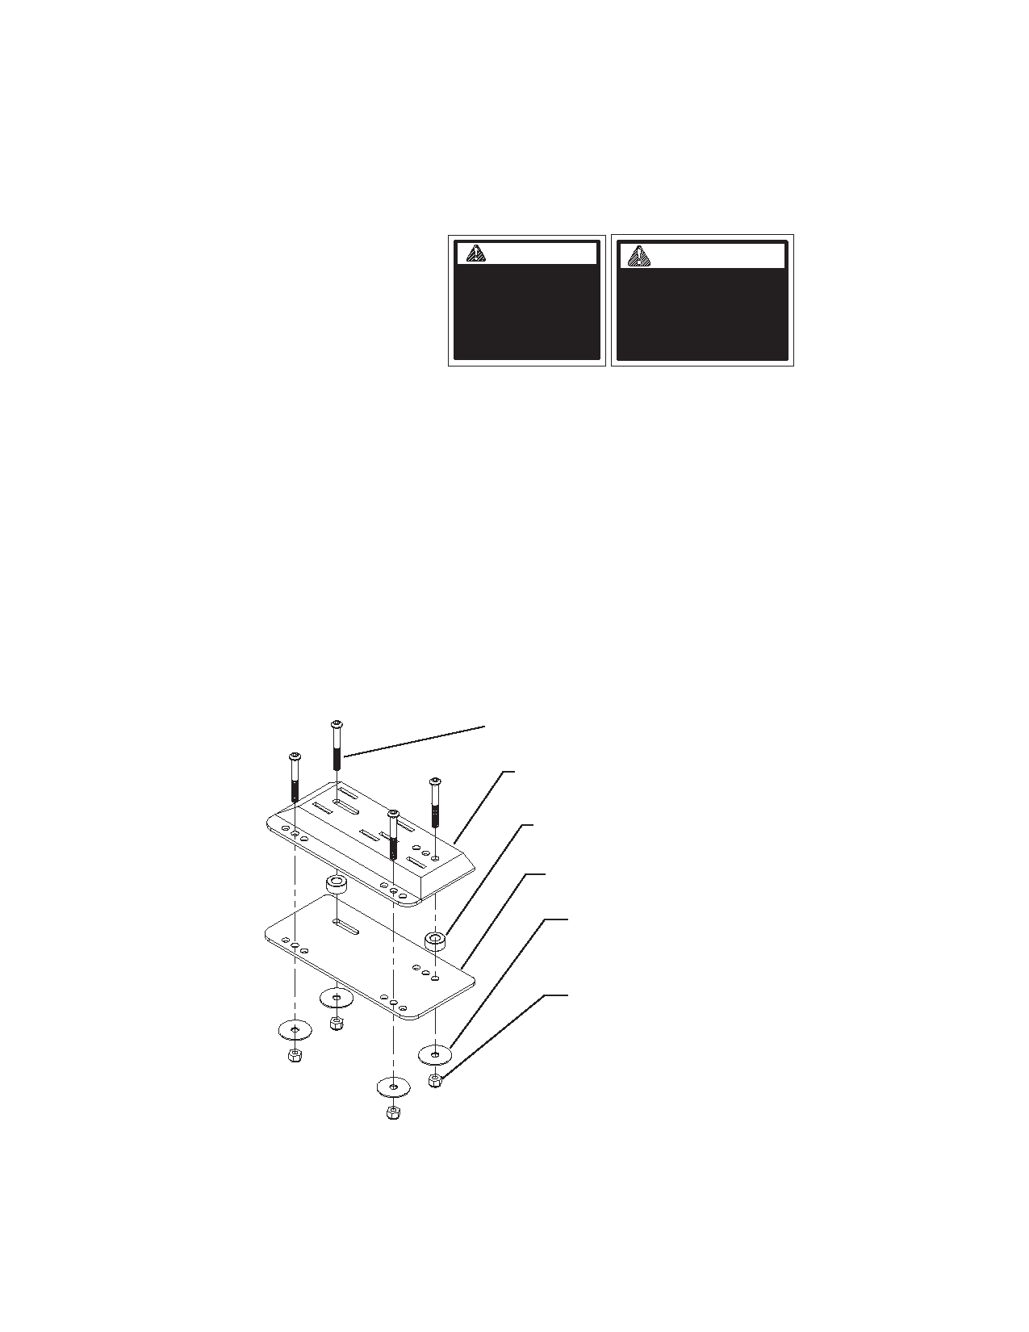
Step 2) Marking Base Plate Location

Once the proper
location of the Left
Foot Gas Pedal is
determined, mark by placing tape along 2 edges of the Lockout Base.

CAUTION
Prior to drilling the
mount holes, check
for obstructions
such as wiring, fuel lines, etc. under the
carpet and vehicle
floor

WARNING
Do not install the Base
Plate on the top of floor mats or any other loose
floor covering not
attached by the vehicles original manufacturer.

Step 3) Mount LFGP and Base Plate
Place LFGP Base Plate on the floor in the area previously marked
(the slot in Base Plate should be toward the front, left side as shown in figure 4).
Check under vehicle and under the carpet to make sure you don't
drill into unwanted objects (such as… gas lines, brake lines, wires, etc.).
Using the Base Plate as a template, drill four holes for the
mounting bolts using a 9/32" drill bit.
Secure LFGP Base Plate, Spacers, and Base to the floor using the
bolts provided.
Figure 4 1/4" Bolts

Lockout Base

Spacers (2)

Base Plate

1/4" Fender Washers

1/4" Nylock Nuts (torque to 50 to 70
in./lbs

4

Step 4) Attach LFGP to Base

A. Hold on to the LFGP Accelerator Guard and Actuator Arm with one hand.

B. Push the LFGP down into the slots of the Base.

C. Slide the LFGP to the right until it latches. At this time be sure
the LFGP is secure and the Latch is completely engaged. Refer to caution note.

CAUTION
1) If the red mark on the latch is visible, unit is
not latched. Do not use until securely latched.
2) This device has been adjusted for this vehicle. Do not use in other vehicles.

Figure 5
STEP C

STEP B

Actuator Arm

Accelerator Guard

5

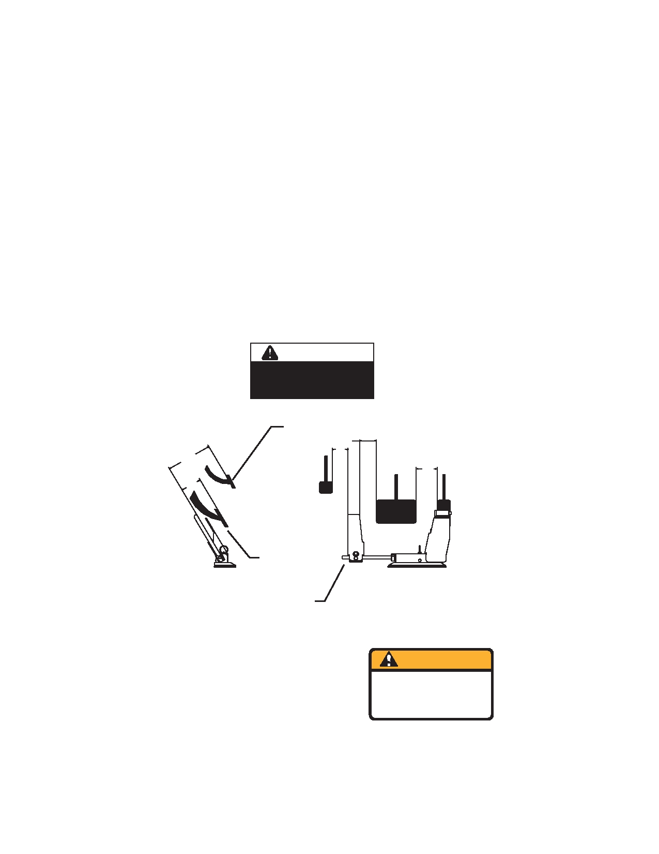
Step 5) Adjusting Left Foot Gas Pedal Position

Dimension A is equal to Dimension B: Distance (left to right) between OEM Gas Pedal and OEM Brake Pedal should be the same as the distance between OEM Brake Pedal and LFGP.

You must be able to completely activate the Emergency Brake
without interfering with the Left Foot Gas Pedal. (Dimension C
and D)
Dimension E: Distance (front to back) between OEM Gas and
Brake Pedals should be approximately the same as distance between LFGP and OEM Brake Pedal.

WARNING
If it is not possible to make dimension
B equal to dimension A, DO NOT
use the LFGP in this vehicle.

Figure 6

OEM Emergency

D

E
Brake
C
B

A

OEM Brake
Pedal
Trim excess rod off
at this point.
Trim off any excess rod length on the bottom Activator Arm.
WARNING Install the Warning Decal on the
This vehicle has been

vehicle windshield or drivers win-
dow.
modified with an Adaptive
Driving Device - to be used by
trained and licensed
operators only! 90051-000

6

Step 6) Removing LFGP From Base
A. Lift the key ring on LFGP assembly.
B. While lifting and holding the key ring up, slide the Lockout
Base to the left.
C. When the assembly begins to move, release the key ring and
continue to slide the assembly left until it can be lifted out of Base.
Step B
Figure 7

Step C

Step A

Step 7) Post Installation Inspection by Installing
Dealer
1) Make sure that all the fasteners are secure and the Base is rigid
with the vehicle floor.

2) Verify the Left Foot Gas Pedal latching mechanism works properly by removing and attaching the mechanism three or
more times. When attaching, notice:
A) The Base latches in the slots with minimal effort. The latch should engage so the red line on the latch does not show.
B) When removing, the latch should disengage
smoothly, and the Base should slide out of the slots
with little effort. It should not be necessary to use any tools to remove the LFGP from the Base.
7

Post Installation Inspection Continued

3) Verify correct operation of the Left Foot Gas Pedal:
A) With the engine off, make sure the LFGP operates
freely and has the proper clearances outlined in these instructions.
B) Verify the force it takes to operate the Left Foot
Gas Pedal is similar to the force it takes to operate the OEM accelerator.
C) Verify the operation is a smooth motion. It should
not stick at any point.
WARNING

D) Completely
depress LFGP. It must not lock in a partial or
fully accelerated position.
IMPROPER ADJUSTMENT OR
INSTALLATION OF THE LEFT FOOT
GAS PEDAL, MAY RESULT IN THE
OEM PEDAL BEING LOCKED IN
THE PARTIAL OR FULL ACTIVATION
POSITION

4) Press on the Accelerator Guard lightly to determine that it
will not contact the Actuator Arm. If it does, refer to step 1B
to readjust
5) Make sure the OEM Parking Brake Pedal or mechanism
does not activate or interfere with the operation of the LFGP.
6) Test drive the vehicle yourself, after installation or any
adjustments, to ensure the LFGP is functioning properly. Verify that the vehicle will go into passing gear and return to idle.
7) Make sure the customer has had proper training by a
Certified Driver Rehabilitation Specialist.
8) Ensure the Left Foot Gas Pedal has been adjusted for the
driver's comfort and fit.
9) Record vehicle information on

decal located on back side of
Accelerator Guard. (To ensure that
if the LFGP is removed, it is
reattached into the same vehicle.)
10) Give this manual to the customer.
8
Vehicle I.D.
Year 2002 Make Dodge
Model Caravan

Left Foot Gas Pedal Operating Instructions
We recommend all customers have a driver evaluation performed
by a qualified evaluator.

The Left Foot Gas Pedal transfers the force of the drivers left foot to
the OEM accelerator pedal. It operates the same way as the OEM
accelerator pedal, except the left foot is used instead of the right foot.

The Left Foot Gas Pedal can be quickly attached (refer to step 4, figure 5) and is to be used by TRAINED OPERATORS ONLY.

The Left Foot Gas Pedal is designed to be quickly detached (refer
to step 6, figure 7) and MUST BE REMOVED IF SOMEONE OTHER THAN THE TRAINED OPERATOR IS USING THE VEHICLE.
The accelerator guard is designed to guard the OEM accelerator
from unintentional operation. The accelerator guard is NOT A
FOOT REST. Except for performing a post installation
inspection, DO NOT PUSH ON THE ACCELERATOR GUARD FOR ANY REASON.
Alternate between the LFGP and the brake with left foot to further
familiarize yourself with the function.
Before each use:
Make sure the Left Foot Gas Pedal is properly
seated in the Base, and the red mark is not visible.
Make sure the Left Foot Gas Pedal operates
freely and properly.
Make sure nothing is obstructing the operation of
the Left Foot Gas Pedal (i.e.. Keep floor clean of
rocks, mud, ice, and any form of debris)

Make sure all fasteners are secure.
9

Maintenance

As the owner and user of the Left Foot Gas Pedal, it is your obligation to follow through with the required maintenance.

Regular cleaning is required to ensure optimum performance.

It is required that every 3 months:

Vacuum out the Base and clean out any debris from under the Base.

Verify that the LFGP Roller moves freely.

Verify that the LFGP Latch moves freely. If needed, a drop
of light weight oil may be applied to the latch, latch pin, and/or spacer. Remove any excess oil.

It is required that every 6 months:

Have an authorized Source One Mobility dealer
inspect, and maintain the unit. Document any work completed on the chart provided.

10

Dealer Date Maintenance or Service Parts
Signature Performed Replaced

11

Warranty Policy

Source One Mobility products are warranted to be free from defects in material and workmanship for a period of two (2) years from the date of the original customer's
purchase. All warning messages on labels must be adhered to strictly, and regular maintenance procedures must be followed.

This Warranty is effective only if the products or parts of the product have been installed
in accordance with Source One Mobilitiy’s written recommendations and with established installation practices and by an authorized dealer of Source One Mobility. Source One Mobility does not assume liability for defective products not manufactured or supplied by it, even though some products are used in conjunction with Source One Mobility products. Any and all claims for Warranty adjustments must be originated within the twenty-four (24) months Warranty period and must be submitted
by an authorized Source One Mobility dealer in accordance with established
Source One Mobility Warranty Claim procedures. The properly completed
Warranty Registration must be on file at the office of Source One Mobility, for
any Warranty claim to be considered. The Warranty period begins upon installation of the product or the date the product is placed in service.

If, within such a Warranty period, any part of the product shall be proved to Mobility
Products & Design's satisfaction to be defective, such part shall be repaired or replaced at
Mobility Products & Design's option. Mobility Products & Design's sole obligation and
the customer's exclusive remedy, hereunder, shall be limited to such part repair or replacement.

Service under this Warranty is available from the authorized Source One Mobility
dealer who installed the equipment. If such dealer is not available, you may call
(248) 687-9870 for the name of another servicing dealer or visit our website www.sourceonemobility.com and click on Dealer Locator.

NO RETURNS WILL BE ACCEPTED WITHOUT FIRST OBTAINING A SHIPPING
AUTHORIZATION AND WARRANTY AUTHORIZATION RETURN GOOD
NUMBER FROM SOURCE ONE MOBILITY SHIPMENTS SENT FREIGHT COLLECT OR C.O.D. WILL BE REFUSED, UNLESS PREVIOUSLY AUTHORIZED.

Source One Mobility, reserves the right to inspect any product or part which is subject of a Warranty claim in order to make final determination of the validity of such claim. Damage due to misuse, improper maintenance, improper installation, or damage from mishap or collision, is not covered.

In any event, Source One Mobility’s liability extends only to the repair or replacement of such components as are necessary to restore the product to normal operating condition. All other claims or liabilities are expressly denied.

12

This Warranty states the entire liability of Source One Mobility with respect to
the products it manufactures. It is exclusive; and in lieu of all warranties expressed or implied, including but not limited to implied warranties of merchantability and fitness
for particular use unless applicable by law, and then shall not extend beyond the
minimum law or the duration of the express Warranty whichever is less. Under no
circumstances will Source One Mobility be responsible for incidental or
consequential damage arising out of the use of any of it's products or any breach of this warranty, and any such damages are specifically excluded from this Warranty.

Some states do not allow limitations on how long implied warranties last, so the above
limitation with respect to implied warranties may not apply. Some states do not allow the
exclusion or limitation of incidental, or consequential damages, so the above limitation or exclusion with respect to incidental or consequential damages may not apply.

This Warranty gives you, the customer, specific legal rights and you may have other rights which vary from state to state.

AGAIN, THE WARRANTY REGISTRATION CARD MUST BE COMPLETELY FILLED OUT, SIGNED AND IN POSSESSION OF MOBILITY PRODUCTS & DESIGN'S WARRANTY DEPARTMENT WITHIN THIRTY (30) DAYS AFTER
INSTALLATION TO BE RECORDED AND RECOGNIZED. NO WARRANTY WILL BE AUTHORIZED UNLESS THIS IS COMPLETED.

This Warranty is to the original purchaser only and is not transferable, and applies only
to vehicles with power brakes, power steering and automatic transmission. Any products installed on vehicles without these features is strictly prohibited.

This Warranty extends only to those products that are installed or used in transportation
vehicles. Any other use of any of the products manufactured by Source One Mobility, other than as prescribed, are not authorized by Source One Mobility, and
Source One Mobility will make no warranty with respect to such
non-conforming, unauthorized use or installation. Any changes to the product by any
person or dealer, will also cause the Warranty to be null and void. Any person or dealer
who uses or installs any product of Source One Mobility for a use other than
stated above, does so at their own risk with the full knowledge and understanding that
the Warranty is null and void. Any use other than in transportation vehicles for
handicapped persons, unless agreed to and approved in writing by the company shall render the Warranty null and void.

This Warranty will not apply if the product is used or submitted in contests or testing programs. Your vehicle must conform to all Federal Motor Vehicle Safety Standards
(FMVSS) for the Warranty to be valid.

13

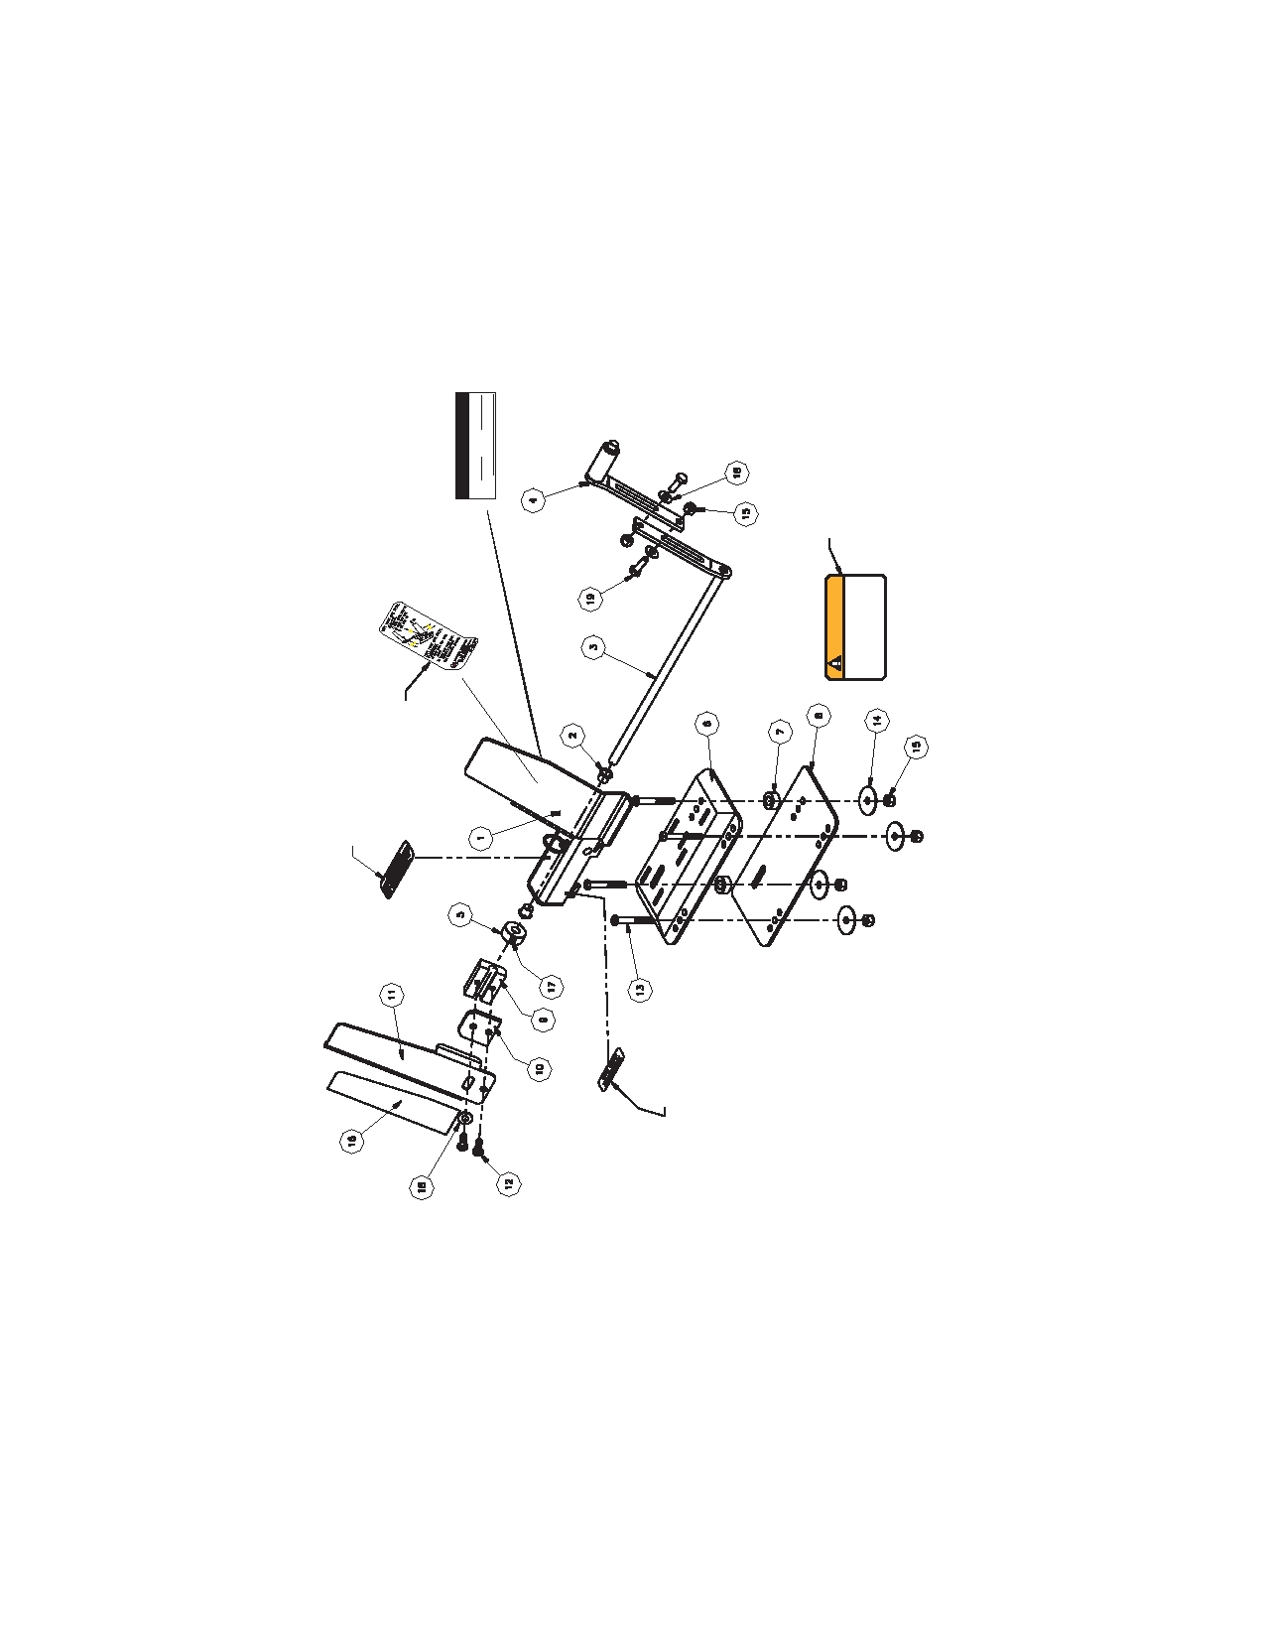
Parts Diagram
Guard
Accelerator
Mount on
90529-000
of unit.
Mount on top
90523-000
Accelerator Guard
located behind
Vehicle ID decal
90549-000
Vehicle I.D.
Year
Make
Model
behind front edge
Mount under asm.
Serial Number
90442-000
WARNING
mount on windshield
90051-000
operators only! 90051-000
trained and licensed
Driving Device - to be used by
modified with an Adaptive
This vehicle has been

14

Parts Listing

ITEM PART NO. QTY DESCRIPTION
1 N/A 1 NOT SOLD SEPARATELY

2 91252-000 2 NYLINER

3 69185-000 1 WELD, LFGP BOTTOM ACTUATOR ARM

4 69751-000 1 ASSEMBLY, LFGP UPPER ACTUATOR ARM

5 69144-000 1 COLLAR, LEFT FOOT GAS PEDAL

6 69193-000 1 LFGP LOCKOUT BASE

7 69198-000 2 LFGP SPACER

8 69194-000 1 LFGP LOCKOUT BASE PLATE

9 69141-000 1 CLAMP

10 69221-000 1 LFGP CLAMP PLATE

11 69195-000 1 LFGP PEDAL

12 81068-000 2 1/4 - 20 x 3/4 BHCS SS

13 81090-000 4 1/4 - 20 x 2 BHCS SS

14 82008-000 4 1/4 WASHER, FENDER

15 83011-000 6 1/4 - 20 NUT, NYLOCK

16 99296-000 1 LFGP SAFETY TRACK

17 84027-000 1 1/4 - 20 x 1/4 SET SCREW

18 82013-000 3 1/4 WASHER FLAT SAE

19 80013-000 2 1/4 - 20 x 3/4 HHCS

15

