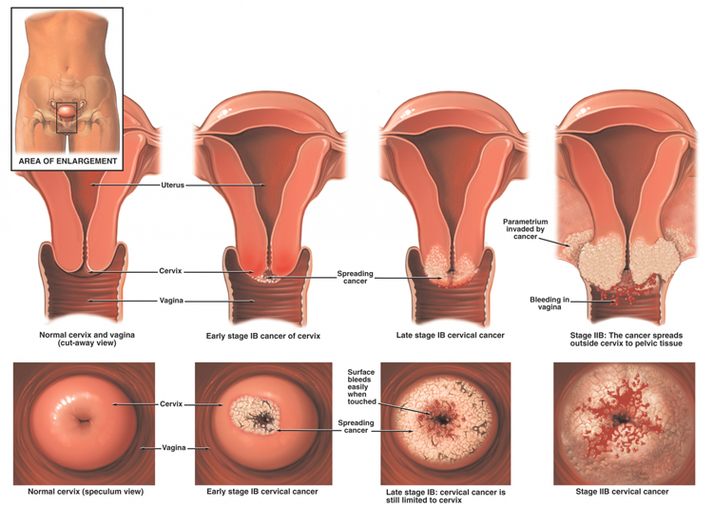

UNDERSTANDING PAP SMEARS

Purpose: to detect any abnormal cells that could lead to cervical cancer
How Early: not before sexually active or after 30
How Often: one a year or every 3 to 6 months if they are showing Atypia Class II or above ratings
How Long: entire life
Accuracy: a) they have a very high rate (as much as 70%) of false positives, giving a more serious class
rating than really exists,
b) and a very high rate of false negatives giving a less serious rating when there really is
trouble.

Causes of Abnormal Cervix Cells:
- Nutritional deficiencies (especially B Complex, Beta Carotene, Amino Acids from Protein)
- Sexually transmitted virus: human papillomavirus (HPV) that causes condyloma warts or lesions in the genital area & the cervix (70% of abnormal pap smears & cervical cancer are caused by this virus)
- tampons, especially whitened with chlorine bleach
- yeast infections
- condoms & spermicides
- douching too much
- smoking
- stress & emotional issues
- cervicitis or chlamydia infection
- traumatic or unloving sex
- lack of exercise – therefore, lack of oxygen getting to cells
- birth control pills (that create a hormonal imbalance)
- progesterone deficiency
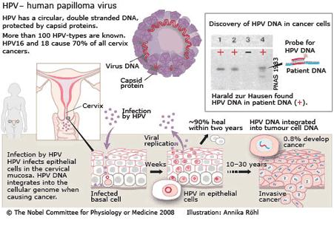

Results of Pap Smears:
- Class I: Normal (benign)

- Class II: Atypia (inflammation or irritation)
-non-typical cells (nucleus larger, ragged edges)
-50% go back to normal in 2-3 months / 50% don’t

- Class III: Dysplasia (can be mild, moderate or severe)
-cells are more significantly abnormal (on the way to cancer)
-often HPV is present

- Class IV: Precancerous or Cancer

- Class V: Seriously Invasive Cancer
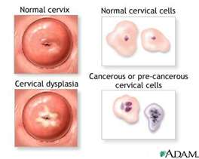

Women usually say: “But I feel find.” That is true…..cervical cancer give no warnings, no pain, no discharge. Some say: “If I don’t know, I don’t have I don’t have to think about it.” How foolish…..abnormal cells can develop into true cancer cells, & if you pick up abnormalities early, it is curable.

How soon do you get Retested after an Atypia Class II result?
The lining in the cervix is totally shed & replaced every 6 to 8 weeks. Retest in three months or twelve weeks. Make your bloodstream a smorgasbord of nutrients and give adequate time for the cells to experience repair.

Good News about Atypia or Dysplasia Results:
Cervical cells grow slowly. Follow the recommendations (take it very seriously) and most atypical & dysplasia results will return to normal.
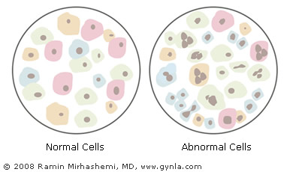

What to Do for Cervical Dysplasia:
- Douche before bed:
  - use a microflora douche (crush 2 Shaklee Bifidus in 1 cup purified water and douche)
  - if inflammation or infection, douche before bed two nights in a row with:
¼ cup hydrogen peroxide to 2 cups water

- Supplements:
  - Shaklee NutriFeron – 2 per day
  - Shaklee Vita Lea – 3 per day
  - Soy Protein – 3 tablespoons … OR … 1 serving of Shaklee Cinch Shake
  - B Complex (maintain yellow urine 24 hours per day) … at least 3 per day
  - CarotoMax (achieve “peachy” palms quickly & maintain) … start out with at least 2+ per day … after cells have gone back to normal, maintain with a minimum of 1 per day.
  - Vitamin E (at least 400 I.U.) – 1+ per day
  - Vitamin C (at least 1500+ mg) – 3+ per day
  - Zinc (at least 30 mg) – 2 per day
  - Garlic – 3 per day
  - OmegaGuard – 3 per day
  - Optiflora - 1 per day
  - IF you have tested positive to the HPV virus … take 3 Shaklee DR 4 days of every week for 8 weeks

- Detoxify
  - Shaklee DTX – 1 to 3 per day (to help the liver get rid of toxins & to protect the liver)
  - Herb-Lax - 1+ per day (whatever is required to maintain 2 to 3 bowel movements per day)
  - Drink ½ oz of water per every 10 pounds of body weight
  - Eat high fibre foods

- Use Natural Bioidentical Progesterone Cream …
  - if you are experiencing typical PMS symptoms (emotional sensitivity, bloating or tender breasts 5 to 10 days before the menstrual cycle starts) … use 1/8th teaspoon of 3% progesterone from ovulation for 12 days twice per day
  - if menopausal & beyond and your blood or saliva hormone testing shows you are low in progesterone … use 1/8th teaspoon of 3% progesterone three weeks of the month twice per day.

- Avoid:
  - unopposed estrogen supplementation
  - birth control pills
  - spermicides (used in diaphragm jelly & on condoms)
  - commercial douches
  - tampons
  - unloving, traumatic sex

- Change your diet: eliminate caffeine, alcohol, sugar & fried foods - eat lots of raw fruits, vegetables, whole grains, nuts, seeds, beans, & legumes

7. Reduce Stress (Stress Relief Complex highly recommended)

