Governor Jim Doyle
P.O. Box 7863
Madison, WI 53707

April 15, 2010

RE: Veto SB 273

Dear Governor Doyle:

Waukesha County Environmental Action League (WEAL) is asking that you Veto SB 273.

• Wisconsin Could be the first Plasma Gasification Test Case

Dozens of startup companies are pitching gasification proposals across the United States as "green," renewable energy, The fact is, WEAL along with national, statewide, and local environmental groups across the nation believe these facilities waste energy, destroy resources and should not qualify as renewable energy. (1)

The only thing "green" that will be realized from SB 273 will be the dollars companies like Alliance Federated Energy (AFE) want to receive through stimulus money for construction, grants, low interest loans and renewable portfolio standards.

Since there are no facilities in the United States for comparison, AFE and other proponents refer to Hitachi Metals, a 200 ton per day (tpd) facility in Japan. AFE is proposing a 1200 tpd facility here in Wisconsin.

When faced with a proposal similar to AFE's, the City of Sacramento, CA sent representatives to Japan, considered the facts and said no to plasma gasification. (2)

Clearly the race is on for one of these facilities to be built, somewhere, anywhere. During a lecture given by the CEO of AFE at Carroll University on 3/30/2010, the question of "Why Wisconsin?" was answered. Those in attendance were told Chicago was the first choice, but the "politics" were better in Wisconsin" and that AFE was in discussions for six facilities in this state.

WEAL would like to point out that Under Chapter 289 communities cannot say no to a disposal facility at the local level which makes Wisconsin an ideal target to have the first plasma gasification (staged incinerator) in the country.

• Air Quality Issues

Gasification proponents will say "there are no emissions" but this is not accurate. During the combustion of syngas minute particulate emissions containing volatile organic compounds, sulfur dioxide, heavy metals, mercury, and persistent organic pollutants such as dioxins and furans are released into the atmosphere. (3)

• Zero Waste or Trash & Gas?

We do not have to make a choice between landfills and gasification. Wisconsin can decide to continue on the path toward Zero Waste. While you have been Governor, a significant first step has been taken toward Zero Waste with the recent e-waste legislation. Additional extended-producer responsibility and re-manufacturing initiatives and serious composting can be planned for the future or we can just trash and gas resources.

Plasma gasification is also very expensive. AFE's "Project Apollo" is expected to cost $225 million dollars and only produce 45-50 jobs.

On the contrary following a Zero Waste approach will avoid waste, create numerous jobs, prevent pollution and improve our environment. The DNR has also adopted a Zero Waste philosophy. (4)

Countries and cities around the world have chosen Zero Waste. The City of San Francisco Zero Waste approach is now achieving a 72% diversion rate.(5)

WEAL asks that you veto SB 273 to allow Wisconsin to continue our very strong tradition of environmental stewardship and move forward with sustainable practices that will reduce waste, prevent pollution, and preserve resources.

Thank you for the opportunity to present our recommendation to Veto SB 273.

Sincerely,
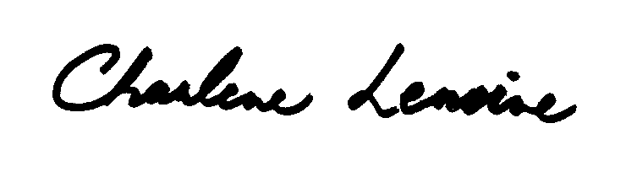
Charlene Lemoine
Waste Issues Representative
Waukesha County Environmental Action League (WEAL)

Sent via email on 4/15/2010

(1) GAIA : Organizations signed onto No Incentives for Incinerators statement
www.zerowarming.org/article.php?id=248

(2) Plasma Gasification Plan Goes Up in Smoke for Sacramento, Calif. Government Technology Jan 19, 2009, By Chad Vander Veen, Associate Editor
http://www.govtech.com/gt/588496

(3) An Industry Blowing Smoke: 10 Reasons Why Gasification, Pyrolysis and Plasma Incineration are Not "Green Solutions" - Global Alliance for Incinerator Alternatives (GAIA) 6/09
http://nobiomassburning.org/docs/Industry_Blowing_Smoke.pdf

(4) Moving Toward Zero Waste: A Shared Vision for Wisconsin’s Future
http://dnr.wi.gov/org/aw/wm/vision/futureofwaste.pdf

(5) San Francisco Zero Waste http://www.sfenvironment.org/our_programs/overview.html?ssi=3

