Kidneys and Protein in the Urine!

- Our two kidneys are filters

- What if we have protein in the urine? … this is a digestive problem! … It means the digestive organs are NOT making enough protease to digest our proteins properly and undigested protein goes into the urine, which can damage the kidneys.
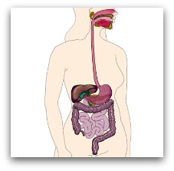


- What causes this lack of protease? … it is very common in the aging digestive system. Many people find it essential to supplement with digestive enzymes as the digestive system ages and does not produce as many enzymes as it used to.

- There are three different members of the protease family located at three key locations in the digestive system:
  - In the stomach we have gastric acid protease
  - At the first part of the small intestine another member of the protease family breaks protein molecules into even smaller pieces
  - In the lower part of the small intestine a third protease breaks the protein molecules into amino acids which are then absorbed.

Solution:
A. Diet:
Eliminating protein is NOT the answer … the body MUST have adequate protein for the health of the tissue of each cell.
- Animal based protein is the most difficult for the body to digest, and therefore should be decreased
- Vegetable based protein is an easier form of protein to digest, and therefore should be increased
- Soy protein powder is predigested and the easiest form of protein for the digestive system to utilize, and therefore is highly recommended in generous amounts

B. Supplement with Digestive Enzymes
- To effectively address the problem take a Multi-Digestive Enzyme Supplement. Shaklee EZ-Gest is a perfect option. It contains all of the MAIN ENZYMES required to digest food:
  - Three Protease for digesting protein
  - Lipase for digesting fats
  - Amylase, Lactase and Alpha-galactosidase for digesting carbohydrates

