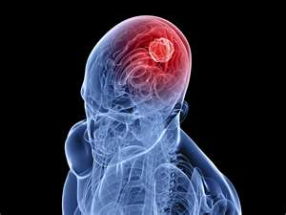
Brain Tumour

When a brain tumour develops, it means normal cells are multiplying – can be benign or malignant.

This can be caused by a variety of things. It is not the same cause in everyone. Common causes include:
- Accumulation of heavy metals
- Accumulation of toxins
- Nutrient deficiencies
- Poor circulation to the brain

Accumulation of Heavy Metals: A hair analysis will reveal if heavy metals are a problem. To order a hair analysis, call Martha Willmore @ 905-871-4281. If heavy metals are present, chelation therapy is advised. Call the number above for chelation suppositories.

Accumulation of Toxins: Detoxification is always advised for good health, brain tumour or not. But definitely this is imperative when abnormal cells have formed.
- There are several cleanses that can be done
- Daily detoxification:
  - Optimize water & fibre
  - Daily Probiotics – Shaklee Optiflora
  - Whole body detoxifier – Shaklee Herbal Laxative
  - Blood purifier – Shaklee Alfalfa
  - Liver detoxifier – Shaklee DTX

Nutrient Deficiencies: Optimal supplementation is always in order for those who wish optimal health. We recommend the Shaklee Rx for a Healthier Life

Poor Circulation to the Brain: To improve circulation to the brain, the following supplements are beneficial:
- Vitamin E (in Vitalizer … you can increase if you choose)
- Lecithin
- CoQHeart
- OmegaGuard (in Vitalizer … you can increase if you choose)
- Mental Acuity
- Alfalfa

