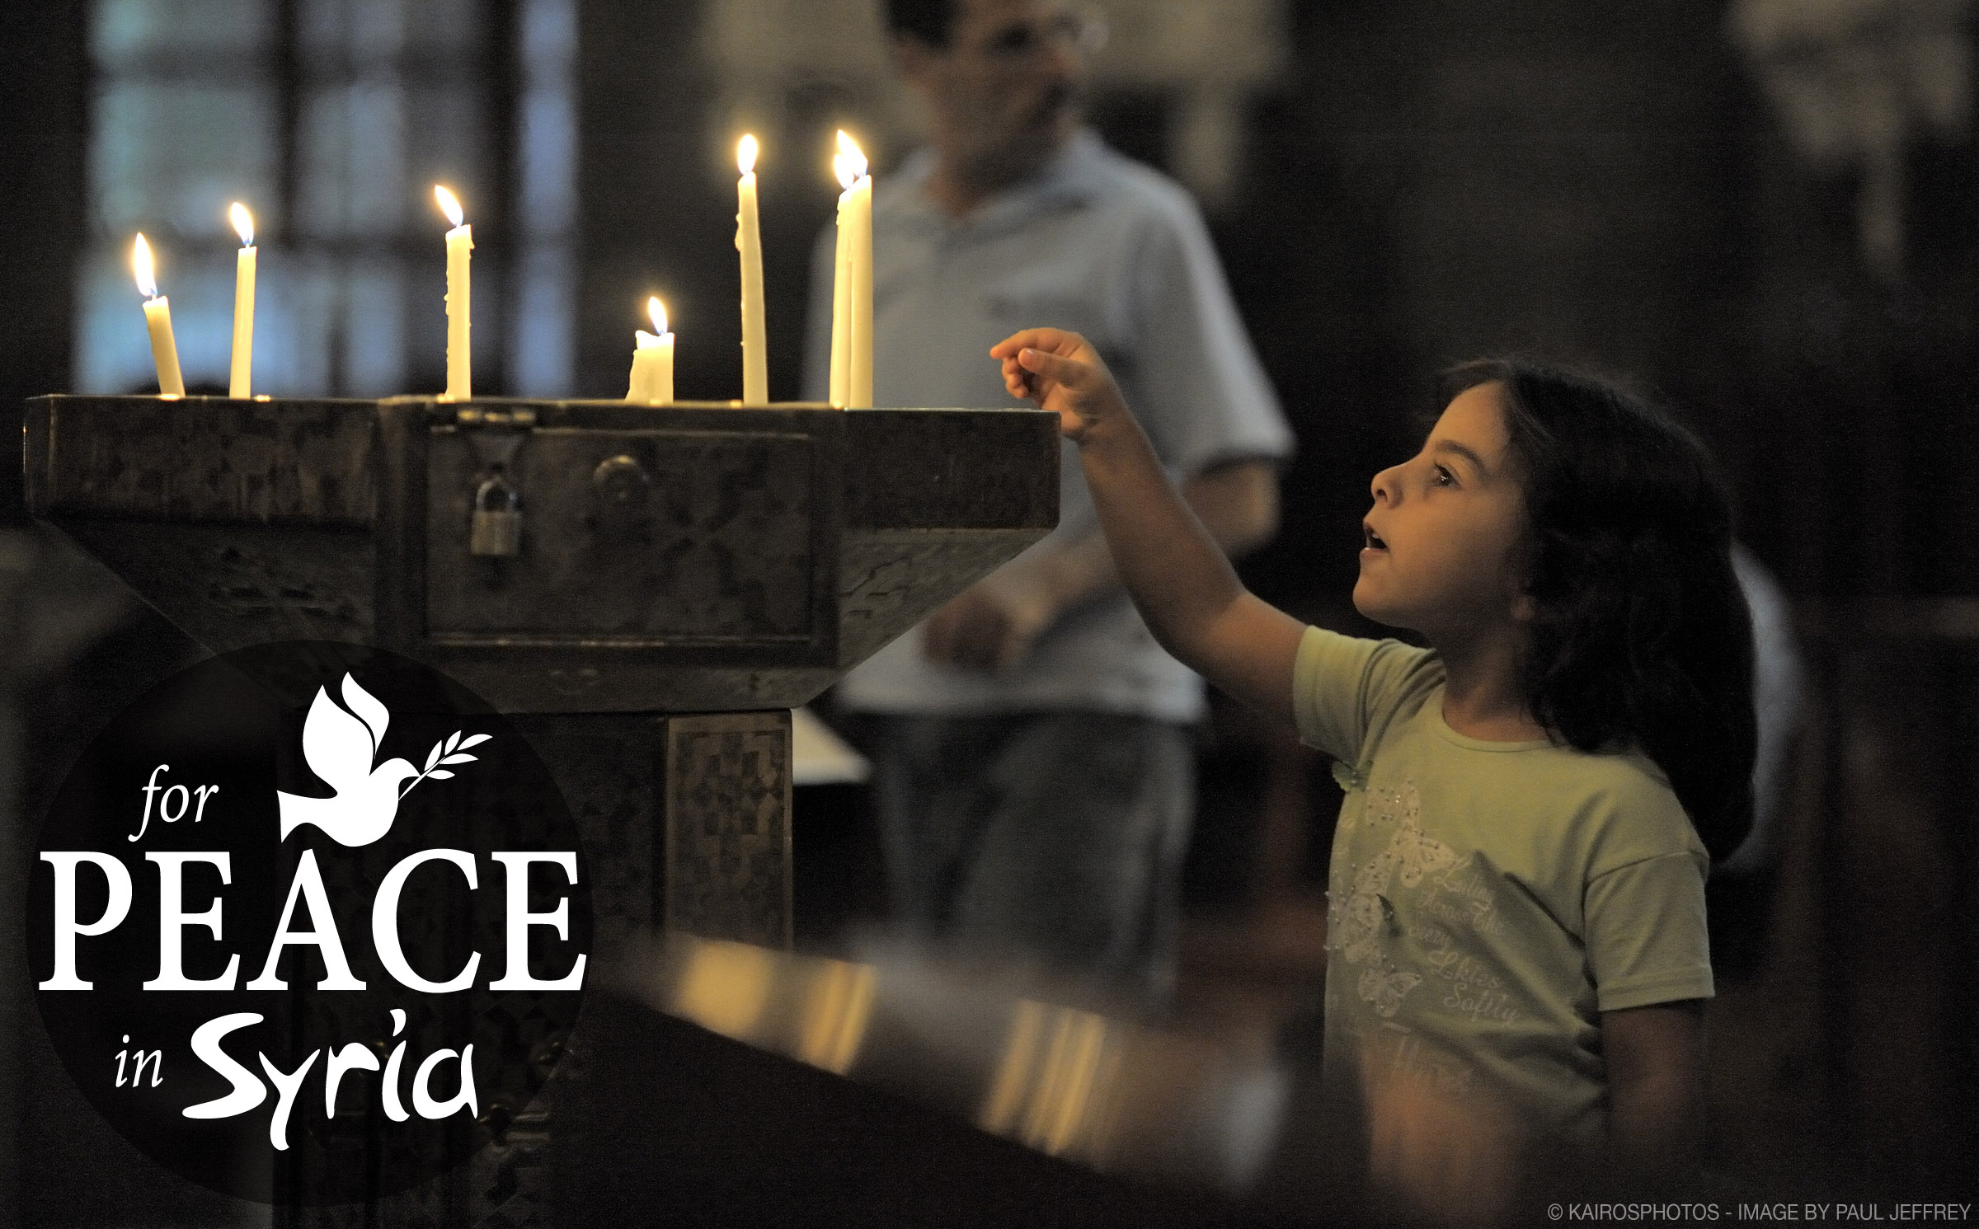
A Prayer for Our World in Light of the Crisis in Syria
Rev. D J del Rosario, a Minister in the United Methodist Church

Sacred One,

We confess to you that we are often blind to the plight of our neighbors.
Instead of turning the other cheek, we look the other direction.
Rather than hearing the cry of the oppressed, we turn up the volume in our lives.
Rather than be prophetic, we heap words that are meaningless to make us sound good.

There are people dying in Syria - suffering, displaced, lost.
The innocent go to bed each night, afraid of what the darkness will bring.

We pray for peace in Syria.
We pray for those in power.
We pray for those who are suffering.

We pray for leaders who must make difficult decisions.

Will you join us as we pray and fast this day?
Will you change what is happening in Syria,
as you sit in the ashes with the innocent, the suffering and the lost...

We don't know the answers, but we know that you do.

Please draw us closer to you.
Please hear our prayers.
Please show us your way.

Free us for joyful obedience, not because of what we can do...but because of who you are.

Amen
September 7, 2013
Homer United Methodist Church joins with our sister churches of the Greater Northwest Episcopal Area and Christians around to world to fast and pray for peace in Syria.

A Prayer for the World and Its Peoples
The United Methodist Book of Worship #526

O God, you are the hope of all the ends of the earth, the God of the spirits of all flesh.

Hear our humble intercession for all races and families on earth,
that you will turn all hearts to yourself.

Remove from our minds hatred, prejudice, and contempt for those who are not of our own race or color, class or creed, that departing from everything that estranges and divides, we may by you be brought into the unity of spirit in the bond of peace.

Amen.

A Prayer for Peace
The United Methodist Book of Worship #520

Remember, Prince of Peace, the people of the world divided into many nations and tongues. Deliver us from every evil that obstructs your saving purpose, and fulfill your promises of old to establish your kingdom of peace.

From the curse of war and all that creates it,
O Lord, deliver us.
From believing and speaking lies against other nations,
O Lord, deliver us.

From narrow loyalties and selfish isolation,
O Lord, deliver us.
From fear and distrust of other nations, from all false pride, vainglory, and self-conceit,
O Lord, deliver us.

From the lust of the mighty for riches that drive peaceful people to slaughter,
O Lord, deliver us.
From putting our trust in the weapons of war, and from want of faith in the power of justice and goodwill,
O Lord, deliver us.

From every thought, word, and deed that divides the human family and separates us from the perfect realization of your love,
O Lord, deliver us.

Amen.

Christ’s Example of Peace
For to us a child is born, to us a son is given, and the government will be on his shoulders. And he will be called Wonderful Counselor, Mighty God, Everlasting Father, Prince of Peace. Isaiah 9:6

Peace I leave with you; my peace I give you. I do not give to you as the world gives. Do not let your hearts be troubled and do not be afraid. John 14:27

“I have told you these things, so that in me you may have peace. In this world you will have trouble. But take heart! I have overcome the world.” John 16:33

Hymns of Peace
Sometimes our most sincere prayers are those that we sing. The words of these hymns, whether sung or spoken, lift our desire for peace to God’s ears.
TFWS 2048 God Weeps
TFWS 2171 Make Me a Channel of Your Peace
UMH 426 Behold a Broken World
UMH 428 For the Healing of the Nations
UMH 431 Let There be Peace on Earth
UMH 437 This is My Song

The United Methodist Book of Discipline ¶165.C
We believe war is incompatible with the teachings and example of Christ. We therefore reject war as an instrument of national foreign policy. … As disciples of Christ, we are called to love our enemies, seek justice, and serve as reconcilers of conflict. We insist that the first moral duty of all nations is to work together to resolve by peaceful means every dispute that arises among them.

