NEVER Pressure Wash A Deck!
I tell my neighbors. I tell my clients. I tell everybody who will listen. NEVER pressure wash a deck! When the pressure-wash companies send their college kids to knock on my door to "wash" my deck, I tell them why they should not be doing that to decks! When I see their trucks*, they advertise cleaning decks, patios, siding, roofs - you name it! Don't do it!
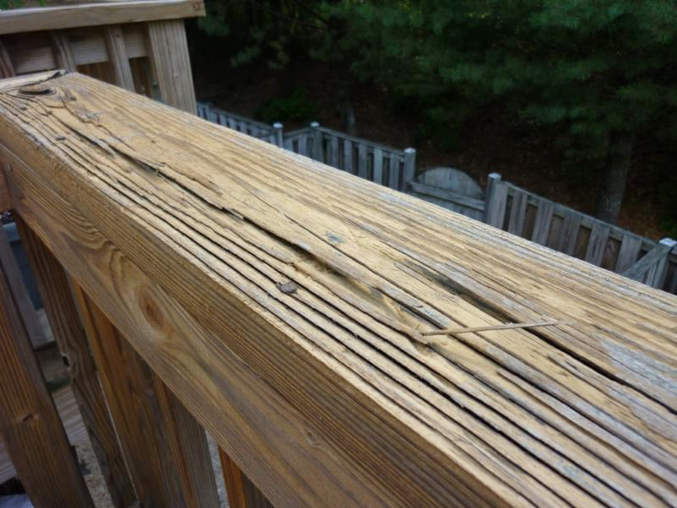
The older the deck, the worse the wood reacts to pressure washing. The big mistake is that companies and homeowners have a tendency to set the pressure way too high. But even at low pressures the deck can become damaged.
What does pressure washing decks do?
- It removes loose material and leaves a gafillion dangerous splinters and gaps. Those gaps open up further letting in more damaging sun and water.
- It removes the natural oils in the wood that are not replaced with sealants.
- It causes wood to dry quickly causing cupping and warping.
- It causes damage.
- It loosens nails as the wood expands.
- It can cause water to enter the house.
So what to do instead?
There are various, excellent, gentle cleansers out there. Be sure to select cleansers that do not have caustic lye or acid, or say not to use around children, pets or water features. A company called Dekswood makes an excellent cleanser that can be followed with sealants. And the so-called "oxygen" cleansers, with the active ingredient of sodium percarbonate, are great and don't damage the wood, the kids or pets, the house or the yard.
You MUST seal your deck after cleaning. The sun does more damage to your deck than rain and snow. BE SURE TO USE A SEALANT THAT HAS UV INHIBITORS IN ADDITION TO WATER PROTECTION. Read the label. It will tell you what the contents are. Water proofing alone is not enough.
My recommendation: Keep your deck gently cleaned and protected and it will last many decades. Not doing so makes it unsafe and age much faster.

* I once gave my spiel to a guy sitting in his company truck in a parking lot (with a smile on my face) and he told me he would NEVER pressure-wash his deck. He said he sees what damage it can do later!
Jay Markanich Real Estate Inspections, LLC
Based in Bristow, serving all of Northern Virginia

