Worship Workshop – Mt. Beulah/Lake City
Rev. Carleathea Benson, Pastor
Rev. Angela Ford Nelson, Facilitator

“Meaningful Worship Through Pastor and Worship Committee Teamwork”

May 18, 2019

- Opening Worship – 5 Minutes

- The Gathering

- The Call to Worship
L: We have gathered here Lord from different churches, from different families, and from different parts of our community. Yet, we have all gathered in Your Name.
C: Lord, come and abide with us we pray.
L: Father, we are Your children, called by Your Name. Teach us to lead your people in faithful worship.
C: Lord, come and abide with us we pray.
L: Jesus, we want to tell the story of your saving grace and your tender mercies. Lead us in Your Way!
C: Lord, come and abide with us we pray.
All: Show us Lord, how to lead Your church in joyful praise to You! Lord, come and abide with us we pray! Amen!
- The Opening Song – “Blessed Assurance, Jesus is Mine” UMH 369

- The Opening Prayer

- The Passing of the Peace

Congratulations!
You Have been Called to Serve!

Our Learning Goals (2.5 Minutes):
- Introduce you to the concepts of worship
- Overview of Responsibilities – Pastor and Worship Leader
- Provide you with tools to take back to your local church and community
- Enhance your confidence
- Have Fun!

Housekeeping (2.5 Minutes):
- Introductions
- Confidentiality is key here and there!
- Speak freely and openly and considerately
- Resources:
  - Leading in Worship, Taylor Burton-Edwards
  - Inside Out: Worship in an Age of Mission, Thomas H. Schattauer
  - Worship Committee Leader Article: https://www.umcdiscipleship.org/resources/worship-committee-leader
  - UMC Guidelines for Small Churches

Worship That Connects:
A Lesson from the Woman with the Alabaster Box
Jesus Anointed by a Sinful Woman – Luke 7:36 - 50
- ³⁶ When one of the Pharisees invited Jesus to have dinner with him, he went to the Pharisee’s house and reclined at the table. ³⁷ A woman in that town who lived a sinful life learned that Jesus was eating at the Pharisee’s house, so she came there with an alabaster jar of perfume. ³⁸ As she stood behind him at his feet weeping, she began to wet his feet with her tears. Then she wiped them with her hair, kissed them and poured perfume on them.
- ³⁹ When the Pharisee who had invited him saw this, he said to himself, “If this man were a prophet, he would know who is touching him and what kind of woman she is—that she is a sinner.”

- Must First Connect with Jesus
  - She came for an encounter with Jesus…
  - Jesus must be the CENTER of our Joy!

- Must Connect with the Everyone
  - Sinner and Saint, Young and Old, Rich and Poor…
  - Churched and Unchurched, The Leper and the “Healthy”

- Must Ultimately Connect with the “Heart of the Matter”
  - Love! Forgiveness! Acceptance!
  - And invite everyone to show that LOVE!

Key Content (40 Minutes) –

What is the Missio Dei? 2 Corinthians 5:18- 19

What is our role, individually and as a gathered community, in the Missio Dei?

The Missio Dei (Thomas H. Schattauer, “Inside Out” 3)
“The Missio Dei is God’s own movement outward in relation to the world – in creation and the covenant with Israel, and culminating in Jesus Christ and the community gathered in Him. This community is created by the [Holy] Spirit to witness to the ultimate purposes of God, to reconcile the world to God’s Ownself.”

Given this purpose statement - So what is worship?

Worship defined:
“Our worship in both its diversity and its unity is an encounter with the living God through the risen Christ in the power of the Holy Spirit.” (Book of Worship 13)

It is (Hickman 9 – 16, Schattauer 2):
- An Encounter
- A Drama of Life – but not a performance
- Requiring of a variety of God given gifts
- Central to our identity as the Church!
- It’s not done “Inside so we can go Outside!
- It’s Inside Out: It’s who we are as witnesses to the reconciling love of God!

What are the 5 Basic Principles of Worship (Hickman 17 – 19):
- God Word is primary
- Active Congregational Participation is Crucial
- Spontaneity and order are both important
- Relevant and Inclusive
- Worship is communion

Worship nurtures individuals, the gathered community, and the world with God’s Love!
Rev. Angela Ford Nelson

So what is the role of the Worship Committee?

Our Role: “It’s a Commitment”
- Commit to keeping God’s Mission at the forefront of all that we do

- Commit to prayer – so we know where God is, what He is doing, and the role He desires us to fulfill.

- Commit to teamwork:
- With the Pastor who is called to Sacrament, Word, Order and Service
- With other ministries: Drama, Choir, Worship Leaders, Ushers, Scripture Readers, Musicians…
- With the Congregation
- With each other

- Commit to learning
- Lectionary Study
- Asking Questions
- Finding, purchasing and using resources

- Commit to JOY!

My Job Description… https://www.umcdiscipleship.org/resources/worship-committee-leader
What is my job?
- Work with the pastor and others for vibrant worship of God.
- Lead the congregation in providing opportunities for worship celebrations that focus on God, help people of all ages grow in their understanding of the gospel, and become better equipped for daily living as faithful disciples.
Spiritual Gifts and Skills for this leader
Spiritual gifts: servanthood, teaching, exhortation (encouragement), leadership, wisdom, knowledge, faith, discernment, administration, evangelism, and shepherding
Experience, skills: Show evidence of passion for worshiping God and helping others worship through music, liturgy, and in personal and community practices. Useful skills for this position are the ability to listen to and communicate with people of all ages, interest in a wide range of worship experiences, interest in music and other worship-related arts, skills for researching worship issues, and sensitivity both to what makes worship effective and ways people relate to God.

What does this leader do?
- Maintain a growing and healthy spiritual life and lead others to do the same.
- Know the goals of the congregation in order to support and expand the ministry goals through worship. Learn about worship and the people in your congregation and community so you can develop with others worship opportunities appropriate to the community. The worship team must be sensitive to new worship styles and to congregational traditions.
- Coordinate with the pastor and other worship leaders. Support worship by identifying, training and supporting worship leaders such as acolytes, scripture readers, ushers, greeters, artists and others.
- Explore resources (United Methodist and other) for worship in order to recommend their use with children, youth and adults.
- Promote individual and family worship and opportunities for spiritual formation.
- Work with other ministry leaders so that worship celebrates the whole life of the congregation and community.
- Encourage a team approach to worship planning led by the pastor.

- Good Hope Wesley Chapel UMC – “The Church with a Big Heart”
  - Grown by 100 members in 3 years
  - From Part-time to Full-time Clergy Appointment

- Why? Intentional & Continuous Worship
  - Worship that is Spirit Led is also well planned and well executed
    - Our Worship Schedule

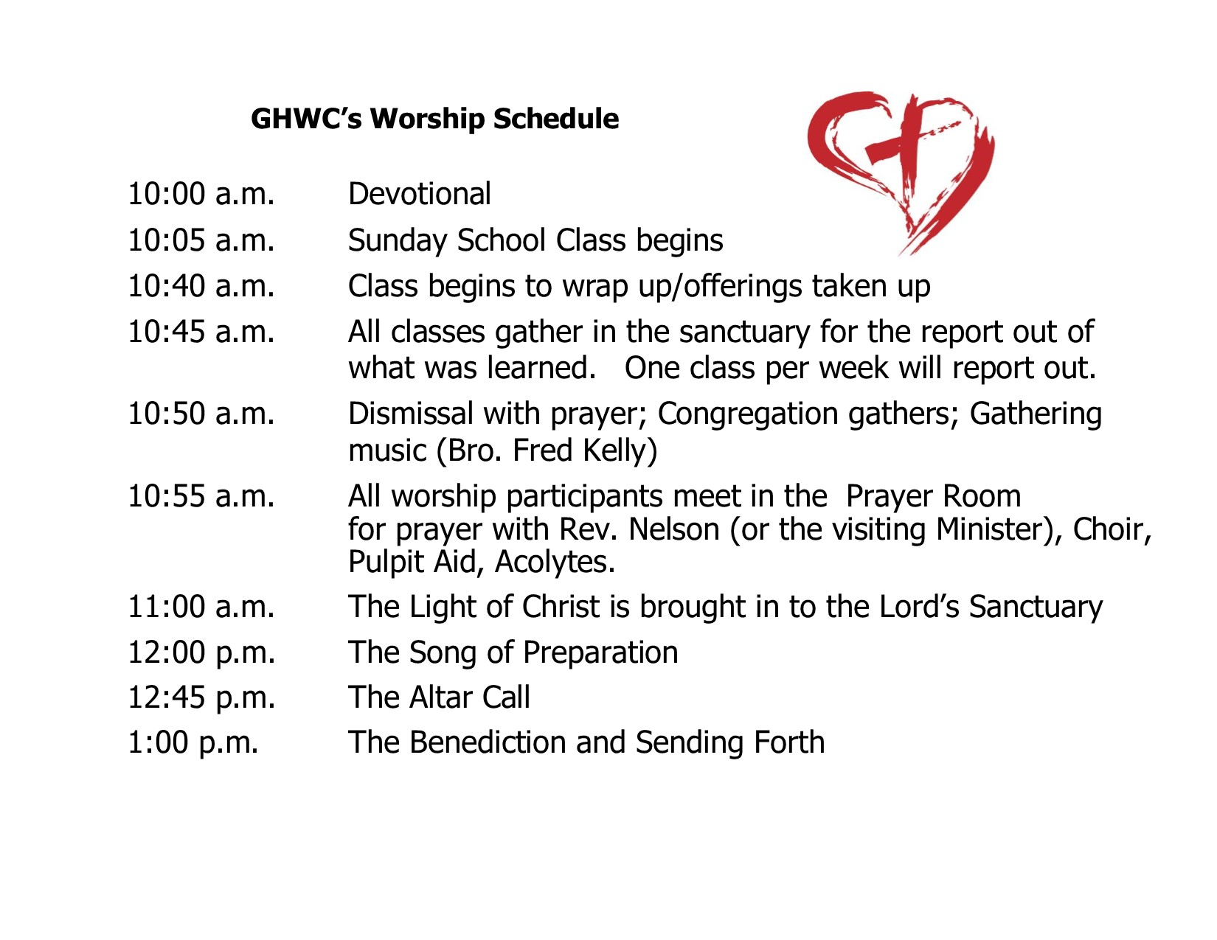

- A Focus on the Little Things
  - Candy for the children during passing of the peace
  - Visitor gifts are ready
  - Water is always in the Baptismal Font
  - Anointing Oil is always on the altar
  - The Altar is Touchable – Just like Jesus’ feet!
  - The Pastor is available at the altar after the benediction
    - Prayers continue
  - The lights don’t go off until the last person leaves…
  - Reflection and Correction…
- The Laity is a part of all aspects of worship – Means of Grace!
  - All Ages
    - Worship Leadership
    - Children’s Sermon Preachers
    - Scripture Readers
    - Choirs
    - Ushers, Greeters
    - Proclamation – Youth and Adults

QUESTIONS (7 MINUTES)

Sending Forth (3 Minutes)
Let us sing our closing song – Amazing Grace!
Leader: Go now in the Shalom and strength of Christ.
People: Thanks be to God!

