Weston on the Green  Neighbourhood Plan | 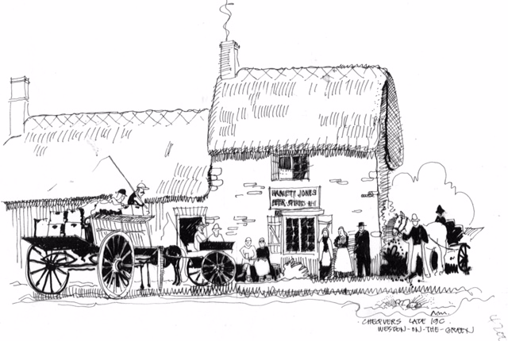

March 2017

The Neighbourhood Plan is in the closing stages of production, with the final proofs being signed off and the Parish Council will formally submit it to Cherwell.

The Planning body will either agree the Plan and maybe make comments/suggestions or it will be rejected. If agreed with suggested amendments, the Steering Group will make changes as advised by the CDC.

The NP will be formally published for consideration by statutory consultees for a six week period. This is known as the “Formal Consultation Period” and begins once Cherwell have come back with any amendments and we have altered the Plan as suggested by them.

Once the Formal Consultation Period is finished it will be submitted to the External Examiner for review and recommendations and if the External Examiner authorises the Plan it will go to the village to seek approval via a referendum.

We will keep the village informed of all these stages via the website at http://www.wotgneighbourhoodplan.co.uk/ or go to Facebook.com, and search for Weston on the Green Neighbourhood Plan.

Dates of the next Steering Group Meetings:
NB: these are draft dates and are to be confirmed. Notices will be put up around the village before each meeting.

13th April 2017
11th May 2017

They are all held at 7.30 pm in the Village Hall and open to the public.
Alex Reid

