Nutrition Plus, Inc.
Emily Roark Patti Brenn Susan Morrell
(620) 221-2777 (620) 218-4994 (785) 224-4104
roark2@cox.net pattibrenn@cox.net smorrell12@gmail.com
www.nutritionplusinc.com
April is:
National Fresh Celery Month
National Garden Month
National Pecan Month
National Soft Pretzel Month
National Soy Month

Important dates to remember:

“Infant Feeding in the CACFP”

TBD - Topeka Workshop at library 6:30 pm
TBD – Winfield Workshop at Presbyterian church
6:30 pm
April 30 – Checks and direct deposits go out

Grocery shopping on a budget
Let’s save some money!!

- Cut your produce as soon as you return from the store. This reduces meal prep time during the rest of the week and makes you less likely to waste the food.
- Prepare your own food. When buying convenience foods, you are paying more for the labor. Try shredding your own cheese. Also, use tap water instead of bottled water.
- Keep real snacks in the house. Convenience items like chips are not only costly but are also empty calories and aren’t filling. You may be able to eat a half of a bag of chips but have you every eaten half a bag of apples? Ditch the chips for fresh fruit, carrots and hummus or string cheese!
2020

- Extend shelf life. Place a wet paper towel in the drawer with lettuce to help it last longer!
- Use up leftovers. Money is down the drain when you throw food out. Eat that leftover spaghetti for breakfast the next day! This goes for the pantry, too. Use that can of tomato soup and crackers for a fun snack!
- Use recipe puppy. Type recipe puppy into your search engine. It is a website that helps you decide what to do with the ingredients you have on hand. Type the random ingredients you have and it’ll come up with different recipes you can use! I tried it!!
- Freeze foods that you won’t use all at once to pull back out at a later time so they don’t go bad.
- Salvage foods before they go bad. Foods that are on the verge to spoil can make great foods:
Stale bread into croutons. Kale into chips. Ripe bananas into bread.
- Use digital coupons. Stores have many they don’t put into their flyers so google it before you shop!
- Have some go-to inexpensive meals to offset more expensive ones during the week. Pastas and rice dishes can be inexpensive. If you usually spend $15 per meal, have a couple $10 ones in your pocket for end of the week overspending emergencies.
- Go meatless. You don’t have to go full-vegetarian to utilize alternatives from time to time. Nuts and dries beans/peas can make great dishes and can help your wallet! Use
recipe puppy!

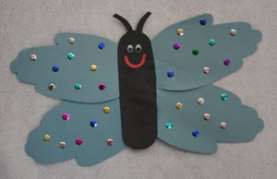
Handprint butterfly
You will need:
Construction paper
Googly eyes
Scissors
Glue
Sequins, glitter, stickers, markers, puff paint…
How to make a handprint butterfly
Trace your child's hands (with their fingers together) onto construction paper and cut them out. You will need two cut-outs of each hand (4 total).
Cut a long, thin oval out of a different color of construction paper for the body. You need the body to be long enough so that you can glue the wings to it.
Glue the wings to the back of the body so that they overlap slightly on each side.
Cut two antennae out of black construction paper and glue to the top of the body.
Cut a smile out of construction paper and glue to the body or use puff paint.
Glue on two googly eyes.
Decorate your butterfly with sequins, glitter, markers, etc.

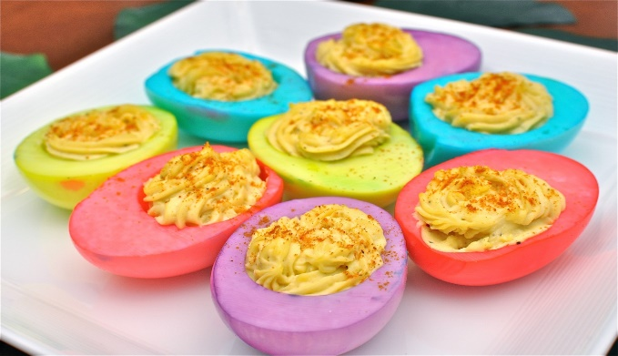

Colorful Deviled Eggs

12 large eggs
1/2 cup mayonnaise
2 tsp. pickle juice
2 tsp. mustard
4 tbsp. finely chopped dill pickles
Salt and pepper (to taste)
For the Deviled Egg Dye:
About 6-8 oz of water in a cup
1 tsp. white vinegar
Food coloring

To color your eggs:
Stir food coloring into cups of water in desired colors.
Add the vinegar to the colored water (don’t worry, you won’t taste the vinegar).
Gently place boiled and cut egg halves into the colored water.
Let the egg halves soak in the colored water for at least 10 minutes or until desired shade is achieved.
While the egg halves are soaking in food coloring, make the deviled egg mixture with the yolks
Using a spoon, gently remove the colored egg halves and place them on a stack of paper towels to dry.
Pat dry with additional paper towels
Fill with prepared egg mixture

Egg mixture:
Place eggs in a large saucepan and cover with cold water.
Set pan over medium-high heat and bring water to a boil.
Turn off heat, cover pan with a lid and let sit for 12 minutes.
Drain and rinse eggs under cold water.
Peel shells off of the eggs.
Cut eggs in half lengthwise and scoop out yolks into a bowl.
Add mayonnaise, pickle juice, and mustard to bowl, then mash the yolks and stir until mixture is smooth.
Stir in minced pickles and then season with salt and pepper.
Place the mixture in a large ziplock bag.
Cut the tip off of the ziplock bag (a DIY piping bag) and pipe the egg mixture back into the colored eggs shells

Thanks for being the best part of Nutrition Plus!
Emily, Patti & Susan

