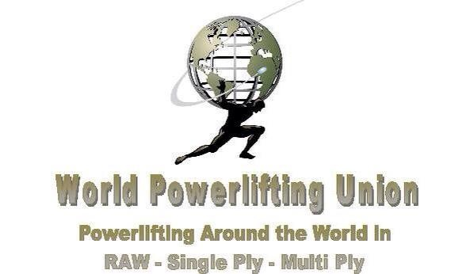

BRITISH POWERLIFTING FEDERATION
IPL –WRPF-WPU

British Qualifier CHAMPIONSHIPS

Sunday March 10th, 2019

ENTRY FORM
Strength Therapy 9 Choir Street Salford Manchester M7 12D

SURNAME ………………………………………………………………….

FIRST NAME/S ………………………………………………………………….

ADDRESS ………………………………………………………………….

………………………………………………………………….

………………………………………………………………….

POSTCODE ………………………. PHONE NO : …………….………….

NATIONALITY ………………………. D.O.B :………………… AGE : …….

MEMBERSHIP NUMBER .........................

Your e-mail address please……………………………………………….

BODYWEIGHT (Please circle bodyweight class)

Mens 52 56 60 67.5 75 82.5 90 100 110 125 140 140+

Womens 44 48 52 56 60 67.5 75 82.5 90 90+

I hereby agree to enter this competition on the following terms :

1/ That I take part entirely at my own risk and that there shall be no liability whatsoever on the part of the British Powerlifting federation , its officials, employees or agents for any loss, damage or injury suffered by me howsoever caused,

2/ That I know of no reason why I should not take part on the grounds of ill health,

3/ Entry form and fee to be sent to:
Mark Griffiths, 173 Ray Street Heanor Derbyshire Tel 07566201973 Email : marcusmro6@gmail.com
No later than 14th OF February 2019 .24hr Weigh-in on entry.

Signature : ……………………………….. Date : …………………..

I am the Parent / Guardian of ………………named above who is under 18 years of age and I confirm acceptance of the above terms on his/her behalf

Signature : …………………… Print Name : …………………………

FEES :Per Discipline
£25.00 Full Power
£25.00 BENCH ONLY
& Dead Lift only
All cheques to be made payable to Mark Griffiths or payable into account as follows sort Sort Code 09-01-29 Account 23762882 Santander .
173 Ray Street Heanor Derbyshire DE75 7GL

