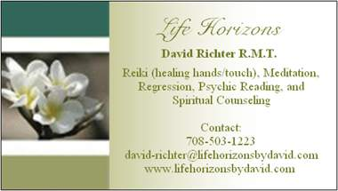

TIME
Time is usually referred to as a way of measuring events or a series of events. Time is also referred to as past, present, and future. In this document I will discuss Time as it relates to past, present, and future.
First I would like say that all we really have is the present or the Now. The past is done and the future doesn’t exist. This can be confusing for some so let me break it down. The past has ended and really has no importance in the present unless of course a person drags the past with. By dragging the past with I mean they constantly talk of the past and are worried how the past affects the future. This is not really necessary. There are some people who say we should honor people or masters of the past. I say instead of honoring them in the past do so in the present. To honor someone in the present even if they have long since died is really easy. All a person has to do is think about who they choose to honor. The living and those who have died will know that you are honoring them.
A little side note about death. We never die we just change. Each and every living thing that supposedly dies really just leaves its physical body to live as its true nature of spirit. We are spiritual beings having a physical experience. So all are loved ones are still alive and well they just don’t have a physical body. They are also more in tune with communication through thought so they will definitely know when we honor them. I could keep going on this topic but let us get back to time.
The future is not really a factor. I think everyone can agree that the future hasn’t happened. My theory is why worry about what hasn’t happened. By doing so the very thing that is being worried about is what will show up. Also the future has an infinite number of possibilities with that many options why worry about just one.
This brings us to the present. The present is going on right Now and it is always going on for eternity. To illustrate this take a moment and look around where ever you are at. Is there anything that is the past? Is there anything that is the future? By looking around you may notice that everything is current it is in this place and this time but not in the past or future. The past and future are really just concepts created by our own fears. As you read this are you reading in the past or future? More than likely you are reading this in the present or the Now. So give living in the Now a try.
Living in the Now or present may seem difficult especially when we live in a world obsessed with the past and future. Many times we live in the Now and don’t know it. For example when we are working on a task and there is nothing we are focused on but the task. It is moments when are thoughts are able to wonder that being in the Now is difficult. So this brings up a tool that I have suggested before monitor your thoughts and bring yourself back to the Now.
What is written here is just a very small sample of time. There have been whole books written on this subject. There have been Masters and Gurus and Spiritual Teachers and Scholars that have talked on this subject extensively. Some of those who have talked or written about time are Jesus, Albert Einstein, and Eckhart Tolle. Feel free to look up these and any others and you will find that most agree that all we have is NOW. As stated earlier, there are books on this topic and I have just given a taste about TIME.

