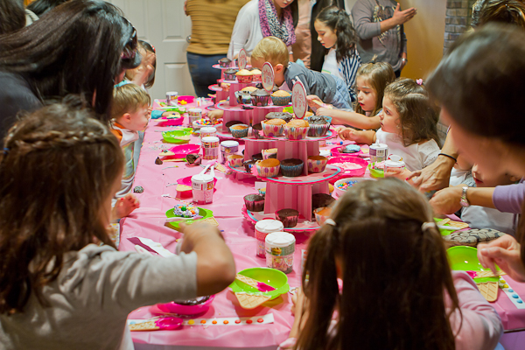
Bundles of Fun Cupcake Parties!!
We can offer a variety of different Cupcake Party packages to suit any age – we can customize your special party in your own home or venue to create a fun and memorable event for your child.
- Cupcake Decorating Party
Host a Cupcake Decorating Birthday Party in your home or venue. We will create decorating tools based on ages of group.
Cupcake Party: Includes 1.5hr service, setup, attendant(s) (based on size) and cleanup!
-Cupcake Bar: Includes all supplies, bowls, spatula’s, individual sprinkles, piping bags, icing and decorations.
♥ Personal Apron for each guest to wear & keep
♥ Personalized with name Apron for Birthday Girl or Boy to keep
♥ Chef Hat for Birthday Girl or Boy to keep
♥ 4 cupcakes for each guest to decorate and take home
♥ Pink or White Cupcake Box with inserts with personalized thank you
label (Loot gift) for all guests to take home their decorated goodies.

**No additional party favors required as each child will bring home:
-Their own fabric Apron
-Pretty cupcake box filled with their own decorated cupcakes

Bundles of Fun Cupcake Parties can also be customized for any event!

All Icing is homemade buttermilk icing, with choices of all colors !!

Birthday Cake – A special BIG Cupcake Birthday Cake can also be ordered for $50 for 12 people for all your birthday guests to decorate for the Birthday Boy or Girl’s Cake!

Cupcake Bar
Have a Cupcake Bar at your next party and let your guests make their own dessert!
You choose the flavors and the colors and I will bring icing, sprinkles and cupcakes as well as be on hand through the party to assist with the decorating.
*This package can be modified for any amount of people. Perfect for a birthday party, ladies night out, wedding reception or corporate event*

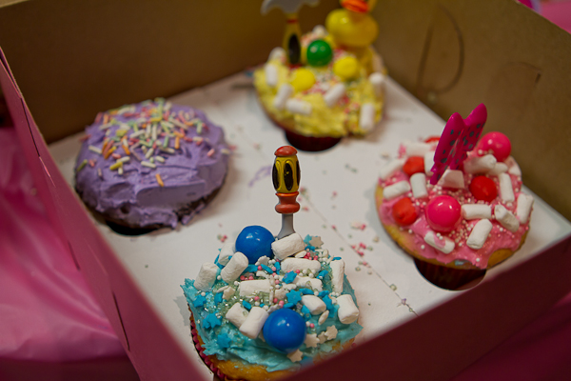
Prices:
Attended Parties with Host(s) $25 per guest minimum 8 guests per event.
Unattended Parties without Host ($20 per guest minimum 8 guests per event.

Book Your Party Early!
Weekend dates fill up quickly as Saturdays and Sundays are popular for parties.
**Bundles of Fun will cater to the Lower Mainland, some driving fees may apply for some distances.
﻿
50% deposit is required at time of booking. Deposit is non-refundable if party is cancelled 2 weeks or less before reserved date. Final head count must be confirmed no later than three business days before the party. You will be charged for the number of participants you originally booked.
Our products are not allergen free. Our products may contain some or all of the following common food allergens: milk, eggs, peanuts, tree nuts, soy and wheat. Please inform each of your guests of the foregoing allergen warning. Please let us know immediately prior to your party if any of your guests have food allergies and we can custom order allergen free products

