**4/20/19 Sue’s Rumpass in Bumpass Olympic Distance Race Report!**

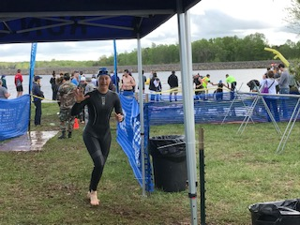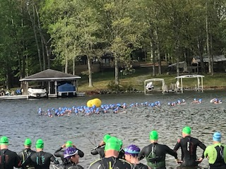

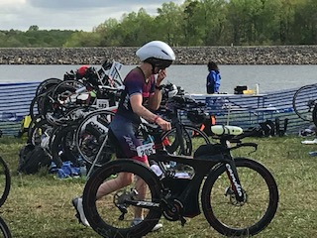

The women’s wave. That’s me!

This distance race “Olympic” or also known as “International,” is a 1500km swim (just shy of a mile), 25 mile bike, 6.2 mile run. The pacing of this shorter, more intense race is “always pushing” with continual pressure on the pedals. It has a very different feel in the body—it’s very demanding! Every-thing feels hard—always pressing, no letting up, unlike the more endurance focused longer races.

63o water temperatures, even with a wetsuit, can be intimidating if you let it! Once you get used to it, it’s actually quite refreshing! Getting in requires a tactic of getting everything acclimated to the cold: your feet first, then your face and neck, then rinsing your goggles. A cold face with cold goggles keeps the goggles from fogging up, even if you’ve used a “defogger” on the inside of the lenses. It sure helps to have the wisdom and confidence of experience!

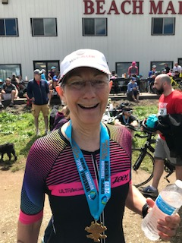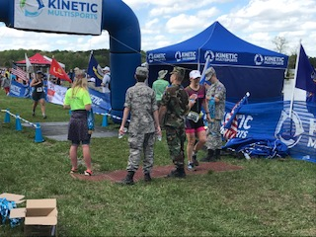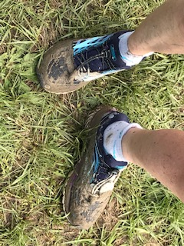

Lake Anna Beach Marina, Bumpass, VA

**1st Race, 1st Place!!**

Some may wonder why I put myself through all this, and I have asked myself this question several times before, early in my racing career. I learned first of all, to never ask myself this question while I’m racing!!! I challenge myself with races because I’m supposed to. It’s a piece and part of my life purpose. I challenge myself because I keep growing as a person by overcoming hard and difficult challenges and I learn to be solution-focused which brings resiliency and adaptability in the moment. I need these same qualities when facing the challenges of my everyday life!

I race to inspire others that fitness can be a way of life, that you don’t have to give up and get old, because truly age IS just a number. This time as I was racing I heard from others: “I want to be you when I’m 68!” “You’re a Rock Star!” (said as I was passing them on the bike!), and “You’re an inspiring role model!” I was the oldest woman and I passed many on each of the swim, bike and run legs.

The beginning and end of the run was through hilly grass paths, and through the woods where there were several sections of deep mud puddles! I had moments of slipping and sliding and there was no way around these puddles except to go through them! Just like life!! –Tough patches come where the only path you have, is straight through!!