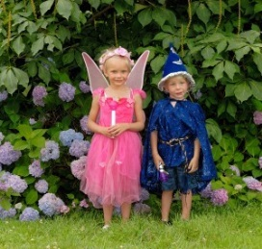
Fredericksburg’s Fall Fairy Festival
A Community Affair, percentage of proceeds to be donated to Charity!

Organized by Olde Towne Carriages hosted by Izaak Walton League.
Sponsorship, Craft, Vendor and Volunteer Registration
September 21, 2019
Registration Deadline: September 1st, 2019

Festival Hours - 12:00 pm to 5:00 pm.  Vendors are expected to be set up and ready to go by 11:30 am but may arrive and set up early.  - All Entertainers will receive a vendor spaces or spaces to perform in if they are not performing in the pavilion. Each space will be designated as a 10 x 10 ft., but there is plenty of space. If you need additional space for crafts or activities just let us know.  - Vendors must provide their own tables, chairs, and/or display racks. Vendors are permitted to bring a tent or other items that will help with their display. You may steak into the ground if needed.  - Electricity for performers will need to be arranged we will need to place you in certain areas.  - All entertainment must be approved by the festival organizer.  - Entertainers and their employees/volunteers must follow all rules set by the Izaak Walton League. No children will be unattended, parents must be with the children at all times. | RULES AND POLICIES  All entertainment must be pre-approved! Don’t assume if you do not get a confirmation call!  Once entertainment is approved booth space (if needed), and performance schedule will be determined as well as deposit and payment methods. Each Entertainer should plan provide all equipment needed to perform, i.e. sound system, etc. We are expecting over 2000 attendees this year.  Clubs, Non-profit organizations and other non-professional entertainment will be given a negotiated donation for performing at the festival.  You can be expected to be paid a down payment prior to the Festival and full payment at day of the Festival.  Please detach & return the form below with to:  Marriage Carriage and More, LLC  dba Olde Towne Carriages  22 Marchant Dr.  Fredericksburg, VA 22406

Craft, Vendor and Volunteer Registration – Fredericksburg
Business Name: | Individuals Name:
Address: | Type of Entertainment:
Email Address:  Phone number: | Fees:
Length of show: | Do you need Electricity, we also have personal microphones?
For further information, please contact event organizers at: info@oldetownecarriages.com at 540-371-0094 Chris. Location of Festival will be 12432 Herndon Rd. Spotsylvania, VA 22443

