The Five Tibetan Rites
Make Your Body A Tuning Fork For Optimum Health And Satisfying Relationships...

The Five Rites Exercise Program
This program is often described as a modified yoga program. Simply put, yoga is a science that unites the body, mind and spirit. Today this is often called Mind/ Body Healing. The author of the book believes that yoga was brought to Tibet from India in the 11th or 12th century and that Tibetan monks over time developed modified these exercises and developed an effective program of exercises that western society now calls the "Five Tibetan Rites". The rugged mountainous conditions these monks live in may well account for their particular emphasis on vigor. Many of the yoga exercises and practices being taught in the western world today are very new. The "Five Tibetan Rites" are exactly what the ancient Tibetans developed over many centuries of time. Therefore it's very important to do the "Five Tibetan Rites" exactly as they are presented without altering the form or sequence to achieve some of the benefits accrued to these "Rites".

The Five Tibetan Rites
Rite #1
Stand erect with arms outstretched horizontal to the floor, palms facing down. Your arms should be in line with your shoulders. Spin around clockwise until you become slightly dizzy. Gradually increase number of spins from 1 spin to 21 spins.
Breathing: Inhale and exhale deeply as you do the spins.

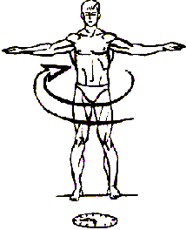

Rite #2
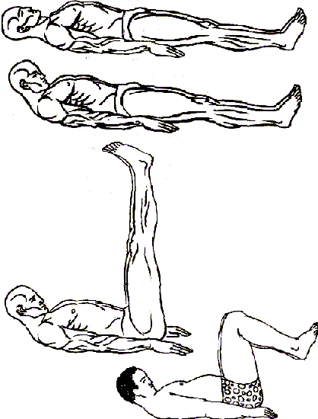
Lie down flat on the floor, face up. Fully extend your arms along your sides and place the palms of your hands against the floor, keeping fingers close together. Then raise your head off the floor tucking your chin into your chest. As you do this, lift your legs, knees straight, into a vertical position. If possible, extend the legs over the body towards your head. Do not let the knees bend. Then slowly lower the legs and head to the floor, always keeping the knees straight. Allow the muscles to relax, and repeat. The last pictures shows modification if your lower back bother you.
Breathing: Breathe in deeply as you lift your head and legs and exhale as you lower your head and legs.

Rite #3
Kneel on the floor with the body erect. The hands should be placed on the backs of your thigh muscles. Incline the head and neck forward, tucking your chin in against your chest. Then lean forward as far as possible, bending at the waist, with head well forward and chin on chest. Then throw the head and neck backward, arching the spine. Your toes should be curled under through this exercise. As you arch, you will brace your arms and hands against the thighs for support. After the arching return your body to an erect position and begin the rite all over again.
Breathing: Inhale as you arch the spine and exhale as you return to an erect position.
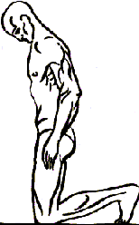
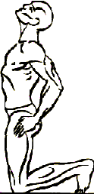

Rite #4
Sit down on the floor with your legs straight out in front of you and your feet about 12" apart. With the trunk of the body erect, place the palms of your hands on the floor alongside your buttocks. Then tuck the chin forward against the chest. Now drop the head backward as far as it will go.
At the same time raise your body so that the knees bend while the arms remain straight. Then tense every muscle in your body. Finally let the muscles relax as you return to your original sitting position. Rest before repeating this Rite.
Breathing: Breathe in as you raise up, hold your breath as you tense the muscles, and breathe out fully as you come down.
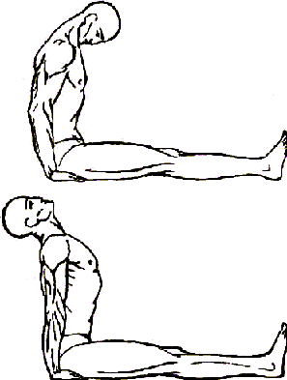

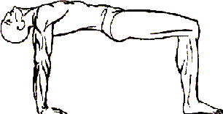

Rite #5

Lie down with your face down to the floor. You will be supported by the hands palms down against the floor and the toes in the flexed position. Throughout this rite, the hands and feet should be kept straight. Start with your arms perpendicular to the Floor, and the spine arched, so that the body Is in a sagging position. Now throw the head back as far as possible. The, bending at the hips, bring the body up into an inverted "V". At the same time, bring the chin forward, Tucking it against the chest.
Breathing: Breathe in deeply as you raise the body, and exhale fully as you lower the body.

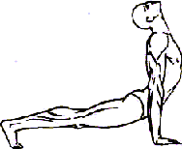

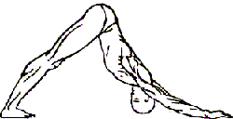

Beginning the "Five Rites" Exercise Program
- For the first week, and only if your are relatively healthy
- and fit, do each exercise three times.
- If you are inactive, overweight, or have health problems begin these exercises doing one of the first three each day, and only if you feel totally comfortable doing this. Later in this article I will describe exercises you can do to help yourself strengthen so you can begin to do the "Five Rites". If you have any concerns whatsoever, please consult with your physician. Individuals on serious medications should consult with their physicians.
- If you are overweight do not do Rites #4 and #5 until you have developed some strength and endurance. Do the substitutes for #4 and #5 until you yourself feel ready to begin doing #4 and #5 of the "Five Rites".
- Do only what you feel comfortable doing. That may be only one of each exercise for the first week. Build up to two of each exercise the second week, three of each exercise the third week, etc. or at a faster pace only if your body does not hurt when you do these exercises.
- 21 is the maximum of each exercise you should ever do. If you want to enhance your program, do the exercises at a faster pace, but do not so more than 21 of each exercise each day. Doing more than 21 repetitions of each exercise in any day will affect your chakras negatively and can create imbalances in your body.
- The "Five Rites" may stimulate detoxification and often creates many unpleasant physical symptoms. This is why it's recommended to increase the number of each exercise gradually on a weekly basis.
- If you have not exercised for some time, prepare to begin your "Five Rites" exercise program by walking daily, for a half hour each day if possible. Another alternative in preparation for the Five Rites is a stretching program with a gradual increase in the types of stretching exercises and the duration of this program.
- A sugar free and low fat diet is an important support when integrating the "Five Rites" exercise program into your life. Also check for Digestive Food Sensitivities and eliminate all foods you do not digest easily.
- Do the Five Rites exercises every day. The maximum you should skip is one day each week. If the exercises are done less than six days each week, the results will be greatly reduced.
- If on certain days your time is limited, do 3 repetitions of each exercise. This takes less than five minutes.
- For maximum benefit, do the exercises before breakfast in the morning, if at all possible. If this is not possible do them anytime during the day.

