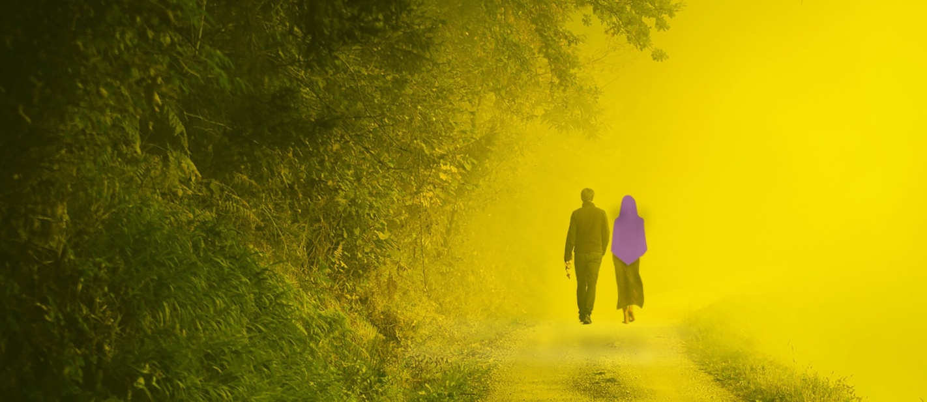
A STROLL IN ECSTASY
by Ted Harasti, President, Queen of the Holy Rosary Shrine,
Creative Director and Project Manager for The Rosary Path at Marylake
Manresa – Summer 1974
At work, Fridays would always drag on; but, this particular Friday was everlasting. Driving home, the expressway seemed endless. It was the summer of 1974. The weather was hot. The traffic was stop-and-go. I was thinking about the retreat which I had booked for this weekend.
I had been on a silent retreat once before, many years earlier. However, since then, I had put on hold all but my core spiritual devotions as I was working at several jobs to make a down payment for a home. I had also been working with my friend, John Rooney, to establish in Canada “The Right To Life Committee”. As a result, there had been no time for such spiritual luxuries as a weekend retreat let alone a day alone to pray and reflect. Now having achieved these goals, I sought to re-establish my normal spiritual practices. This retreat would be a welcome opportunity to rekindle those devotions and to reflect on the path ahead.
Arriving home, I quickly showered and dressed. I grabbed the suitcase which I had packed the night before. Bidding my wife and kids goodbye, I jumped back into the car again and set off toward Manresa Retreat Centre in Pickering, Ontario. The road leading to Manresa was natural and inviting.
There ahead, at the end of that road, was my refuge of truth. In the reception area, I was greeted by the retreat master. There with him were some people from my parish and my best friend, John Rooney. During our chat over coffee, I told John about how deeply I had missed my formal Marian devotions and how much I was looking forward to a public Rosary planned for the next day. John talked about his affiliation with the Legion of Mary and how glad he was to see that I had taken the time to come and to touch base with him. A few jokes and our expectations of the weekend was our last chance to talk until the end of the retreat. We said good night and retired to our respective rooms. The room was small but, it had an inviting aura to it -austere but neat:
a single bed beside the window, a small writing desk and chair, a lamp, and wash basin. On the desk was a copy of The Imitation of Christ by Thomas A Kempis and on the wall hung a small carved wooden crucifix. I had an extremely good and refreshing sleep. Having been used to four hours or less for the past several years, even eight hours would have been heaven. Those ten hours were bliss.
The bells awakened me - those same bells which were to signal the beginning of each segment of each days' itinerary. One by one the doors of our rooms opened and each of us in our own time strolled down toward the Chapel. After prayers, it was on to the dining hall. Like seasoned monks, we silently ate breakfast - passing condiments from one to another whether needed or not. Words were spoken only in response to prayer. Then the bells led us to prayers and then to the public Rosary.
Everyone gathered for the Rosary outside on the beautiful lawns which graced the grounds. I was at the rear with John beside me. As the leader began to recite the prayers, he began to walk. We each followed behind him in single file. The leader recited the first part of each prayer and we completed the lost port in unison. To my horror, each man began to race verbally through the response as though there were a prize for the first to finish.
Shattered and disillusioned, I left the group. I was left wondering: wondering about what value there was in haste when thoughtful meditation was the goal; wondering about how gravely we had wounded our Holy Mother by such superficiality? The nuns at St. Patrick's School, in Toronto, had taught us as students to pray the Rosary with a reverent and patient cadence. The idea was to meditate. How could that be done hurriedly? My mind reeling, I went back to my room. There, I sat at the desk for a short time, absently flipping through A Kempis' book. Unable to fix my mind on anything, I laid down. Praying to our Holy Mother. I drifted off to sleep even though I had been awake for only few hours.
And what a sleep! I found myself back on the retreat grounds, but I wasn't alone, and I wasn't walking. Standing erect, I was suspended about four feet above the ground gliding along at the pace of a stroll. Our Lady was beside me, walking with me as though we were the closest of friends. As one would walk in conversation with friend, there was no need to look at each other.
Our Lady spoke to me in earnest as though She had complete conviction that I would understand Her request and comply with it. When I say that She spoke, there was no audible conversation; but it was clearer than conversation. She made it known to me that She wished me to build a Rosary: not to 'make' one but to sculpt one. She also made it known that She felt there was a great need to design and build an environment which would encourage prayerful meditation upon the mysteries of the Rosary. As we 'walked', She 'spoke' very softly, completely explaining, to the last detail, the design and layout of the Rosary and its Path. The beauty of the sculpture and its natural environment together with the requirement of walking though the Rosary would encourage pilgrims to slow their recitation to a proper cadence for meditation. "Only then will people learn the lessons of His life which are revealed through the recitation of the Rosary."
As She ‘spoke’, we were in fact travelling its' Path. It was there before us just as She had explained. The magnitude of the work was awesome. I remember the tremendous. Overwhelming feeling of peace and serenity which surrounded this place. It stood on about one hundred acres of land filled with rolling hilIs, beautiful trees, a running stream, and wildlife in abundance. As you might randomly cast a conventional Rosary on the ground, so this Rosary wound through the countryside. This was not a man-made, manicured garden. Rather. it was natural landscape: very simple in its beauty, as you would find when walking through a wooded countryside. Simplicity was the keynote. Other than the sculptures, the only landscaped feature was the neat Pathway which was the Rosary - sufficiently wide to accommodate battery-powered vehicles for the handicapped two abreast. The Path was neither levelled nor built up but followed the natural terrain with simple wooden bridges in places where the Rosary Path crossed the stream or culvert.
The beads of the Rosary were about three feet in diameter with a kneeling notch carved into its side. The Path went from one bead to the next and the beads were spaced randomly, about one hundred feet apart…...joined with chain. Each link of that chain was two Inches long. The beads were cast In ceramic and glazed thistle purple with a large red flash -like a tongue of fire, opposite the kneeling notch.
The circle of beads joined at a large, beautiful fountain. In the centre of that fountain was a large sphere with large cut-out circles pierced through it. At its centre was a statue of Our Lady. Behind the sphere was a stained-glass panel and radiating from the panel were curved stainless-steel pipes projecting over the sphere, spraying water into the pool below. The circular pipe feeding the pipes was also made of stainless steel, about 3 inches in diameter. It also acted as a frame for the stain-glass panel. The Panel was multi coloured with a large Holy Spirit Dove in its center.
She told me that we hadn't started at the beginning so that I could have an overview of the terrain. As we continued towards the beginning of the Rosary, She pointed out that the “Our Father’ beads were to be oval and white. Across from and near each “Our Father’ bead were wooden, screened Gazebos where pilgrims could wait and meditate on benches, placed inside.
Our Lady explained this was only the first phase. After this stage had been completed and the Rosary Path had been opened to pilgrims, artists from around the world would come continually to work at the Rosary Path producing sculptures of the Mysteries of the Rosary to be placed throughout the grounds….close to the ‘Our Father’ Mystery beads. She told me, "Pilgrims who come here will be healed and enlightened. When they return to their home, they will practice the Holy Rosary as they have never done before. Many souls will be brought to my Blessed Son." As the Rosary Path Sculpture is a gift from Her to her most precious Son, Christ our Lord. Before parting, I asked where the Rosary Shrine should be built? "You will know," She said. Then just as I fell asleep, I awoke with a start.
My mind raced as I searched for a pen or pencil to sketch what I had seen. Then I bolted out of my room and raced for the front door. Was our Lady still here? No, it was a dream…. or was it? Questions thundered through my mind. I searched for someone to talk to. I saw my friend, John, walking in the gardens of the Retreat Centre. I stopped him by the shoulder. As he turned, I tried to speak. He looked at me strangely and then he held his finger to his lips reminding me of our pledge of silence. I shouted, "I have something fantastic to tell you!" Reluctantly, breaking the silence, he said, "Where have you been?" "What do you mean," replied. "We've been looking for you. Don't you realize that its Sunday at two o’clock? Everyone's getting ready to go home."
Then it dawned on me that I had been sleeping over twenty four hours – actually, about twenty eight hours. I'd never done that before. We found a secluded placed to talk and as I explained to him what I had seen, he laughed at me. In fact, he was rolling around on the ground, roaring with laughter. He didn’t understand my meagre attempt to describe the Rosary Path request. He thought I meant that I was going to build one about twenty feet long and that the person who was to praying it would have to lug it on his/her shoulder through the grounds.
When he had gathered himself, I explained further. It was only then that he became more sympathetic. He couldn't get over how I could have slept that long. He had thought I had decided to have a private retreat….. staying in my room. As we spoke, he became, again, my old reliable, John; affirming me and promising to get together to discuss these events again at a later date. Excited, we quickly left the retreat house for home. I was ecstatic, bubbling over with joy. I couldn't wait to get home and put down on paper everything that I had seen before I forgot the details.
Arriving home, I burst into the house. I must have sounded like a mad man, feverously attempting to explain the events of the week end. Within days I had finished a set of rough drawings and had begun building a model. Once I had completed this work, I began a period of reflection. Over several months, I viewed the model from every angle. It rested on two ping pong tables, each tree, shrub, and bead was to scale. I re-lived that wonderful journey many times.
Questions bombarded my mind: Was this a dream or a religious encounter? Was this something my subconscious had devised to bring attention to myself? Why was this project entrusted tome? There were many such questions. I decided to put the whole thing to the test of time. I dismantled the model and put away the drawings: not from loss of conviction but, simply because I knew that the time was yet not right.
Time passed, but the concept continued to pursue me. I found myself researching different methods of building large sculptures. I studied Fine Arts for three years at York University to refine my artistic abilities. Many years were taken up by starting the Right To Life. John Rooney and I travelled extensively, organizing. I added a few ideas of own: Keep in mind that these additions are mentioned only to show the endless possibilities... building and completing The Rosary Path remains and always will be the primary goal...God willing, the following is possible. Why not a family, private, lay-run retreat? We would develop the concept around a Family campground tor Christians. In today’s society, the family seems to be disintegrating. This would be a great place for families who are in trouble - a place to get back to basics; a chance to have God, nature, community and fellowship heal their troubled lives, With the Rosary as the focal point.
Many Souls would be brought to Christ. We eventually envisage trailer sites, cabins and even a Lodge like setting…. for those not into camping and for the infirmed. The environment we wish to create would be as stress-free and as un-regimented as possible - a place for families to rest, to meditate and to enjoy nature. The revenues which may follow will be used to faster devotion to Our Lady and to help the poor.
The concept is exciting. It has boundless potential for rekindling Christian teachings. Many years have passed since the Rosary dream began. The dream goes on and will be realized. Neither its cost nor size will ever deter realization of it. Let us join hands and hearts and complete the build together. My faith in God is boundless. Let His will be done.
I had a stroll in ecstasy, and I would love to have others experience it too.
Queen of the Holy Rosary Shrine
50 Cluett Drive
Ajax, Ontario L1S 7C3 Canada
Phone: 905-995-6302 | Email: holyrosaryshrine@sympatico.ca

