Summer
- Explain to your child that we are moving into a new season called Summer.

- Talk about the change of weather and that it usually is hotter in the summer. Model the Lámh sign for hot. (found on www.lamh.org). it consists of rubbing the back of your hand on your forehead from left to right and saying hot)

- Describe the characteristics of Summer by discussing the pictures below:

The website below plays a summer song that your child will enjoy.
https://www.youtube.com/watch?v=hfZ-438DrIs

- Print out the activity sheet below for child to complete.

- They ring the picture that is associated with summer. They then write the word underneath, by copying fee hand or with hand over hand assistance.

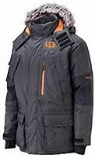

Summer Counting

Season Chart
- Cut out the below chart into 4 segments.

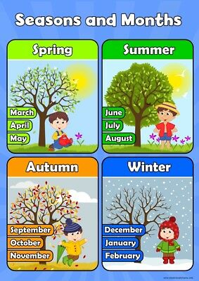
- Using glue and a cardboard sheet help your child to reassemble it chronologically and stick it back together.

