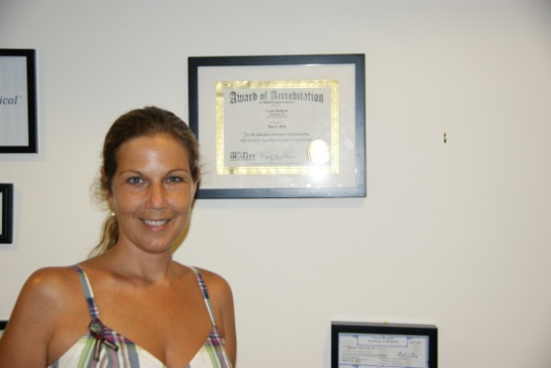 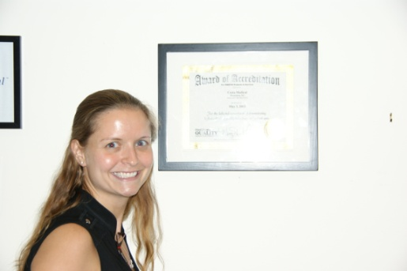

Amber Costa, RN, Co-Founder

/V.P of Communications and Operations

Suzanne Podolski, CEO, Co-Founder,

Inventor. Former ostomy patient

  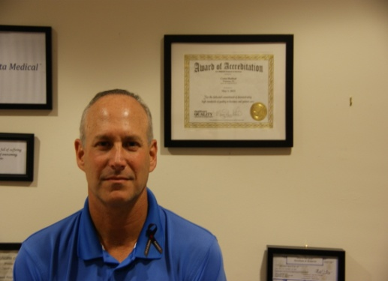

Steven M. Swartz, CPA

CFO & Taxation Officer

Larry Deutsch, MD,

Chairman of the Board

Orthopedic Surgeon.

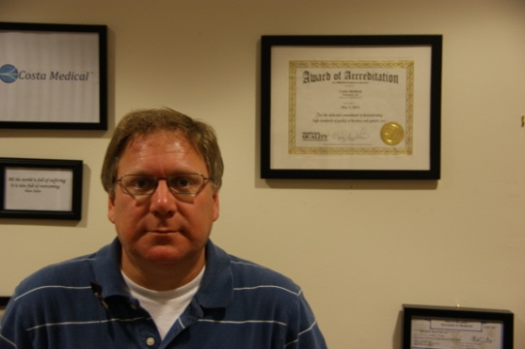 

Dr. David Schaffzin, Chief Medical Director, Colon Rectal Surgeon.

Robert Goldfarb CPA, MBA

Chief Operations Officer

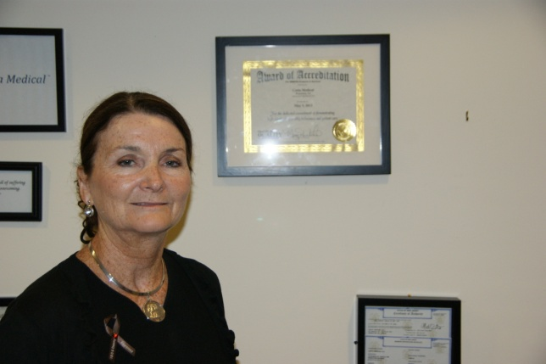

Dr. Andrew Camerota, Co-Inventor,

General Surgeon, Colon Rectal and Hernia

Meg Helms, MBA

President of Morgan Wallace Associates

Costa Licensing Agent



David Eisenbud, MD, MBA, FACS,

Consultant

Vascular and wound care physician