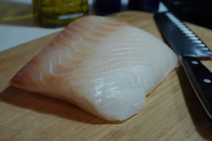

Common Names:
Pacific Halibut, Northern Halibut, Alaska Halibut

Scientific Name:
Hippoglossus Stenolepsis

Seasonal Availability:
March-November
Primary Product Forms
Fresh:
H&G, Fillets, Loins, Steaks, Fletches, Roasts
Frozen:
H&G, Fillets, Loins, Steaks, Fletches, Roasts
Locations:
Canada, Russia, United States

Product Profile
Flavor:
Texture:

