Homes By
EMERSON
DESIGN & DEVELOPMENT, INC.

New Construction - Bedford, NH
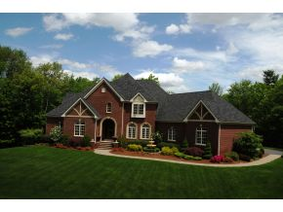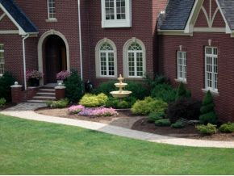
Front Elevation Brick Façade with Cast Accents

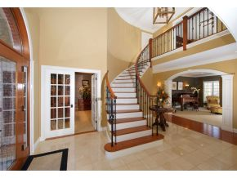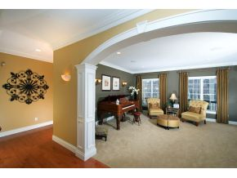
Foyer with Turned Staircase Custom Arched Opening

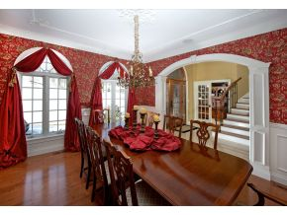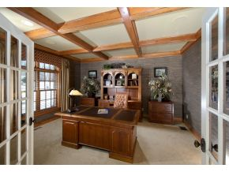
Dining Room Office (coffer ceiling)

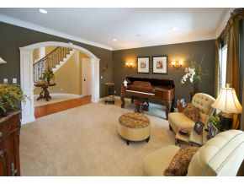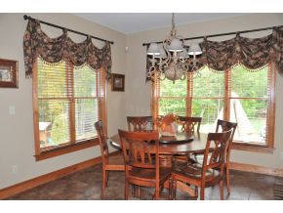
Formal Living Room Breakfast Area

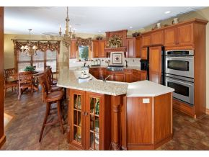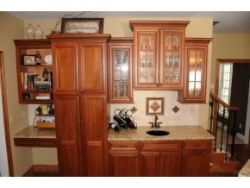
Gourmet Kitchen Kitchen Wet Bar

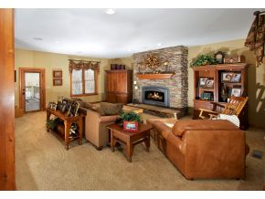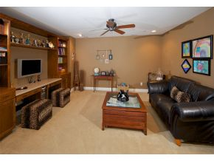
Great Room with Stone Fireplace Entertainment/Media Room

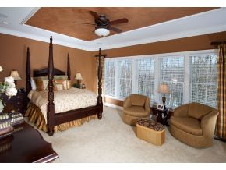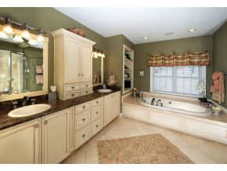
Master Bedroom Suite Master Bath Suite

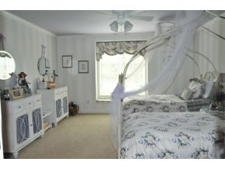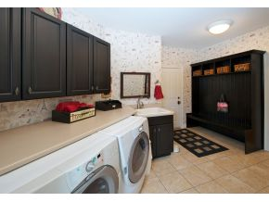
Bedroom Laundry/Mud Room

Project details:
Custom design French Country style home
Approx. 4,500 square feet
Four bedrooms
4 full baths & 2 half baths (custom tile/glass shower in master)
Gourmet kitchen with granite/“Corian ” tops
Marble entry foyer with turned staircase (2nd staircase in family room)
Three car attached garage
Cast iron gas fireplace with stone veneer
Brick façade with cast concrete accents
“Pella ” and “Andersen ” architectural windows (custom detailing)
Custom details through-out
Quality construction through-out (to many details to list)

