NORTH ISLAND COPPER PROJECT
The North Island Copper Project covers 7 known documented mineral occurrences, just north of the past producing Island Copper Mine.

BHP’s past producing Island Copper mine which produced 345 million metric tonnes @ 0.41% Cu, 0.017% Mo, 0.19 g/t Au, and 1.4 g/t Ag. During its prime operating period the Island Copper mine was Canada’s third-largest copper producer. The Mine produced about 1227 million kilograms of copper, 35,268 kilograms of gold, 360,800 kilograms of silver), 32 million kilograms of molybdenum and 236 kilograms of rhenium from 367 million tonnes of ore.

Showings on the North Island Copper Project
AMAZON

Locally Copper and zinc mineralization is present in rocks of the Karmutsen Formation, and based on other mineralization in the area (092L 159 - Little Joe), this mineralization is probably in a replaced limestone lens which is intercalated within the Karmutsen volcanics. A grab sample collected in 1980 assayed 4.12 per cent copper and 1.45 per cent zinc (Assessment Report 9811). FRANCES In the area of the old Frances showings, chalcopyrite, sphalerite and pyrite occur in skarn zones at the footwall and hangingwall contacts of a limestone band in Karmutsen volcanics.

CRANBERRY

Locally, quartz diorite and andesite dykes intrude Karmutsen Formation limestone, andesite and basalt. The sediments and volcanics strike 070 degrees and dips 35 degrees south. The Cranberry A showing is a 2.0 metre thick zone of skarn exposed for 60 metres along a lime- stone-andesite contact.
A grab sample from the showing assayed 3.180 per cent copper, 11.66 grams per tonne silver and 0.10 grams per tonne gold (Assessment Report 8284).
The Cranberry B showing is a 1.7 metre thick zone of skarn exposed for 27 metres along a limestone-andesite contact, and may be a faulted portion of the Cranberry A showing. Chalcopyrite and malachite are reported to be present.

RAINBOW

The Rainbow showings are spread out along a strike length of 500 metres and have widths of up to 18 metres. Skarn is erratically developed in narrow beds of limestone and along limestone-volcanic (andesite, basalt) contacts. The host rocks strike 070 degrees and dip 035 degrees south. Stratigraphically, the limestones and volcanics lie near the top of the Karmutsen Formation. The rocks have been intruded by andesite dykes and quartz diorite.

The skarn consists of grossularite disseminated with chalco- pyrite and minor magnetite ("brown ore") and hedenbergite, hornblende, tremolite, actinolite, ilvaite, magnetite and sphalerite and disseminated chalcopyrite ("black ore"). Two 18 kilogram samples assayed, respectively, 3.070 per cent copper, 0.11 per cent zinc, 66.85 grams per tonne silver, 0.02 per cent lead and 0.10 grams per tonne gold ("brown ore") and 4.88 per cent copper, 4.42 per cent zinc, 91.87 grams per tonne silver, 0.10 per cent lead and 0.14 grams per tonne gold ("black ore"), (Assessment Report 8284). Malachite can be found at surface.

CLIFF

Locally, quartz diorite and andesite dykes intrude Karmutsen Formation limestone and tuff which strike 070 degrees and dip 35 degrees south. At the West showing a 1 by 3 metre lens of skarn is present in limestone near a limestone-tuff contact. The skarn contains a high amount of disseminated pyrite and chalcopyrite.
Similar skarns, comprised of grossularite, are found nearby. A grab sample assayed 6.7 per cent copper, 44.6 grams per tonne silver and 0.309 grams per tonne gold (Assessment Report 8284).

BRANCH 7

Locally, limestone (Karmutsen Formation) is altered to skarn along limestone-andesite contacts. The skarn is rich in disseminated chalcopyrite and, in places, magnetite. Several showings are present within a 200 by 200 metre area. The largest showing (South Showing) is traceable for 35 metres, striking northwest and dipping 30 degrees south. Skarn is also developed along the margins of an andesite dyke. The limestone in this area has been metamorphosed to marble. A grab sample of the skarn containing chalcopyrite and magnetite assayed 5.75 per cent copper, 6.86 grams per tonne silver and trace gold (Assessment Report 8284).
The Branch 7 showing outcrops along a logging road. A grab sample of this skarn assayed 8.45 per cent copper, 65.13 grams per tonne silver and 0.69 grams per tonne gold (Assessment Report 8284).
The East showing is a small exposure 150 metres southeast of the Branch 7 showing and may be a continuation of that showing. A grab sample assayed 1.69 per cent copper, 1.31 grams per tonne silver and 0.34 grams per tonne gold.

SWAMP

Locally, hornblende granodiorite and an andesite dyke intrude Karmutsen Formation limestone. Skarn has formed at the granodiorite- limestone contact. The skarn is mineralized with grossularite, andradite, calcite, chlorite, quartz and magnetite and contains disseminated to massive pyrite, chalcopyrite and sphalerite with lesser galena and bornite.
The skarn is irregular in outline, having a sharp contact with the limestone and a gradual contact with the grano- diorite.
Diamond drilling in 1983 intersected 8.4 metres assaying 1.26 per cent copper, 7.72 per cent zinc, 57.25 grams per tonne silver, 0.28 per cent lead and 0.17 grams per tonne gold (Assessment Report 11407).

For further information contact Rich River Exploration Ltd.
Craig Lynes… email prospect@richriver.bc.ca Ph. 250-804-6189 or 250-833-2203

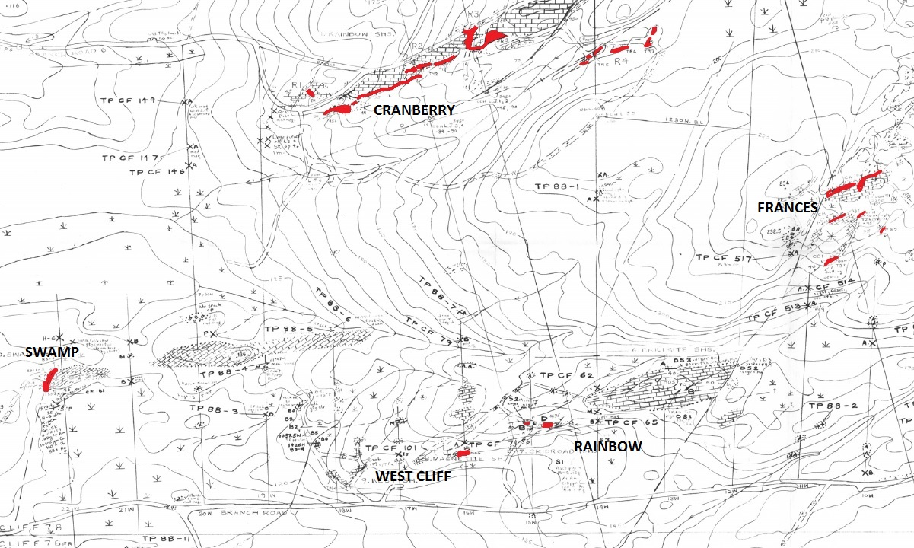
Map of claim area showing areas of copper silver zinc mineralisation

