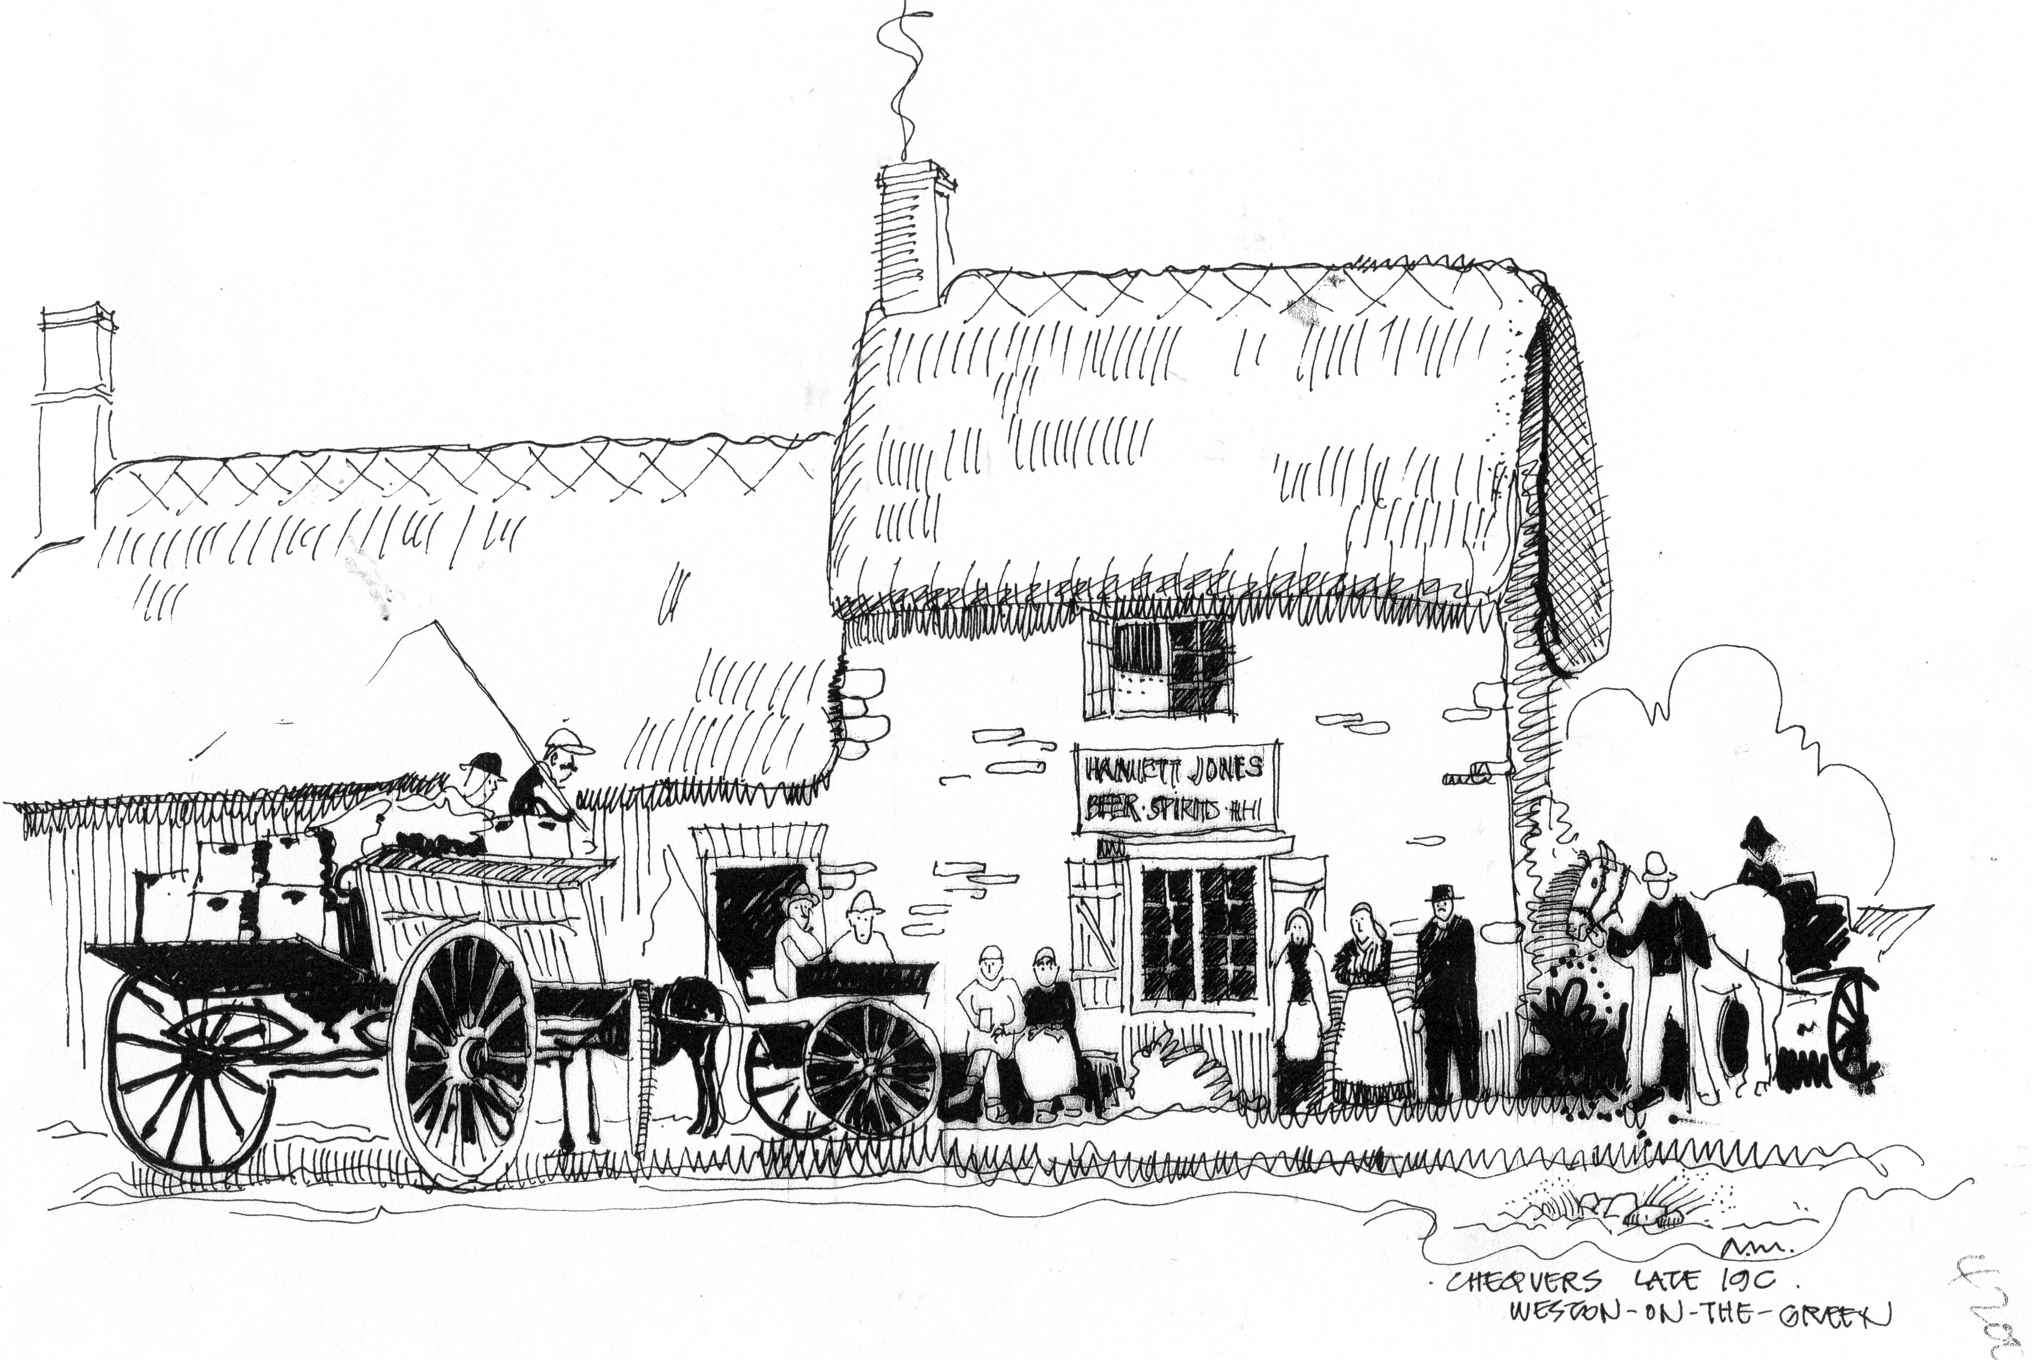

Village News November 22nd, 2017

Weston on the Green Neighbourhood Plan 2017-31

Months of consultation both within the village and with statutory bodies is finally at an end. The fourth and final background document is a screening report which determines whether or not the contents of the Weston on the Green Neighbourhood Plan requires a Strategic Environmental Assessment (SEA), in accordance with regulatory directives for all Neighbourhood Plans. In order to write this report, the CDC officer must have a completed final draft to go through and carry out the assessment. This has been a complicated piece of work because it has demanded detail and evidence of every stage or our work. It is at this point that the team has fully understood that we are writing a planning document and not just an overview of our village and its characteristics.

As soon as the final plan is submitted to Cherwell District Council, I will send an email to everyone on our mailing list. The work will also be posted on the website. The work over the past few months has been tedious, at times grinding and quite complex. The team is proud of the final result. Our hope is that we have a successful vision for Weston on the Green. Every member of the village will have the opportunity to give support through an affirmative vote at the Referendum - date to be announced.

Diane Bohm

