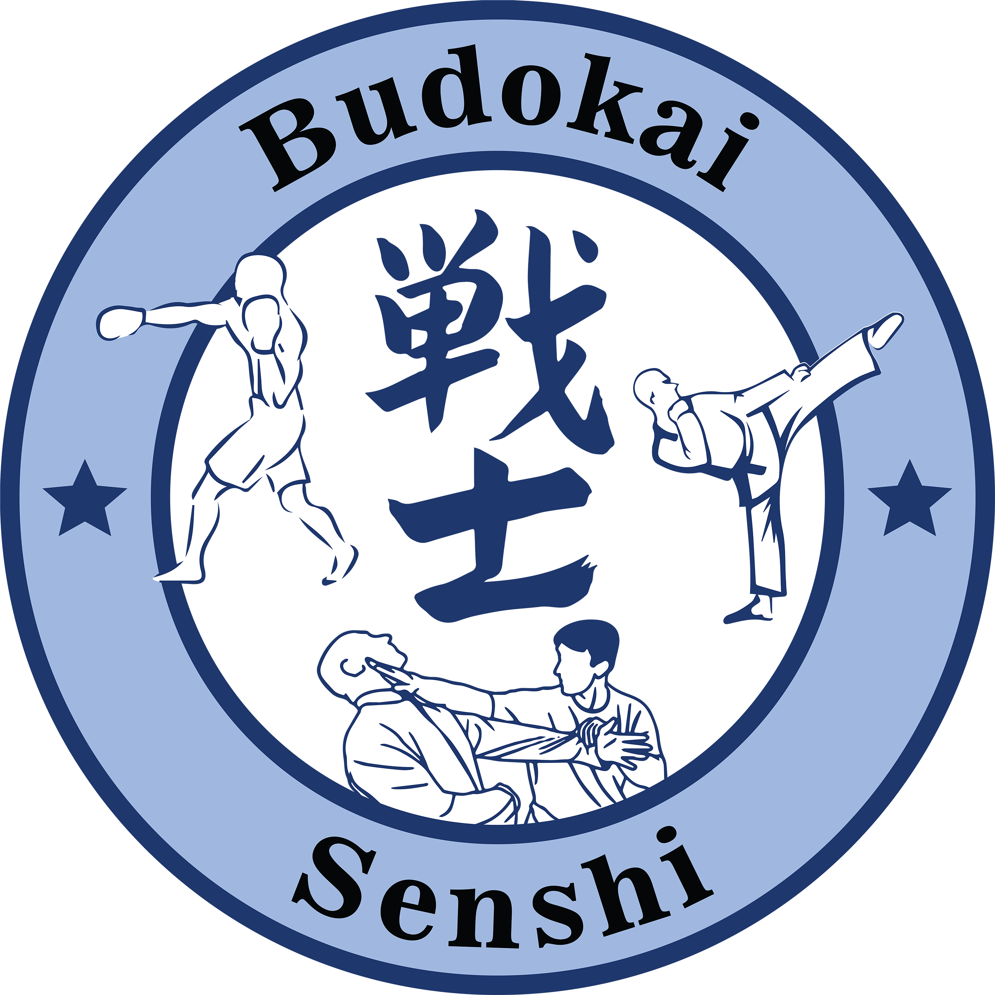
Oude Tonge February 8/9 2020,

Sportsclub/Dojo:………………………………………………..

The undersigned hereby declares,
that all contestants have familiarized themselves with the rules in regards to the Yujin Cup, and all the potential consequences in relation to these rules.
that of all the contestants younger than 18 years old, their parents end/or legal guardians are informed about their participation of this tournament.
that participation is at their own risk and that one can not, in any way, hold the organization and/or people of the organization accountable for both physical, psychic and material damage.
Name:
-----------------------------------
Date of birth:
-----------------------------------
Signature:
-----------------------------------

Without signing this document, participation at the tournament is not possible.
The Dojo keeper and/or coach will sign this document.

