Whitewater River Watershed Steering Committee Meeting
Minutes of February 12th, 2014

Attendees: Chelsea Tooley, Heather Wirth, Chris Fox, Jon Seymour, Emma D’Arcy, Lynn White, Bruce Koehler, Tim Hesselbrock, Mike Kohlsdorf, Sarah VanFrank, John Williams

The meeting began at 6:00pm at the Harrison Library in Harrison, OH. After Chelsea Tooley called the meeting to order, attendees were asked to introduce themselves. Under old business, Ms. Tooley gave a presentation about the Whitewater River Watershed Project. She detailed the project history, watershed history, project goals, and project schedule.
Ms. Tooley also updated the group on project current events, and explained that baseline data was just coming in and would be discussed at the next meeting. After the presentation conclusion, attendees were asked to complete a goals and mission statement worksheet. A short discussion of the worksheets followed. Ms. Tooley will put together a summary of those worksheets to be reviewed and discussed at the next meeting.
Under New Business, attendees were also asked to complete a stakeholder concern survey. A short discussion about concerns followed. Many members were concerned about increasing development and wanted to make sure that the management plan addressed those issues.

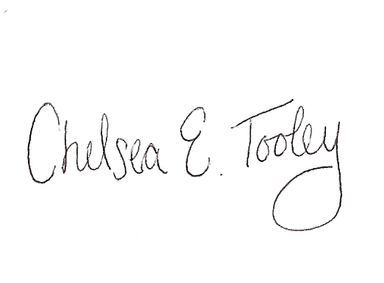
With no further business, discussion points, or concerns the meeting was adjourned. The next Steering Committee for the Whitewater River Watershed Project was set for mid-March, with further details to be announced.

Chelsea E. Tooley, Outreach Coordinator

