Affirmations to Ease Your Anxiety Through the Covid-19 Quarantine

A virus can spread far and fast — but love, hope, and help can spread, too

Brianna Wiest
Follow
Mar 24 · 3 min read

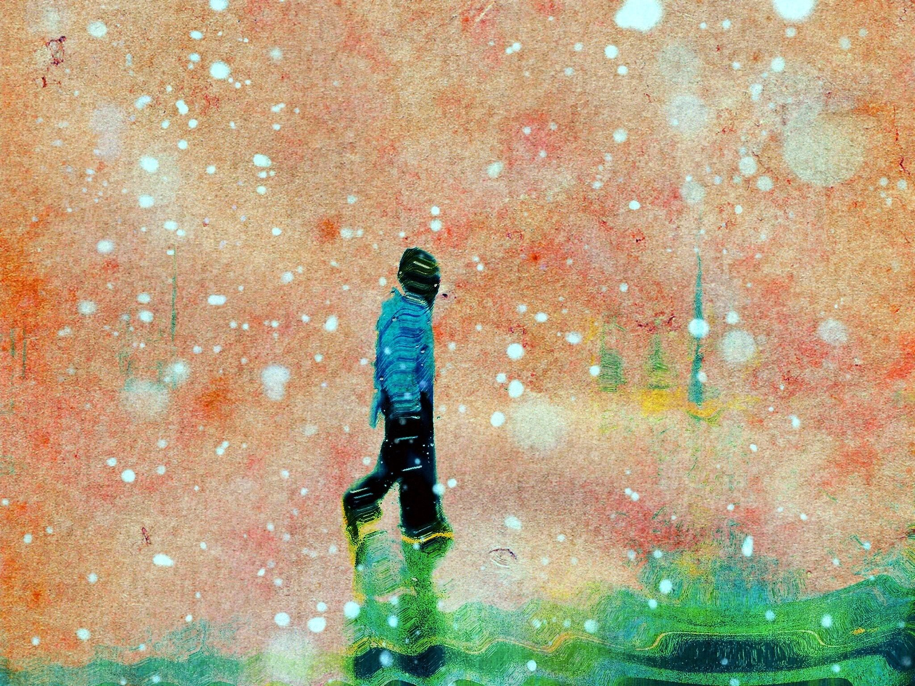
Photo: Jose Chavarry/Flickr
- What looks, from the outside, as though the world is closing in on itself is really just the world taking precautionary measures to ensure as few people as possible perish, even if those at highest risk aren’t the majority. We are, in a way, coming together as we never have before.
- When we look at how fast and far a virus can spread, we can imagine how fast love, hope, and help can spread, too.
- No, things are not going according to plan.
- We will make new plans.
- Worrying will not change the outcome of this.
- Worrying will not do anything but make us feel worse than we already do.
- All we can do right now is the absolute best with what we have right in front of us, one day at a time.
- This means we should cancel our plans, wash our hands, stay inside, clean as much as possible, stay informed, and donate if we can.
- It might seem as though this entire mess is totally unfair and completely unprecedented. But, unfortunately, through the course of human history — and even through recent years — illnesses like this have touched and impacted the lives of millions. The difference is that they usually don’t touch developed nations in such a drastic way, so we’re now noticing what’s always existed in some form in some places.
- This will pass, but the world will be slightly different.
- This will expose necessary flaws in our thinking, our systems, our communication, and our empathy.
- This is also an opportunity to help correct those things.
- Telling ourselves that what’s happening isn’t a problem and that we should stop worrying will not help us stop worrying. This is not only an ineffective response to anxiety, it’s an irresponsible way to think.
- We are all irrevocably connected, and the actions of any one person have a much more significant impact on humanity than we think. We all matter. We are all important. We all count.
- No, the trajectories do not look good.
- We also have an opportunity, right now, to adjust them as much as is humanly possible.
- We can all contribute to this, and each day that we do is a small victory.
- With access to the internet, we can stay connected in a way we’ve never been able to before. We are fortunate in that. While pandemics do come around every century or so, this is the first in which we have a rapid and consistent connection to the ones we love. This is a gift.
- We will never again take for granted our wellness.
- We will recognize how precious and fragile human life can be.
- We will be more hygienic.
- We will not question nor doubt taking action the next time we hear of a

