Facilitator Training Manual:

Mental Health Recovery including Wellness Recovery Action Plan Curriculum

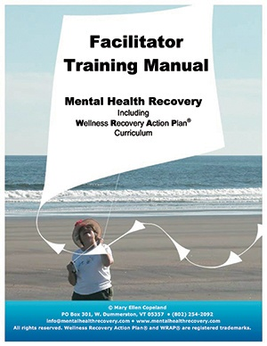
$129.00
In English, or in the newly available Spanish translation, this manual is the cornerstone of the Mental Health Recovery and WRAP program. It is designed for use by people who facilitate WRAP groups and is the text for five day WRAP facilitator certification training. It includes a CD-ROM of PowerPoint slides, a DVD of video introductions with Mary Ellen Copeland, one WRAP book, and complete instructions for facilitating WRAP groups, workshops and seminars. For information on attending a training to receive mental health recovery and WRAP facilitation certification, go to
www.copelandcenter.com .

This revised manual [ 2012 ] can be used by anyone who is familiar with Mary Ellen's Mental Health Recovery work, including her focus on Wellness Recovery Action Planning. It includes two completely new sections and a wealth of new PowerPoint slides. The materials are specific to facilitating Mary Ellen's WRAP workshop, Mental Health Recovery: Introduction to Recovery and WRAP and is not necessarily a resource to be used in developing other kinds of programs. However, some facilitators and programs are successfully using this Recovery/WRAP focus in combination with other programs.

This non-scripted program is based on years of research experience by Mary Ellen Copeland, PhD.

The curriculum package includes:

Section I: specific instructions on all aspects of setting up, implementing, adapting, and facilitating Mental Health Recovery including Wellness Recovery Action Plan workshops and seminars; values and ethics of doing this work, and preliminary course of study for anyone interested in becoming proficient in facilitating Mental Health Recovery and WRAP workshops and seminars;
Section II: thumbnail sketches of each slide included on the CD-ROM;
Section III: supporting activities, handouts, essays by Mary Ellen Copeland and other professionals, and discussion topics;
Section IV: a complete model for holding an 8-session WRAP group including a break-down of each session, supplies needed, timing, and advice; and
Section V: instructions for enhancing learning opportunities for participants with different learning styles
Designed for use in facilitating Mental Health Recovery and WRAP groups, the curriculum can also be used for working with individuals one-on-one.

This popular educational evidence-based curriculum presents an approach which is complementary to, but not a replacement for, other mental health treatment protocols. It is flexible and easily adaptable to meet different needs. A variety of formats, timelines, and activities are included. You will have at your disposal a thorough framework that will allow you to design a program that best meets your needs.

WRAP & Peer Support Handbook

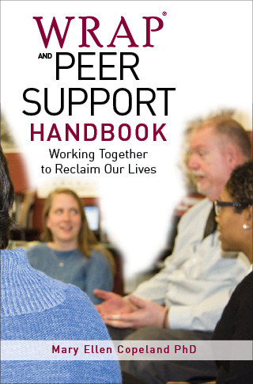
$24.95
The WRAP and Peer Support Handbook: Working Together to Reclaim our Lives describes the evidence-based practice of WRAP and the evidence-based practice of peer support, demonstrating how the two work together to enhance wellness and recovery. This book supports the effective implementation of peer support and the evidence-based WRAP peer group intervention.

Who this Item is for
If you are a peer supporter, a certified peer support specialist, someone who supervises peer support staff, or a WRAP Facilitator, this book is essential reading for understanding the powerful combination of peer support and the evidence-based peer-group intervention of WRAP. This book will help you learn to, or strengthen your ability to, arrange and implement mental health and whole health training, programs, seminars, workshops, and groups founded on peer support. It will also empower you as a participant in peer support, both individually and in groups.

Special Features
- Includes dozens of examples of the power of peer support and unconditional high regard in recognizing each individual as the expert on himself or herself
- Complements and expands on the flagship WRAP: Wellness Recovery Action Plan
Supports the effective implementation of peer support and the evidence-based WRAP peer group intervention

WRAP Plus

$19.95
$16.00 On Sale!
WRAP Plus is the go to book for all things WRAP! This easy to read volume is loaded with real life examples, making it a wonderfully relatable resource. The information in this book, along with our other resources, are based on years and years of interviewing people who experience serious mental health issues in their lives.
WRAP Plus is an extensively updated version of the book, Living Without Depression and Manic Depression. The original book was published in 1994 and was based on a study I did of the skills and strategies of people who have gotten well and stayed well over time. This was at a time when recovery from mental health issues was not even considered to be possible.

Recovery is now a word that is used in mental health all the time, but I didn’t want the original text with all its great information to cease to be. It was too important for too many people and led many out of the depths of despair into a rich and rewarding life. So, WRAP Plus was born. I added lots of updates about recovery and WRAP to make this a truly comprehensive resource for people dealing with all kinds of mental health challenges.

This is a required text for the Copeland Center's Mental Health Recovery and WRAP

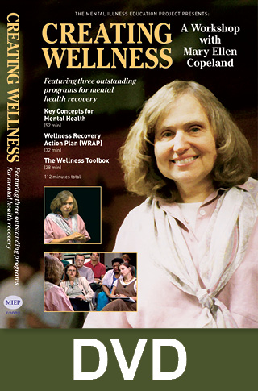
Creating Wellness Workshop - with Mary Ellen Copeland, DVD

$49.95
This three-part series, based on a workshop with WRAP: Wellness Recovery Action Plan author Mary Ellen Copeland, PhD, presents simple, effective, and non-invasive self-help strategies for anyone dealing with emotional, behavioral, or psychological challenges.

This workshop provides useful information on getting well and staying well. It is invaluable for in-service trainings and for self-help and support groups.

Session 1—Key Concepts for Mental Health offers an introduction to the underlying principles of Mary Ellen Copeland's recovery model. Lively and insightful discussions include the topics of hope, personal responsibility, education, self-advocacy, support, health care, and managing medication use. (52 minutes)

Session 2—The Wellness Toolbox introduces the concept of Wellness Tools—simple actions that anyone can use to feel better and stay well. Participants discuss with Mary Ellen how to create a personal “Toolbox” for their own use in times of stress or when they are feeling badly. The workshop is organized into various topics, including reaching out for support, peer counseling, focusing, relaxation, stress reduction, and journaling. (28 minutes)

Session 3—Wellness Recovery Action Plan (WRAP) provides a simple system for monitoring and managing mental health difficulties. In this session, Mary Ellen discusses with the group the steps for developing a WRAP. Participants both learn and share personal strategies for dealing with daily maintenance issues, triggering events, early warning signs, when things are breaking down, and crisis and post-crisis issues. (32 minutes)

Who this Item is for: This DVD is for use by individuals, agencies, organizations, classes, and libraries.

Special Features
- For ease of use, the workshop may be viewed in its entirety without interruption, or each session and even each topic may be viewed individually

The WRAP Story

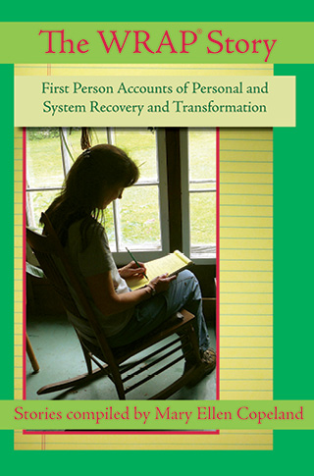
$19.95
WRAP was created in 1997 by a group of peers, and peers have continued to share the story of wellness ever since.
WRAP Facilitators and others have reported how their agencies, mental health systems, and their own lives have been changed and improved by incorporating a WRAP.
This book collects some of those stories.

Who this Item is for:
People using WRAP, WRAP Facilitators, advocates and allies, peers, professionals, program administrators, and others will all enjoy stories showing the transformative power of WRAP across the United States and around the world in countries and cultures with varied practices and beliefs about mental health.

Special Features
- 82 personal stories demonstrating the effectiveness of this simple peer-developed tool

- Inspiration and encouragement for individuals using WRAP; Facilitators leading WRAP groups; and anyone who wants to share the message of hope, recovery, and wellness without limits

Guided Relaxation with Mary Ellen Copeland - Audio Download

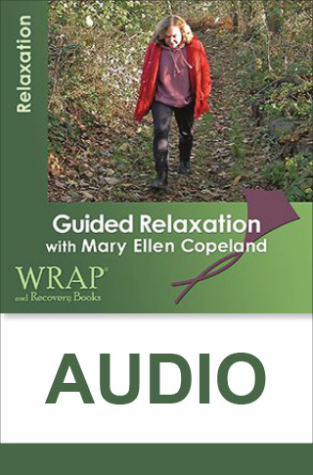
$1.99
This audio recording from WRAP: Wellness Recovery Action Plan author Mary Ellen Copeland, PhD, will help you relax anytime you’re feeling nervous, tense, or irritable, or when you just need a “break” in your day.
Use this relaxation and stress reduction program as a way to feel better.
It is a great addition to your Wellness Toolbox.
Mary Ellen personally guides you through a full-body relaxation exercise accompanied by a soothing music.
Her guided imagery technique draws upon your imagination to direct your focus in a way that is both relaxing and healing.

Who this Item is for

This full-body relaxation exercise is perfect for anyone looking to release tension and promote feelings of wellness and peace.

Special Features
- The recording can be played on any computer, MP3 player, smartphone, or tablet

- Purchase now for immediate download. Please note this is a downloadable product. After checkout, you will be notified about how to download the program

WRAP Brochure

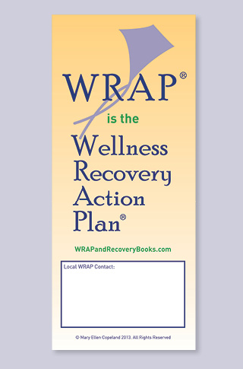
$2.00
Quantity | 1 - 9 | 10 - 49 | 50 - 99 | 100 - 999 | 1000 - 9999 | 10000+
Price | $2.00 | $1.00 | $0.75 | $0.45 | $0.35 | $0.25

This tri fold brochure provides a brief overview of the Wellness Recovery Action Plan and its key elements.
Distribute this useful handout to agencies and offices of care providers.
You can also use it as a handout at events, workshops, and conferences.

Who this Item is for
WRAP Facilitators will love this handy brochure to help promote WRAP groups in their community.

Special Features
- Available for purchase singly and in quantity
- Blank space provided for you to fill in your own agency or group information

The WRAP app

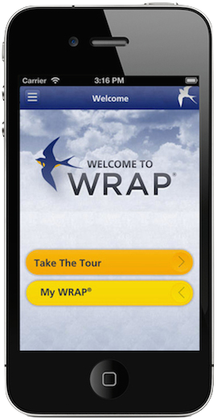
The WRAP® App is for anyone, any time, and for any of life’s challenges.

Using a WRAP involves listing your personal resources (Wellness Tools), and then using these resources to develop Action Plans.

You decide how and when to use your WRAP.

The Wellness Recovery Action Plan® (WRAP) is an evidence-based system that is used world-wide by people who are dealing with mental health and other kinds of health challenges, and by people who want to attain the highest possible level of wellness.

WRAP was developed by a group of people who have a lived experience of mental health difficulties; people who were searching for ways to resolve issues that had been troubling them for a long time.

With the WRAP App you can:
- Develop a Wellness Toolbox
- Create Daily Maintenance Plan
- List Triggers and create an Action Plan
- List Early Warning Signs and create
an Action Plan
- List When Things Are Breaking Down
and create an Action Plan
- Create a Crisis Plan
- Create Post Crisis Plan
The WRAP App guides you in creating and using your WRAP day to day. Use the WRAP App and take control, with your personalized action plans that help you feel better, get well, and stay well for life.
Here’s what people are saying about the new release of the WRAP app:

“This is such a helpful tool. Now I have room to fully express my thoughts in all the fields. Thank you for listening to feedback.”

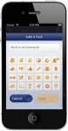
“Great app! Love that I can manage my WRAP on the go from my phone! The new version you released with the increased character limit makes this App so much better! Thank you.”
“My WRAP is always with me. I am from the digital generation so this app is for me. A great tool that helps you help yourself.”

“Great wellness tool. It is great to have my WRAP in my pocket. It is easy to use and share. I love it!”

“WRAP – I’m glad I found this app, it makes it so much easier to have it with me all the time and on hand when I need it as I can’t carry the book with me at all times. Great for helping with mental health issues and how to deal with them,. A++++”

The WRAP® app allows you the convenience of accessing and updating your WRAP anytime and anywhere. It’s convenient and easy to use, leaving you secure in knowing it’s right at your fingertips.

$4.99

WRAP AND RECOVERY BOOKS

Mission
WRAP and Recovery Books was established by Dr. Mary Ellen Copeland to develop, distribute, and make available to everyone, the recovery and wellness skills and strategies, including the Wellness Recovery Action Plan that she discovered through her research.
I now feel like a whole person for the first time in my life. -WRAP User

Goals
The goals of Mental Health Recovery and Wrap are to teach participants recovery and self-management skills and strategies:
- promote higher levels of wellness, stability and quality of life
- decrease the need for costly, invasive therapies
- decrease the incidence of serious mental health challenges
- decrease traumatic life events
- increase understanding of these mental health challenges and decrease stigma
- raise participants' level of hope and encourage actively working toward wellness
- increase participants' sense of personal responsibility and empowerment

Objectives
The following topics are covered using a workshop style, including presentations, demonstrations, interactive discussion, and related activities:
- hope, personal responsibility, education, self-advocacy, and support
- accessing good health care and managing medications
- self-monitoring using WRAP: A Wellness Recovery Action Plan (an individualized system for monitoring and responding to symptoms to achieve the highest possible levels of wellness)
- wellness tools, include finding and keeping a strong support system, peer counseling, focusing, relaxation exercises, diet, light, exercise, sleep, journaling, music, etc
- dealing with the effects of trauma
- suicide prevention
- building self-esteem
- changing negative thought patterns to positive
- building a lifestyle that promotes wellness
Phone: 978-261-1444 ordering Questions: books@mentalhealthrecovery.com
General Inquiries: info@mentalhealthrecovery.com

