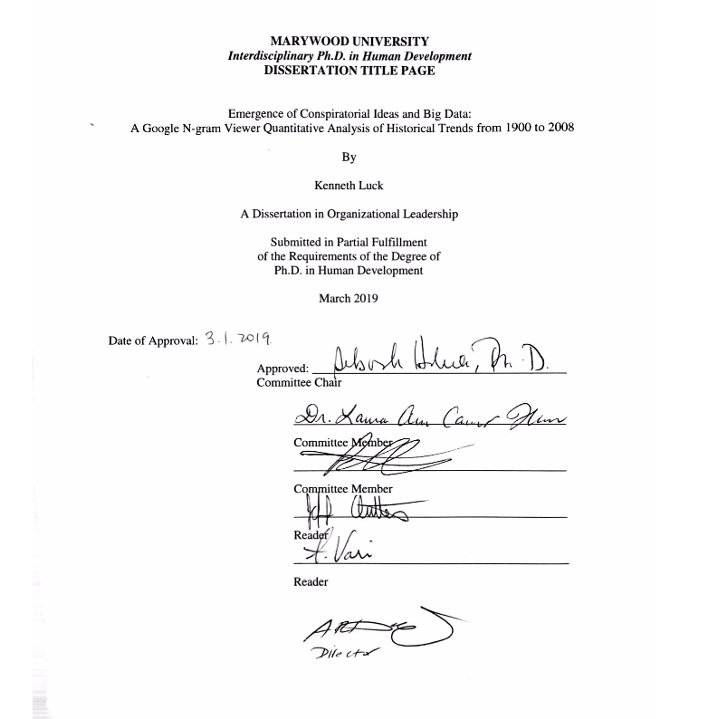

Emergence of Conspiratorial Ideas and Big Data:
A Google N-gram Viewer Quantitative Analysis of Historical Trends from 1900 to 2008
Kenneth Luck
Marywood University
College of Professional Studies
1 March 2019

Acknowledgements
I would like to extend my sincerest appreciation for my chair, Dr. Deborah Hokien, for her personal and professional guidance over the past several years. She has been a constant positive force throughout my time in the program and prior. I would also like to thank Dr. Patrick Seffrin for serving on my dissertation committee and for his content area knowledge. His knowledge and passion for the subject of this dissertation has helped to shape this project. Finally, I would also like to thank Dr. Laura Houser for all of her technical writing expertise, for her friendship, and for her personal encouragement throughout this process.
I would like to thank my parents, Joan and Andy Wanat, for their unwavering support and encouragement over the 15 years of my formal education. I could not have made it this far without them. I would also like to thank my former Marywood University professors Dr. Ann Bush, Dr. Kathleen Munley, and the late professor Barbra Hoffman for their inspiration, support, and encouragement early in my college career and beyond. I would also like to thank my eighth-grade teacher, Lisa Kliamovich, who many years ago saw my academic potential when others may have not. Finally, I would also like to thank my friend, Ryan Ward, for his inspiration to study this topic as well as Dr. Lee Sebastiani, who has always supported my creative and academic pursuits.

Abstract
Non-factual counter narratives that attempt to explain scientific advances and interpret political events through a distorted lens are often referred to as “conspiracy theories.” Although a number of studies have emerged in the literature in recent years that examine conspiracy theories, no research study performed a massive culture-wide quantitative approach to investigating the emergence of conspiratorial trends across time using a corpus of digitized English-language texts. The purpose of this quantitative content analysis was to measure the frequency patterns of 15 conspiratorial-related n-grams between the years 1900 to 2008 using the Google Books N-gram Viewer English language 2012 version. The Google Books N-gram Viewer was launched in 2010 and contains a corpus of more than 15 million books, which represents approximately ~4% of all books ever published over two centuries and includes approximately 361 billion English-language words. The time-series plots word frequencies (y-axis) were compared against the yearwise sum results (x-axis) to assess the rising, peaking, and falling of particular 2- and 3-gram conspiracy-related phrases selected for this study. Results demonstrate that 11 out of 15 conspiracy theory n-grams increased from 1900 to 2008, emerging in response to historic events, political trends, and popular culture. After the terrorist attacks on September 11, 2001, there was a +542.9% increase from 2003 to 2008 of the 3-gram “September 11 conspiracy,” an increase of +22400% for the 2-gram “conspiracy theory” from 1900 to 2008, and an increase of +2400% of the 2-gram “AIDS conspiracy” from 1982 to 2008. The 2-gram “medical conspiracy” decreased -62.48% from 1905 to 2008 as well as the 2-gram “leftwing conspiracy,” which also decreased -16.95% from 1948 to 2008. An overall average decrease for the 2-gram “conservative conspiracy” of -66.67% from 1915 to 2008 also occurred. Results for the 2-grams “rightwing conspiracy” and “liberal conspiracy” did not result in an overall average percent increase or decrease during the time period selected for this study. Additionally, results also indicate that conspiracy theories emerge across the left-right political ideological spectrum in the United States with peaking occurring for the 2-gram “rightwing conspiracy” at 0.000000275% in 2005 and peaking occurring for the 2-gram “leftwing conspiracy” at 0.000000195% in 1963. Finally, Google Books N-gram Viewer remains a developing methodology that offers future researchers the ability to investigate cultural phenomena that was previously out of reach.

Table of Contents
Chapter 1: The Problem and its Setting …………………………………………………………10
Introduction ………………………………………………………………………...…..10
Theoretical Framework ………………………………………………………...………13
Purpose Statement …………………………………………………………………...…14
Central Question ………………………………………………………………………..15
Sub Questions ………………………………………………………………...…15
Hypotheses ……………………………………………………………………………..16
Definition of Terms …………………………………………………………………….16
Biased Attribution of Intentionality………………………………………...……16
Conspiracy Theory ………………………………………………………...…….17
Conspiratorial Ideation……………………………………………...…...…...…..17
Culturomics…………………………………………………………………..…..17
Google Books N-gram Viewer……………………………..…………..…….….17
Historic Events…………………………………………………………….……..17
Need for Cognitive Closure………………….……………………………….….18
N-gram…………………………………………………………………….......…18
Popular Culture……………………………………………………………….….18
Powerful Others………………………………………………………………….18
Assumptions ……………………………………………………………………….…...19
Delimitations …………………………………………………………………………...19
Limitations …………………………………………………………..………………….19
Rationale and Significance of the Study ……………………………………….………19
Chapter 2: Review of the Literature …………………………………………………….….……22
Introduction ……………………………………………………………….……………22
Psychological Dimensions of Conspiracy Theories ……………………………….…...22
Political Science and Historical Trends …………………………………………….…..29
Science and Conspiracism ……………………………………………………........…...35
Conclusion………………………………………………………………………………41
Chapter 3: Methodology ……………………………………………………………….………..43
Research Design ………………………………………………………………….…….43
Data and Methods ……………………………………………………………………....45
Procedure …………………………………………………………………………….…45
Analysis of Data …………………………………………………………………….….45
Chapter 4: Analysis of Data……………………………………………………………...………47
Introduction……………………………………………..………………………………47
Central Question……………………………………………………………………...…47
Sub-question 1………………………………………………………………………….52
Sub-question 2……………………………………………………………………...…..56
Summary……………………………………………………………………………..…62
Chapter 5: Discussion………………………………………………………………………...….63
Introduction………………………………………………………………………………63
Summary of Results……………………………………………………………….……..63
Interpretation of Results………………………………………………………………….66
Implications………………………………………………………………………………69
Limitations and Recommendations for Future Research…………………………….…..72
Conclusions…………………………………………………………………………..…..73
References ……………………………………………………………………………….………75
List of Figures
Figure 4.1 Results for the search for “conspiracy theories,” 1900 – 2008………………………48
Figure 4.2 Results for the search “government conspiracy,” 1900 – 2008………………...….…50
Figure 4.3 Results for the search “political conspiracy theories,” 1900 – 2008………...…….…50
Figure 4.4 Results for the search “racist conspiracy,” 1900 – 2008…………..………....………52
Figure 4.5 Side-by-side results for the search terms “JFK Conspiracy,” September 11
Conspiracy,” “Terrorist Conspiracy,” and “UFO Conspiracy” from 1900 – 200……..53
Figure 4.6 Results for the search term “communist conspiracy,” 1900 – 2008………………….54
Figure 4.7 Results for the search for “AIDS conspiracy,” 1900 – 2008………………..………..55
Figure 4.8 Results for the search for “medical conspiracy,” 1900 – 2008…………………...….56
Figure 4.9 Results for the search “leftwing conspiracy” and “rightwing conspiracy,” 1900 –
2008…………………………………………………………………………………..57
Figure 4.10 Results for the search “liberal conspiracy” and conservative conspiracy,” 1900 –
2008………………………………………..………………………………………..59

List of Tables
Table 4.1 Word frequencies from first year of recorded data indexed by the Google Books N-
gram Viewer to the year 2008…………………………………………………….…..61

Chapter 1: The Problem and Its Setting
Introduction
The process by which individuals interpret and create meaning from external events has remained the subject of scholarship across disciplines for many decades. Non-factual counter narratives that attempt to explain scientific advances and interpret political events through a distorted lens are often referred to as “conspiracy theories” (Imhoff & Bruder, 2014; Leman & Cinnirella, 2013). Additionally, although it remains impossible to know exactly when conspiracy theories were first conceived, the twentieth and early twenty-first centuries appear to be a time when conspiracies theories have gained solid footing in the minds of many groups and individuals. From the six fevrier 1934 riots in France, where political rivals accused each other of conspiracy and subversion (Jenkins, 2011), to the “pre-millennium tension” of the late 1990s where television programs such as the X-Files turned the conspirator into a heroic figure, where the conspiracy theorist touted phrases such as “I want to believe,” “The truth is out there,” and “Trust no one,” (Irvine & Beattie, 1998) to finally the current climate of “fake news” and “alternative facts” (Himma-Kadakas, 2017; Yaxley 2017), conspiracy theories appear to emerge continuously, and repeatedly, throughout recent history.
Until recently, however, researchers have largely ignored the psychological underpinnings of conspiratorial ideation (Brotherton & French, 2014) and how conspiracism may develop as a recurrent trend throughout history, even though large numbers of individuals endorse conspiracy theories (Brotherton, French, & Pickering, 2013) conspiracy beliefs persist throughout the general population (Dagnall, Drinkwater, Parker, Denovan, & Parton, 2015), conspiracy theories have persisted over time (Oliver & Wood, 2014), and conspiracy theories occur in many regions of the world (Crawford & Bhatia, 2012; Iqtidar, 2016; Ortmann & Heathershaw, 2012; Yablokov, 2015).
Thirty-six percent of Americans, for example, believe that is was “somewhat likely” that the federal government assisted in the September 11, 2001, terrorist attacks on New York City and Washington D.C., and one third of Americans believe that former President Barak Obama was not a U.S. citizen (Crawford & Bhatia, 2012; Dagnall et al., 2015). The impulse to conspire in reaction to large-scale historic events is not a recent phenomenon. McCauley and Jacques (1979) report that although “the Warren Commission reported in 1964 that the assassination [of President John F. Kennedy] was the work of one assassin, Lee Harvey Oswald,” and the authors continue: “In 1979, the issue is evidently not settled . . . Polls indicate that the majority of Americans, around 80 percent in fact, believe that others beside Oswald were involved in the assassination.”
Indeed, since the election of President Donald J. Trump in 2016, terms such as “fake news” and “alternative facts” have entered into American discourse (Himma-Kadakas, 2017). These twin concepts remain closely conceptually related to conspiratorial thinking, as “fake news” has “been interpreted as intentionally widely speared[ing] misinformation,” whereas “alternative facts” “ha[s] been treated as the intentional misinterpreting of factual material” (Himma-Kadakas, 2017). As noted by Bolton and Yaxley (2017), “Although the term ‘fake news’ seems to have been first conceived only around 2015, its reach into society since then has been profound, with the term gaining popularity during the recent USA presidential election.” Moreover, the digital landscape and online social networks (OSN) have made it easier for conspiratorial ideas to spread. A 2015 finding, for example, found that 77.92% likes and 80.86% of comments on the social networking site, Facebook, “are from users usually interacting with conspiracy theories” (Bessi et al., 2015). This finding demonstrates the reach and scope conspiracy theories have globally among various populations and individuals.
The Google Books N-gram Viewer was launched in 2010 and contains a corpus of more than 15 million books, which represents approximately ~4% of all books ever published over two centuries and includes approximately 361 billion English-language words (Genovese, 2015; Pettit, 2016). As of September 2015, Pettit (2016) estimates that 11 psychological studies have been indexed in PsycINFO using Google Books N-gram viewer. Also, according to Zeng and Greenfield (2015), 40 libraries in the United States and Europe (e.g. Harvard University, Oxford University and University of California libraries) participated as Google partners, and they included both popular and academic works in the digital corpus. Michel et al. (2011) describes that “each page was scanned with custom equipment, and the text digitized using optical character recognition (OCR).” The authors continue: “Additional volumes – both physical and digital – were contributed by publishers. Metadata describing date and place of publication were provided by the libraries and publishers, and supplemented with bibliographic database.” Moreover, Michel et al. (2011) notes that “[u]sage frequency is computed by dividing the number of instances of the n-gram in a given year by the total number of words in the corpus in that year.”
Although in its infancy, the Google Books N-gram Viewer “offers a novel means of tracing cultural change over time. [It] offers exciting possibilities for cultural psychology by rendering questions about variation across historical time more quantitative” (Pettit, 2016). Pettit (2016) observes that “the N-gram Viewer is not an isolated development, but is part of a larger transformation of how we study and understand the human in an age of ‘big data’.” Moreover, Michel et al. (2011) makes clear that “analysis of this corpus enables us to investigate cultural trends quantitatively.” Described by the authors are “culturomics,” Michel et al. (2011) notes that culturomics “extends the boundaries of rigorous quantitative inquiry to a wide array of new phenomena spanning the social sciences and the humanities.” Indeed, the authors characterize the Google Books N-gram Viewer as form of culturomics because it “. . . is the application of high-throughput data collection and analysis to the study of human culture.”
The digitized corpus is so large that it can not be read by a single human being (Michel et al., 2011). “If you tried to read only the entries from the year 2000 alone,” writes Michel et al. (2011), “at the reasonable pace of 200 words/minute, without interruptions for food or sleep, it would take eighty years. The sequence of letters is one thousand times longer than the human genome: if you wrote it out in a straight line, it would reach to the moon and back 10 times over.”
To date no study has attempted to trace the frequency of conspiracy theories across time using the Google Books N-gram Viewer. This represents a significant deficiency in the literature, since new digital tools “represent a tremendous archive of human cognitions, affects, and behaviors that is accessible and measurable in unprecedented ways” (Pettit, 2016). New digital tools are creating new “possibilities for cultural psychology by rendering questions about variation across historical time more quantitative” (Pettit, 2016).
Theoretical Framework
One way to view the emergence of conspiracy theories is through the lens of a decline in social trust. Studies have emphasized that low interpersonal trust (Acar-Burkay, Fennis, & Warlop, 2014; Einstein & Glick, 2015), less faith in government institutions and services (Einstein & Glick, 2015), and paranoia (Oliver & Wood, 2014) play a role in the formation of conspiratorial ideas. Putnam (2000) found that beginning in the mid-20th century, levels of civic engagement and political participation began to decrease over the following decades. Over that same time period, increase in the interest of conspiracy theories as alternative epistemologies increased. Therefore, Putnam’s (2000) model of decreased civic engagement and political participation will provide the basis of this research. “Trust worthiness lubricates social life,” Putnam (2000, p. 21) writes. “Frequent interaction among a diverse set of people tends to produce a norm for generalized reciprocity” (2000, p. 21).
Also relevant is Mills (1956), who described “the power elite” as opinion shapers of a culture. This remains important because the Google n-gram data set that will be used in this study comes from print culture that is shaped by educated classes (Genovese, 2015; Pettit, 2016). Mills’ (1956) observation was later confirmed by Herman and Chomsky (1988) in which they note, “It is our view that, among their other functions, the media serve, and propagandize on behalf of, the power societal interests that control and finance them” (p. xi). The Mills (1956) and Herman and Chomsky (1988) “power elite” framework will be critical in helping to provide interpretation of the Google n-gram data used in this study. This framework suggests that educated classes primarily shape print culture and those opinions and interests primarily reflect the content of that culture.
Purpose Statement
The purpose of this quantitative content analysis is to measure the frequency patterns of 15 conspiratorial-related n-grams between the years 1900 to 2008 using the Google Books N-gram Viewer English language 2012 version. N-Gram Viewer allows for the study of macrotrends by producing word frequency time-series plots, which will be visually assessed for this study (Clark, & Berkel, 2017; Lin et al., 2012; Michel et al., 2011; Roth, Clark, & Berkel, 2017). The time-series plots y-axis word frequencies will be compared against the x-axis yearwise sum results to assess the rising, peaking, and falling – trends and patterns – of particular 2- and 3-gram conspiracy-related phrases selected for this study. Data will be analyzed throughout December 2018 to January 2019.
Word selection was guided by Greenfield (2013), in that, “frequently used words with a narrow range of semantic interpretation” were selected from the literature (Zeng & Greenfield, 2015). Additionally, although the English-language corpus indexed by N-gram Viewer includes texts from the year 1500, the years 1900 – 2008 were selected for this study. As observed by Roth (2013), “The data from 1500 – 1800 is likely to feature biases due to insufficient sample sizes.” The author continues: “The early decades are represented by only a few books per year, comprising several hundred thousand words.” Michel et al. (2011) notes: “The oldest works were published in the 1500s. The early decades are represented by only a few books per year, comprising several hundred thousand words. By 1800, the corpus grew to 98 million words per year; by 1900, 1.8 billion; and by 2000, 11 billion.” More recently, as pointed out by Zeng and Greenfield (2015), the Google Books N-gram Viewer’s corpus ends in 2008.
Central Question
1. What is the emerging frequency of conspiratorial ideas from 1900 to 2008 in response to
political trends, historical events, and popular culture?
Sub Questions
1. Do conspiracy theories reflect historic events and the popular culture of specific time
periods?
2. Are conspiracy theories emergent across the left-right political ideological spectrum in the
United States?

Hypotheses
- (H₀₁) Conspiratorial ideas will not emerge in the aftermath of significant historic events as an attempt to explain, contextualize, or understand those events.
- (H₁) Conspiratorial ideas will emerge in the aftermath of significant historic events as an attempt to explain, contextualize, or understand those events.
- (H₀₂) The of conspiracy theories will not increase and decrease over time.
- (H₂) The frequency of conspiracy theories will increase and decrease over time.
- (H₀₃) Conspiracy theories will not be influenced by political trends of the time period in which they develop.
- (H₃) Conspiracy theories will be influenced by political trends of the time period in which they develop.
- (H₀₄) Conspiracy theories will not develop across the left-right political ideological spectrum.
- (H₄) Conspiracy theories will develop across the left-right political ideological spectrum.
Definitions of Terms
Biased Attribution of Intentionality (BAoI)
Biased Attribution of Intentionality (BAoI) is a type of cognitive bias where individuals will assign intentionality to ambiguous stimuli where intentionality may be absent (Brotherton & French, 2015). Brotherton and French (2015) found an association between conspiratorial ideation and BAoI, lending some evidence to the relatedness of BAoI and its role in formation of conspiracy theories.

Conspiracy Theories
Imhoff and Bruder (2014) have defined conspiracy theories as explanations of “complex world events with references to secret plots hatched by powerful groups.” Moreover, this definition has evolved to include “a subset of false beliefs in which the ultimate cause of an event is believed to be due to malevolent plot by multiple actors” (Swami et al., 2013).
Conspiratorial Ideation
The cognitive processes by which conspiratorial ideas form. Subcomponents to conspiratorial ideation include low levels of interpersonal trust (Acar-Burkay et al., 2014; Leman & Cinnirella, 2013), reduced uncertainty and ambiguity (Dagnall et al., 2015), and increased paranoia (Brotherton et al., 2013).
Culturomics
To investigate cultural trends quantitatively (Michel et al., 2011). Michel et al. (2011) notes that culturomics “extends the boundaries of rigorous quantitative inquiry to a wide array of new phenomena spanning the social sciences and the humanities . . . it is the application of high-throughput data collection and analysis to the study of human culture.”
Google Books N-gram Viewer
The Google Books N-gram Viewer was launched in 2010 and contains a corpus of more than 15 million books, which represents approximately 4% of all books ever published over two centuries and includes approximately 361 billion English-language words (Pettit, 2016; Genovese, 2015).
Historic Events
Refers to large-scale political, social, or scientific developments that occur at a particular time. Examples include the National Aeronautical and Space Administration’s (NASA) Apollo-era moon landings, the 2009 H1N1 influenza outbreak (Smallman, 2015) and the 2014 Zika virus epidemic (Smallman, 2017), the assassination of President John F. Kennedy in 1963 (McCauley & Jacques, 1979), and the terrorist attacks within the United States on September 11, 2001 (Dagnall et al., 2015).
Need for Cognitive Closure (NFCC)
Refers to the cognitive tendency of individuals to “seize and freeze” readily available information when facing ambiguity or uncertainty (Acar-Burkay et al., 2014). The outcome of NFCC tends to insulate an individual from disconfirming information that may challenge his or her mental schema or worldview.
N-gram
Pettit (2016) defines N-grams as “a single unit (or a word), and the viewer allows users to trace the frequency of different n-grams (phrases up to ﬁve words) across the span of speciﬁed years.” Additionally, Michel et al. (2011) defines an n-gram as: “A 1-gram is a string of characters uninterrupted by a space; this includes words (‘banana', ‘SCUBA’) but also numbers (‘3.14159’) and typos (‘excesss’). An n-gram is sequence of 1-grams, such as the phrases ‘stock market’ (a 2-gram) and ‘the United States of America’ (a 5-gram).”
Popular Culture
Parker (2011) observes the definition of popular culture to mean “a set of generally available artefacts: films, records, clothes, TV program[s], [and] modes of transport.”
Powerful Others
Conspiracy theories will often include individuals, groups, or institutions as powerful others. These individuals, groups, or institutions – in the minds of conspiracy theorists – will often have complete control over situations and events (Yablokov, 2015). Powerful others include governmental agencies (Einstein & Glick, 2015; Swami et al, 2013), corporations (Blaskiewicz, 2013; Jolley & Douglas, 2014a), socially marginalized groups (Pollard, 2016), and nation-states (Yablokov, 2015).
Assumptions
- The search term’s meaning remains consistent over time.
- The Google Books N-gram Viewer contains books that are representative of print culture, which is primarily represented by the intelligentsia, journalists, and an educated elite.
Delimitations
- This study is delimited to English language texts included in the Google Books N-gram Viewer corpus.
- This study is delimited to the time period between 1900 and 2008.
- This study is delimited to 15 conspiracy theory n-grams.
Limitations
- This study is limited to the reliance upon print culture.
- This study is limited to English-language popular and academic texts.
Rationale and Significance of the Study
Although a number of studies have emerged in the literature in recent years that examine conspiracy theories, no study has yet to perform a massive culture-wide quantitative investigating the emergence of conspiratorial trends across time using a corpus of digitized English-language texts (Zeng & Greenfield, 2015). As noted, conspiracy theories have begun to capture the attention of researchers within several disciplines, including the fields of psychology (Brotherton & French, 2015; Leman & Cinnirella, 2013; Van Elk, 2015) and political science (Imhoff & Bruder, 2014; Oliver & Wood, 2014). Additionally, what some researchers have long assumed was a fringe topic of investigation has now blossomed into “fertile ground for psychological study” (Leman & Cinnirella, 2013), and the topic remains as timely as ever.
Although individuals with a higher education remain less likely than individuals with a lower education to believe in conspiracy theories (Van Prooijen, 2017), digital technologies have made conspiracy theories easier to spread (Himma-Kadakas, 2017), and conspiracy theories remain difficult to eradicate or correct. Wood (2016) found, for example, that labeling something a conspiracy theory does not reduce belief in it. Additionally, compounding the problem further, although rare, sometimes conspiracies have occurred historically (Raikka, 2009). Raikka (2009) recalls that, “In 1941 a belief in the Holocaust was a belief in some sort of conspiracy theory, as it denied the official claim that the Jews were merely being resettled. But now” Raikka (2009) notes, “Holocaust denial is a crime in some countries, for instance in the UK, and the belief in the Holocaust is certainly not called a conspiracy theory.” The author goes on to cite other examples, noting that “the Watergate burglary was also once a conspiracy theory,” and “[p]eople who claimed that President Reagan sold guns to Iran in order to fund right-wing Contra guerrillas in Nicaragua were conspiracy theorists in 1986, but people who make the same claim now are just repeating something that everyone knows.” Finally, Mattocks et al. (2017) cites previous research that some African-Americans endorse HIV-related conspiracy theories, and this “may arise from the legacy of the Tuskegee Syphilis Study, a 40-year Public Health Service study of the natural progress of untreated syphilis among African American men living in rural Alabama.”
Moreover, since the recent introduction in American discourse of concepts such as “fake news” and “alternative facts” (Himma-Kadakas, 2017; Yaxley 2017), conspiracy theories and conspiracy theorists tend to discredit and discount information presented though official and mainstream mediums. “Government officials’ public statements and testimonies in a court of law that contradict a conspiracy theory can be interpreted as signs that support the theory,” writes Raikka (2009). The author continues: “Almost all potentially falsifying evidence can be construed to be supporting or neutral. Official reports that contradict conspiracy theories are exactly what conspiracy theories expect governments to produce.” Put simply, as noted by Garrett and Weeks (2017), “[f]acts do not have the authority they once did.” Widespread belief in conspiracy theories, therefore, create challenges in a range of areas including government policy, science communication, and education (Iqtidar, 2016; Ortmann & Heathershaw, 2012; Yablokov, 2014).
The need for continued research into the emergence of conspiracy theories within a historical and current context remains great. Previous research has focused on the psychological underpinnings of conspiracy theories (Brotherton & French, 2015; Leman & Cinnirella, 2013; Van Elk, 2015), the emergence of conspiracy theories in relation to specific historic events (Imhoff & Bruder, 2014; Oliver & Wood, 2014), and the negative impact of conspiracy theories on scientific knowledge (Lewandowsky, Gignac, & Oberauer, 2013), but no studies have taken advantage of emerging digital tools such as the Google Books N-gram Viewer to quantitatively analyze conspiracy theory n-grams across time using a corpus of digitized English-language texts. Finally, highlighting this issue will shed light on the emergence of conspiracy theories across time, fill a gap in the existing literature, and will provide context for current events.

Chapter 2: Literature Review
Introduction
Hofstadter (1964) established some of the first scholarship on conspiracy theories, describing the “paranoid-style” strain in American politics. That said, however, much of the literature to date has been an attempt to better understand the psychological and cognitive underpinnings of conspiracism (Brotherton & French, 2015; Leman & Cinnirella, 2013; Van Elk, 2015), the global and political consequences of entertaining conspiratorial ideas (Imhoff & Bruder, 2014; Oliver & Wood, 2014), and the impact of conspiracy theories on scientific knowledge (Blaskiewicz, 2013; Jolley & Douglas, 2014a).
Scholars have begun to expand the scope of their investigations into conspiracy theories. In 2016, for instance, two articles appeared that focused on micro-level conspiracy theories and their effects (Douglas & Leite, 2016; Van Prooijen & De Vries, 2016). The area of micro-level conspiracy theories – those occurring within one institution, for instance – have received little attention in the literature. Macro-level conspiracy theories, on the other hand, receive nearly all of the focus. Additionally, a large gap in the literature persists regarding any possible positive consequences of endorsing conspiracism. Sapountzis and Condor (2013) note how in some specific instances conspiracism may “challenge dominate ideological assumptions,” but the literature in this area remains underdeveloped and needs further clarification and investigation as well.
Psychological Dimensions of Conspiracy Theories
A number of recent journal articles in the literature have begun to explore the psychological mechanisms underlying how conspiracy theories form. Prior to the past decade, exploring the psychological roots of conspiracy theory formation remained of little interest to researchers, as large gaps and deficiencies in the literature have persisted (Brotherton & French, 2014). That said, however, in more recent years, researchers have begun to look at conspiracy theories through a psychological lens (Brotherton & French, 2015; Leman & Cinnirella, 2013; Van Elk, 2015). In addition, Dagnall, Denovan, Drinkwater, Parker, and Clough (2017) have described “[c]urrent academic interest in the psychological correlates of conspiratorial ideation [as] high.” As addressed in recent psychological literature, three themes have emerged that attempt to offer explanations for conspiratorial ideation. These themes are cognitive processes/errors, perceptual biases/biased attributions, and thinking styles (Douglas, Sutton, Callan, Dawtry, and Harvey, 2016). Each theme highlights errors and perceptions made at cognitive level, which may contribute to the formation of conspiratorial beliefs.
An important strand of literature related to conspiratorial ideation relates to personality type and cognitive processes. Some research has attempted to detect correlations between conspiratorial ideation and personality, specifically relating to Big-5 personality traits such as high openness and low agreeableness (Brotherton et al., 2013; Lewandowsky et al., 2013), but only weak correlations have been reported. Additionally, Brotherton et al. (2013) note that the correlations that have been previously reported among these Big-5 personality traits and conspiratorial ideation in the literature have not been replicated. Collectively, previous studies, then, establish conspiratorial ideation as a cognitive process rather than a stable personality trait (Brotherton et al., 2013; Lewandowsky et al., 2013). As a cognitive process, conspiratorial ideation contains specific features as reported in previous studies. These features include low levels of interpersonal trust (Acar-Burkay et al., 2014; Leman & Cinnirella, 2013), reduced uncertainty and ambiguity (Dagnall et al., 2015), and increased paranoia (Brotherton et al., 2013). With regard to the latter, paranoia, early researchers in both the psychology and political science literatures emphasized an individual’s “paranoid style” and its role in a conspiracist worldview (Hofstadter, 1964; Oliver & Wood, 2014). Although some current literature continues to emphasize paranoia as a main driver of conspiratorial ideation (Oliver & Wood, 2014), the consensus in the literature appears to be that conspiracism remains a “generalized political attitude” rather than a subcomponent of a paranoid-style of cognition (Dagnall et al., 2015). Paranoid thinking may thus be assembled into a larger model including low interpersonal trust and the Need for Cognitive Closure (NFCC) that describe a conspiracist’s cognitive style. This remains noteworthy because much scientific policy in the United States, from climate change (Douglas and Sutton, 2015; Lewandowsky et al., 2013; Majima, 2015) to childhood vaccines (Blaskiewicz, 2013; Colbert, Saroglou, & Van Pachterbeke, 2015; Jolley & Douglas, 2014a) takes on a political dimension, as much of the scientific process and the making of science policy remains a group-level activity.
Recent literature explores the role of an individual’s NFCC and belief in conspiracy theories (Leman & Cinnirella, 2013). NFCC remains a tendency of individuals to reduce ambiguity and avoid uncertainty (Acar-Burkay et al., 2014). When presented with ambiguous or uncertain information, individuals with high NFCC tend to “seize and freeze” information that remains immediately accessible (Leman & Cinnirella, 2013). Additionally, because many conspiracy theories develop in response to major national and international historic events, such as the HIV/AIDS pandemic (Kalichman, 2014), individuals may rely on easily accessible or incomplete information to make a sense of a situation with unclear and ambiguous causes or origins.
Another dimension of NFCC that emerges in the literature involves the role of interpersonal trust. Studies have produced consistent findings highlighting the inverse relationship between low interpersonal trust and high NFCC (Acar-Burkay et al., 2014; Leman & Cinnirella, 2013). As a related concept to NFCC, low interpersonal trust remains relevant to the explanation of the formation of conspiracy theory beliefs. The literature makes clear that individuals with a high NFCC also have low levels of interpersonal trust (Acar-Burkay et al., 2014). This finding remains illustrative because individuals who endorse conspiracy theories also have low levels of interpersonal trust (Acar-Burkay et al., 2014; Einstein & Glick, 2015). One study found, for example, that the exposure to conspiracy theories led to less trust in government services and institutions (Einstein & Glick, 2015). In particular, this may illustrate the affect that the endorsement of conspiracy beliefs may have on undermining democratic-organizational processes both on the micro (Douglas & Leite, 2016; Van Prooijen & De Vries, 2016) and macro (Einstein & Glick, 2015) levels. Trust, as noted, remains vital to a healthy, functioning social system and to pro-social behavior.
NFCC, low interpersonal trust, and a paranoid style of thinking may all be described as cognitive process and errors that, as the current literature suggests, create the psychological mechanisms of conspiratorial ideation (Acar-Burkay et al., 2014; Leman & Cinnirella, 2013; Oliver & Wood, 2014). Taken together, these three constructs form the first area identified in the literature that may explain the formation and sustention of conspiracy beliefs at the cognitive level.
A second theme that emerges from the recent literature on the psychological underpinnings of conspiratorial ideation is perceptual biases/biased attributions. Similar to NFCC, individuals may mistakenly make biased attributions of intentionality (BAoI) to ambiguous stimuli (Brotherton & French, 2015). The critical difference between NFCC and BAoI remains that, with regard to the former, NFCC is a cognitive tendency of individuals to “seize and freeze” readily available information when facing ambiguity or uncertainty (Acar-Burkay et al., 2014), whereas BAoI remains a cognitive bias where individuals may assume intentionally behind ambiguous stimuli where intentionality may be absent (Brotherton & French, 2015). BAoI is a psychological factor that does not have deep roots in the literature when applied to conspiracy theories.
Brotherton and French’s (2015) findings need emphasizing because it sheds insight into the complexity of conspiracy theory formation. The content of conspiracy theories varies widely and often times involve the nefarious intentions of a powerful other (Imhoff & Bruder, 2014; Jolley & Douglas, 2014b). The anti-vaccine conspiracy theory, for instance, demonstrates how BAoI applies to a particular conspiracy believe. Jolly and Douglas (2014a) found that when individuals endorse the conspiracy belief that the Measles, Mumps, and Rubela (MMR) vaccine causes autism, a drop in the intention to get vaccinated decreases. Here, conspiracy theorists maintain it is the intention of a powerful “other” such as pharmaceutical companies (Blaskiewicz, 2013) or the government (Swami et al., 2013) to introduce harm to a population in the face of ambiguous circumstances. BAoI appears to highlight how some conspiracy-prone individuals will seek intentionality where there is none.
A related concept to BAoI is the conjunction fallacy. As a second psychological factor that supports the emerging theme of perceptual biases/biased attributions in the literature, the conjunction fallacy occurs when individuals may incorrectly “overestimate the likelihood of co-occurring events” (Brotherton & French, 2014; Dagnall, et al., 2017). Described as a cognitive error in the literature, conjunction violations apply when two events may occur simultaneously and an individual infers causality between them. In two studies, Brotherton and French (2014) found that individuals who endorse conspiracy theories more strongly also made more conjunction errors. This finding also has appeared in the work of Dagnall et al. (2017). Moreover, the conjunction fallacy appears to work in concert with the aforementioned BAoI as a reasoning error that reinforces conspiratorial thinking. An in-depth look at the literature illustrates how the intersection between BAoI and the conjunction fallacy may work together at the cognitive level, as the conspiracist may construe two unlikely events as causal (the conjunction fallacy) and that human intent and agency may remain the cause of such events (BAoI) when in fact the inverse may be true (Brotherton & French, 2014; Brotherton & French, 2015). Although more studies are needed on this point, one area of future research may include statistical techniques to measure the strength of BAoI and the conjunction fallacy to assess to what extent each psychological factor contributes to an individual’s overall perceptual biases/biased attributions and their relationship to the formation of conspiracy theories. The literature does, however, support the claim that BAoI and the conjunction fallacy work in concert at an individual’s cognitive level to enable a conspiratorial worldview (Brotherton & French, 2014; Brotherton & French, 2015).
A related concept to BAoI that appears in the literature is hypersensitive agency (Douglas, et al., 2016). Described as a cognitive bias, hypersensitivity agency is defined as “the tendency to attribute agency and intentionality where it does not exist or is unlikely to exist” (Douglas, et al., 2016). These twin concepts, BAoI and hypersensitivity agency, display a consistency in the psychological literature, highlighting an individual’s NFCC, where randomness and coincidence remain unlikely to occur in the world, and all events are underpinned by agency and intentionality, usually by a powerful other or by a powerful group (Douglas et al., 2016). As Donskis (1998) puts it: “In the twentieth century world, the conspiracy theory and conspiratorial worldview of the universe in fact manifest themselves through a belief that the world and the human being are shaped and moved by biological and social forces in all essentials beyond the control.”
A final theme that can be identified in the psychological literature on conspiracy theories is an individual’s thinking style. This theme, though general, also includes social dimensions as well (Lantian et al., 2017). For instance, Lantian, Muller, Nurra, and Douglas (2017) highlight that an individual’s high need for uniqueness will “be more likely to believe in conspiracy theories.” Need for uniqueness, as a thinking style, is defined by the authors as “the need (or desire) to be reasonably different from others” (Lantian et al., 2017). What is more, the authors note: “People who believe in conspiracy theories can feel ‘special,’ in a positive sense, because they may feel that they are more informed than others about important social or political events” (Lantian et al., 2017). Others, such as van Prooijen (2015), have found that “inclusion breeds suspicion”; that, in other words, “messages communicating inclusion by others lead to stronger conspiracy beliefs about impactful societal events than messages communicating exclusion by others.” This finding remains illustrative in, for example, conspiracy groups who demonize the other (Donskis, 1998). Pollard (2016), for instance, has analyzed the conspiracy theories of racist skinheads, and – as an inclusive, conspiratorial group – racist skinheads tend to display need for uniqueness from the rest of mainstream societal norms (Donskis, 1998; Lantian et al., 2017; van Prooijen, 2015).
As a thinking style, need for uniqueness coheres with the findings of Douglas and Sutton (2011), where the authors found that “endorsement of conspiracy theories is influenced by [a] personal willingness to conspire.” In other words, these findings have revealed that “individuals [are] more likely to endorse conspiracy theories if they thought they would be willing, personally, to participate in conspiracies” (Douglas & Sutton, 2011). This willingness to participate in conspiracies may satisfy an individual’s needs for uniqueness (Lantian et al., 2017) and increase his or her sense of inclusion (Van Prooijen, 2015).
On focusing on the psychological mechanisms of conspiratorial ideation, three distinct threads have emerged from the literature: cognitive processes and errors, perceptual biases/biased attributions, and thinking style. In sum, the literature discussed throughout this section describes the psychological mechanisms of how conspiracy beliefs form and how an individual may activate such beliefs to rationalize his or her conspiratorial worldview.
Political Science and Historical Trends
Recent surveys indicate that half of the American population endorses at least one conspiracy theory (Oliver & Wood, 2014). For instance, as of 2015, 36% of American respondents believed that the United States government had either assisted in – or neglected to do anything to stop – the terrorist attacks that occurred on September 11, 2001 (Dagnall et al., 2015). This demonstrates the widespread popularity of conspiracism. Additionally, emerging areas in the literature appear to suggest that the endorsement of conspiracy theories transcends political party affiliation and identity in the United States (Imhoff & Bruder, 2014; Oliver & Wood, 2014). In other words, as a study of the literature makes clear, individuals may be prone to conspiracism regardless of where they fall on the left-right political ideology continuum.
In attempting to synthesize recent the political science literature of conspiracy theories, two distinct motifs have emerged. The first is the emergence of conspiracism as a political attitude in general in the United States, detached from any political ideology (Imhoff & Bruder, 2014; Oliver & Wood, 2014). The second theme remains the dissemination of conspiracy theories across geopolitical space and how the endorsement of conspiracism may undermine democratic values and public health concerns (Iqtidar, 2016; Ortmann & Heathershaw, 2012; Yablokov, 2014). Regarding the former, a large and robust interdisciplinary literature in both psychology and political science has, for instance, established Social Dominance Orientation (SDO) and Right-Wing Authoritarianism (RWA) as distinct political ideologies (Kugler et al., 2014; Shaffer & Duckitt, 2013). As noted, an emerging area in the recent literature tends to suggest that conspiratorial thinking remains its own distinct political belief independent from kmlkSDO and RWA (Dagnall et al., 2015). The latter area, conspiracy theories across geopolitical space, remains a thread in the literature that highlights the global regional variants of conspiracism. Each theme addresses the deeper threads of conspiracism within a political science framework, while demonstrating that conspiracism may undermine pro-social, democratic behavior.
Although a myriad of examples abound, one example remains illustrative. Conspiracists claim that the National Aeronautical and Space Administration (NASA) had faked the Apollo-era moon landings (Swami et al, 2013). As a significant historic, political event, this example concurs with the previous literature that conspiracy theories develop to explain large-scale, political events as an alternative narrative (Dagnall et al., 2015.) What is more, the Apollo-era moon landings in particular as well as space programs more generally engender science public policy and scientific knowledge, and the moon landing hoax conspiracy theory demonstrates how conspiratorial thinking may lead to the rejection of scientific knowledge (Swami et al., 2013).
The forgoing remains an attempt to synthesize the literature and political dimensions of conspiracism as a reaction to large-scale, public events. Moreover, whereas past scholarship (Hofstadter, 1964) viewed conspiracism as a nuanced dimension of paranoid thinking or as a type of “collective pathology” (Swami et al., 2013), recent investigations have produced empirical evidence that conspiracism remains more diffused and widespread among individuals in the United States (Imhoff & Bruder, 2014; Oliver & Wood, 2014). This new body of research remains important because it challenges the assumptions of earlier scholarship in the political science literature because it firmly establishes conspiratorial thinking as its own distinct political attitude rather than a nuanced position, or subcomponent, of the left-right political continuum.
Examples from the political science literature outlined above focus on conspiracy theories within the United States. That said, however, a second emerging area in the literature is the emergence of conspiracy theories across geopolitical space (Iqtidar, 2016; Ortmann & Heathershaw, 2012; Yablokov, 2015). Collectively, the studies that constitute this global view of conspiracism remain important for two reasons. First, this body of literature demonstrates that conspiracism is not an isolated phenomenon, and, second, it sheds light on how the endorsement of conspiracy theories may undermine public health in the case of HIV/AIDS and childhood influenza vaccines and democratic processes aboard.
With an estimated 34 million individuals living with HIV/AIDS globally, the disease remains a significant public health threat, particularly in countries across the African continent (Kalichman, 2014). As with the aforementioned conspiracy examples, a disease pandemic remains a significant, large-scale event. In response to the HIV/AIDS pandemic, “AIDS denialism” – a conspiracy theory that proclaims HIV does not cause AIDS or that HIV/AIDS is not a real disease has emerged (Kalichman, 2014). Former South African President Thabo Mbeki is an AIDS denialist, and during his tenure as president of South Africa, Kalichman (2014) documents how an estimated 330,000 individuals died of AIDS and 35,000 babies were born with HIV infection. The AIDS denialism conspiracy theory remains but one example in the literature of how the endorsement of anti-science conspiracy theories may cause harm or death across geopolitical space.
Another example that emerges from the literature concerns the 2009 H1N1 influenza pandemic. That year, the H1N1 influenza strain originated in southern Mexico and quickly spread to North America, Egypt, Europe, and Indonesia (Smallman, 2015). In concert with the cognitive processes and errors theme identified in the psychology literature documented above (Acar-Burkay et al., 2014; Leman & Cinnirella, 2013), Smallman (2015) notes how conspiratorial narratives about the H1N1 influenza pandemic arose laden with “fear of capitalism and globalization” and mistrust of governments and governmental health interventions.
Additionally, the more recent outbreak of the 2015 Zika virus also was surrounded by conspiratorial ideas (Smallman, 2017). Conspiracies surrounding the 2015 Zika virus outbreak were similar to the 2009 H1N1 influenza pandemic. These conspiratorial causes ranged from narratives involving international actors to chemical companies to the Gates Foundation (Smallman, 2017). Conspiracies surrounding the Zika virus outbreak spread quickly across the digital information landscape, circulating across online platforms such as YouTube, blogs, podcasts, and other alternative media (Smallman, 2017). The manifestation of NFCC (Leman & Cinnirella, 2013) and medical mistrust (Clobert et al., 2015; Kalichman, 2014) during a disease outbreak such as the 2009 H1N1 influenza pandemic and the 2015 Zika virus outbreak appear to demonstrate the intersectionality of the aforementioned latent psychological dimensions of conspiratorial thinking and the manifest political reality in which they become realized in geopolitical space.
In post-Soviet Russia, beliefs in conspiracy theories remain strong. Although it remains outside of the scope of this inquiry to detail the plethora of worldwide conspiracy theories, post-Soviet Russia figures prominently in the political science literature (Ortmann & Heathershaw, 2012; Yablokov, 2014; Yablokov, 2015) and remains a vital part of the motif outlined above of conspiracy theories in geopolitical space.
Scholars have noted that conspiracy theories “have found fertile ground across the Russian Empire and indeed the Soviet Union” for many decades (Ortmann & Heathershaw, 2012). One reason for this concerns the breakup for the Soviet Union from 1988 to 1991. In the post-Soviet era, Ortmann and Heathershaw (2012) point out that some regions within Russia and its former satellites experienced widespread social instability, and when individuals lose their sense of agency, conspiracism may emerge (Ortmann & Heathershaw, 2012). What is more, this insight is expressed elsewhere throughout the political science literature. One finding discusses the development of conspiracy theories in a political context as a form of intergroup relations among groups where power and resources are unequally distributed across a society (Sapountzis & Condor, 2013; Yablokov, 2015). In other words, from this viewpoint, political conspiracy theories develop to delegitimize one group in favor of another. This may become manifest in the case of science-related conspiracy theories because, in the example of AIDS denialism, South Africans were portrayed as the victims of a plot by western governments and institutions to spread false notions about HIV/AIDS origins (Kalichman, 2014). Here, proponents of the AIDS denialism conspiracy theory delegitimize one group in favor of another.
In post-Soviet Russia no one conspiracy theory dominates as a plethora of conspiracist ideas are disseminated by, for example, broadcast television outlets such as Russia Today (Yablokov, 2015). In former President Thabo Mbeki’s South Africa, for instance, AIDS denialism remained the monolithic conspiracy theory that shaped public health policy (Kalichman, 2014). In post-Soviet Russia, by contrast, conspiracism has taken on a regional variant. Viewing Europe and North America as a powerful “other” (Yablokov, 2015), post-Soviet Russian conspiracies tends to include content that demonizes western institutions, contain an element of “victimhood” (Ortmann & Heathershaw, 2012), and condemns subversive minorities that may challenge the legitimacy of Russian statehood (Yablokov, 2014).
Elsewhere around the globe, the nation of Turkey has also developed its own brand of conspiratorial ideation similar to South Africa and post-Soviet Russia. There, in the 2000s, “the meteoric rise of the popularity of conspiracy theories . . . was observed, especially among the educated upper middle classes, as a reaction to the reformist Islamist Justice and Development Party’s coming to power in Turkey in 2002” (Gurpinar, 2013). Gurpinar’s (2013) finding was that “[t]hese conspiracy theories provided satisfactory and comprehensive answers to the quandaries of domestic and international politics and geopolitics . . .”
The victimhood narrative (Ortmann & Heathershaw, 2012) is not only limited to nation-states, but it also extends to counterculture sub groups. The literature, for instance, notes that groups of racist skinheads, who “now constitute a significant element of the global radical right,” also view themselves as a victim of globalization and multiculturalism (Pollard, 2016). These racist skinheads, in order to compensation, concoct conspiratorial narratives in an attempt to justify their racist ideology. Pollard’s (2016) findings demonstrate that these groups often feel “persecuted and oppressed by the ‘police states’ of the liberal democracies and demonized by the media, [and] the skinhead frequently presents himself as a victim.” What is more, individuals within these groups will often get tattoos of the “crucified skin,” and Pollard’s (2016) research notes that these types of tattoos are “extremely common” among racist skinhead group members. In short, the victimhood narrative (Ortmann & Heathershaw, 2012) is used by nation-states such as Russia and post-soviet satellite countries (Yablokov, 2015), South Africa (Kalichman, 2014), and Turkey (Gurpinar, 2013) as well as socially marginalized sub groups such as racist skinheads (Pollard, 2016). All of the aforementioned examples fit into Donskis’ (1998) view that “[w]hatever happens in the world – including thinks which people as a rule dislike, such as war, poverty, shortages – are the results of direct design by some powerful individuals or groups.” Thus, the concept of the victimhood (Ortmann & Heathershaw, 2012) and a powerful other (Imhoff & Bruder, 2014; Jolley & Douglas, 2014b) remains highly relevant to understanding the development of conspiratorial ideation in a geopolitical context.
When examined from a political science framework, the literature on conspiracy theories reveals two key insights. First, a consistent theme emerges that conspiratorial thinking is, itself, its own distinct political attitude. Rather than remaining a subset of a larger ideological political construct, conspiracism appears across the left-right political ideological continuum (Dagnall et al., 2015; Imhoff & Bruder, 2014; Oliver & Wood, 2014). A second key insight is that conspiratorial thinking is a global phenomenon that takes on regional variants (Kalichman, 2014; Ortmann & Heathershaw, 2012). Additionally, the content of conspiracy theories differs globally from public health concerns to governmental policy.
Science and Conspiracism
Many conspiracy theories involve scientific claims or science-related public policy issues (Clobert et al., 2015; Kniveton, et al., 2014). From climate change (Kniventon et al. 2014) to health science (Jolley & Douglas, 2014a), scientific knowledge often becomes the subject of individual conspiracy theories. That said, however, a review of the literature in this area reveals two content areas of scientific knowledge, climate change and health science, which form extensive motifs throughout the literature regarding conspiracism and the rejection of scientific knowledge. Each of these themes will be addressed individually. Finally, these themes also underscore the content areas within a larger scientific body of knowledge where conspiracism often takes root.
For years, conspiracy theories have emerged that challenge the consensus of climate scientists that human industrial activities and the emission of greenhouse gases are responsible for changes in climate that have been observed by climate scientists (Douglas & Sutton, 2015; Kniveton et al., 2014). In other words, this body of scholarship reveals that climate change denialists often doubt the established scientific consensus that the climate is changing and that this change is due to human activities (Douglas & Sutton, 2015). Additionally, empirical studies reveal that both the exposure and the acceptance of climate denialism remain harmful because these conspiracy theories decrease an individual’s “intentions to engage in politics and reduce one’s carbon footprint” (Jolley & Douglas, 2014b). This thread in the literature supports the contention that conspiracism undermines prosocial behavior such as voting and “steer[s] public opinion and policy away from efforts to reduce, adapt to, the impacts of global warming” (Douglas & Sutton, 2015).
Motivations for climate change denialism appear to cohere with both the aforementioned psychological and political science perspectives in this paper. As noted, themes within both the psychology and political science literatures highlight that conspiracy theories often involve large, socio-political global events (Dagnall et al., 2015), and conspiracy theories will, at times, involve a powerful other, often a government actor, with malicious intentions (Yablokov, 2015). Climate change denialism contains both features. Because climate change remains a global phenomenon and because inter-governmental policy interventions are often seen as the primary way to handling the problem (Douglas & Sutton, 2015), this area of scientific knowledge remains vulnerable to denial or distortion by conspiracists.
Research demonstrates that conspiracism takes hold throughout the entire political ideological spectrum (Imhoff & Bruder, 2014; Oliver & Wood, 2014). Lewandowsky, Gignac, and Oberauer (2013), however, note that since the 1970s, trust in science among American political conservatives has been most in decline, and, in particular, American political conservatives are more vulnerable than American liberals or moderates in accepting climate change denialist claims. As the scholarship illustrates, this has made climate science a polarizing issue among lawmakers and the public (Lewandowsky et al., 2013) and presents challenges for the dissemination and communication of science to the public (Jamieson, 2015).
The political polarization of climate science and the challenges of communicating scientific knowledge to the public encourage the formation of conspiratorial ideas about climate science, and it also encourages the rejection of scientific knowledge (Lewandowsky et al., 2013) and undermines science literacy (Majima, 2015). With the NFCC (Leman & Cinnirella, 2013) and BAoI (Brotherton & French, 2015) forming themes within the psychology literature about how conspiracy theories take root on a cognitive level – and with a polarization of climate science and the challenges of scientific communication about climate science to the public –conspiracy theories such as the “chemtrail” conspiracy, for example, emerge. Although few studies examine geoengineering conspiracy theories within the context of climate science, Cairns (2016), for instance, highlights how a marginal, albeit growing, conspiracy belief that contrails left in the wake of airplanes are evidence of the intentional modification – or, geoengineering – of the global climate by world governments (Cairns, 2016). Although it originated in North America, the Chemtrail conspiracy gained ground in Greece, for example, after the 2008 economic crisis (Bakalaki, 2016). This particular conspiracy theory demonstrates the global reach of conspiracy theories (Gurpinar, 2013; Kalichman, 2014; Yablokov, 2015), the speed at which they spread (Himma-Kadakas, 2017), and the particular local variations they take on once conspiracy theories take root in a particular locality.
The emergence of such conspiracy theories and the rejection of scientific knowledge about climate change highlight the need for clearer communication between climate scientists and the public (Jamieson, 2015; Suhay & Druckman, 2015). Moreover, because public participation is regarded as an important dimension in shaping positive policy interventions regarding climate change (Cairns, 2016), it remains critical to “bridge the gap between producers and users of climate information” (Kniveton et al., 2014). Finally, these findings illuminate how the exposure and adoption of conspiracy theories influence an individual’s acceptance of scientific content knowledge about climate change. Other areas of scientific knowledge, such as health science, remain as vulnerable to conspiritorialization as climate science and form another emergent theme in the literature where conspiracy theories appear to thrive.
Another content area of scientific knowledge that has received much attention in the literature and appears to remain subject to conspiracy theories relates to health science. With this domain, childhood vaccinations (Jolley & Douglas, 2014a), genetically modified (GM) foods (Lewandowsky et al., 2013), and mistrust of conventional medical practices (Clobert et al., 2015) remain illustrative and form a theme within the literature of how conspiracy theories undermine the acceptance of health science knowledge and also adversely impact health-related behaviors.
In the area of childhood vaccines, the combined MMR vaccine has remained central to conspiracy theories since a 1998 article by Andrew Wakefield in The Lancet (Jolley & Douglas, 2014a). The article claimed “a possible link between the MMR vaccine and the appearance of autism,” which although was later retracted by the journal, fed into conspiratorial beliefs about medical mistrust and “Big Pharma” (Blaskiewicz, 2013; Jolley & Douglas, 2014a). Jolley and Douglas (2014a) note that after the media seized upon Wakefield’s findings, MMR vaccinations rates fell below the 95% threshold in some regions, and in 2008, 14 years after the spread of measles, mumps, and rubella was halted, “measles was declared to be endemic in the United Kingdom.” Jolley and Douglas (2014a) found that anti-vaccine conspiracy theories have an adverse impact upon vaccine intentions and shape health-related behaviors.
Moreover, the MMR vaccination episode appears to cohere to other health-related conspiracy theories throughout the literature, most notably how conspiracy beliefs shape adolescent’s knowledge about HIV origins in South Africa (Hogg et al., 2017). Public officials in that country, former President Thabo Mbeki, for example, denied treatment for individuals who contracted HIV and denied that HIV causes AIDS, a conspiracy belief known as “AIDS denialism” (Kalichman, 2014). A decade later, South Africa has made progress toward individuals’ access to antiretroviral therapy, but Hogg et al. (2017) found that despite the progress of science-based public health education in South Africa, one third of the 830 adolescent participants in the study continued to believe in conspiracy theories about the origins of HIV. Participants who accepted conspiratorial beliefs about the origins of HIV believed that the disease came from the U.S. government (2.3%), the pharmaceutical industry (2.2%), and vaccines (2.1%) (Hogg et al., 2017). The authors conclude that AIDS denialism and other health-related conspiracy theories “may create obstacles to HIV prevention and treatment efforts” (Hogg et al., 2017). This finding converges on the conclusion reached by Jolley and Douglas (2014a) that anti-vaccine conspiracy theories adversely impact an individual’s intention to get inoculated against disease.
In the United States, medical mistrust and skepticism toward government health agencies remains high within some populations (Mattocks et al., 2017), echoing the sentiment of some South Africans about HIV/AIDS. Among HIV/AIDS-infected African American veterans, for example, the endorsement of conspiracy theories remains high (Mattocks et al., 2017). This can, in part, be explained by the historical mistreatment of African Americans by the government. The Tuskegee Syphilis Study, for instance, was “. . . a 40-year Public Health Service study of the natural progress of untreated syphilis among African American men living in rural Alabama” (Mattocks et al., 2017). As of 2017, Mattocks et al., (2017) note that “26% of African Americans believe that HIV was created by a government laboratory, whereas 16% believe that AIDS was created and intentionally spread by the government to control the black population, suggesting that African Americans feel racially targeted by the government, and therefore mistrust it.” This notion may be difficult to correct because of the aforementioned historical medical mistreatment of African Americans (Mattocks et al., 2017), and because in a certain number of limited cases, conspiracies have been known to occur historically (Raikka, 2009).
A final area where conspiracy theories enable the rejection of scientific health knowledge remains in pharmaceuticals. The Big Pharma conspiracy theory has several variants, but proponents of this conspiracy theory claim vaccines are harmful (Jolley & Douglas, 2014a) and the use of pharmaceuticals to treat disease is often more dangerous than the disease itself (Blaskiewicz, 2013). The Big Pharma conspiracy theory encourages mistrust of conventional science-based medicine as well as the rejection of scientific health knowledge. As a result, complementary and alternative medicine (CAM) practices have been on the rise (Colbert et al., 2015). Colbert et al. (2015) found that individuals who turn to CAM, in particular acupuncture, mistrust science and conventional healthcare systems and medical interventions to treat disease. Medical mistrust and the rejection of scientific health knowledge appear to adversely affect an individual’s health behaviors and health knowledge (Blaskiewicz, 2013; Colbert et al., 2015; Jolley & Douglas, 2014a).
Individuals who endorse conspiracy theories about climate science are more likely to reject scientific knowledge and less likely to reduce one’s carbon footprint (Douglas & Sutton, 2015; Lewandowsky et al., 2013; Majima, 2015). What is more, endorsing conspiratorial beliefs also appears to reduce an individual’s intent to get vaccinated (Jolley & Douglas, 2014a), seek conventional medical practices to treat disease (Colbert et al., 2015), and promotes mistrust of the use of pharmaceuticals (Blaskiewicz, 2013). Reviewing this literature demonstrates the adverse effect of conspiratorial thinking on whether an individual remains inclined to reject scientific knowledge in the areas of climate science and health science as well as the negative behaviors that stem from conspiratorial thinking.
Conclusion
In summary, the literature demonstrates that conspiracy-prone individuals are present across the political spectrum (Imhoff & Bruder, 2014; Oliver & Wood, 2014). The literature also makes clear that conspiracism as a political attitude has an international foothold, as it remains present throughout geopolitical space in the United States and globally (Dagnall et al., 2015; Hogg et al., 2017; Kalichman, 2014; Ortmann & Heathershaw, 2012). Despite the recent attention in the psychology, political science, and science literatures regarding conspiracy theories, gaps in these literatures persist. No study, for example, has yet to perform a massive culture-wide quantitative content analysis investigating the emergence of conspiratorial trends across time using a corpus of digitized English-language texts (Zeng & Greenfield, 2015). Moreover, detecting historical trends of the emergence and frequency of conspiracy theories remains important in aiding in a broader understanding of this subject and is a topic that previous studies have not addressed.

Chapter 3: Research Methodology
Research Design
The purpose of this quantitative content analysis is to measure the frequency patterns of 15 conspiratorial-related n-grams between the years 1900 to 2008 using the Google Books N-gram Viewer English language 2012 version. N-Gram Viewer allows for the study of macrotrends by producing word frequency time-series plots, which will be visually assessed for this study (Lin et al., 2012; Michel et al., 2011; Roth, Clark, & Berkel, 2017). The time-series plots word frequencies (y-axis) will be compared against the yearwise sum results (x-axis) to assess the rising, peaking, and falling – trends and patterns – of particular 2- and 3-gram conspiracy-related phrases selected for this study. As noted by Genovese (2015):
[C]reated a corpus of words from English language books published between 1800 and 2000. This corpus includes approximately ~4% of all books ever published and over 361 billion [English-language] words. The corpus can be searched using an online tool, the Google N-gram Viewer. This data set allows social scientists to study cultural trends over two centuries by charting the frequency of meaningful words and to make inferences about cultural change.
Moreover, as noted by Zeng and Greenfield (2015), “[t]he method is based on the premise that books are a tangible and public representation of culture.” This sentiment is echoed by Roth (2013), who notes that “the importance of concepts is often defined in terms of the frequency of their occurrence in given corpora.”
The use of such “big data” sources remain, at present, a way for social science researchers to measure change over time. As noted by Pettit (2016), “The N-gram Viewer is not an isolated development, but is part of a larger transformation of how we study and understand the human in an age of ‘big data’.” He continues: “[B]ig data [is defined] as “massive and continually generated digital datasets that are produced via interactions with online technologies” (Pettit, 2016). The Google Books N-gram Viewer does this, in short, by “allow[ing] for trending in terms of the production of customized timeseries plots for entered search terms” (Roth, 2013). Therefore, this method remains the best approach to addressing the research questions presented in Chapter 1.
Word selection was guided by Greenfield (2013), in that, “frequently used words with a narrow range of semantic interpretation” were selected from the literature (Zeng, R., & Greenfield, 2015). The selected words constitute themes in the interdisciplinary conspiracy literature discussed in Chapter 2. Words entered into Google N-gram Viewer for this study include: “conspiracy theory,” “government conspiracy,” “political conspiracy theories,” “racist conspiracy,” “terrorist conspiracy,” “JFK conspiracy,” “September 11 conspiracy,” “UFO conspiracy,” “communist conspiracy,” “AIDS conspiracy,” “medical conspiracy,” “rightwing conspiracy,” “leftwing conspiracy,” “liberal conspiracy,” and “conservative conspiracy.”
Finally, Montagne and Morgan (2013) describe the smoothing function for Google Books N-gram Viewer:
The smoothing function refers to viewing the data as a moving average. The smoothing number represents the number of years on either side of the given year that are included in calculating the average. A smoothing of four means that the raw count for a given year, for instance 1950, is added to the raw counts for the four years on either side of the given year, and then the total raw count is divided by the number of years, in this case by nine (1946–1954). The larger the smoothing number, the more years on either side of a given year are used in averaging, the flatter the peaks on the curve. No smoothing means no averages, only raw data are graphed.
Therefore, with the aim of analyzing the raw data for specific years, the case insensitive mode was chosen, and a soothing value of zero was accepted.
Data and Methods
The instrument that will be used for this study will be the Google Books N-gram Viewer.
The more than 361 billion English-language words contained with the Google Books N-gram Viewer is a large enough sample to ensure validity and reliability (Genovese, 2015).
Procedure
This study was conducted in accordance with Marywood University research policy, and the research proposal will be submitted to the Institutional Review Board (IRB) for exempt approval. Data were obtained using the research approaches outlined in the Method section for this project.
Analysis of Data
To test the hypothesis, a quantitative analysis using descriptive statistics were used. As discussed by Genovese (2015): “A virtue of n-gram research is that the reader can easily compare alternative search criteria and pass judgment on the author’s choices. Because this is an exercise in descriptive statistics, and because the sample size is so large, a test of statistical signiﬁcance would be uninformative.” That said, therefore, for the purposes of this study, descriptive statistics will be relied upon, and reasons for n-gram patterns are discussed. The following subproblems were analyzed using descriptive statistics:
1. Do conspiracy theories reflect historic events and the popular culture of specific time
periods?
2. Are conspiracy theories emergent across the left-right political ideological spectrum in
the United States?
As guided by Roth (2013), “the null hypothesis will be rejected in favor of the alternative hypothesis (H₁) when the time-series plots produced by Google N-gram Viewer” increases or decreases for search terms at specific time periods in relation to the question. In other words, trends should be detected in the time-series plots produced by Google N-gram Viewer for search terms.

Chapter 4: Analysis of Data
Introduction
The purpose of this quantitative content analysis is to measure the frequency patterns of 15 conspiratorial-related n-grams between the years 1900 to 2008 using the Google Books N-gram Viewer English language 2012 version. N-Gram Viewer allows for the study of macrotrends by producing word frequency time-series plots, which will be visually assessed for this study (Lin et al., 2012; Michel et al., 2011; Roth, Clark, & Berkel, 2017). The time-series plots word frequencies (y-axis) will be compared against the yearwise sum results (x-axis) to assess the rising, peaking, and falling – trends and patterns – of particular 2- and 3-gram conspiracy-related phrases selected for this study.
The Google Books N-gram Viewer was launched in 2010 and contains a corpus of more than 15 million books, which represents approximately ~4% of all books ever published over two centuries and includes approximately 361 billion English-language words (Genovese, 2015; Pettit, 2016). An assessment was performed using Google Books N-gram Viewer to search digitized texts that contain the following 15 2- and 3-gram phrases: “conspiracy theory,” “government conspiracy,” “political conspiracy theories,” “racist conspiracy,” “terrorist conspiracy,” “JFK conspiracy,” “September 11 conspiracy,” “UFO conspiracy,” “communist conspiracy,” “AIDS conspiracy,” “medical conspiracy,” “rightwing conspiracy,” “leftwing conspiracy,” “liberal conspiracy,” and “conservative conspiracy.”
Central Question
The central question – “what is the emerging frequency of conspiratorial ideas from 1900 to 2008 in response to political trends, historic events, and popular culture?” – was answered using the graphs of data that resulted from Google Books N-gram Viewer searches (Montagne & Morgan, 2013). In Figure 4.1, results are presented for the 2-gram search for “conspiracy theory” for the timeframe 1900 – 2008. The graph for “conspiracy theory” shows little activity in the first half of the twentieth century until the decade 1950 – 1960 when the frequency begins to trend upward, peaking in the 2000s. This positive trendline over five decades demonstrates increased interest in conspiracy theories between the period 1950 – 2008. Moreover, conspiracy theories appear to increase in popularity over this time period as, according to Putnam’s (2000) model, civic engagement and political participation decrease. The biggest peak occurs after the year 2000, when more individuals gained access to the internet and personal computers. The time period between 1990 and 2008 shows a significant increase in conspiracy theories, suggesting that
FIGURE 4.1 Results for the search for “conspiracy theories,” 1900 – 2008. (source: own Google N-gram enquiry)
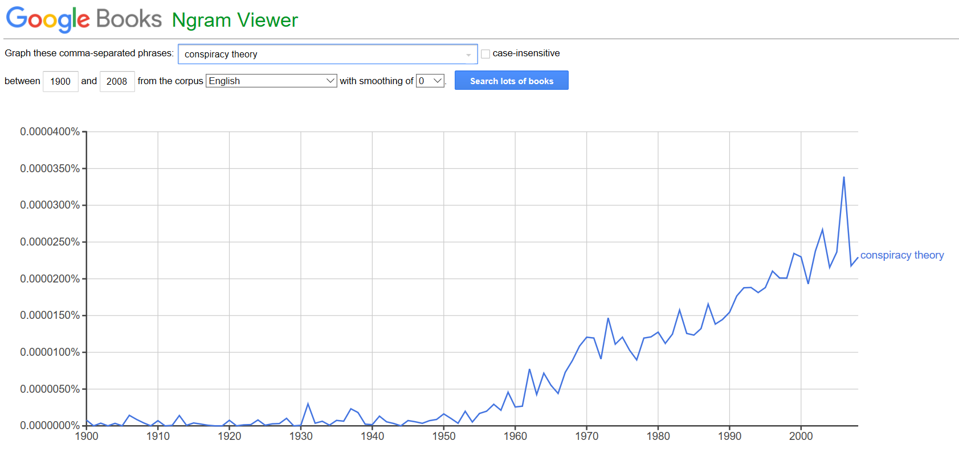
conspiracism may increase with access to digital information and as civic engagement and political participation decrease (Putnam, 2000). Moreover, clicking on the link for the scanned books from 1992 – 1994 produced a 1992 New York Times article titled, “28 Years After Kennedy’s Assassination, Conspiracy Theories Refuse to Die” (Krauss, 1992). As the title suggests, decades-old conspiracy theories, such as the assassination of President John F. Kennedy, which occurred in 1963, continued to remain popular despite their age. This suggests that the positive slope observed since 1950 may include newly emerged conspiracy theories as well as previous conspiracy theories that, as noted by Krauss (1992), “refuse to die.”
Figures 4.2 and 4.3 represent the search results for the terms “government conspiracy” and “political conspiracy” during the period 1900 – 2008. Similar to the search results for the term “conspiracy theory,” the trendlines for the words “government conspiracy” and “political conspiracy theory” are positive and begin to increase after the year 1950. Additionally, all discussion of “conspiracy theory,” “government conspiracy,” and “political conspiracy” became prominent after the year 1950 and have increased since then. Rapid changes in politics, government, and technology after the second world war in the United States appear to cohere to the increase in conspiracy theories during this period.
The largest peaks for these 2-grams, “conspiracy theory,” “government conspiracy,” and “political conspiracy,” all occur after the year 2000. Clicking on the link for the scanned books for this time period produces books advocating for particular conspiracy theories such as the assassination of President John F. Kennedy, the downing of TWA Flight 800, the shootings at Kent State in 1970 as well as other books attempting to debunk conspiracy theories. Moreover, the Google Books N-gram Viewer data suggests that conspiracy theories emerge as a response to societal and political changes. The 2-gram “political conspiracy,” for example, first appears in the late 1970s – after the Nixon Watergate scandal, and it peaks in the late 1980s following the Regan Administration’s Iran-Contra scandal, again in the mid-1990s during the Monica Lewinsky/Whitewater scandals of the Clinton Administration (Irvine & Beattie, 1998), and in the mid-2000s after the terrorist attacks of September 11, 2001 (Crawford & Bhatia, 2012).
FIGURE 4.2 Results for the search “government conspiracy,” 1900 – 2008. (source: own Google N-gram enquiry)
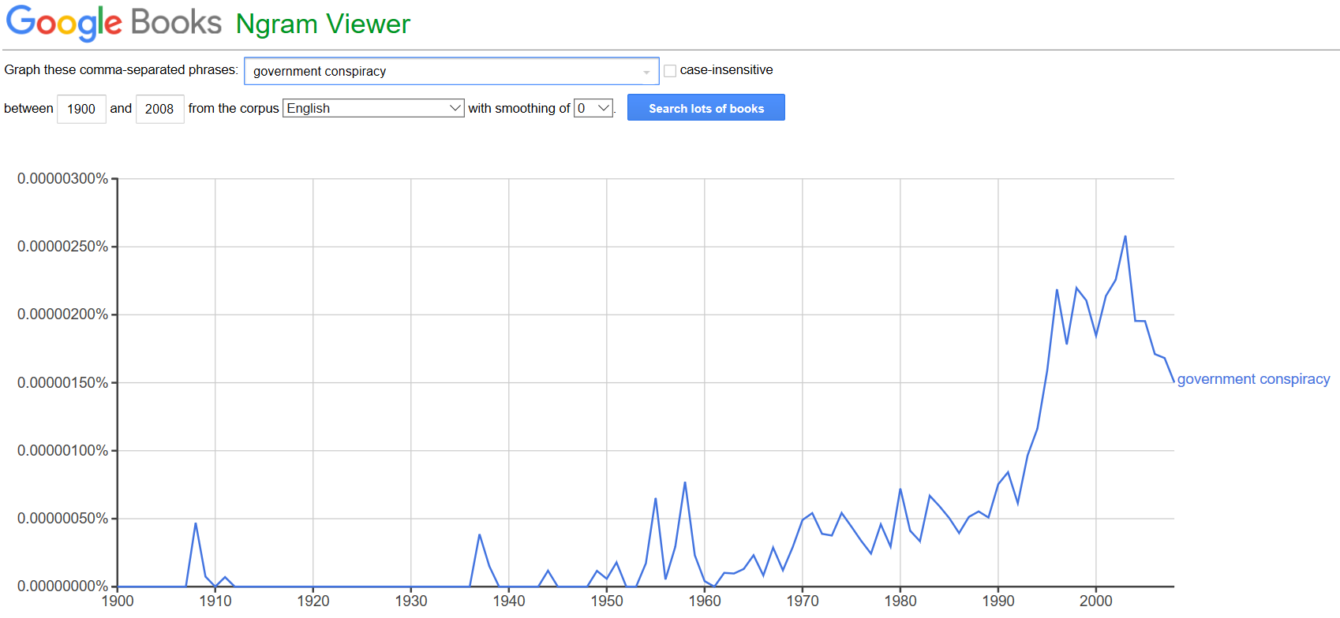
FIGURE 4.3 Results for the search “political conspiracy theories,” 1900 – 2008. (source: own Google N-gram enquiry)
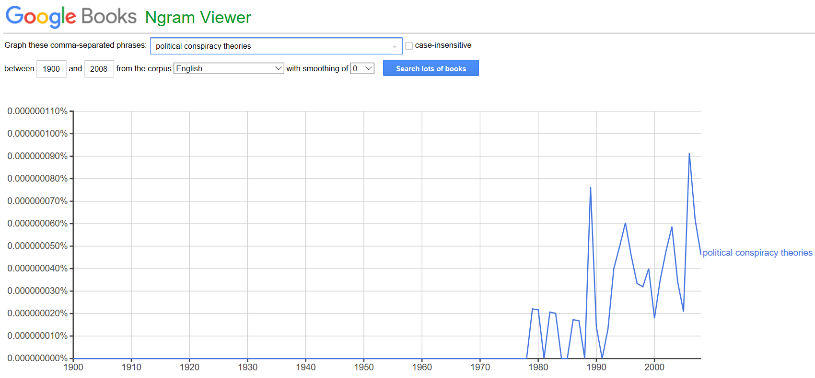
The quantitative changes detected by the Google Books N-gram Viewer data suggest that particular political events may also influence the emergence of conspiracy theories. In other words, conspiracy theories may emerge in the wake of particular societal events as an attempt by the conspiracist to make sense of those events (Brotherton & French, 2014; Dagnall, et al., 2017). Because conspiracy theories are macro in nature (Imhoff & Bruder, 2014; Oliver & Wood, 2014), establishing correlations between particular large-scale events and particular political conspiracy theories remains tenable.
Figure 4.4 illustrates the search results for the words “racist conspiracy.” The first peak occurs in the year 1960. By the mid-1960s, the trendline appears to increase until reaching a significant peak in the late 1990s. This search was chosen because of the clear power differential between African-Americans and whites historically in the United States. Much of the aforementioned literature in Chapter 2 describes many of the cognitive and social dimensions of conspiratorial ideation such as the concept of a powerful other (Yablokov, 2015) and lack of faith in government institutions and services (Einstein & Glick, 2015), which applies here. This N-gram Viewer data indicates just how conspiracy theories emerge over time in response to political trends and historic events.
Clicking on the link for the scanned books for this time frame reveals published content by African-American authors who – because of the historical systemic racism by whites against African-Americans in the United States – advocate for conspiracy theories, which to them explains the historical power differential between whites and African-Americans. As observed by Mattocks et al. (2017), some African-Americans endorse HIV-related conspiracy theories, and this may be because of the Tuskegee Syphilis Study, a 40-year Public Health Service study that left African-American men in rural Alabama untreated for syphilis.
FIGURE 4.4 Results for the search “racist conspiracy,” 1900 – 2008. (source: own Google N-gram enquiry)
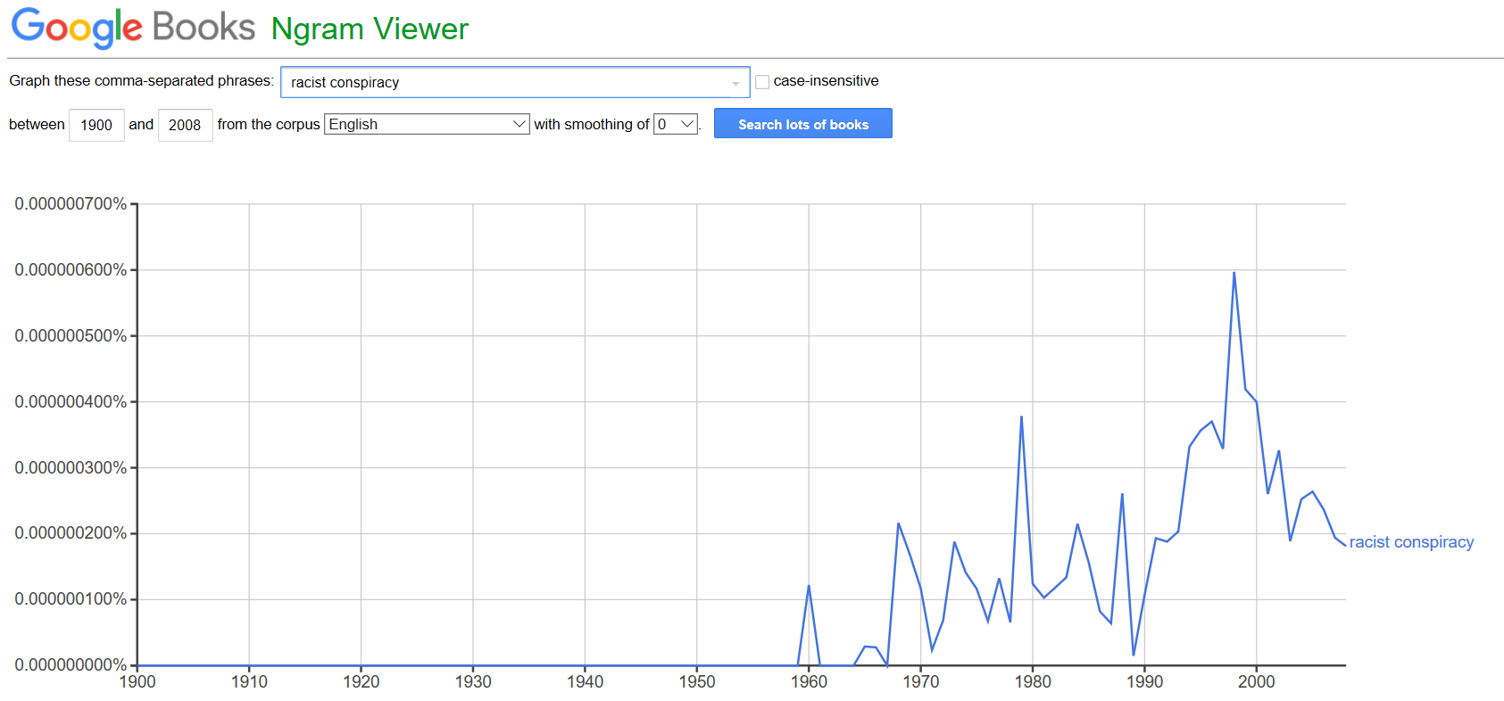
Moreover, the content of the timeframe 1900 – 2008 reflects particular historic events and conspiracy theories involving race. This demonstrates how conspiracy theories emerge in the wake of particular historic events as a way to explain or contextualize those events. Specifically, the 2-gram “racist conspiracy” also may indicate how oppressed groups – in this case African-Americans – may use /conspiracy theories as a “weapon of the weak” (Scott, 1987) against perceived powerful others (Yablokov, 2015).
Sub-question 1
Sub-question one – “do conspiracy theories reflect historic events and the popular culture of specific time periods?” – was answered using the descriptive statistics produced by Google Books N-gram Viewer data. Figure 4.5 are the side-by-side search results for the 2-grams and 3-grams “JFK Conspiracy,” “September 11 Conspiracy,” “Terrorist Conspiracy,” and “UFO Conspiracy” from 1900 to 2008. These data indicate trendlines for particular conspiracy theories over a century. Consistent with “conspiracy theories,” “political conspiracy theories,” and “government conspiracy,” analyzed above, overall interest in these particular conspiracy theories appear to increase after 1990.
Interest in UFO conspiracies reach a peak in the year 2000, where the trendline turns downward. Throughout the 1990 – 2000 decade, Irvine & Beattie (1998) describe the “pre-millennium tension” of the period and popular culture interest in conspiracies and UFOs, which undoubtedly may have influenced this peak in UFO conspiracy theories. Additionally, many of the books that N-gram Viewer has archived regarding UFO conspiracies include mostly popular texts about government cover-ups of UFOs, declassified United States government documents from the Cold War era, and other related materials.
FIGURE 4.5 Side-by-side results for the search terms “JFK Conspiracy,” September 11 Conspiracy,” “Terrorist Conspiracy,” and “UFO Conspiracy” from 1900 – 2008. (source: own Google N-gram enquiry)
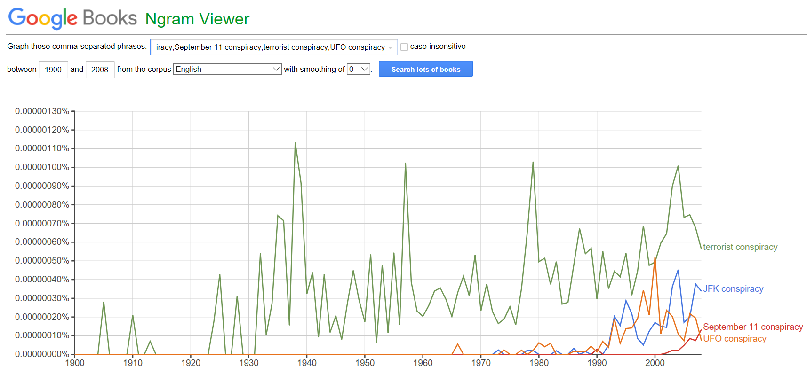
In the early 2000s, interest in all of the abovementioned conspiracy theories increase. After the September 11, 2001, terrorist attacks in the United States, the 3-gram “September 11 Conspiracy” emerges in the data, indicating that that event triggered conspiratorial reactions, which is in line with Dagnall et al.’s (2015) finding that conspiracy theories develop in an attempt to explain large-scale, historic events. Finally, the 2-gram “terrorist conspiracy” first appears just after the year 1900, where it continued to reach a number of significant peaks in the 1930s, 1950s, 1970s, and 2000s. These data show that interest in a terrorist conspiracy has historical roots as well as contemporary relevance.
Figure 4.6 illustrates the search results for the 2-gram “communist conspiracy” from 1900 – 2008. The graph shows a significant spike in usage of “communist conspiracy” in the early 1950s, during the early period of the Cold War between the United States and the Soviet Union. This trendline coheres to prediction that conspiracy theories emerge as a reaction to popular culture and historic events. The peak occurs in the mid-1950s, during the paranoia of the McCarthy-era witch hunts in the United States. Moreover, after reaching initially high peaks in the mid-1950s and mid-1960s, the trendline turns downward, indicating decreased interest in “communist conspiracy” as the Cold War continued throughout the 1970s and 1980s.
FIGURE 4.6 Results for the search term “communist conspiracy,” 1900 – 2008. (source: own Google N-gram enquiry)
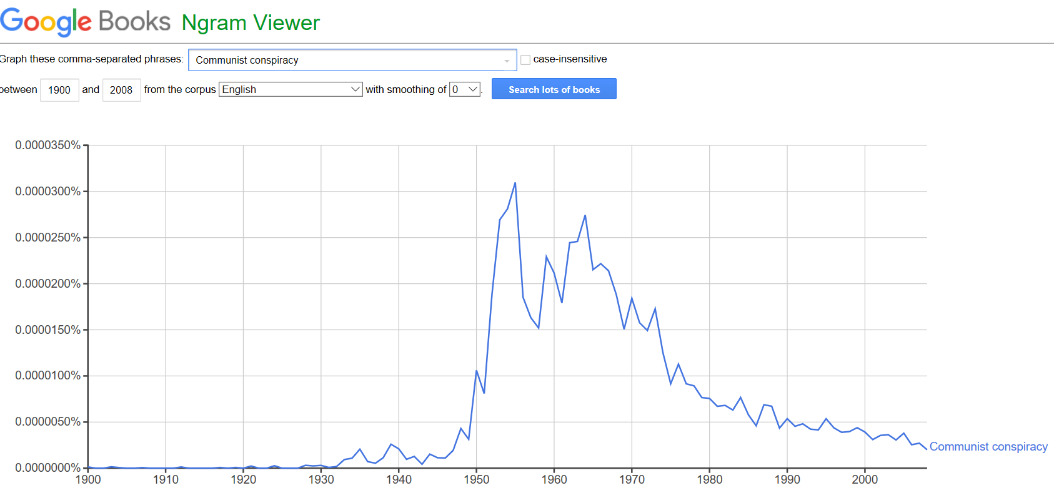
Figures 4.7 and 4.8 illustrate the search results for the 2-grams “AIDS Conspiracy” and “Medical Conspiracy” between the period 1900 – 2008. As pointed out in Chapter 2, conspiracy theories often develop in response to global pandemics (Kalichman, 2014; Smallman, 2015) and medical innovations (Clobert et al., 2015). The search results of Figure 4.7 confirm significant peaking after 1980, a time when the AIDS pandemic began to take root around the globe (Kalichman, 2014). From the early 1980s until 2008, interest in an “AIDS Conspiracy” increased throughout that period, providing additional evidence that conspiracy theories appear to emerge as an alternative epistemology to ambiguous information, such as during a global pandemic.
FIGURE 4.7 Results for the search for “AIDS conspiracy,” 1900 – 2008. (source: own Google N-gram enquiry)
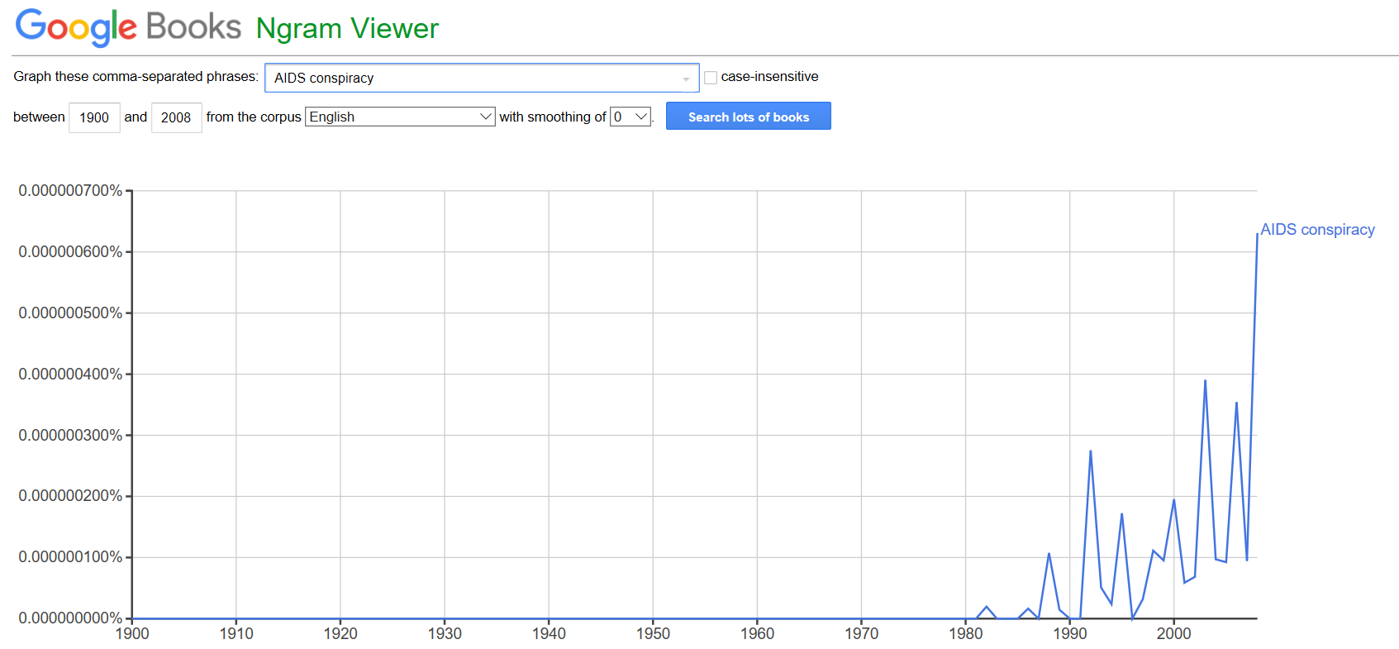
In Addition, Figure 4.8 illustrates the search results for the 2-gram “medical conspiracy” from 1900 – 2008. The results indicate several significant peaks from 1900 to 1960, indicating intense but short-lived interest in medical conspiracies. After 1960, however, the trendline for medical conspiracies appear to settle into a less intense but consistent pattern, which may reflect the “medical mistrust” indicated by Blaskiewicz (2013).
FIGURE 4.8 Results for the search for “medical conspiracy,” 1900 – 2008. (source: own Google N-gram enquiry)
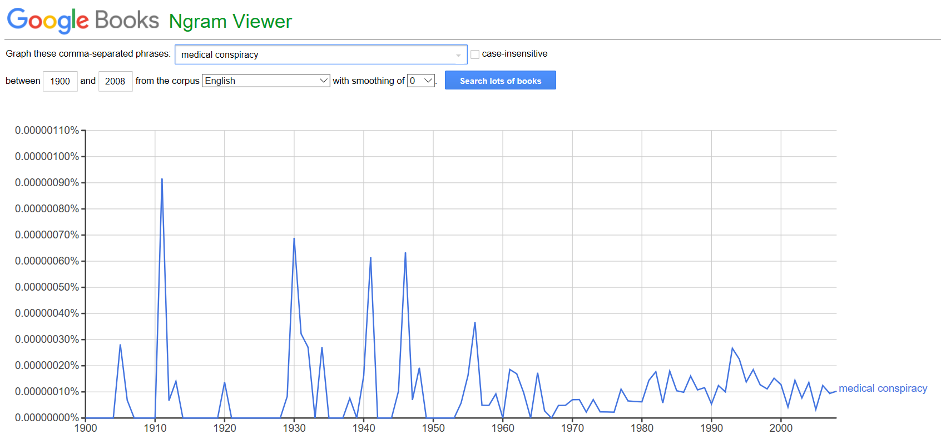
Sub-question 2
Sub-question two – “are conspiracy theories emergent across the left-right political ideological spectrum in the United States?” – was also answered using descriptive statistics produced by Google Books N-gram Viewer. Search results indicate no activity for the search terms “leftwing conspiracy” and “rightwing conspiracy” from 1900 to the late 1940s. Then, from the late 1940s until 1980, “leftwing conspiracy” appears in a series of peaks. Much of the published content N-gram Viewer has achieved from this timeframe are books and articles that describe the rising fear of British and American conservatives against communism. By 1980, however, N-gram Viewer detects a quantifiable trend change whereby “rightwing conspiracy” peaks in the mid-1980s, decreases, then peaks again throughout the late 1990s and early 2000s.

FIGURE 4.9 Results for the search “leftwing conspiracy” and “rightwing conspiracy,” 1900 – 2008. (source: own Google N-gram enquiry)
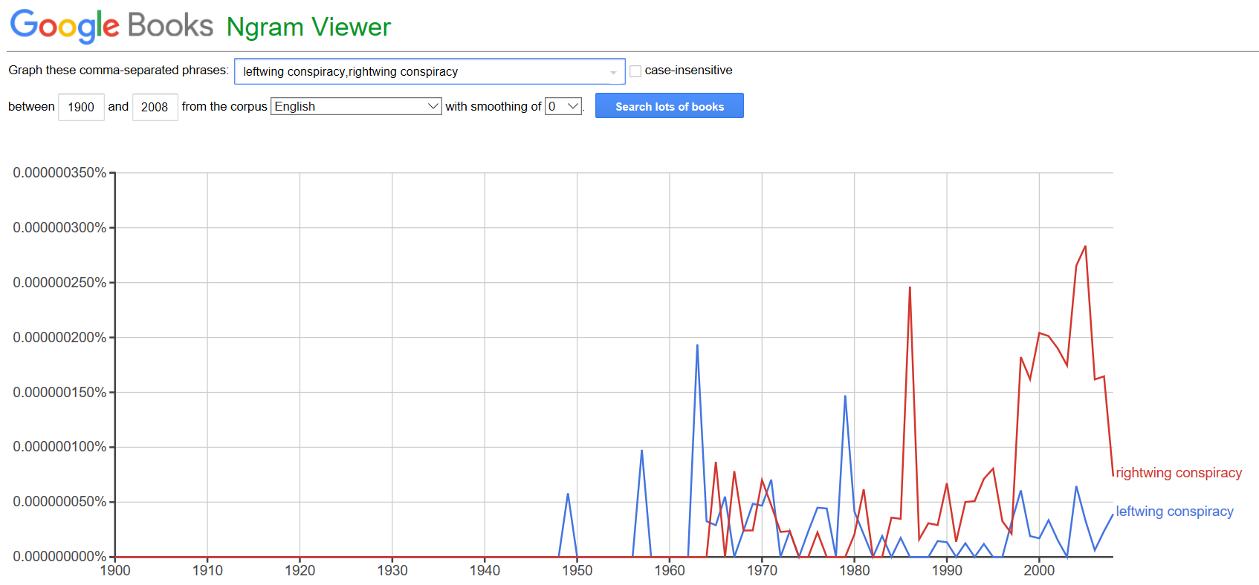
The Google Books N-gram Viewer data contains “a mix of technical and popular publications” and, thus, captures an accurate snapshot of popular and academic English-language publications on a given topic over time (Pettit, 2016). Viewed through the theoretical frameworks presented in Chapter 1 – Putnam’s (2000) model of decreased civic engagement and political participation, Mills’ (1956) power elite, and Herman and Chomsky’ (1988) manufacturing consent thesis – the views and opinions of elite, educated classes that are overrepresented in print culture remains baked into the Google Books N-gram Viewer data. Additionally, this assumption can help guide an accurate interpretation of the search results presented for sub-question two. With this in mind, it appears that the post-WWII period until 1980 remains dominated by concern of a leftwing conspiracy. The New Deal policies that began prior to the aforementioned period and the Great Society programs of the 1960s, along with legislation such as the Civil Rights Act and other societal changes that occurred throughout the decade, clearly influenced concerns of a leftwing conspiracy, as the Google Books N-gram Viewer data demonstrates. That concern changes, however, in 1980, where concern of a rightwing conspiracy emerges. These changes were almost certainly triggered by the election of Ronald Reagan in 1980 in the United States and the neoliberal policies of Margaret Thatcher in the United Kingdom during the same period.
The years when peaking occurs, whether or not the trendline is positive or negative, and the precise words that the Google Books N-gram Viewer detects remains telling. The behavior of the n-gram data peaks and the trend toward a concern over rightwing conspiracies since the 1980s suggest – and leftwing conspiracies prior to 1980 – two things. First, historical political events, such as the election of a president from a different party affiliation and the policies that follow, can trigger conspiratorial ideas from those opposite on the left-right ideological spectrum. Second, from the timeframe 1900 – 2008, concern over leftwing conspiracies remained prominent in the post-WWII to 1980 era, and concern over rightwing conspiracies became dominant in print culture after 1980. For example, in the 1990s, when the N-gram Viewer indicates an increase in rightwing conspiracies, much of the content taken into account includes articles by leftwing authors, who were concerned about rightwing conspiracies about President Bill Clinton (Kaiser & Chinoy, 1999). In fact, Hillary Rodham Clinton described "a vast right-wing conspiracy that has been conspiring against [her] husband since the day he announced for president” (Kaiser & Chinoy, 1999).
Next, Figure 4.10 are the Google Books N-gram Viewer search results for the words “liberal conspiracy,” and “conservative conspiracy” from 1900 to 2008. The patterns that emerge for the terms “liberal conspiracy” and “conservative conspiracy” remain different from the search results for “leftwing conspiracy” and “rightwing conspiracy.” Where there were no quantifiable results for the terms “leftwing conspiracy” and “rightwing conspiracy” in the N-gram Viewer data prior to the late 1940s, “liberal conspiracy” and “conservative conspiracy” appear earlier in the decades 1900s and 1910s. What is more, there appears to be significant spikes for “liberal conspiracy” in the 1940s. Since 1950, both “liberal conspiracy” and “conservative conspiracy” begin consistent trendlines.
Figure 4.10 also shows more concern over a “liberal conspiracy” since 1980 than a “conservative conspiracy.” Further investigation reveals that most of the content written in the 1990s that N-gram Viewer archives refers to liberal conspiracy theories about conservative political trends of the time. This includes the popularity of conservative talk radio, which became increasingly popular during the 1990s (Devries, 1996).
FIGURE 4.10 Results for the search “liberal conspiracy” and conservative conspiracy,” 1900 – 2008. (source: own Google N-gram enquiry)
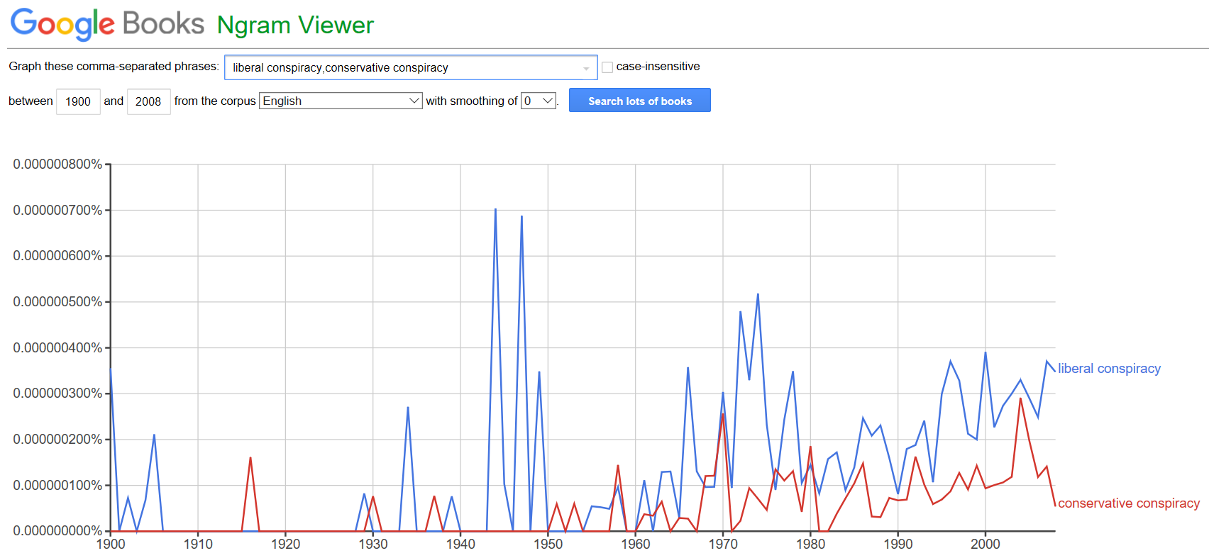
Additionally, the last significant spike in 2000 concerns content regarding another liberal conspiracy theory about the controversial supreme court decision, Bush v. Gore (Lund, 2011). Briefly, by the year 2000, five of the nine justices on the Supreme Court were appointed by Republican presidents. When the court decided Bush v. Gore, stopping the Florida recount thus handing the election to then-candidate George W. Bush, many liberal-leaning conspiracy theories emerged that claimed conservatives conspired to take the presidency (Lund, 2011). This example demonstrates how conspiracy theories emerge across the left-right political ideological spectrum.
Finally, Table 4.1 displays the frequencies for the 15 conspiratorial-related n-grams examined for this study. The “year” column for Table 4.1 indicates the first year of recorded data indexed by the Google Books N-gram Viewer for each phrase until the year 2008. Results indicate increases for 10 of the 15 conspiratorial-related n-grams. The 2-gram “conspiracy theory” had the largest increase of 22400% from 1900 to 2008 followed by the 2-gram “AIDS conspiracy,” which increased 2400% from 1983 to 2008. The 2-gram “communist conspiracy” had the third largest increase of 1800% from 1925 to 2008.
Three n-gram phrases, “leftwing conspiracy,” “medical conspiracy,” and “conservative conspiracy” decreased overall from the first year of recorded data indexed by N-gram Viewer to 2008. “Leftwing conspiracy” decreased -16.95% from 1948 to 2008. The 2-gram “medical conspiracy” decreased -62.48% from 1905 to 2008. Additionally, the 2-gram “conservative conspiracy” decreased -66.67% from 1915 to 2008. The results for two politically related 2-grams, “liberal conspiracy” and “rightwing conspiracy” did not indicate an overall percent increase or decrease over the years examined for this study.
N-gram phrase frequency decreases may suggest that individual conspiracy theories come in and out of fashion over time. “UFO conspiracy” and “JFK conspiracy,” for instance, remain prime examples, with the N-gram Viewer data suggesting that these conspiracy theories rise, peak, and decline over shorter time periods. Additionally, the majority of the n-grams examined for this study – 10 out of 15 – increased, indicating that, overall, since roughly 1950 conspiracy theories have been on the rise.
TABLE 4.1 Word frequencies from first year of recorded data indexed by the Google Books N-gram Viewer to the year 2008.
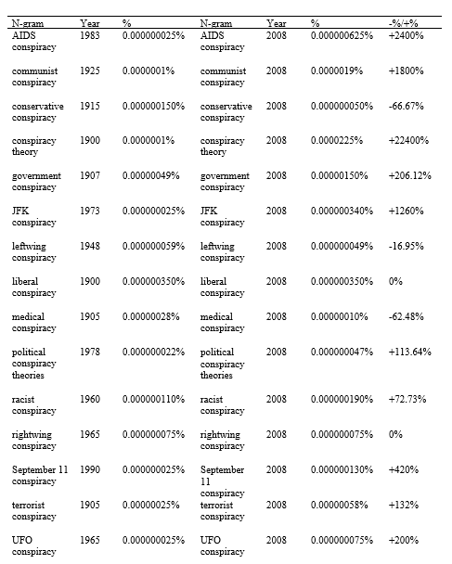
As shown in Figure 4.1, the 2-gram “conspiracy theory,” which increased by 22400%, continues on a linear trendline from its first appearance in 1900 to 2008.
Summary
In summary, the descriptive statistics and the N-gram Viewer search results discussed above indicate that conspiratorial ideas emerge over time in response to particular political trends, historic events, and disease outbreaks. Additionally, a relationship exists between political trends and disease pandemics between 1900 and 2008 and the emergence of conspiracy theories. Finally, conspiratorial ideas emerge across the left-right political ideological spectrum in the United States. Therefore, there is evidence for accepting the proposed hypotheses. Thus, one can reject the null hypotheses that conspiratorial ideas will not emerge in the aftermath of significant historic events as an attempt to explain, contextualize, or understand those events; the frequency and trendlines of conspiracy theories will not increase and decrease over time; conspiracy theories will not be influenced by political trends of the time period in which they develop, and conspiracy theories will not develop across the left-right political ideological spectrum.

Chapter 5: Discussion
Introduction
The purpose of this quantitative content analysis was to measure the frequency patterns of 15 conspiratorial-related n-grams between the years 1900 to 2008 using the Google Books N-gram Viewer English language 2012 version. N-Gram Viewer allows for the study of macrotrends of published articles by producing word frequency time-series plots, which were visually assessed for this study (Lin et al., 2012; Michel et al., 2011; Roth, Clark, & Berkel, 2017). The time-series plots word frequencies (y-axis) were compared against the yearwise sum results (x-axis) to assess the rising, peaking, and falling – trends and patterns – of particular 2- and 3-gram conspiracy-related phrases selected for this study. This chapter includes a summary and discussion of the research findings as well as implications, limitations, and suggestions for future research. The discussion is organized around the following research questions:
Central research question: What is the emerging frequency of conspiratorial ideas from 1900 to 2008 in response to political trends, historical events, and popular culture?
Sub-question 1: Do conspiracy theories reflect historic events and the popular culture of specific time periods?
Sub-question 2: Are conspiracy theories emergent across the left-right political ideological spectrum in the United States?
Summary of Results
The current study utilized the Google Books N-gram Viewer’s descriptive statistics to analyze how conspiratorial ideas emerge over time in response to political trends, historic events, and popular culture. To test the hypotheses, a quantitative analysis using descriptive statistics were used. The results are presented in percentages and parts per million (ppm). As noted by Roth, Clark, and Berkel (2017), the percentages represent “. . . the relative word frequency per million words in the Google Book corpus,” while “[t]he unit per million is used to avoid longer chins of digits after the decimal point.” Both percentages and parts per million (ppm) were presented in the results.
The results of this study indicated that for H₁ conspiratorial ideas will emerge in the aftermath of significant United States historic events as an attempt to explain, contextualize, or understand those events (Fig. 4.5) showed that from 1973 to 2008 there was a +1260% increase in the 2-gram “JFK conspiracy,” increasing from 0.000000025% (0.00025ppm) in 1973 to 0.000000340% (0.0034ppm) in 2008. Relatedly, after the terrorist attacks on September 11, 2001, there was a +542.9% increase from 2003 to 2008 of the 3-gram “September 11 conspiracy,” increasing from 0.000000021% (0.00021ppm) in 2003 to 0.000000135% (0.00135ppm) in 2008. Finally, the 2-gram “AIDS conspiracy” increased +2400% from 1982 to 2008, increasing from 0.000000025% (0.00025ppm) in 1982 to 0.000000625% (0.00625ppm) in 2008. The hypothesis was supported; therefore, the null hypothesis was rejected.
Second, results indicated that for H₂ the frequency of conspiracy theories will increase and decrease between 1900 to 2008. Word search frequencies display this behavior for all 15 2-grams and 3-grams tested for this study. For the 2-gram “conspiracy theory” (Fig. 4.1), for instance, from 1900 to 2008 there was an overall +22400% increase. Between 2006 and 2008, however, the 2-gram “conspiracy theory” decreased –34.8%, from 0.0000345% (0.345ppm) in 2006 to 0.0000225% (0.225ppm) in 2008. Figure 4.2 shows the results for the 2-gram “government conspiracy.” Results demonstrate that from 1992 to 1995, there was a +275% increase, from 0.00000060% (0.006ppm) in 1992 to 0.00000225% (0.0225ppm) in 1995. However, from 2003 to 2008 a –42.3% decrease occurred, from 0.00000260% (0.026ppm) in 2003 to 0.00000150% (0.015ppm) in 2008. The hypothesis was supported; therefore, the null hypothesis was rejected.
Third, the results for H₃ indicated that conspiracy theories will be influenced by political trends of the time period in which they develop. Figure 4.6 are search results for the 2-gram “communist conspiracy.” The 2-gram “communist conspiracy” peaks in 1963 at 0.0000120% (0.12ppm) in the middle of the Cold War but slowly decreases throughout the 1970s, 1980s, and 1990s until reaching 0.0000019% (0.019ppm) in 2008 – a decrease of –82.4% from its peak in 1963. Additionally, Figure 4.5 shows the search results for the 2-gram “terrorist conspiracy.” Between 2000 to 2004, there was a +100% increase for the 2-gram “terrorist conspiracy” following the September 11, 2001, terrorist attacks, from 0.00000050% (0.005ppm) in 2000 to 0.00000100% (0.01ppm) in 2004. The hypothesis was supported; therefore, the null hypothesis was rejected.
Finally, the results for H₄ indicated that conspiracy theories will develop across the left-right political ideological spectrum in the United States. Figure 4.9 are the search results for the two 2-grams “leftwing conspiracy” and “rightwing conspiracy.” There are two large peaks for the 2-gram “leftwing conspiracy” in 1963 0.000000190% (0.0019ppm) and in 1979 0.000000149% (0.00149ppm). Relatedly, a search for the 2-gram “rightwing conspiracy” also displays large peaks. For example, a large peak occurs in 1985 0.000000149% (0.00149ppm) and in 2005 0.000000275% (0.00275ppm). These results suggest that conspiracism occurred on both ends of the left-right political spectrum in the United States during that timeframe. Moreover, Figure 4.10 are the search results for two related 2-grams, “liberal conspiracy,” and “conservative conspiracy.” There are several large peaks for the 2-gram “liberal conspiracy,” occurring in 1944 0.000000700% (0.007ppm), 1947 0.000000690% (0.0069ppm), and in 1974 0.000000510% (0.0051ppm). The 2-gram “conservative conspiracy” displays peaking in the years 1970 0.000000250% (0.0025ppm) and in 2004 0.000000290% (0.0029ppm). Again, these peaks suggest active conspiracism across the political spectrum during the years between 1900 and 2008. The hypothesis was supported; therefore, the null hypothesis was rejected.
Interpretation of Results
Previous studies have explored the psychological underpinnings of conspiratorial ideation (Brotherton & French, 2014), how individual conspiracy theories occur in many regions of the world (Crawford & Bhatia, 2012; Iqtidar, 2016; Ortmann & Heathershaw, 2012; Yablokov, 2015), proportions of individuals who endorse conspiracy theories (Dagnall et al., 2015), and particular conspiracy theories that have emerged in recent decades (Oliver & Wood, 2014). These studies have yielded results with a limited scope, in that, they have focused on specific conspiracy theories in a specific region of the world (Dagnall et al., 2015) or on the cognitive underpinnings of how conspiratorial beliefs form (Brotherton & French, 2014). Conversely, the current study remains the first to take a big data approach to analyzing conspiracy theories using a corpus of millions of digitized English-language books (Lin et al., 2012; Michel et al., 2011; Roth, Clark, & Berkel, 2017).
The findings of this study are supported by Imhoff and Bruder (2014), for instance, which suggest that the endorsement of conspiracy theories transcends political party affiliation and identity in the United States. As the N-gram Viewer data indicate in Chapter 4, there have been rises, peaks, and falls for both the 2-grams “leftwing conspiracy” and “rightwing conspiracy” as well as with the 2-grams “liberal conspiracy” and “conservative conspiracy” over the decades analyzed in this study, suggesting that conspiracy theories emerge across the left-right political ideological spectrum. This finding may have important consequences for those seeking educational interventions to help abate the spread of conspiracy theories in public discourse (Wood, 2016), particularly educational interventions that are aimed at specific ideological groups.
The finding that conspiratorial ideas will emerge in the aftermath of significant United States historic events as an attempt to explain, contextualize, or understand those events also may have implications for news media and social media. Increased frequencies found in the N-gram Viewer data in the aftermath of significant historic events in the United States (Figure 4.5) remains a consistent trend. Journalists and media content creators may consider, for example, taking proactive measures to guard against conspiracy-driven “fake news” in the aftermath of such events (Himma-Kadakas, 2017), as the likelihood of conspiracy theories emerging in the aftermath of a significant historic event remains high in light of this study’s findings.
Additionally, the results of this study are also supported by Dagnall et al. (2015), which indicate that conspiracy theories emerge after large-scale, historic events, such as the terrorist attacks in the United States on September 11, 2001, and also form in reaction to the political trends and reflect the popular culture in the time period they emerge. The pattern – rising, peaking, and falling – for example, for the 2-gram “communist conspiracy” illustrates how a conspiracy theory reflects the time period in which it emerges. The fear of communism is hardly the threat that it once was in Western countries since the break-up of the Soviet Union in 1991, so it is not surprising that the N-gram Viewer data detects peaks for a “communist conspiracy” in the mid-1950s and mid-1960s – during the height of the Cold War. This era was also around the same time when Hofstadter (1964) established some of the first scholarship on conspiracy theories, describing the “paranoid-style” strain in American politics (see Chapter 2). The 2-gram “communist conspiracy” has been falling steadily ever since also indicating a decreased interest in the subject.
Parker (2011) observes the definition of popular culture to mean “a set of generally available artefacts: films, records, clothes, TV program[s], [and] modes of transport.” Relatedly, Figure 4.5 (Chapter 4) includes the N-gram Viewer search results for the 2-gram “UFO conspiracy,” which demonstrates a peak in the year 2000 and a sharp decrease thereafter. Television programs and movies such as the X-Files turned the conspirator into a heroic figure, where the conspiracy theorist touted phrases such as “I want to believe,” “The truth is out there,” and “Trust no one,” (Irvine & Beattie, 1998). The popularity of UFO conspiracies indicated by the N-gram Viewer search results in the year 2000 may reflect the “pre-millennium tension” noted by Irvine and Beattie (1998). It should be no surprise, then, that after the September 11, 2001, terrorist attacks in the United States interest in UFO conspiracies waned as conspiracy theories immediately reflected more terrestrial concerns, such as terrorism (see Figure 4.5).
The N-gram Viewer search results for “AIDS conspiracy” and “medical conspiracy” remains consistent with the findings of Kalichman (2014). Additionally, these findings support the contention of Mattocks, et al. (2017) that medical mistrust and skepticism toward government health agencies remains high for conspiracy theorists; moreover, the findings of this study additionally demonstrate that medical conspiracy theories tend to emerge after the onset of a global disease epidemic such as HIV/AIDS. It remains highly probable that similar conspiracy theory patterns will emerge after other recent global disease epidemics such as the 2009 H1N1 influenza pandemic (Smallman, 2015) and the 2015 Zika virus outbreak (Smallman, 2017), but since the Google Books N-gram Viewer corpus currently ends in 2008 (Zeng & Greenfield, 2015), and therefore there is no way to test this hypothesis with the current data set.
Implications
Since the recent introduction in American discourse of concepts such as “fake news” and “alternative facts” (Himma-Kadakas, 2017; Yaxley 2017), and with the findings from this study indicating an increased frequency from 1900 to 2008 for the 15 conspiracy-related n-gram phrases examined, conspiracy theories have become entrenched in the English language and appear to be on the rise, as indicated by the linear increase of the 2-gram “conspiracy theory” from after WWII to 2008. These findings have important consequences for the broader domain of public discourse, political debate, science communication, and education (Iqtidar, 2016; Ortmann & Heathershaw, 2012; Yablokov, 2014).
As the results of this study demonstrate, individuals on both of the left-right political ideological spectrum remain susceptible to endorsing conspiracy theories, and political trends, historic events, and popular culture have the potential to inspire new conspiracy theories. A clear and concrete example of this is highlighted by the 2016 Presidential Election in the United States. As documented by United States intelligence agencies (Banks, 2017; Ohlin, 2017), the Russian government engaged in a series of “active measures” to influence the outcome of the 2016 Presidential Election. As part of their campaign, Russian hackers’ cyber inference included spreading a number of conspiracy theories on online social networks (OSNs) about Democratic candidate Hillary Rodham Clinton and the Democratic National Committee (DNC). These efforts targeted liberals with the aim of undermining trust in the United States electoral system and helping then-candidate Donald J. Trump win the election (Banks, 2017; Ohlin, 2017). Although these events are too recent to show up in the N-gram Viewer data (Zeng & Greenfield, 2015), they communicate two messages. First, the role of conspiracy theories in the 2016 presidential election demonstrate that no part of the American electorate is immune from endorsing conspiracy theories, and, second, it also demonstrates that conspiracy theories have the potential to undermine the democratic political system.
In the area of science communication, the results of this study remain particularly unsettling. Medical mistrust and skepticism toward government health agencies, which conspiracy theories tend to fuel (Mattocks et al., 2017), remains a threat to global health and safety. When individuals endorse conspiracy theories that the Measles, Mumps, and Rubella (MMR) vaccine causes autism, for instance, a drop in the intention to get children vaccinated decreases (Jolly & Douglas, 2014a). These consequences have already been felt in South Africa within the context of HIV/AIDS, for example, as during the presidential tenure of AIDS denialist Thabo Mbeki an estimated 330,000 individuals died of AIDS and 35,000 babies were born with HIV infection (Kalichman, 2014). Additionally, as described in Chapter 2, conspiracy theorists tend to endorse the idea of a “powerful other” (Douglas et al., 2016; Yablokov, 2015), and medical interventions are often a top-down, group-level activity – such as the use of vaccines (Jolley & Douglas, 2014a) – so, conspiracy theories may also present challenges for creating public buy-in for implementing future top-down health strategies. Moreover, the finding that conspiracy theories emerge in the aftermath of disease epidemics such as AIDS (Figure 4.7) and that medical conspiracies have been occurring since 1905 (Figure 4.8) and continue through the year 2008 also may have implications for implementing future top-down health interventions such as vaccinations, for instance (Jolley & Douglas, 2014a). Public health officials may consider implementing disease epidemic readiness education procedures to communicate with the public and stakeholders prior to implementing future top-down heath strategies or to prepare for the onset of a disease epidemic outbreak in order to ensure patient compliance. As explored in Chapter 2, conspiracy theories reduce interpersonal trust (Acar-Burkay et al., 2014; Leman & Cinnirella, 2013) and foster skepticism toward governmental agencies (Swami et al., 2013); therefore, getting in front of conspiracy theories prior to a disease epidemic may improve health outcomes.
The findings of this study also give credence to Putnam’s (2000) model of decreased civic engagement and political participation. In the latter decades of the 20th century, Putnam (2000) found that levels of civic engagement and political participation began to decrease. At the same time, as the findings of this study show and as the literature shows, there has been an increase in the level of conspiracy theory activity since the 1950s. This infers that civic engagement and conspiracy theories are inversely related, and as the influence of the digital landscape and OSNs continues to increase (Bessi et al., 2015), conspiracy theories may have found a fertile breeding ground in the current moment.
In summary, conspiracy theories remain more than fringe collection of ideas held by a limited number of individuals. On the contrary, belief in conspiracy theories goes back decades and, as the findings of this study demonstrate, conspiracy theories are on the rise. Moreover, conspiracy theories can disrupt elections (Banks, 2017; Ohlin, 2017), undermine group-level medical interventions (Jolly & Douglas, 2014a), and have the potential to emerge across the left-right political spectrum. The implications of the findings of this study suggest that policymakers, educators, and the media need to consider how conspiracy theories may undermine their work. Within the areas of health policy and education, for instance, policymakers and educators may confront conspiracy theories from their constituents or students, conspiracy theories such as vaccines cause autism (Jolly & Douglas, 2014a) from constituents or that the Apollo moon landings were faked (Swami et al, 2013) from students. In these instances, simply labeling something a conspiracy theory does not necessarily reduce a person’s belief in it (Wood, 2016). Understanding, therefore, that conspiracy theories may emerge in response to historic events, political trends, and popular culture may remain the first step toward devising corrective interventions that are aimed at reducing the belief in conspiracy theories. Public health officials, government agencies, and the media may be responsible for conveying this message to the public. Additionally, as stated in Chapter 1, journalists must now contend with “fake news” and “alternative facts” (Himma-Kadakas, 2017) in which conspiracy theories play a role, and governments, for example, such as Russia (Yablokov, 2015), South Africa (Kalichman, 2014), and the United States (Himma-Kadakas, 2017) have aided in spreading conspiracy theories. Finally, the awareness that conspiracy theories may constitute an epistemological threat and that the popularity of conspiracy theories has increased each decade since roughly 1950 may help journalists shed a light on conspiracism and its effects, as described above.
Limitations and Recommendations for Future Research
The findings presented in this study present insights into the emerging historical trends of conspiracy theories, although the methodology was limited to quantitative data. Future research on this topic may include a qualitative approach. The advantage of a potential qualitative approach for example, may provide additional depth through interviews with conspiracy theorists to understand their individual perceptions and motives for endorsing conspiratorial beliefs (Creswell, 2014). This study was also limited to 15 conspiratorial n-grams analyzed between the years 1900 to 2008. Future research using N-gram Viewer may focus on a different time period, measuring conspiracy theories prior to the year 1900, for example, to see if potential “proto-conspiracy theories” have emerged earlier in history.
Additionally, due to the large Google Books N-gram Viewer data set used in this study, results remain generalizable, although such as with similar methodologies, results remain limited to the variables studied; or, in other words, results remain limited to the particular 15 n-gram phrases selected for this study. Finally, future N-gram Viewer research may want to focus on other particular conspiracy theories not examined in this analysis, or concepts related to conspiracy theories such as, for instance, magical thinking (Brashier & Multhaup, 2017) or superstitious beliefs (Risen, 2016) – concepts related to conspiratorial thinking (Brotherton & French, 2014).
Conclusions
In order to function, large institutions such as the government, the media, and the educational system require a minimal level of public trust in order to remain effective and useful to their constituents. In 1961, President Dwight D. Eisenhower warned of a “military-industrial complex,” where public interests would become submissive to the interests of large bureaucracies. Although Eisenhower’s fears of a military-industrial complex never materialized (Dunlap, 2011), large institutions remain the targets of conspiracy fear mongering (Dagnall et al., 2015; Imhoff & Bruder, 2014; Oliver & Wood, 2014), while maintaining a status of powerful others within the minds of many conspiracy theorists.
The findings of this study demonstrate that 10 out of 15 conspiracy theory n-grams have increased from 1900 to 2008, emerging in response to historic events, political trends, and popular culture. For example, peaking has occurred in the aftermath of the September 11 terrorist attacks in the United States (Figure 4.5), interest in communist conspiracies peaked in concert with the Cold War political trends of the 1950s and 1960s (Figure 4.6), and UFO conspiracies reached their apex in the year 2000 as a possible result of the “pre-millennium tension” of the late 1990s and the popular culture of the era (Irvine & Beattie, 1998). In particular, n-gram phrase frequency trends such as “September 11 conspiracy” and “AIDS conspiracy” demonstrate how conspiracy theories emerge in the aftermath of a historical event, while the frequency trends of the 2-gram “leftwing conspiracy” and the 2-gram “rightwing conspiracy” in Chapter 4 illustrate how conspiracy theories increase and decrease over time in response to political trends. Finally, the 2-gram “UFO conspiracy” and the 2-gram “communist conspiracy” show that conspiracy theories will emerge in the context of popular culture as defined by Parker (2011), as both UFO conspiracies – while peaking at the millennium – and communist conspiracies, which fluctuated throughout the Cold War years and had an impact not only on politics but also on popular films and television (White, 2015), remain arguably representative of the decades in which these conspiracy theories peaked in the N-gram Viewer data.
Future research using N-gram Viewer may attempt an inferential statistical approach to study conspiracy theories. Although there has been some research utilizing Google N-gram Viewer data and inferential statistics (Hamamura & Xu, 2015) no study to date has used this approach to study conspiracy theories in Google Books N-gram Viewer. Such statistical methodologies may focus on correlational relationships between peak years and n-gram phrases, for example. Moreover, as noted above, N-gram Viewer methodology may be applied to related concepts, such as magical thinking (Brashier & Multhaup, 2017) or superstitious beliefs (Risen, 2016) in order to test if these related concepts display the same frequency patterns in the n-gram data as conspiracy theories n-grams do – emerging in the aftermath of historic events, for example, or emerging within the context of political trends and popular culture. Broadening the understanding of conspiracy theories, or, perhaps, as suggested, magical thinking and superstitious beliefs, may help shed light how these epistemologies emerge and if they display statistical relationships with each other or the time period in which they develop.
Finally, as an emerging methodology, the Google Books N-gram Viewer presents several potential benefits for future research. As previously noted, N-gram Viewer “offers a novel means of tracing cultural change over time” (Pettit, 2016), and it enables researchers to “investigate cultural trends quantitatively” (Michel et al., 2011), which remains a methodological approach that was not possible previously. Additionally, the quantitative study of human culture – referred to as “culturomics” (Michel et al., 2011) – remains a developing methodology that offers future researchers the ability to investigate cultural phenomena that was previously out of reach, a truly exciting prospect.

References
Acar-Burkay, S., Fennis, B. M., & Warlop, L. (2014). Trusting others: The polarization
effect of need for closure. Journal of Personality and Social Psychology, 107(4): 719-35. doi: 10.1037/a0037022
Bakalaki, A. (2016). Chemtrails, crisis. And loss in an interconnected world. Visual
Anthropology Review, 32(1), 12-23. doi: 10.1111/var.12089
Banks, W. (2017). State responsibility and attribution of cyber intrusions after Tallinn 2.0. Texas
Law Review, 95(1487), 1487 – 1513.
Bessi, A., Coletto, M., Davidescu, G. A., Scala, A., Caldarelli, G., & Quattrociocchi, W. (2015).
Science vs conspiracy: Collective narrative in the age of misinformation. PLoS ONE 10(2). doi:10.1371/journal.pone.0118093.
Blaskiewicz, R. (2013). The big pharma conspiracy theory. Medical Writing, 22(4):
259-61. doi: 10.1179/2047480613Z.000000000142
Bolton, D. M., & Yaxley, J. (2017). Fake news and clickbait: Natural enemies of evidence-based
medicine. BJU International, 119, 8-9. doi:10.1111/bju.13883
Brashier, N. M. & Multhaup, K. S. (2017). Magical thinking decreases across adulthood.
Psychology and Aging, 32(8), 681–688. doi: 10.1037/pag0000208
Brotherton, R. & French, C. C. (2014). Belief in conspiracy theories and susceptibility to
the conjunction fallacy. Applied Cognitive Psychology, 28, 238-48.
doi: 10.1002/acp.2995
Brotherton, R. & French, C. C. (2015). Intention seekers: Conspiracist ideation and
biased attributions of intentionality. PLOS ONE, 10(5): 1-14.
doi: 10.1371/journal.pone.0124125
Brotherton, R., French, C. C., & Pickering, A. D. (2013). Measuring belief in conspiracy
theories: The generic conspiracist beliefs scale. Frontiers in Psychology, 4(279): 1-15. doi: 10.3389/fpsyg.2013.00279
Cairns, R. (2016). Climates of suspicion: ‘Chemtrail’ conspiracy narratives and the
international politics of geoengineering. The Geographical Journal, 182(1):
70-84. doi: 10.1111/geoj.12116
Clobert, M., Saroglou, V., & Van Pachterbeke, M. (2015). Who turns to acupuncture?
The role of mistrust of rationality and individualist success. The Journal of Alternative and Complementary Medicine, 21(8): 466-71.
doi: 10.1089/acm.2014.0229
Crawford, J. T. & Bhatia, A. (2012). Birther nation: Political conservatism is associated
with explicit and implicit beliefs that president Barack Obama is foreign. Analysis of Social Issues and Public Policy, 12(1): 264-376.
doi: 10.1111/j.1530-2415.2011.01279.x
Creswell, J. (2014). Research design: Quantitative, qualitative, and mixed methods. Thousand
Oaks, CA: Sage.
Dagnall, N., Drinkwater, K., Parker, A., Denovan, A., & Parton, M. (2015). Conspiracy
theory and cognitive style: A worldview. Frontiers in Psychology, 6(206): 1-9.
doi: 10.3389/fpsyg.2015.00206
Dagnall, N., Denovan, A., Drinkwater, K., Parker, A., & Clough, P. (2017). Statistical bias and
endorsement of conspiracy theories. Applied Cognitive Psychology, 31, 368-378.
Devries, T. (1996, March – April). We'll talk about that: can liberals do radio? The American
Prospect, 25. Retrieved from http://www.prospect.org
Donskis, L. (1998). The conspiracy theory, demonization of the other. Innovation, 11(3), 349-
360.
Douglas, K. M. & Leite, A. C. (2016). Suspicion in the workplace: Organizational
conspiracy theories and work-related outcomes. British Journal of Psychology,
1-21. doi: 10.1111/bjop.12212
Douglas, K. M. & Sutton, R. M. (2015). Climate change: Why the conspiracy theories
are dangerous. Bulletin of the Atomic Scientists, 7(2): 98-106.
doi: 10.1177/0096340215571908
Douglas, K. M., Sutton, R. M., Callan, M. J., Dawtry, R. J., & Harvey, A. J. (2016). Someone is
pulling the strings: Hypersensitive agency detection and belief in conspiracy theories. Thinking & Reasoning, 22(1), 57-77.
Dunlap, C. J. (2011). The military-industrial complex. Daedalus, 140(3), 135–147.

Einstein, K. L. & Glick, D. M. (2015). Do I think BLS are BS? The consequences of
conspiracy theories. Political Behavior, 37, 679-701.
doi: 10.1007/s11109-014-9287-z
Garrett, R. K., & Weeks, B. E. (2017). Epistemic beliefs role in promoting misperceptions and
conspiracist ideation. PLoS ONE, 12(9), 1-17. doi: 10.1371/journal.prone.0184733
Genovese, J. E. C. (2015). Interest in astrology and phrenology over two centuries: A Google
n-gram study. Psychological Reports, Sociocultural Issues in Psychology, 117(3), 940-943.
Greenfield, P. M. (2013). The changing psychology of culture from 1800 through 2000.
Psychological Science, 24, 1722–1731. doi: 10.1177/0956797613479387

Gurpinar, D. (2013). Historical revisionism vs. conspiracy theories: Transformations of Turkish
historical scholarship and conspiracy theories as a constitutive element in transforming Turkish nationalism. Journal of Balkan and Near Eastern Studies, 15(4), 412-433.
doi: 10.1080/19448953.2013.844588
Hamamura, T. & Xu, Y. (2015). Changes in Chinese culture as examined through changes in
personal pronoun usage. Journal of Cross-Cultural Psychology, 46(7), 930–941.
doi: 10.1177/0022022115592968
Herman, E. D., & Chomsky, N. (1988). Manufacturing Consent: The political economy of mass
media. Pantheon Books, New York.
Himma-Kadakas, M. (2017). Alternative facts and fake news entering journalistic content
production cycle. Cosmopolitan Societies: An Interdisciplinary Journal, 9(2).
doi: 10.5130/css.v9i2.5469.
Hofstadter, R. (1964). The paranoid style in American politics. New York: Knopf.
Hogg, R., Nkala, B., Dietrich, J., Collins, A., Closson, K., Cui, Z., Kanters, S., Chia, J.,
Barhafuma, B., Palmer, A., Kaida, A., Gray, G., & Miller, C. (2017). Conspiracy beliefs and knowledge about HIV origins among adolescents in Soweto, South Africa. PLOS ONE, 12(2): 1-9. doi: 10.1371/journal.pone.0165087
Imhoff, R. & Bruder, M. (2014). Speaking (un-)truth to power: Conspiracy mentality as
a generalized political attitude. European Journal of Personality, 28, 25-43.
doi: 10.1002/per.1930
Iqtidar, H. (2016). Conspiracy theory as political imaginary: Blackwater in Pakistan.
Political Studies, 64(1), 200-215. doi: 10.1111/1467-9248.12157

Irvine, S., & Beattie, N. (1998). Conspiracy theory, pre-millennium tension and the x-files:
Power and belief in the 1990s. Social Alternatives, 17(4), 31-34
Jamieson, K. H. (2015). Communicating the value and values of science. Issues in
Science and Technology, 32(1), 72-9. Retrieved from http://issues.org/32-
1/communicating-the-value-and-values-of-science/
Jenkins, B. (2011). Plots and rumors: Conspiracy theories and the Six Fevrier 1934. French
Historical Studies, 34(4), 649-678. doi: 10.1215/00161071-1422874
Jolley, D. & Douglas, K. M. (2014a). The effects of anti-vaccine conspiracy theories on
vaccination intentions. PLOS ONE, 9(2): 1-9. doi:10.1371/journal.pone.0089177
Jolley, D. & Douglas, K. M. (2014b). The social consequences of conspiracism:
Exposure to conspiracy theories decreases intentions to engage in politics and to reduce one’s carbon footprint. British Journal of Psychology, 105, 35-56.
doi: 10.1111/bjop.12018
Kaiser, R. G. & Chinoy, I. (1999, May 2). Scaife: funding father of the right. Washington Post,
pp. A1.
Kalichman, S. (2014). The psychology of AIDS denialism: Pseudoscience, conspiracy
thinking, and medical mistrust. European Psychologist, 19(1): 13-22.
doi: 10.1027/1016-9040/a000175
Kniveton, D., Visman, E., Tall, A., Diop, M., Ewbank, R., Njoroge, E., & Pearson, L.
(2014). Dealing with uncertainty: Integrating local and scientific knowledge of the climate and weather. Disasters, 39, 35-53. doi: 10.1111/disa.12108
Krauss, C. (1992, January 5). 28 Years after Kennedy's assassination, conspiracy theories refuse
to die. The New York Times. Retrieved from https://www.nytimes.com
Kugler, M., Jost, J. T., & Noorbaloochi, S. (2014). Another look at moral foundations
theory: Do authoritarianism and social dominance orientation explain liberal-conservative difference in “moral” intuitions. Social Justice Research, 27, 413-431.
doi: 10.1007/s11211-014-0223-5
Lantian, A., Muller, D., Nurra, C., & Douglas, K. M. (2017). “I know things they don’t know!”:
The role of need for uniqueness in belief in conspiracy theories. Social Psychology, 48(3), 160-173. doi: 10.1027/1864-9335/a000306
Leman, P. J. & Cinnirella, M. (2013). Beliefs in conspiracy theories and the need for
cognitive closure. Frontiers in Psychology, 4(378): 1-10.
doi: 10.3389/fpsyg.2013.00378
Lewandowsky, S., Gignac, G. E., & Oberauer, K. (2013). The role of conspiracist
ideation and worldviews in predicating rejection of science. PLOS ONE, 8(10):
1-11. doi: 10.1371/journal.pone.0075637
Lin, Y., Michel, J. B., Aiden, E. L., Orwant, J., Brockman, W., & Petrov, S. (2012). Syntactic
annotations for the google books ngram corpus. Proceedings of the 50th Annual Meeting of the Association for Computational Linguistics, pages 169–174, Jeju, Republic of Korea, 8-14 July 2012.
Lund, N. (2011). A very streamlined introduction to Bush v. Gore. St. Thomas Law Review,
23(3), 449–460.
Majima, Y. (2015). Belief in pseudoscience, cognitive style and science literacy. Applied
Cognitive Psychology, 29, 552-59. doi: 10.1002/acp.3136

Mattocks, K. M., Gibert, C., Fiellin, D., Fiellin, L. E., Jamison, A., Brown, A., Justice, A. C.
(2017). Mistrust and endorsement of human immunodeficiency virus conspiracy theories among human immunodeficiency virus-infected African American veterans. Military Medicine, 182, e2073-e2079.
McCauley, C., & Jacques, S. (1979). The popularity of conspiracy theories of presidential
assassination: A Bayesian analysis. Journal of Personality and Social Psychology, 37(5), 637-643.
Michel, J. B., Shen, Y. K., Aiden, A. P., Veres, A., Gray, M. K., Pickett, J. P., Hoiberg, D.,
Clancy, D., Norvig, P., Orwant, J., Pinker, S., Nowak, M. A., & Aiden, E. L. (2011). Quantitative analysis of culture using millions of digitized books. Science, 331(6014), 176–182. doi:10.1126/science.1199644.
Mills, C. W. (1956). The power elite. Oxford University Press, London.
Montagne, M., & Morgan, M. (2013). Drugs on the internet, part IV: Google’s n-gram viewer
analytic tool applied to drug literature. Substance Use and Misuse, 48, 415-419.
doi: 10.3109/10826084.2013.763493
Ohlin, J. D. (2017). Did Russian cyber interference in the 2016 election violate international
law? Texas Law Review, 95(1579), 1579–1598.
Oliver, J. E. & Wood, T. J. (2014). Conspiracy theories and the paranoid style(s) of mass
opinion. American Journal of Political Science, 58(4): 952-66. doi:10.7910/DVN/22976
Ortmann, S. & Heathershaw, J. (2012). Conspiracy theories in the post-soviet space. The
Russian Review, 71, 551-64. doi:10.1111/j.1467-9434.2012.00668.x
Parker, H. N. (2011). Toward a definition of popular culture. History and Theory, 50, 147–170.
Pettit, M. (2016). Historical time in the age of big data: clinical psychology, historical change,
and the google books n-gram viewer. History of Psychology, 19(2), 141-153.
doi: 10.1080/0031322x.2016.1243349
Pollard, J. (2016). Skinhead culture: The ideologies, mythologies, religions and conspiracy
theories of racist skinheads. Patterns of Prejudice, 50, 398-419.
doi: 10.1080/0031322x.2016.1243349
Putnam, R. D. (2000). Bowling alone: The collapse and revival of American community. Simon
& Schuster, New York.
Raikka, J. (2009). On political conspiracy theories. The Journal of Political Philosophy, 17(2),
185-201. doi: 10.1111/j.1467-9760.2007.00300.x
Risen, J. L. (2016). Believing what we do not believe: Acquiescence to superstitious beliefs and
other powerful intentions. Psychological Review, 123(2), 182–207.
doi: 10.1037/rev0000017
Roth, S. (2013). The fairly good economy: testing the economization of society hypothesis
against a google n-gram view of trends in functional differentiation. The Journal of Applied Business Research, 29(5), 1495-1500. doi: 10.19030/jabr.v29i5.8030
Roth, S., Clark, C., & Berkel, J. (2017). The Fashionable Functions Reloaded. An Updated
Google Ngram View of Trends in Functional Differentiation (1800-2000). Research Paradigms and Contemporary Perspectives on Human-Technology Interaction (pp. 241 – 269), Hershey, PA: IGI Global. doi: 10.4018/978-1-5225-1868-6.ch011
Sapountzis, A. & Condor, S. (2013). Conspiracy accounts as intergroup theories:
Challenging dominant understandings of social power and political legitimacy. Political Psychology, 34(5): 731-52. doi: 10.1111/pops.12015
Scott, J. C. (1985). Weapons of the weak: everyday forms of peasant resistance. New Haven,
CT: Yale University Press.
Shaffer, B. & Duckitt, J. (2013). The dimensional structure of people’s fears, threats, and
concerns and their relationship with right-wing authoritarianism and social dominance orientation. International Journal of Psychology, 48(1): 6-17.
doi: 10.1080/00207594.2012.696651
Sinclair, C. (2017). Ethics in psychology: Recalling the past, acknowledging the present,
and looking to the future. Canadian Psychology, 58(1): 20-29.
Smallman, S. (2015). Whom do you trust? Doubt and conspiracy theories in the 2009
influenza pandemic. Journal of International and Global Studies, 6(2): 1-24. Retrieved from http://www.lindenwood.edu/files/resources/1-24.pdf
Smallman, S. (2017). Conspiracy theories and the zika epidemic. Journal of International and
Global Studies, 9(2), 1-13.
Suhay, E. & Druckman, J. N. (2015). The politics of science: Political values and the
production, communication, and reception of scientific knowledge. The Annals of the American Academy, 658, 6-15. doi: 10.1177/0002716214559004
Swami, V., Pietschnig, J., Tran, U. S., Nader, I. W., Stieger, S., & Voracek, M. (2013).
Lunar lies: The impact of informational framing and individual differences in shaping conspiracist beliefs about moon landings. Applied Cognitive Psychology, 27, 71-80.
doi: 10.1002/acp.2873
Valles, S. A. (2015). Biothics and the framing of climate change’s health risks. Bioethics,
29(5): 334-41. doi: 10.1111/bioe.12110

Van Elk, M. (2015). Perceptual biases in relation to paranormal and conspiracy beliefs.
PLOS ONE, 10(6): 1-15. doi: 10.1371/journal.pone.0130422
Van Prooijen, J. (2015). Sometimes inclusion breeds suspicion: self-uncertainty and
belongingness predict belief in conspiracy theories. European Journal of Social Psychology, 46, 267-279. doi: 10.1002/ejsp.2157
Van Prooijen, J. & De Vries, R. E. (2016). Organizational conspiracy beliefs: Implication
for leadership styles and employee outcomes. Journal of Business Psychology, 31, 479-91. doi: 10.1007/s10869-015-9428-3
Van Prooijen, J. (2017). Why education predicts decreased belief in conspiracy theories. Applied
Cognitive Psychology, 31, 50-58. doi: 10.1002/acp.3301
Walsh, R. T. G. (2015). Introduction to ethics in psychology: Historical and philosophical
grounding. Journal of Theoretical and Philosophical Psychology, 35(2): 69-77.
doi: 10.1037/teo0000015
White, K. (2015). Strangeloves: From/de la region centrale, air defense radar station moisie, and
media cultures of the cold war. Grey Room, 58, 50–83. doi: 10.1162/GREY_a_00162
Wood, M. J. (2016). Some dare call it a conspiracy: labeling something a conspiracy does not
reduce belief in it. Political Psychology, 37(5), 695 – 705.
Yablokov, I. (2014). Pussy riot as agent provocateur: Conspiracy theories and the media
construction of nation in Putin’s Russia. Nationalities Papers, 42(4): 622-36.
doi: 10.1080/00905992.2014.923390
Yablokov, I. (2015). Conspiracy theories as Russian public diplomacy tool: The case of
Russia Today. Politics, 35, 301-15. doi: 10.1111/1467-9256.12097

Zeng, R., & Greenfield, P. M. (2015). Cultural evolution over the last 40 years in China: using
the google n-gram viewer to study implications of social and political change for cultural values. International Journal of Psychology, 50(1), 47-55. doi: 10.1002/ijop.12125

