Full Spa Day:
- Toy/Small (up to 20lbs) $40.00+
- Medium (21lb – 40lb) $50.00+
- Large (41lb – 60lb) $60.00+
- Extra Large (60lb+) $70.00+
- Doodle/Poodle $75.00+
- Cat Groom $55.00+
Full Spa Day Include: Hair Cut, Nails, Ears, Bath, Blow Dry, & Brush Out

Express Spa Day:
- Toy/Small (up to 20lb) $35.00+
- Medium (21lb – 40lb) $45.00+
- Large (41lb – 60lb) $55.00+
- Extra Large (60lb+) $65.00+
- Cat Groom $55.00+
Express Spa Day Includes: Bath, Brush Out while Drying, Nails, & Ears

Extras
- Dog Pawdicure $5.00
- Cat Pawdicure $15.00
- Ear Cleaning/Hair Removal $10.00
- Dental Cleaning $15.00
- Weekly Brushing $20.00/15 minute increments
- De-matting $25.00/shave down/groom
- De-shedding Treatment $10.00
- Sanitary Trim $10.00
- Flea treatment & Comb $25.00
- Monthly Flea Prevention $15.00
- Flea Clean up $30.00
1st hour = $70.00
- Feather Extensions $11.00
- Airbrushing $11.00
- Brush Out $35.00 (1st 30 min + ea. Hr)
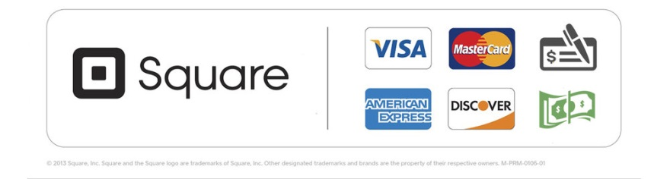
Rustic Paws accepts:

