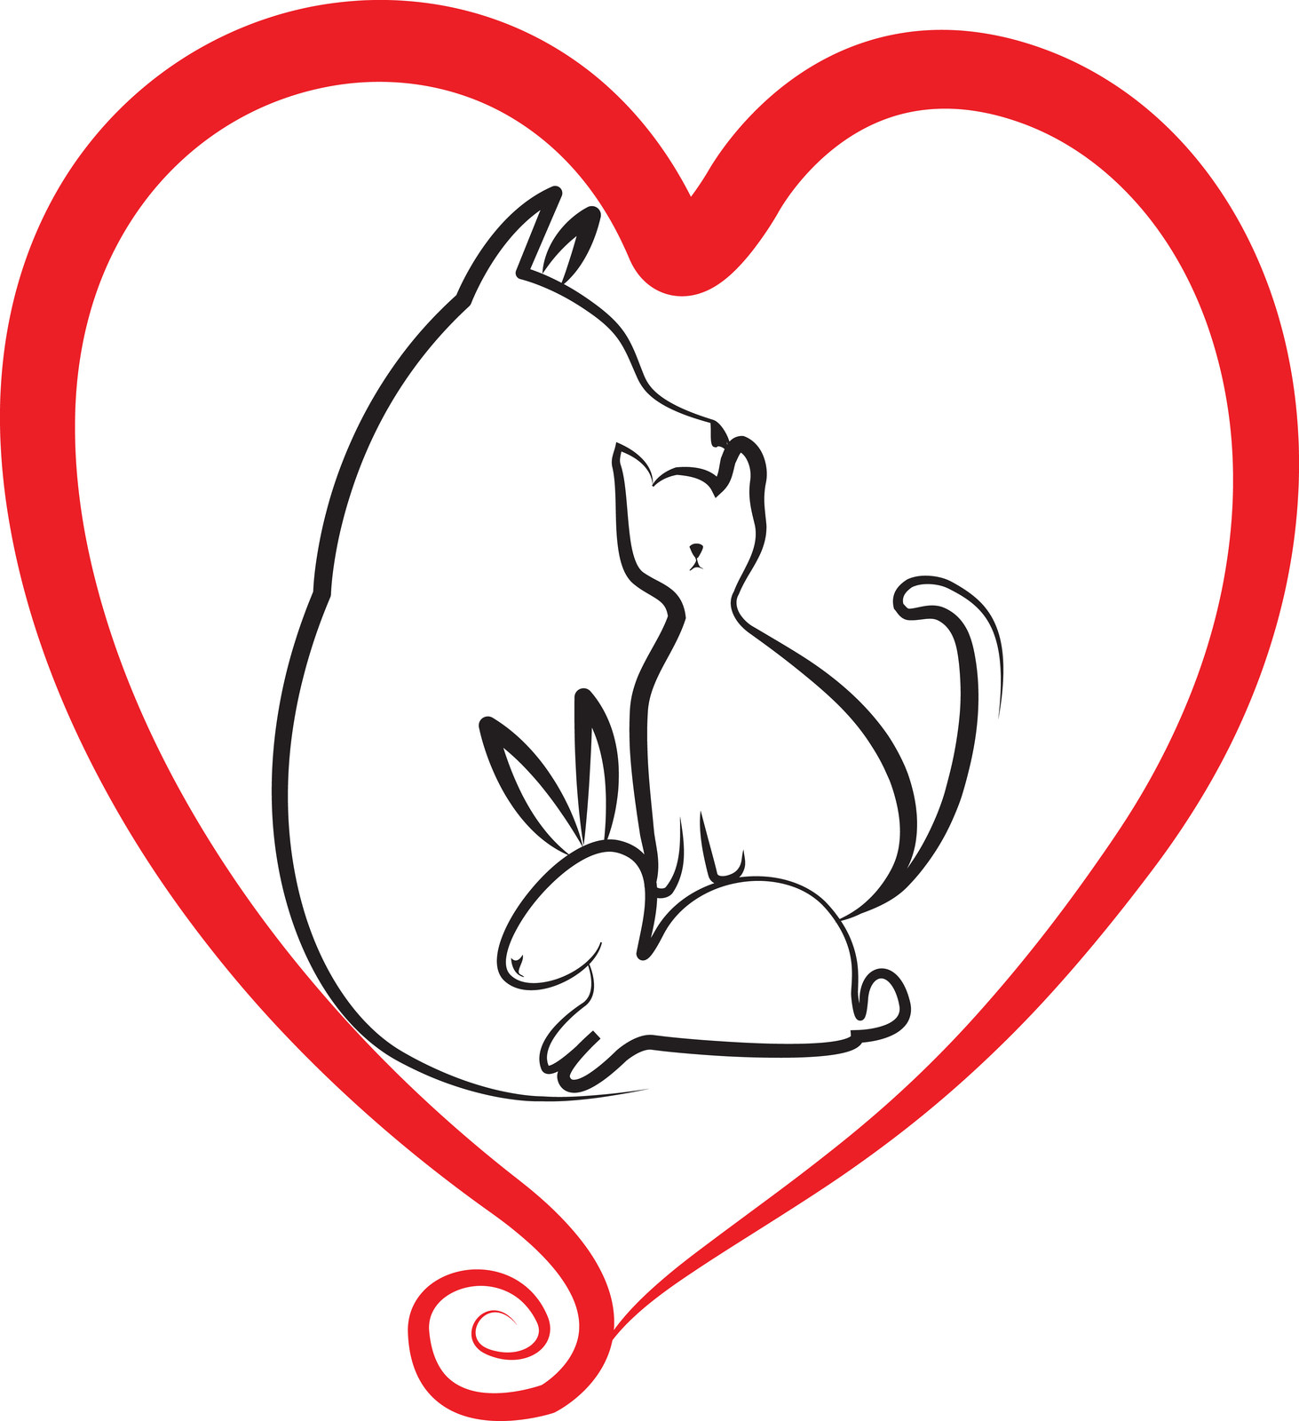
What Now?
Pet Illness and Loss Support Group

POEMS AND QUOTES

RAINBOW BRIDGE

There is a bridge connecting Heaven and Earth. It is called the Rainbow Bridge because of its many colors. Just this side of the Rainbow Bridge there is a land of meadows, hills and valleys with lush green grass.
When a beloved pet dies, she or he goes to this place. There is always food and water and warm spring weather. All the animals who have been ill and old are restored to health and vigor; those who were hurt or maimed are made whole and strong again, just as we remember them in our dreams of days and times gone by.
The animals are happy and content, except for one small thing; they each miss someone very special to them, who had to be left behind. They all run and play together, but the day comes when one suddenly stops and looks into the distance. Her bright eyes are intent; her eager body begins to quiver. Suddenly she begins to run from the group, flying over the green grass, her legs carrying her faster and faster.
You have been spotted, and when you and your special friend finally meet, you cling together in joyous reunion. The happy kisses rain upon your face; your hands again caress the beloved head, and you look once more into the trusting eyes of your pet, so long gone from your life but never absent from your heart.
Then you cross the Rainbow Bridge together, never again to be separated.

QUOTES

“Until one has loved an animal, a part of one's soul remains unawakened.”
- Anatole France

“The risk of love is loss, and the price of loss is grief. But the pain of grief is only a shadow when compared the pain of never risking love.”
- Hilary Stanton Zunin

“What we have once enjoyed, we can never lose. All that we love deeply becomes part of us.”
- Helen Keller

Chris Corrigan Mendez, M.Ed., PLPC
www.ccmcounseling.vpweb.com, ccmmed.2013@gmail.com, 314-608-6150

Practicing under the supervision of Helen Conway-Jensen, M.A., M.Ed., LPC, NBCCH, LIC #2002021231

