RIDGEVIEW EXCAVATING, INC. EMPLOYMENT APPLICATION

POSITION(s) APPLIED FOR: __________________________________
Date of Application: _____________________

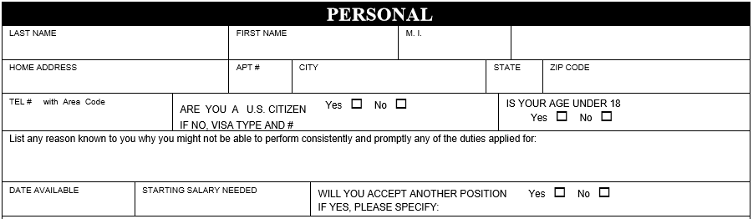

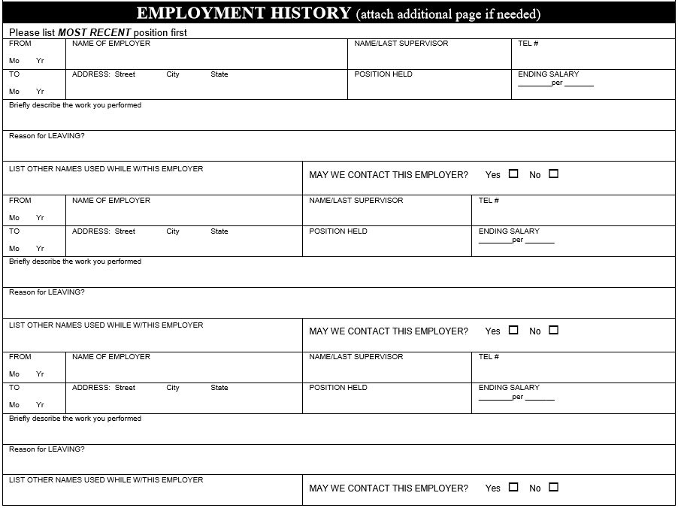

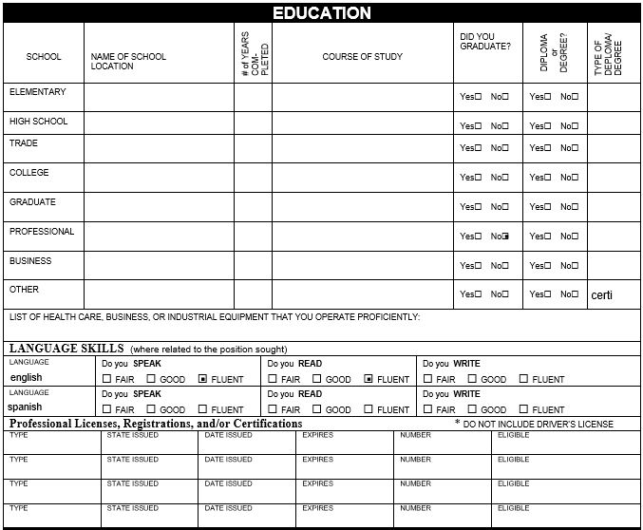
I certify that all matters contained in this application are true and agree that any misleading or false statements would be sufficient cause for immediate dismissal in the event of employment.
I further understand that this is an application for employment and that no employment contract is being offered.
I agree, if employed, to abide by all Ridgeview Excavating, Inc. rules and regulations. I understand that such employment is for an indefinite period of time and that the company can change wages, benefits, and conditions of employment at any time.
I hereby authorize Ridgeview Excavating, Inc. to investigate all matters contained in this application and to contact prior employers to obtain any and all information related to my past work performance.
I have read and understand the above. I understand my electronic signature is accepted as a handwritten signature for the purpose of this application.

SIGNATURE: _______________________________________Date:______________________________

For Office Use Only:
Position Hired For: _____________________________________________
Date Hired: __________________________ Starting Wage _____________
Scheduled Hours: _____________________

Please list at 2-4 PROFESSIONAL REFERENCES that we [Ridgeview Excavating, Inc.] may contact. Professional references may be supervisors, co-workers, or those you’ve supervised. A personal reference may be used only when there is no work history; i.e. a high school student might list a teacher or coach. References may not be a relative.

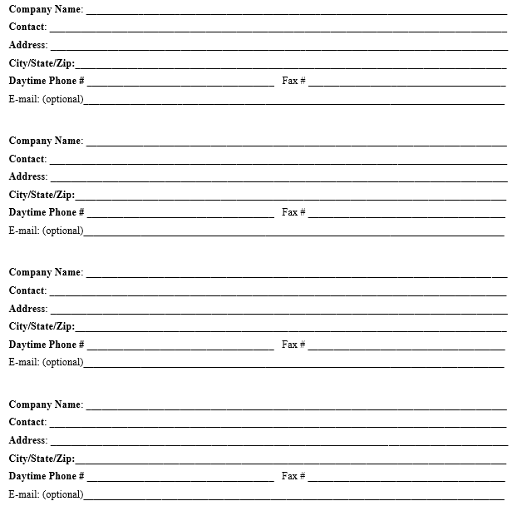

(Check here to verify the statements below)

I authorize Ridgeview Excavating, Inc. to check these references that I have provided as required as part of the interview process.
________________________________________ ______________________
Applicant’s Signature Date

