April/May 2020 Good Newsletter

At the beginning of April I realized that we had not sent out an April newsletter. You have been hearing from us almost daily so it wasn’t that you weren’t getting all of the latest news. It’s just that there were so many questions to answer, procedures to put in place and constant changes that there wasn’t time for much else and everything had to be communicated immediately. Things have fallen into a routine, one we’d rather not be experiencing, but a routine none the less and it’s time for the April/May Good News Letter. Good news only to be shared here!!!!!

**News from the office:** We are thinking about summer!!! It will come and we want to be ready for whatever situation it presents so we are going ahead with summer registration for 4k school age children. Summer registration forms for the 4k School age classroom will go out the first week of April. Hard copies will be given to anyone in the building with a few extras available if you want to stop in and pick one up. Everyone will get an email copy which can be handed in, mailed in or emailed back to us. Normally our spots fill up quickly so you should fill out your form in a timely manner. Spots will be held on a first come, first serve basis. As you fill out the form plan on summer being a normal summer and if we have to adapt we will. We will allow families to drop to down to 2 days a week and still hold a full-time spot for fall. They must be consistent days! Read the form for more details. Parents of children in the upstairs classrooms you are also receiving forms but your spots are there as usual. Please fill out the form so that we know if you will be changing drop off or pick up times for the summer. Your forms can be turned in closer to summer since you may not know about changes at this point.

Our Celebrating Families week will be postponed to a later date. We will still have the special breakfasts for parents and our open house along with our auction but we want to have it when we can all be back together. We are thinking maybe an outdoor Luau theme with burgers and brats on the grill. Everyone will be ready for a party!!!!!!! Keep watching for that date.

**News from Pastor Jim: April Good News**

According to Genesis, biblical Noah shut his family and many pairs of animals in an Ark made of gopher-wood and were isolated together for one hundred fifty days. During their five months of seclusion there is no mention of any distress or dissension aboard their vessel. During this difficult pandemic flood-time, our real-life Noah's Ark has remained a surprisingly cheerful and joyous place while the world outside seems to be drowning in pandemic panic. I continue to have "Pastor Jim Time" on Wednesdays downstairs and have been spending a lot more time upstairs in the afternoons, working on my weekly PowerPoint virtual services and talking with parishioners over the phone. I can testify to the peace and serenity first-hand. In fact, the Ark hasn't been this clean, peaceful, or happy in all the years I've been around. Our staff is doing a great job, especially at becoming teachers with our school-aged kids. With all due respect to our Governor and the CDC, I believe our Ark children are as safe as can be here in the Ark as they might be at home.

Ever since this crisis began, I've had two phrases running around in my head. One is the old British slogan from World War 2: "Keep calm and carry on." The other is a line from a reggae song: "If God is standing by my side, why should I be afraid of the pestilence that crawleth by night?" That one I heard every night on the radio while living under an active volcano in Montserrat. This week is Holy Week, a yearly reminder that, even though the world may try to do its worst to us, there's always a resurrection/Easter Sunday at the end. "The grass withers and the flower fades, but the Word of the Lord endures forever." (Isaiah 40:8) At the end of this era of self-seclusion, the sun will rise and a better day will come. Keep hope, keep faith alive!

If there is any way I can share my peace and calm with you, I'm available, at a safe social distance, Sunday mornings in the Fellowship Hall from 8:30 until 11 AM and can also be reached by semi-smart phone (715-864-6165), by email (jim_altman@yahoo.com), or by appointment (262-246-3748).

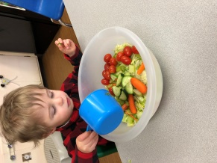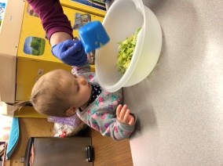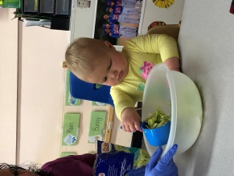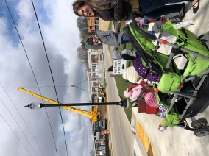**Infant/Toddler room news:** Our combined Infant/Toddler room is jumping into spring. We are talking about puddles and rain boots, umbrellas and rain clouds. We are also making a cross to help us think about Jesus at Easter and painting with Easter eggs. We will microwave a peep bunny and watch it magically grow. Your child will also bring home a bag of bunny salad. This salad is not for your child to eat; it is used to entice the bunny to stop at your house. In May it will be all about bugs, gardening, and flowers. We will take walks outside to watch for things growing and sprouting. Let’s hope for warm spring weather!

**Infant/Toddler wish list includes:**

**Rubber Ducks ** Big plastic bugs

Making salad for the Easter Bunny hoping he will hop by and deliver goodies

Watching the big crane

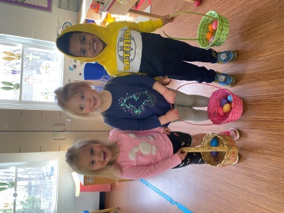**Preschool room news:** During the month of April are learning about Easter, Families, Spring and Pets. Our monthly group goal for three year olds is recognizing their name in print. Our monthly group goal for two year olds is recognizing and naming shapes. As always we will continue working on letter and number recognition and learning how to write our names. Hopefully by May we will be sensing summer on the horizon! During the month of May, we will be learning about Pond Life, Bugs, Gardening and how keep our bodies healthy and in shape with our Nutrition and Exercise theme. As the weather gets warmer keep an eye out for a sunscreen form in your child’s cubby. Along with that form we will ask you to start bringing in your child’s swim wear for water days! Swim items include a swimsuit, towel and swim shoes (or shoes that can get wet.) It’s helpful to keep these items at school since we can’t always predict when we will have a water day.

Practicing egg hunting

**Preschool wish list includes:**

**\*\*** Flower seeds to plant (for our gardening theme in May) ** Summer window clings

**4k/School age classroom news:** Our April has been filled with online learning. It’s been a challenge at times but the students and the teachers are getting the hang of it. Please continue to send in detailed instructions on what you would like your child to work on for the day. Don’t forget to give us passwords or be sure you child knows them. We have learning time in the morning and in the afternoon it’s reading and journaling. We also head outside whenever we can for as long as we can in the afternoon. It’s needed to get the wiggles out from working hard all morning and then again for a period in the afternoon. On days we can’t go outside we head out on a virtual field trip. So far we’ve been to the Cincinnati Zoo and seen volcanoes all over the world. The 4k schoolage room will also crown its Disney March Madness Champion. When the traditional March Madness bracket went by the wayside they created their own Disney version. Two friends 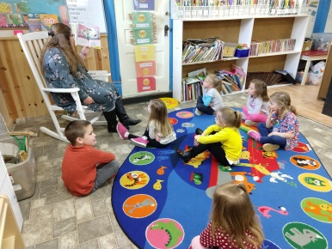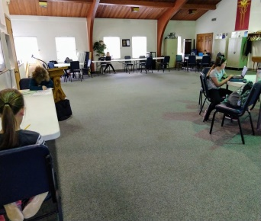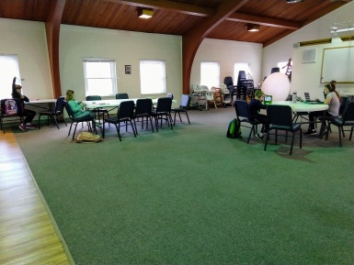roll the dice and add them up. The class does the math to figure out who has more points and is the winner.

**4k/school age wish list includes:**

• Thick and Thin Expo Dry Erase Markers •Electric pencil sharpener

Our 4k/school age students are hard at work. It’s been a new experience for students and teachers but it’s getting better every day. There is a lot of learning going on.

**Parent’s Page**

With all that is going on in the world right now many people are asking, “How can I help”? Not everyone has lost their job, not everyone has gotten sick, not everyone has been affected in the same way so those who can help want to know how. One of the best ways most often mentioned is to help stock a local food pantry. Those who have been affected financially have had to turn to food pantries to make their money go farther. After haven communicated with the director of the Sussex food pantry she indicated that they have changed how they give out food so that they can maintain safe social distancing but they are open and needed more than ever right now. I have included here a list of the most needed items at our pantry. If you are able to pick up any of these items the next time you are in the store feel free to drop them off here and we will get them over to the pantry. The food pantry is a non-profit organization so keep your receipt with your 2020 tax information as record of your donation. If you or someone you know could benefit from a trip to the pantry to help reduced income go farther please see their website ***Sussexareasos.org*** or give them a call at ***262-246-9860*** for more information. Currently there is no registration required to receive help.

**Needed items include:** Toothpaste **Toilet paper**Paper Towel**Jelly/Jam**Canned peas, carrots and mixed veggies**Hamburger Helper**Pasta sides**Stuffing**Ramen noodles**Syrup**Boxed potatoes

Keeping with the theme of helping others - below is an article that is very appropriate for the situation we find ourselves in today and keeping with the Good Newsletter criteria it is all about how bad situations bring out the best in some people. It’s an interesting read and uplifting. The beginning is printed here with a link to the rest of the article.

**How Bad Times Bring Out the Best in People**

It’s easy to look around and see how the Covid-19 crisis has brought out the worst in some people — from [hoarding thousands of bottles of hand sanitizer](https://www.nytimes.com/2020/03/14/technology/coronavirus-purell-wipes-amazon-sellers.html) to [crowding bars and restaurants](https://www.washingtonpost.com/nation/2020/03/16/coronavirus-bars-lockdowns-closures/) despite public-health guidelines. But such irresponsible behavior, I believe, is more the exception than the rule. Time and again, individuals and communities have demonstrated that the worst situations tend to bring out the best in people and the organizations to which they belong. In every moment of darkness, it seems, there are countless moments of light — small gestures of compassion and connection that allow people to show who they are, how they want to live, and what matters to them.

<https://hbr.org/2020/03/how-bad-times-bring-out-the-best-in-people>



April Birthdays!!!!!!! May Birthdays!!!!!

Sierra was 4 on the 5th Sofia will be 4 on the 3rd

Sara was 9 on the 8th Jillian will be 9 on the 3rd

Eloise will be 3 on the 14th Katie will be 10 on the 6th

Carter will be 3 on the 18th Faith will be 3 on the 9th

Miss Sue will celebrate on the 19th Lincoln will be 2 on the 11th

Miss April will celebrate on the 26thGrant B will be 1 on the 21st

Beau will be 4 on the 25th

Emmett will be 5 on the 28th

**Remain calm through thick and thin; hold tightly to your beliefs, knowing time is NOT the enemy, but your closest ally. -Unknown author**

***“The way I see it, every life is a pile of good things and bad things. The good things don’t always soften the bad things, but vice versa, the bad things don’t always spoil the good things and make them unimportant.” – Doctor Who***

***Building with our brand new outdoor blocks. Thanks to Felix’s dad and Leighton and Carter’s dad for cutting them for us. Once things are back to normal we will add other “loose parts” to the mix and see how creative we can be.***

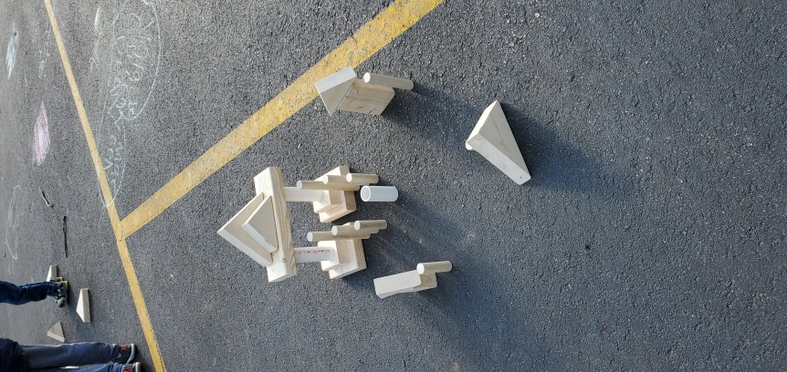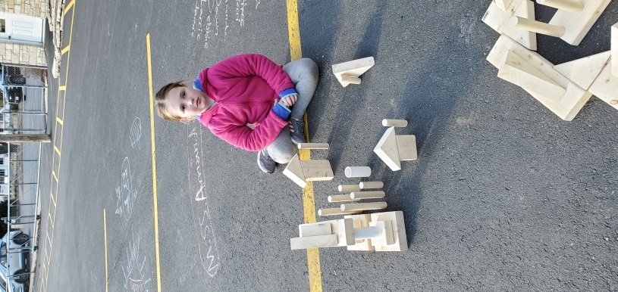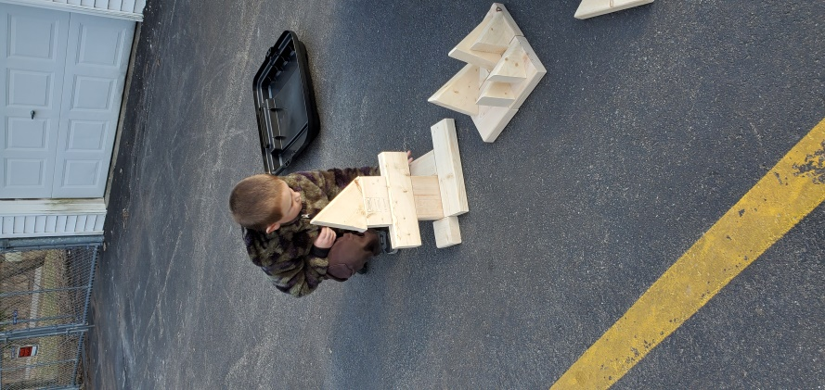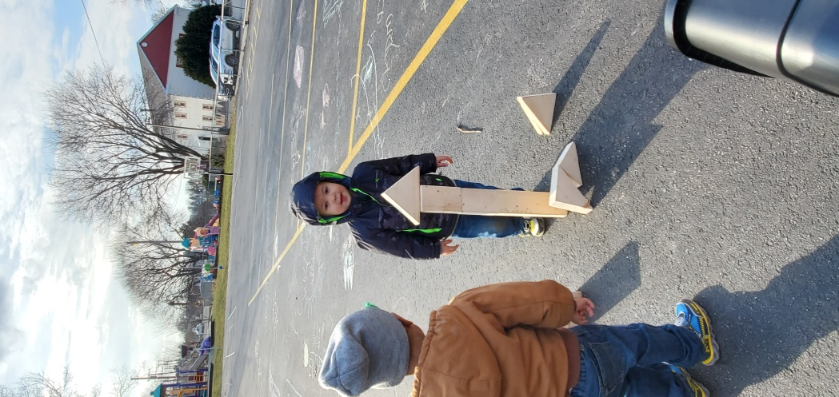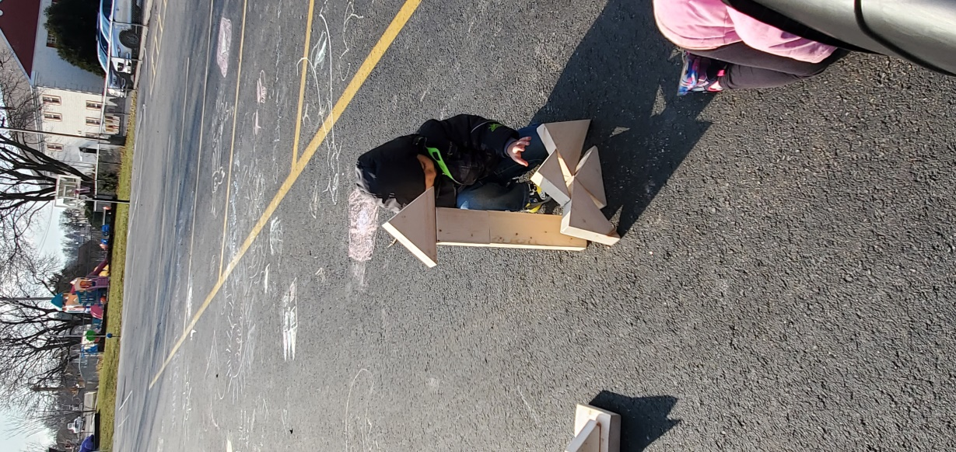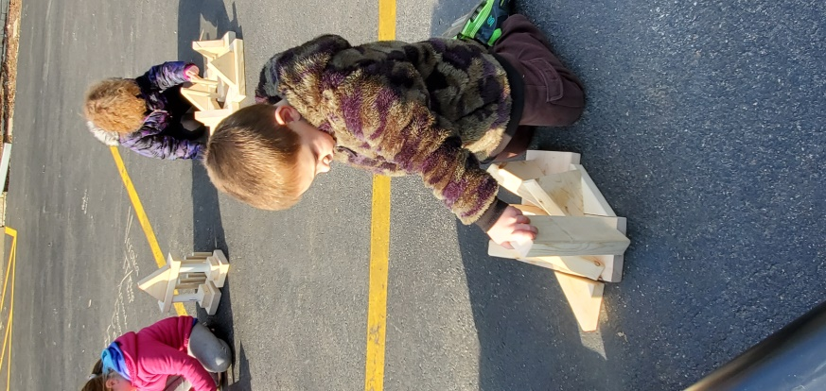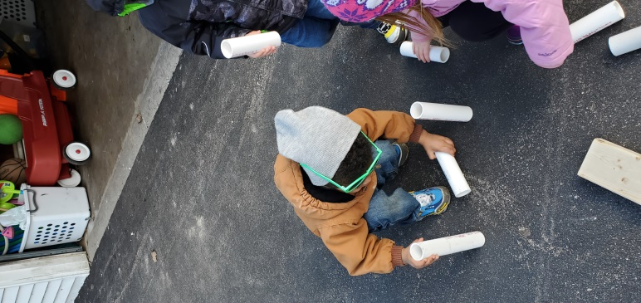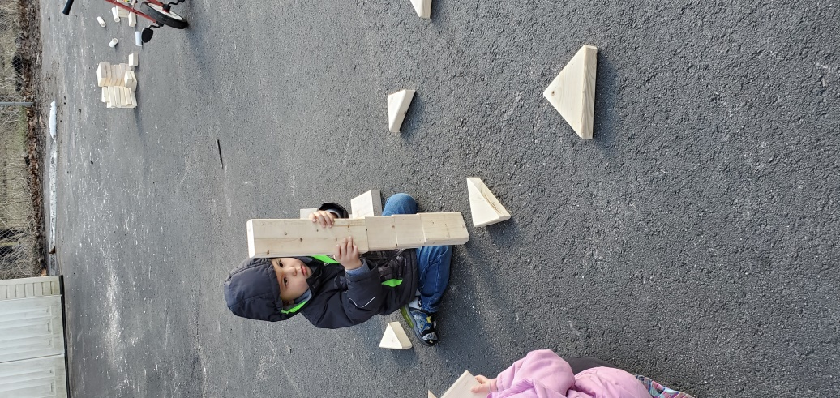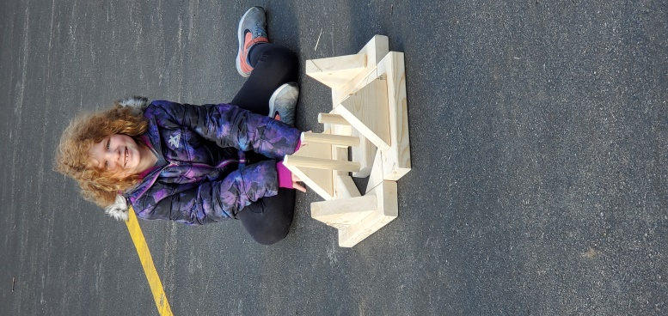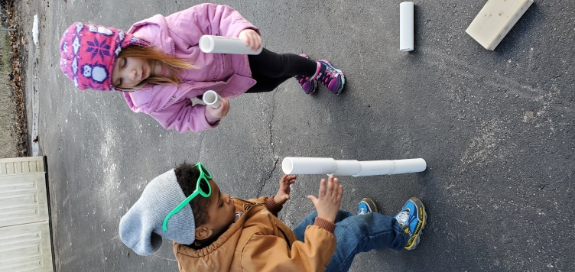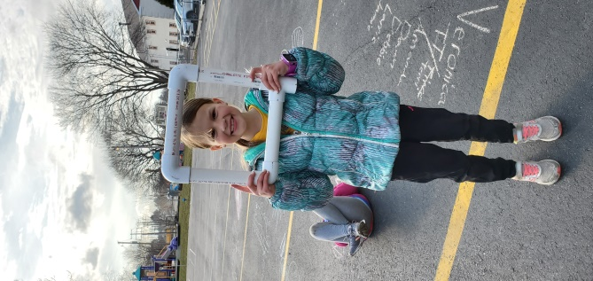

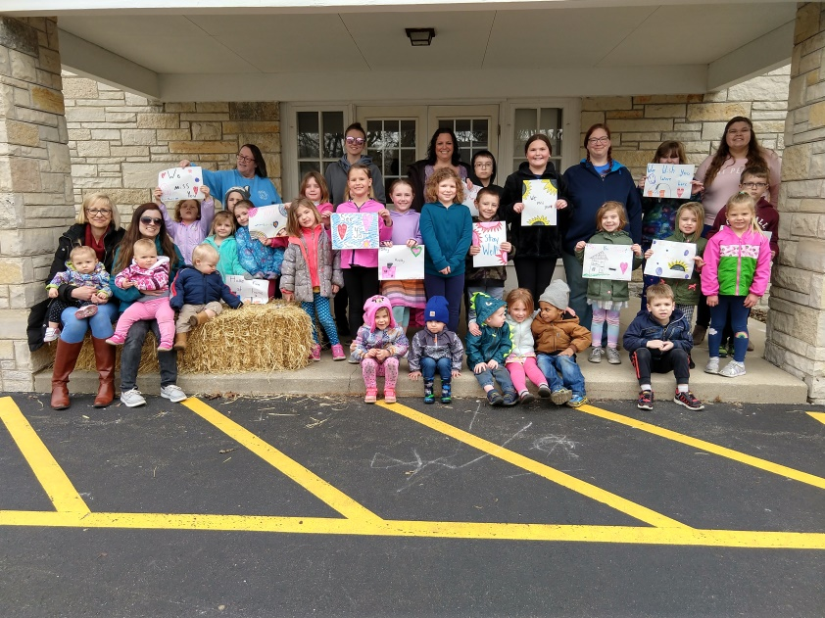***Our Reunion Parade on Friday 4/3***

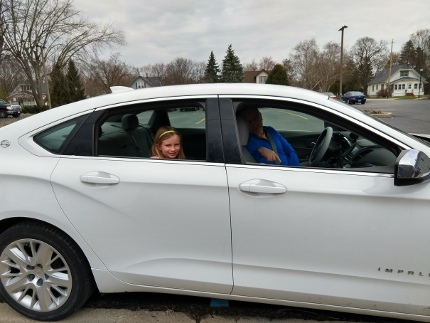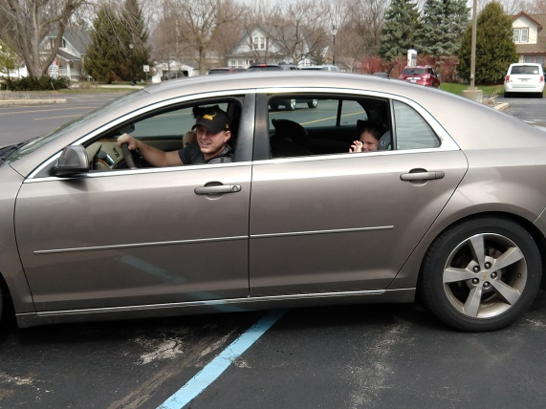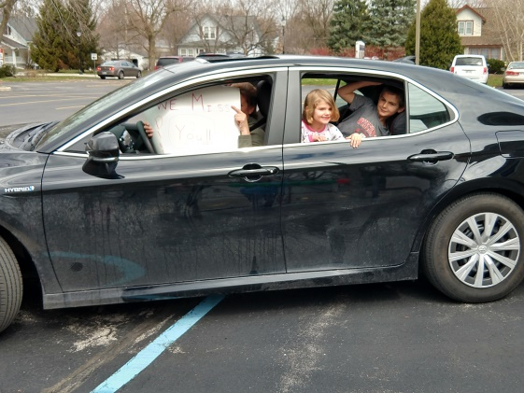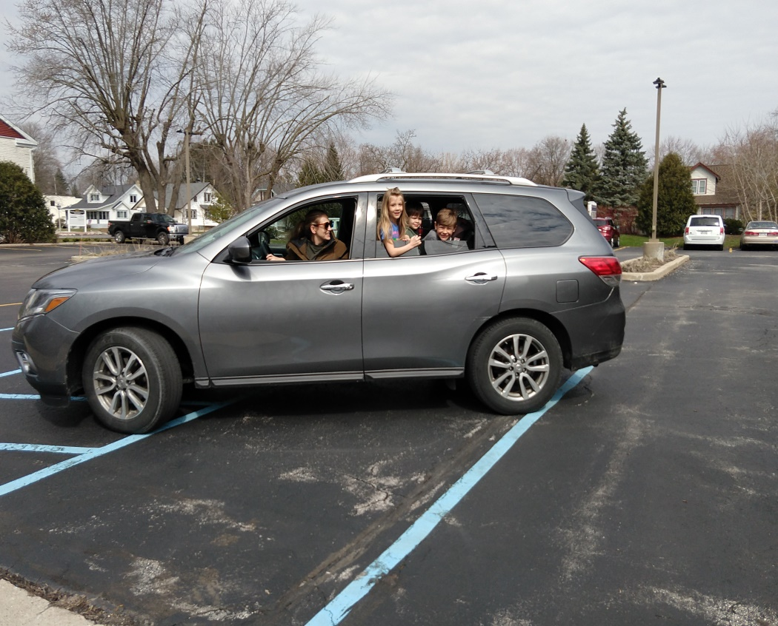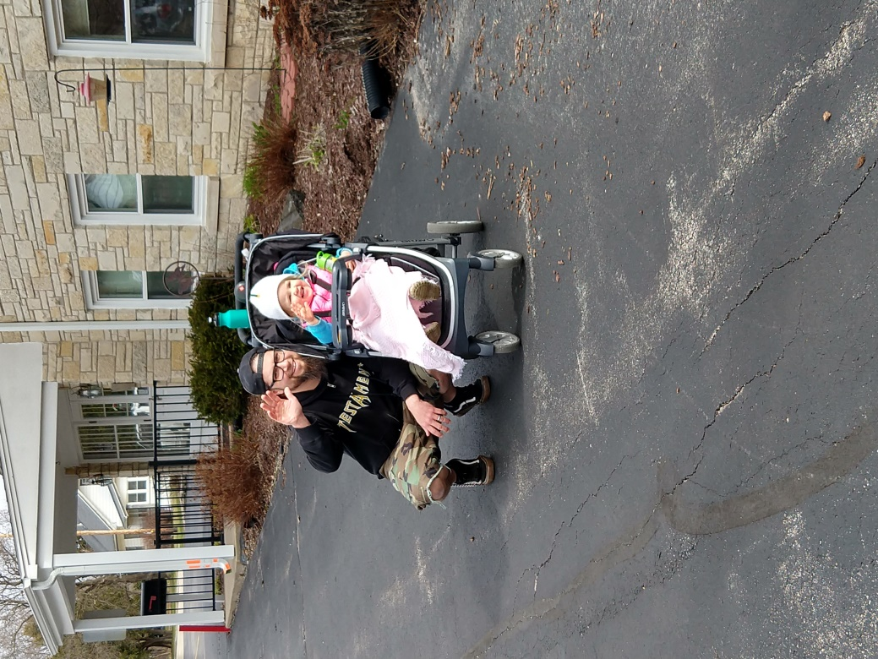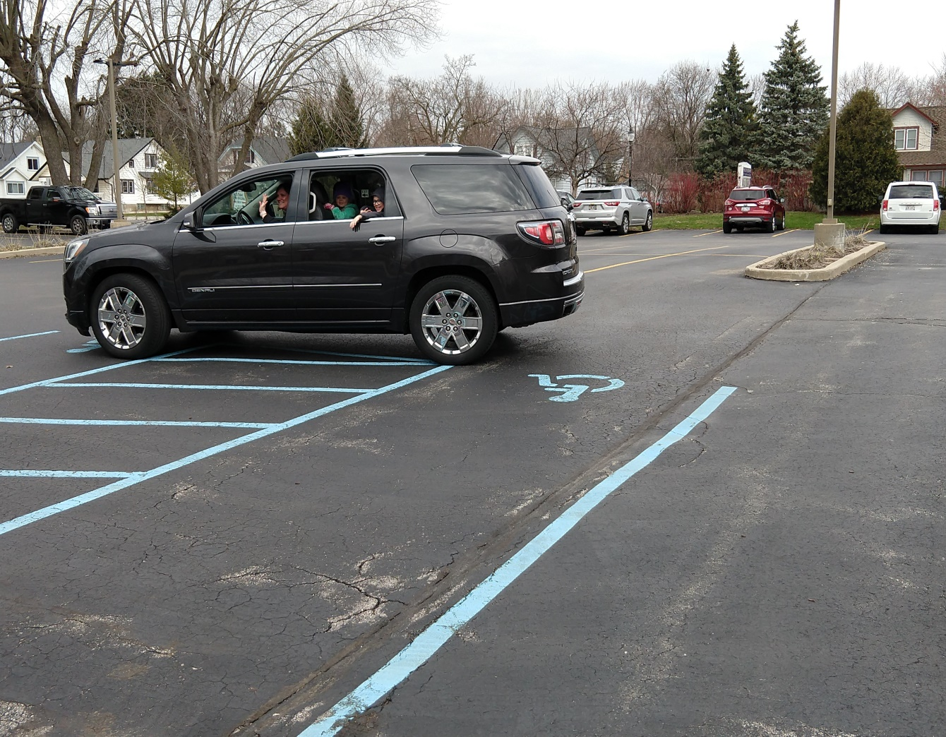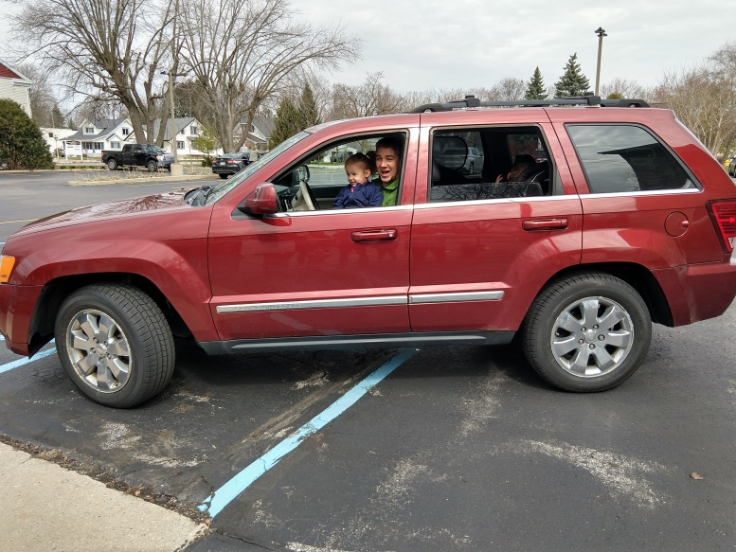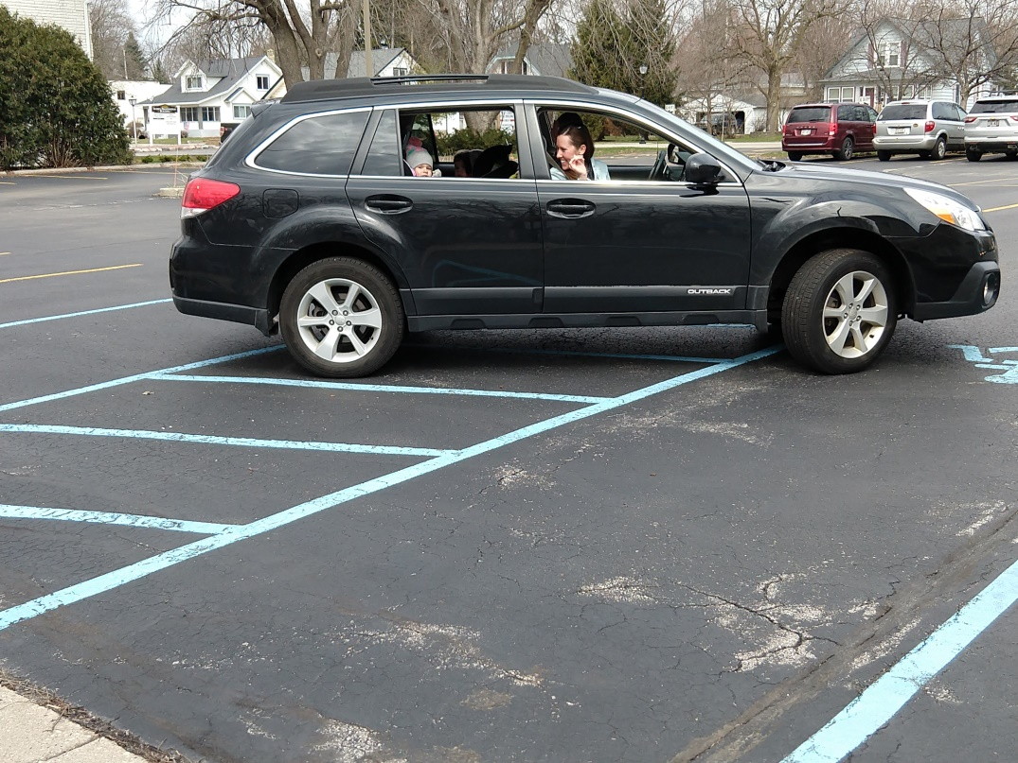

It’s Leighton and Carter with their mom and dad!

Hi Avery and Caleb! Mom and dad, thanks for coming by.

Cora and her dad strolled on over.

Carter and Sierra made a sign for us. Thanks for holding it mom.

Sara stopped in with her dad!

Felix brought his mom and sister Hazel and brother Oscar!

Hi Regan and Aidan and dad too!

It’s Isaac and Hazel with their mom!

The gang is ready for the parade. Who will come to visit us?

**Thank you so much to the families that drove in during our reunion parade. We miss having everyone here with us so it was great to see our friends even if it was across the fence. Hopefully we can see you all back here soon.**