ACCELERATED READER
Student Quizzing

1. Students login to their accounts (https://hosted5.renlearn.com/17870)

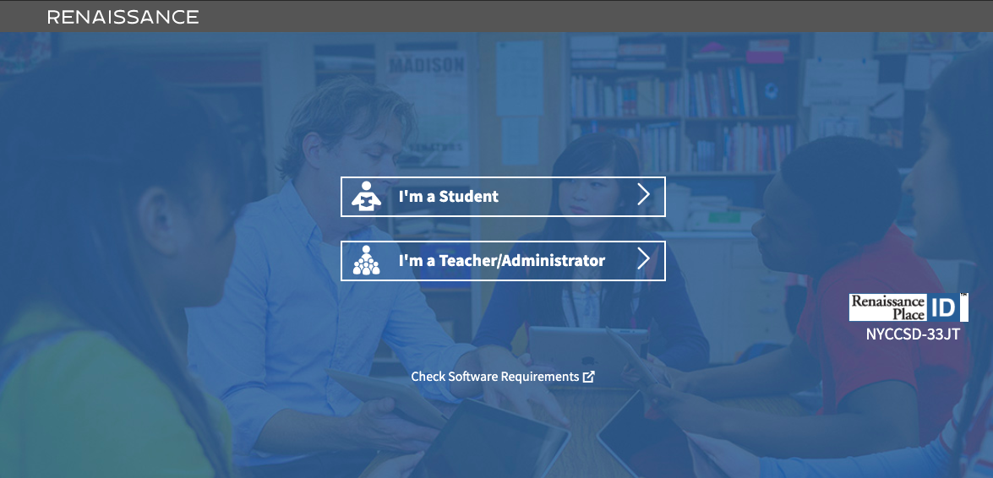

2. Click on Take a Quiz
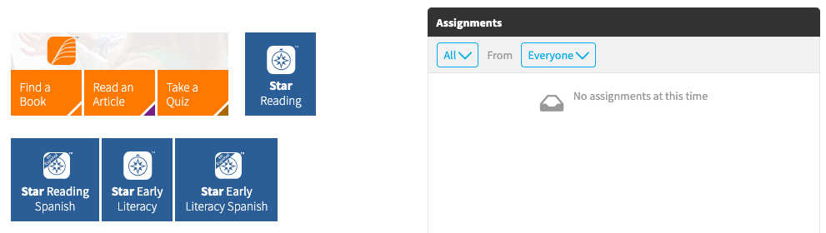

3. Type in the Title or Quiz Number

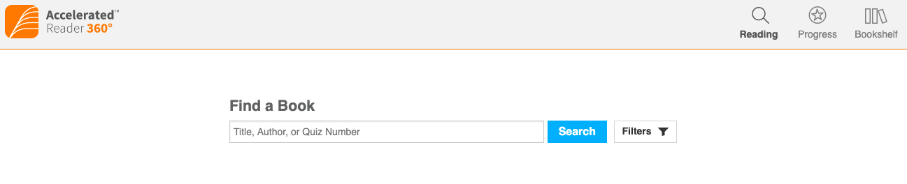

4. When you find the book, Click Take Quiz

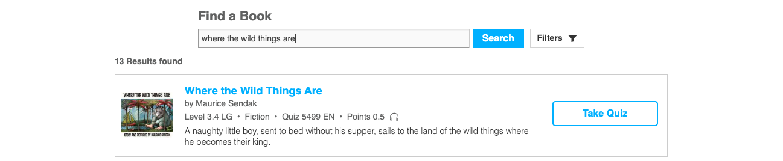

5. Select how you experienced the book and then click Start Quiz
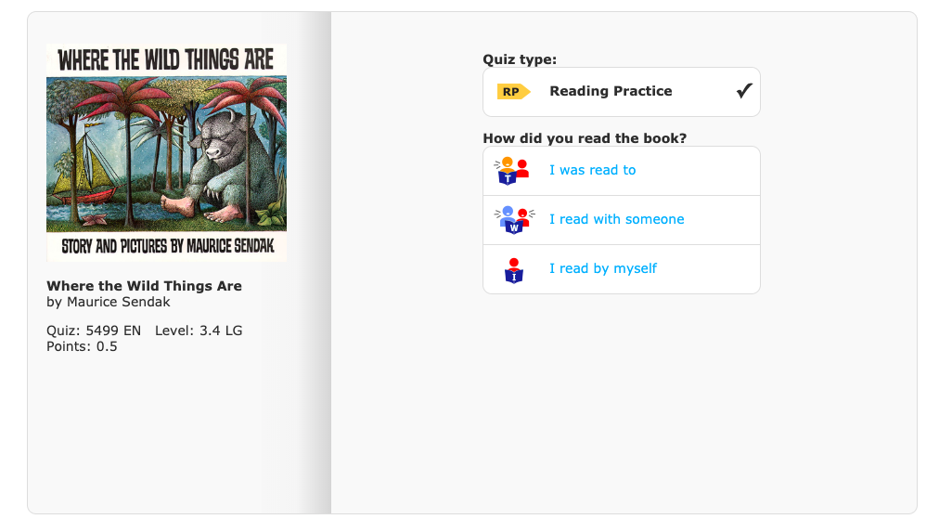

* Note: 3rd – 8th Grade students are required to read 80% of their books independently and must select I read by myself

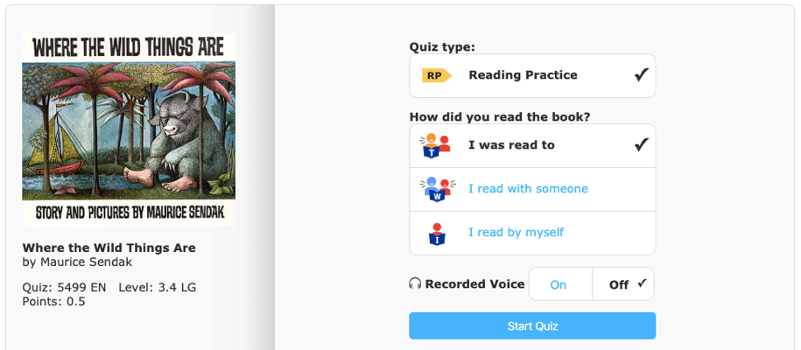 | * Note: Some books will have the option for the books to be read aloud. Click On for this option.

8. After completing the quiz, report how you like the book. 1 Star = a little, 4 Stars = a lot

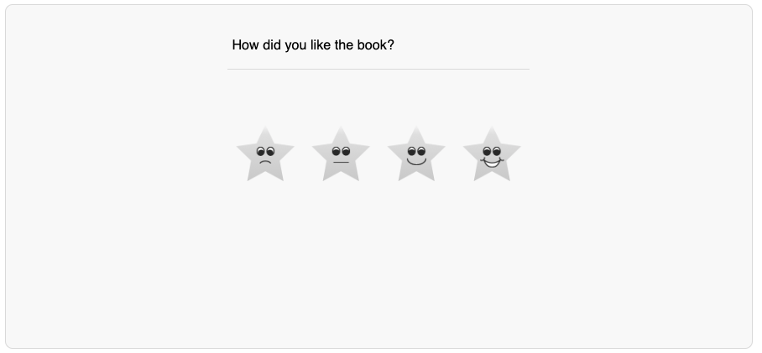
9. See how you did, Then Review Missed Questions or Close
