Cholera in Lebanon
Ava Nazemian
George Mason University

Cholera in Lebanon
Introduction:
We live in a world where the smallest things can cause the most harmful effects. Microscopic bacteria that result in days to months of difficulty and irritation. One example of a life-threatening bacterium is Vibrio cholerae. This bacteria is found in contaminated water that is ingested by humans which can then lead to an infection of the body, often resulting in a diarrheal disease. While we don’t typically worry about cholera outbreaks in the United States, there are several countries in the world that suffer from the fear of this bacteria and all the terror that it can cause. One of these countries being Lebanon. For decades, cholera has caused issues in Lebanon; however, there have been many recent issues within the last five years that bring up concern for many. Through this term paper, the background, methodology and case studies on cholera in the nation of Lebanon will be discussed and elaborated upon.
Background:
Cholera is a diarrheal disease, from the bacteria Vibrio cholerae, that has fatal capabilities when humans are exposed. It is estimated that “1.4 to 4.3 million cases, and 28,000 to 142,000 deaths worldwide” occur due to cholera each year (World Health Organization, 2015). This is a very serious illness that cannot be taken lightly and more research and awareness needs to be brought to the issue so that people globally, whether it directly impacts them or not, can be aware of the bacteria and all that it can cause. A major issue is that the majority of individuals who have cholera do not develop noticeable symptoms; however, they are putting others at risk by spreading the bacteria through their feces without even knowing about it (World Health Organization, 2015).

Methodology:
Cholera has been determined as a health problem in Lebanon because there have been case studies on individuals with cholera in the nation. There are a variety of problems that come from being infected with cholera, such as diarrheal problems and dehydration which can be fatal if not treated right away. Just this past September, an article was released through the International Business Times that stated doctors were warning the people of Lebanon of a greater risk of obtaining cholera because of the infected water due to a major trash problem (Buchanan, 2015). Through this more recent article, it can be noted that as the years go by, cholera continues to remain an issue in this nation. Even though this bacteria can affect any individual, Buchanan states through her article that this particular warning highly impacts Syrian and Palestinian refugees who are living in Lebanon, since the water around their camps is contaminated (2015). This shows that not only does the contamination of the water affect those in Lebanon, but also people of other nations can suffer from the crisis. While there are a numerous amount of different strains of the bacteria, each individual can have a different reaction when they are infected. This is especially clear when comparing and analyzing two specific case studies, published in the Eastern Mediterranean Health Journal, from the country of Lebanon. 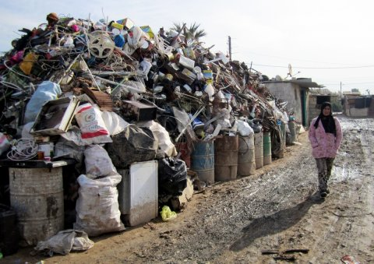
The image to the left portrays the garbage crisis in Lebanon which leads to the water contamination and higher risk of catching an infectious disease (Buchanan, 2015).
First supporting case:
The Eastern Mediterranean Health Journal elaborated on two specific case studies on individuals who were infected with different strains of V. cholerae. First being, “A 54-year-old man with a history of alcoholic liver cirrhosis was admitted with a 1-day history of abdominal pain, high-grade fever and fatigue” (Feghali & Adib, 2011). Based off this immediate description of the patient, it can be noted that he had been experiencing symptoms of fever, fatigue, and abdominal pain, in just a one-day period. The symptoms of the infection can be quite rapid and it seems as though this patient did not feel the need to seek medical attention until after a full-day of symptoms. The patient also has a history of a liver problem which could potentially play a role in his current state of health. According to Feghali and Adib, the patient did not have any diarrhea, although he looked ill (2011). This is interesting because while many believe that cholera is directly linked to immediate diarrhea, according to the World Health Organization, about 80% of infected individuals do not develop symptoms at all (2015). The patient had bloodwork and other labs done and once they were complete, the results showed that he was contaminated with “non-toxigenic V. cholera non-O1/non-O139” (Feghali & Adib, 2011). The patient was discharged after five days being in the hospital once he was treated and all of his symptoms subsided (Feghali & Adib, 2011). At the end of this case, the source of his contamination was discovered. The patient had consumed fish and shrimp in the week before he was admitted to the hospital (Feghali & Adib, 2011). While this case study included an older individual, the bacteria can affect people at any age, even infants.
Second supporting case:
At 33-weeks of age, a premature female infant was born and was in distress just a few hours after its delivery (Feghali & Adib, 2011). As a premature infant she is already weak, and possible contamination from cholera will only make her situation worse. The infant’s vitals were abnormal and labs were done in order to test for the reason behind the distress (Feghali & Adib, 2011). According to Feghali and Adib, “Two days later, the baby developed renal failure” and “started having seizures and brain ultra sound revealed hydrocephalus and intraventricular haemorrhage” (2011). For a premature infant, this is a lot of stress on their body all at once. After testing results came back, it was confirmed that “non-toxigenic V. cholerae non-O1 and non-O139 were identified” (Feghali & Adib, 2011). In this case, since it was an infant, symptoms such as abdominal pain and fatigue could not be immediately identified since the infant cannot speak to explain their pain. Instead, signs of distress lead to tests being done which revealed the cause. After two months of hospitalization, the infant recovered and was discharged; however, no cause behind the contamination was identified (Feghali & Adib, 2011).

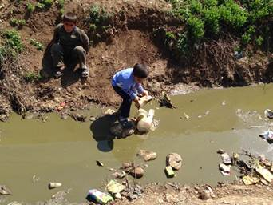
In the image shown above, a child is playing in the contaminated river of Lebanon, putting themselves at risk for contracting cholera (Buchanan, 2015).

Analysis:
Both these cases involved V. cholerae contamination in the country of Lebanon, although they differed in many ways. First being, the age and sex of both cases varied with the first one being a 54-year old male and the second being a premature 33-week old female infant. This shows that this bacteria can affect any individual regardless of age or sex. With case one, the patient was able to explain their symptoms of fatigue, pain, and fever. This lead to appropriate testing to be done in order to confirm the cholera contamination. His physical symptoms and overall malaise were indicators of contamination, even though he did not have any watery diarrhea. Now in case two, a premature infant cannot explain their pain but she was simply in distress. Then once she began undergoing complications such as seizures and renal failure, further testing was done in order to identify it as cholera contamination. A reason behind the contamination in case one was identified to be consuming of seafood products a week prior to the onset of symptoms. In the second case, there was no reason identified, which can bring up concerns. Case one had a much shorter hospitalization of five days while case two had a two month hospitalization, which can be linked to age since it is comparing a middle-aged man and a premature infant. Regardless, these two case studies demonstrate that while any individual, regardless of circumstances, can be infected with the bacteria, the reaction and recovery varies and it must always be treated seriously and immediately in order for the best outcomes.
Conclusion:
This paper discusses how cholera is a serious illness that can happen to anyone, anywhere, but some places more often than others. Through analyzing case studies and articles on the topic, one can see that issue is one that requires great attention, particularly in the nation of Lebanon. For years, cholera has been a rising issue in Lebanon and with this ongoing garbage contamination, it is clear that the issue will live on for some time. More and more individuals are put at risk, whether it is the people of Lebanon, those who are visiting, and even the millions of refugees who are currently calling the nation their home. Proper precautions need to be taken, as always, with diseases like this one, such as frequently washing hands, being aware of highly contaminated areas and staying away from them if possible. While the issue will not be resolved overnight, the more we educate individuals on the issue and how to protect themselves, there is a greater chance that less people will be contaminated until maybe one day this disease can be eradicated.

References
Buchanan, E. (2015, September 15). Lebanon: Doctors warn of spread of cholera in refugee camps as rubbish crisis intensifies. Retrieved April 29, 2016, from International Business Times website: http://www.ibtimes.co.uk/lebanon-doctors-warn-spread-cholera-refugee-camps-rubbish-crisis-intensifies-1519262
Feghali, R., & Adib, S. M. (2011). Two cases of vibrio cholerae non-O1/non-O139 septicaemia with favourable outcome in lebanon. Eastern Mediterranean Health Journal, 17(8). Retrieved from http://search.proquest.com/docview/887254307?pq-origsite=gscholar
World Health Organization. (2015, July). Cholera. Retrieved April 29, 2016, from World Health Organization website: http://www.who.int/mediacentre/factsheets/fs107/en/

