Afternoon Tea
Advance booking is required.
Served Tuesday to Sunday 2.30pm–5.00pm

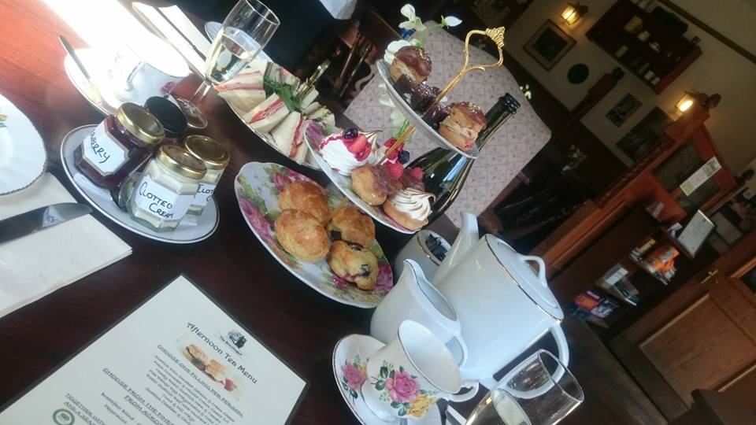

Our Vintage Afternoon Teas are served on 3 tiers.
The first being a classic and contemporary selection of sandwiches, the second is homemade scones, clotted cream with a choice of jams, & the third tier is a seasonal selection of cakes and tray bakes.

£10.95 PER PERSON

AFTERNOON TEA FOR TWO WITH BUBBLES! £34.95
(20CL BOTTLE OF PROSECCO PER PERSON)

AFTERNOON TEA FOR TWO WITH BUBBLES! £39.95
(75CL BOTTLE OF PROSECCO)

Afternoon Tea Menu

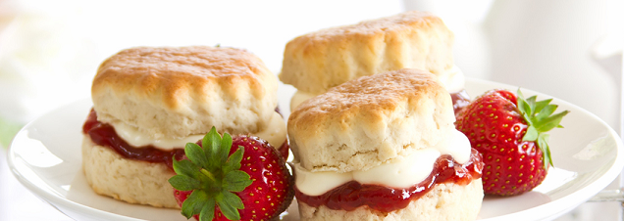

CHOOSE ONE FILLING PER PERSON:

Fresh Cucumber & Minted Cream Cheese (V)
Honey Roast Scottish Ham & Tomato
Free Range Egg Mayonnaise & Cress (V)
Roast Scottish Beef with Mustard Mayo
Tuna & Dill Mayo
Scottish Cheddar & Chutney (V)

CHOOSE FROM THE FINEST TEAS & INFUSIONS FROM ACROSS THE GLOBE

Breakfast Blend - Green Tea - Earl Grey – Camomile –
Peppermint - Lapsong Souchong or Red Berry

TOGETHER WITH HOMEMADE SCONES, CLOTTED CREAM, JAMS, AND A SEASONAL SELECTION OF CAKES AND TRAY BAKES

THE BOUDINGAIT – 43 BONNYGATE, CUPAR KY15 4BU – TEL: 01334654681 – EMAIL:THEBOUDINGAIT@OUTLOOK.COM
WWW.THEBOUDINGAITCUPAR.CO.UK

