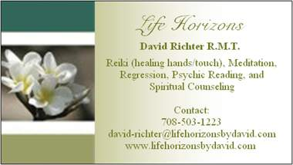

SURRENDER
This is part 3 to the blog Creating Desires. Please feel free to go back and read the last 2 blogs before this one. In the first blog I wrote about how to have our desires show up in the physical. The next blog talked about some of the things that get in the way of our desires and how to correct them. Well this one is about asking for help.
When creating a desire we do not have to do it alone. In fact it is very good not to do it alone. I am not saying ask your family your friends to help, they just might think you are crazy. We find our help by going to what some call a higher power. This higher power can be known as God, Angels, Ascended Masters, the Goddess, Buddha, or any other deity that may be thought up. This higher power can help you create your desires. We ask them for there help by praying, meditating, writing or performing a ritual. It doesn’t matter who you use just use one that truly resonates with you.
When you ask for help in creating your desires just as before it helps to have a pure thought. Pure thought being a thought that is not followed by it’s opposite. In asking your higher power for help be extremely specific, it shows your faith in their power. Also after you finish asking for help surrender the whole of what you are creating over to them. I am not talking about putting up a white flag. What I mean by surrender is to let go. Many of you may have heard of the phrase “Let go and let God.” This is what is meant by surrender. To fully surrender however we have to completely hand it over. It doesn’t work to say here take this and 5 min. later start thinking about how to help. If we truly surrender our desires we give them to our higher power and then leave it alone. Yes sometimes it helps to focus on what we are creating but don’t let it get in the way of the work that the higher power is doing. Repeating your desire or focusing energy on your desire is used to help you believe, not to help the higher power. Your higher power has your best interest in mind and will work to help you create your desire. It’s up to us to stay out of the way.

Sometimes in order to help believe that our higher power has it we can use affirmations. These affirmations might sound like the following: I totally trust that my higher power will do this for me. I surrender this desire fully to my higher power. One I use personally is: “Ok God it’s all Yours you take it from here don’t let me mess it up.”
Letting your higher power take control to help you is not easy especially when we have been raised to believe that we have to do it ourselves. There is nothing wrong with surrendering to a higher power in fact they usually want to help. They don’t help unless we ask. I can attest that surrendering to higher power really works. I have done it several times and it feels like your higher power has your back. The bigger the creation, the more we have to affirm that the higher power has it because we tend to think the higher power is limited like us. So when surrendering to your higher power remember that they have unlimited power and will help, don’t withhold any detail from them.
Anyone with an affirmation they want share, to help surrender to a higher power, feel free to leave a comment. I will answer questions as soon as possible. Look to comments for your answer.

