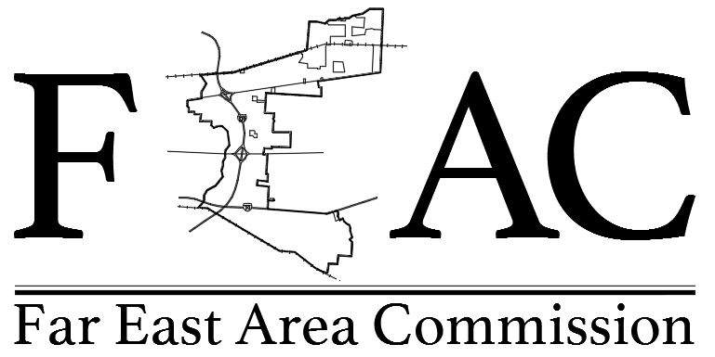

Minutes from December 4, 2018 Special Meeting

1. Chair Commissioner Chamberlain called the meeting to order at 6:50 pm.
a. All Commissioners were present, except Commissioners Hutsko, Pulsifer and Watson.
b. Approval of Former Meeting Minutes. Commissioner Tyree made a motion, which was seconded, to approve September 4, 2018 and November 6, 2018 minutes. Voice voting unanimously approved.

2. Year End Chair Update: Jennifer Chamberlain - Bylaws Review. Chair Commissioner Chamberlain and Commissioner Tyree proposed amendments to Bylaws Article VI, 2 and 5 which were proposed as follow.

Article IV. Membership.
2. Members. The Commission shall consist of eleven (11) members. Each member shall either reside, work, including affiliation with nonprofits, or own property in the Commission Area, and serve without compensation. Those members outside of the Commission Area are limited to no more than one-third (1/3) of the membership.

Article IV. Membership
5. Disqualification. Members shall maintain their residence, work, including affiliation with nonprofits, property or business in the Commission Area from which they were elected or appointed. Failure of a member to maintain his or her residence, work, including affiliation with nonprofits, property or business in the Far East Area Commission, shall be deemed a resignation and the Secretary shall notify the May Mayor, City Clerk and the Director of Development Department of Neighborhood.

Commissioner Abner made a motion, which was seconded, to approve proposed amendments to Bylaws. Roll Call voting resulted in unanimous approval.

3. Year End Zoning Update: Commissioner Marshall. No Zoning Update

4. Year End Secretary Update: Commissioner Eddy – Parliamentary Procedures. Commissioners discussed and agreed on the following.
a. Vice Chair and Secretary will be the Primary and Secondary, respectfully, meeting monitors to ensure smooth, orderly progress of meetings. A gavel may be used as necessary to call order to meetings.
b. Stay on track with meeting Agendas.
c. Require use of Speaker/Comment Forms (Commissioner Marshall passed around a Speaker /Comment Form to view.)

5. Year End Financial Update: Commissioner Tyree – Chair Commissioner confirmed the order of the FEAC sign. Chair Commissioner Chamberlain also agreed to follow up on her contact for safety vest lettering modification cost and style and will notify Commissioners of the outcome.

6. New Business: Table Monthly and Special Meetings Discussion.

Next Regular Meeting: January 08, 2019 (Election)

Adjournment, Commissioner Tyree made a motion, which was seconded, to adjourn. Voice voting unanimously approved. The meeting adjourned 8:50 pm.

